Task 1. Figure out what security precautions are already used in your 'dvd_rental' database. Prepare description
Focus on:
- Existing users/roles and their permissions
- Table-level privileges
- Any existing row-level security policies
- Database-level settings like connection limits or authentication methods
Prepare a detailed description in a text or docx file. Include SQL queries you used and their outputs for evidence.

1. Existing Users / Roles and Their Permissions
SELECT rolname, rolsuper, rolcreatedb, rolcanlogin, rolreplication
FROM pg_roles
ORDER BY rolname;
Output:
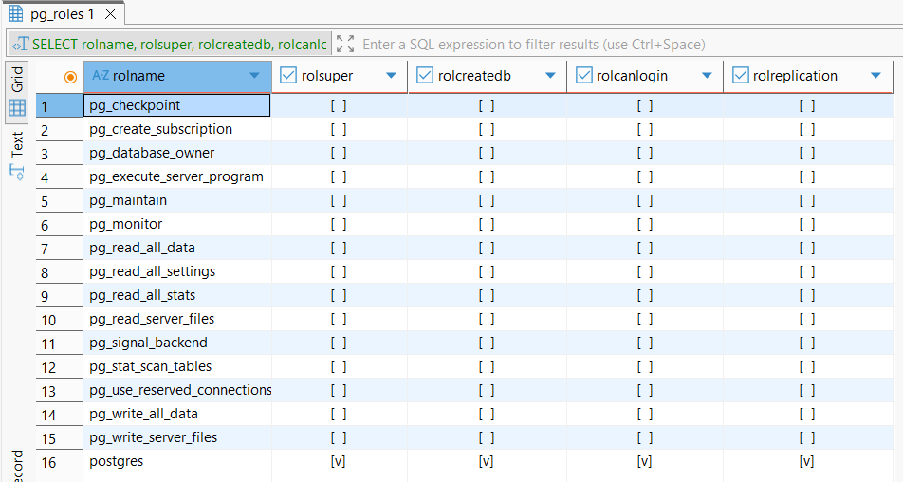

Interpretation:
- postgres is the owner of all important database objects - full unrestricted access.
- public role receives basic usage on schema public, but no special table privileges (other than defaults).
- There are no custom roles, no role groups, and no delegated permission models.
- All privileges are centralized under postgres, which can be risky in multi-user environments.

2. Table-level privileges
SELECT table_schema, table_name, privilege_type, grantee
FROM information_schema.table_privileges
WHERE table_schema = 'public'
ORDER BY table_name;
Output:
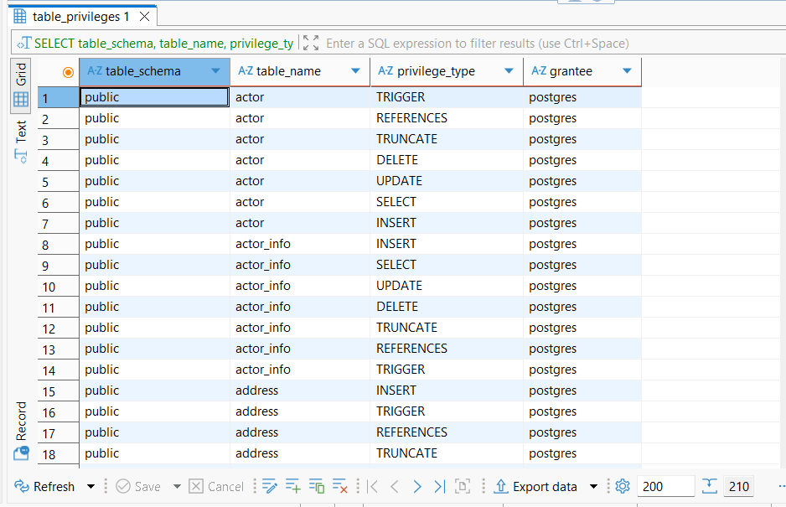

Interpretation:
- Every table is owned by postgres.
- postgres has all privileges: SELECT, INSERT, UPDATE, DELETE, TRIGGER, REFERENCES.
- The public role only inherits schema usage, not table privileges.
- No revocations or granular permission design exists.

3. Any existing row-level security policies
SELECT relname, relrowsecurity, relforcerowsecurity
FROM pg_class
WHERE relrowsecurity = true;

Output:
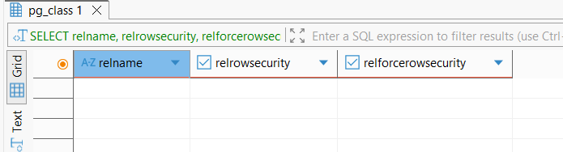
Schema contains no RLS policies and no tables with ROW LEVEL SECURITY enabled.
RLS is not implemented, meaning:
- All authorized users with table SELECT privileges see all rows.
- Multi-tenant or per-user data isolation does not exist.
This is fine for a simple OLTP system but is not suitable for multi-user or sensitive-data contexts.

4. Database-level settings like connection limits or authentication methods
Authentication Method (from pg_hba.conf)
SHOW hba_file;
Output:
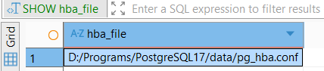

Connection Limits
SELECT datname, datconnlimit
FROM pg_database
WHERE datname = current_database();
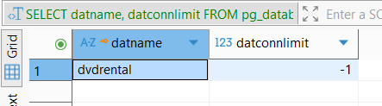
Interpretation:
- No connection limit is enforced.
- Unlimited concurrent sessions allowed → potential DoS risk.

Database-Level Privileges
SELECT * FROM pg_database WHERE datname = 'dvdrental';
Output:

Findings
- Database owner is postgres
- No other roles granted CONNECT or TEMPORARY privileges
- Defaults apply

