SOFTWARE DESIGN DOCUMENT
Vision
Local offline object detection for laptop and Raspberry Pi
Field | Value
Document | Software Design Document (SDD)
Project | Vision
Repository | D:\Projects\Vision
Version | 1.0
Date | 20 September 2026
Status | Design approved — implementation not started
Scope of this version | Phases 0, 0.5 and 1 specified in full; phases 2 to 5 outlined

Reading guide
Sections 1 to 3 state the problem and the constraints it must live inside.
Sections 4 and 5 justify the technology and explain how the detector works.
Sections 6 and 7 are the architecture and the detailed design — the part you implement from.
Sections 8 to 12 cover deployment, the phase plan, exclusions, risks and open issues.

Revision history
Version | Date | Author | Change
1.0 | 2026-09-20 | Project owner | First issue. Captures the design agreed during requirements elicitation.

Contents
Right-click the table below and choose "Update Field" if the page numbers are blank.

1 Introduction

1.1 Purpose
This document specifies the design of Vision, an application that detects objects in images and, later, in a live video stream. It records the decisions taken, the reasoning behind them, and the plan for building the system in phases. It is written for the project owner, who is new to computer vision, and for any engineer or agent picking the work up later.

1.2 Scope
Vision takes an image or a camera frame and reports, for every object it recognises: the object class, a bounding box, the centre of that box, and the offset of that centre from the centre of the frame. The offset is expressed both in pixels and as a fraction of the half-frame. Detections are surfaced four ways: an on-screen overlay, an annotated image file, a structured JSON record, and a callback the owner can attach their own code to.
Phase 1 operates on still images only. Streaming video, object tracking, a desktop GUI, custom-trained classes and Raspberry Pi deployment follow in later phases, described in section 9.

1.3 Definitions
Term | Meaning
Model | A file containing a network architecture plus its learned weights. For YOLO26n, roughly 2.4 million numbers in a 6 MB file.
Weights | The learned numbers inside a model. They are the knowledge; the architecture alone predicts nothing.
COCO | Two meanings. (a) A Microsoft dataset of 118,000 images with 860,000 labelled boxes across 80 classes, on which the stock models were trained. (b) A JSON annotation format.
YOLO | "You Only Look Once" — a family of single-pass detector architectures. One forward pass yields all boxes and classes at once.
NMS | Non-Maximum Suppression: post-processing that merges duplicate boxes for the same object. YOLO26 does not need it.
mAP | Mean Average Precision — the standard accuracy metric for detectors. Higher is better.
CUDA | NVIDIA's GPU compute platform. Unavailable on this hardware, which is the constraint that shapes the whole plan.
Fine-tuning | Retraining a pretrained model on a small custom dataset. Keeps the learned features, replaces the class outputs.
Domain gap | The mismatch between training images and real operating conditions. The most common cause of a model that works in a tutorial and fails in practice.
VLM | Vision-Language Model — a language model that accepts images and answers in words. Gigabytes in size; phase 5 only.

1.4 References
Source | Location
Ultralytics — YOLO26 benchmarks | docs.ultralytics.com/compare/yolo26-vs-yolo11
Ultralytics — end-to-end NMS-free detection | docs.ultralytics.com/guides/end2end-detection
Ultralytics — model export formats | docs.ultralytics.com/modes/export
Ultralytics — training on a custom dataset | docs.ultralytics.com/modes/train
Project design notes | ARCHITECTURE.md, PROJECT_PROMPT.md in the repository root

2 System overview
Vision is a single-process desktop application. There is no server, no database and no account system. Frames enter from one of several interchangeable sources, pass through a detection pipeline, and leave through four independent sinks.
The defining characteristic is the offline boundary. Network access is used exactly twice across the entire life of the project: once to install dependencies, and once to download model weights. Detection itself never touches the network. Phase 4 training is the single deliberate exception, and it happens on a separate machine.
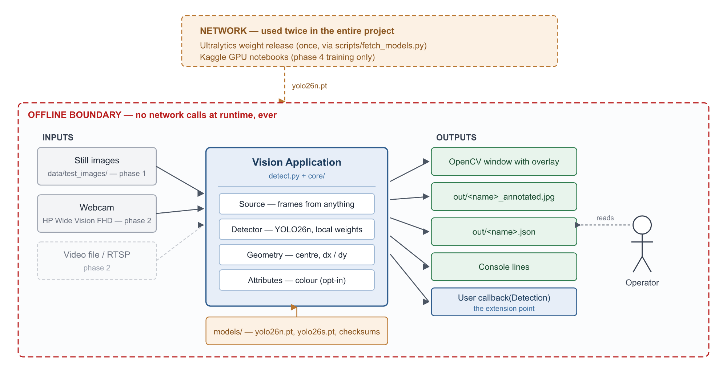
Figure 1 — System context. Everything inside the red boundary runs with no network access.
Why the offline boundary is drawn so aggressively
Ultralytics downloads weights from GitHub automatically when given a bare filename such as "yolo26n.pt".
On a laptop with a connection this is invisible. On a Raspberry Pi with no network it becomes a confusing crash at an inconvenient moment.
The design therefore stores an explicit local path in configuration and fails loudly, by name, when the file is absent. See section 7.4.

3 Constraints and target environment

3.1 Functional constraints
Constraint | Consequence for the design
Runs fully offline | No runtime network calls. Weights are fetched once, by an explicit script, and verified by checksum.
Must eventually run on a Raspberry Pi | The Pi, not the laptop, sets the performance budget. Model size is chosen for the Pi and used everywhere.
Personal and educational, not commercial | The Ultralytics AGPL-3.0 licence is acceptable, which keeps the most convenient tooling available.
Custom classes needed later | The pipeline must support fine-tuning without restructuring: one configuration line, not a rewrite.
Owner is new to computer vision | Favour the conventional path over the clever one. Every tunable value lives in configuration, not in code.

3.2 Development hardware
Measured on the development machine. These numbers are facts, not assumptions.
Component | Specification
CPU | Intel Core i7-8550U — 4 cores, 8 threads, 1.8 GHz base
RAM | 15.8 GB
GPU | Intel UHD Graphics 620 (integrated) — no NVIDIA GPU, therefore no CUDA
Camera | HP Wide Vision FHD (built-in), plus an HP IR camera
Operating system | Windows 11 Home, build 26200
Existing Python | 3.7.3 — too old for current PyTorch; left untouched, 3.11 installed alongside

3.3 Deployment hardware
Raspberry Pi 5, optionally with a Hailo-8L AI HAT. Neither has been purchased. The exact model remains an open issue (section 12), but it does not block phases 0 to 4.

3.4 The consequence of having no CUDA
This single fact shapes the entire plan and is worth stating plainly.
- Training must happen off this machine. A fine-tune that takes roughly 20 minutes on a cloud GPU would take 6 to 10 hours on this CPU. Kaggle notebooks provide a free P100 with 30 GPU-hours per week and private dataset storage.
- Inference stays local. It runs on the CPU, accelerated by OpenVINO, which is Intel’s own runtime and is roughly 2 to 3 times faster than plain PyTorch on this chip.
- Model size is constrained, not chosen freely. Larger models are more accurate but do not fit the frame budget on either target. Section 4.2 makes that trade-off explicit.

4 Technology selection

4.1 Stack
Layer | Choice | Rationale
Language | Python 3.11 | The entire ML ecosystem is Python. 3.11 has prebuilt wheels for every dependency, including OpenVINO and Raspberry Pi builds.
Detection | Ultralytics YOLO26 | Current generation, released October 2025. NMS-free, so latency stays constant regardless of how busy the scene is. The nano size is accurate enough for this project and fast enough for the Raspberry Pi.
Image I/O, drawing | OpenCV | Standard, fast, and already a dependency of Ultralytics.
Acceleration | OpenVINO / NCNN / Hailo | Same weights, different export target. Selected by one configuration line.
GUI (phase 3) | PySide6 | Official Qt bindings for Python under LGPL. Real widgets, and it packages to an .exe.
Annotation (phase 4) | Label Studio | Runs locally through pip. Images never leave the machine. Exports YOLO format directly.
Training (phase 4) | Kaggle Notebooks | Free GPU, private datasets, and sessions that do not drop mid-run.
Configuration | YAML | Every tunable number lives in config.yaml. No magic constants in code.
Language policy: code, comments, log output, README and user-interface strings are all in English. Mixing two languages inside a codebase becomes painful quickly, and every error message and example in the surrounding ecosystem is English.

4.2 Model selection
One model is used for every phase and every target: YOLO26n.
A clarification that matters
The suffixes n and s are not different models. They are one architecture at two capacities.
They share one API, one weights format, one dataset format and one export path.
Switching between them is a single line in config.yaml — it is a dial, not an architectural decision.
Published figures, measured by Ultralytics using ONNX on an Intel Xeon at 2.0 GHz:
Model | mAP 50-95 | Parameters | CPU ONNX | Role
YOLO26n | 40.9 | 2.4 M | 38.9 ms | The working model, everywhere
YOLO26s | 48.6 | 9.5 M | 87.2 ms | Fallback, downloaded and kept on disk
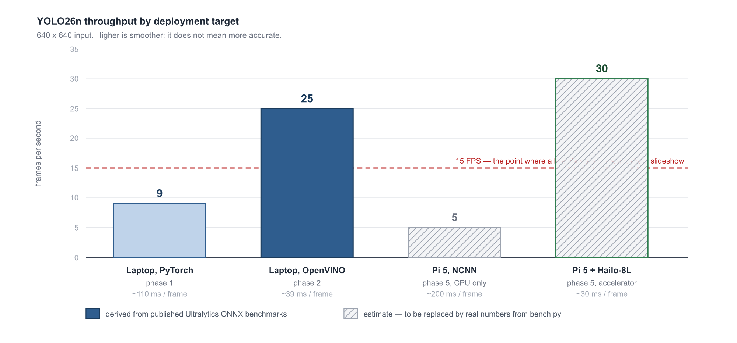
Figure 2 — Expected throughput of YOLO26n across the four deployment targets.
YOLO26n is the only size that produces usable numbers in all four environments. The choice is made against the weakest target, because what does not fit the Pi does not fit at all. Larger sizes are accurate enough but too slow there, so they are not part of this design.
YOLO26s is downloaded alongside it and left unused. Small, thin objects such as a pen are the hardest case for a nano model; if phase 4 shows that n cannot handle them, switching to s must not require a network connection on a machine that may not have one.
Training a detector from scratch is not considered. Reproducing the COCO pretraining would take days on eight A100 GPUs. Transfer learning reuses that work for the cost of a 6 MB download — see section 5.3.

5 How the detector works
This section is background rather than specification. It exists so that the configuration values in section 7.5 are meaningful rather than arbitrary.

5.1 What a model file contains
A model is two things: an architecture, which is the description of which layers run in what order, and weights, which are roughly 2.4 million learned numbers. The weights are the knowledge. They were produced once by Ultralytics, by training on COCO for several days across eight A100 GPUs. The project downloads that result as a 6 MB file.

5.2 One inference pass
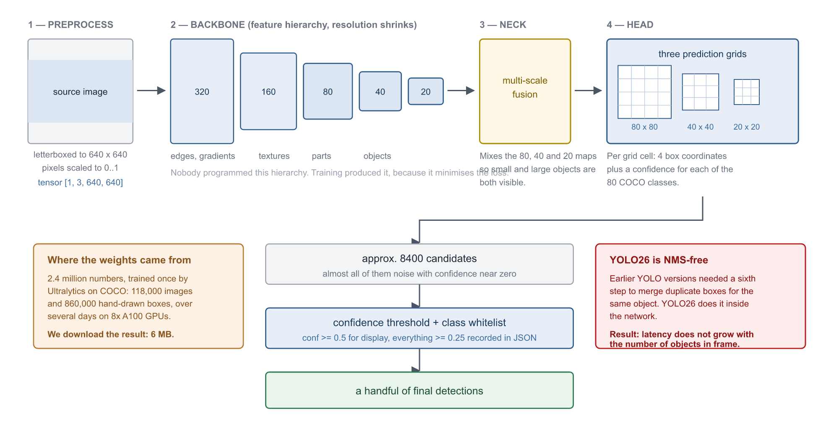
Figure 3 — A single forward pass through YOLO26n, from pixels to final detections.
- Preprocess. The image is letterboxed into a 640 by 640 square and normalised to the range 0 to 1, producing a tensor of shape [1, 3, 640, 640].
- Backbone. Convolutional layers build a hierarchy: edges early, textures and object parts in the middle, whole objects at the end. Resolution shrinks from 640 to 20 while semantic content accumulates. Nobody programmed this hierarchy; training produced it because it minimises the loss.
- Neck. Feature maps at 80, 40 and 20 pixels square are fused, so that small and large objects are both visible to the head.
- Head. For each of roughly 8400 grid cells it predicts four box coordinates and a confidence for each of the 80 COCO classes.
- Filtering. Everything below the confidence threshold is discarded, leaving a handful of detections.
YOLO26 is NMS-free
Earlier YOLO generations needed a sixth step, Non-Maximum Suppression, to merge the several duplicate boxes that neighbouring grid cells produce for the same object.
YOLO26 performs that suppression inside the network. Two consequences follow.
First, inference latency does not grow as the scene gets busier. Second, do not port NMS code from YOLO11 examples into this project — it is not needed and will do harm.

5.3 Why there are exactly 80 classes, and how to add more
The head has precisely 80 outputs, one per COCO class. The model therefore cannot emit "pen" — no such output exists. Of the objects the owner named, "person" and "cell phone" are present in COCO; "pen" and "flower" are not.
Adding them means transfer learning: keep the backbone, which already knows what edges, textures and shapes look like, replace the head with one that has the right number of outputs, and train on a few hundred custom images. This is why 500 images and 20 GPU-minutes suffice where the original training needed 860,000 images and three days.
A consequence that surprises people
A fine-tuned model sees only its new classes. It forgets the original 80.
To detect "person" and "pen" together, either include both in the training set, or run two models in sequence.
Decide which before annotating, because it changes what has to be labelled.

6 Software architecture

6.1 Layering
The system is a library with entry points on top of it. The library, core/, contains all detection logic and knows nothing about how the program was started. Entry points — the CLI today, a Qt window in phase 3, a web server in phase 5 — depend on core/ and never the reverse.
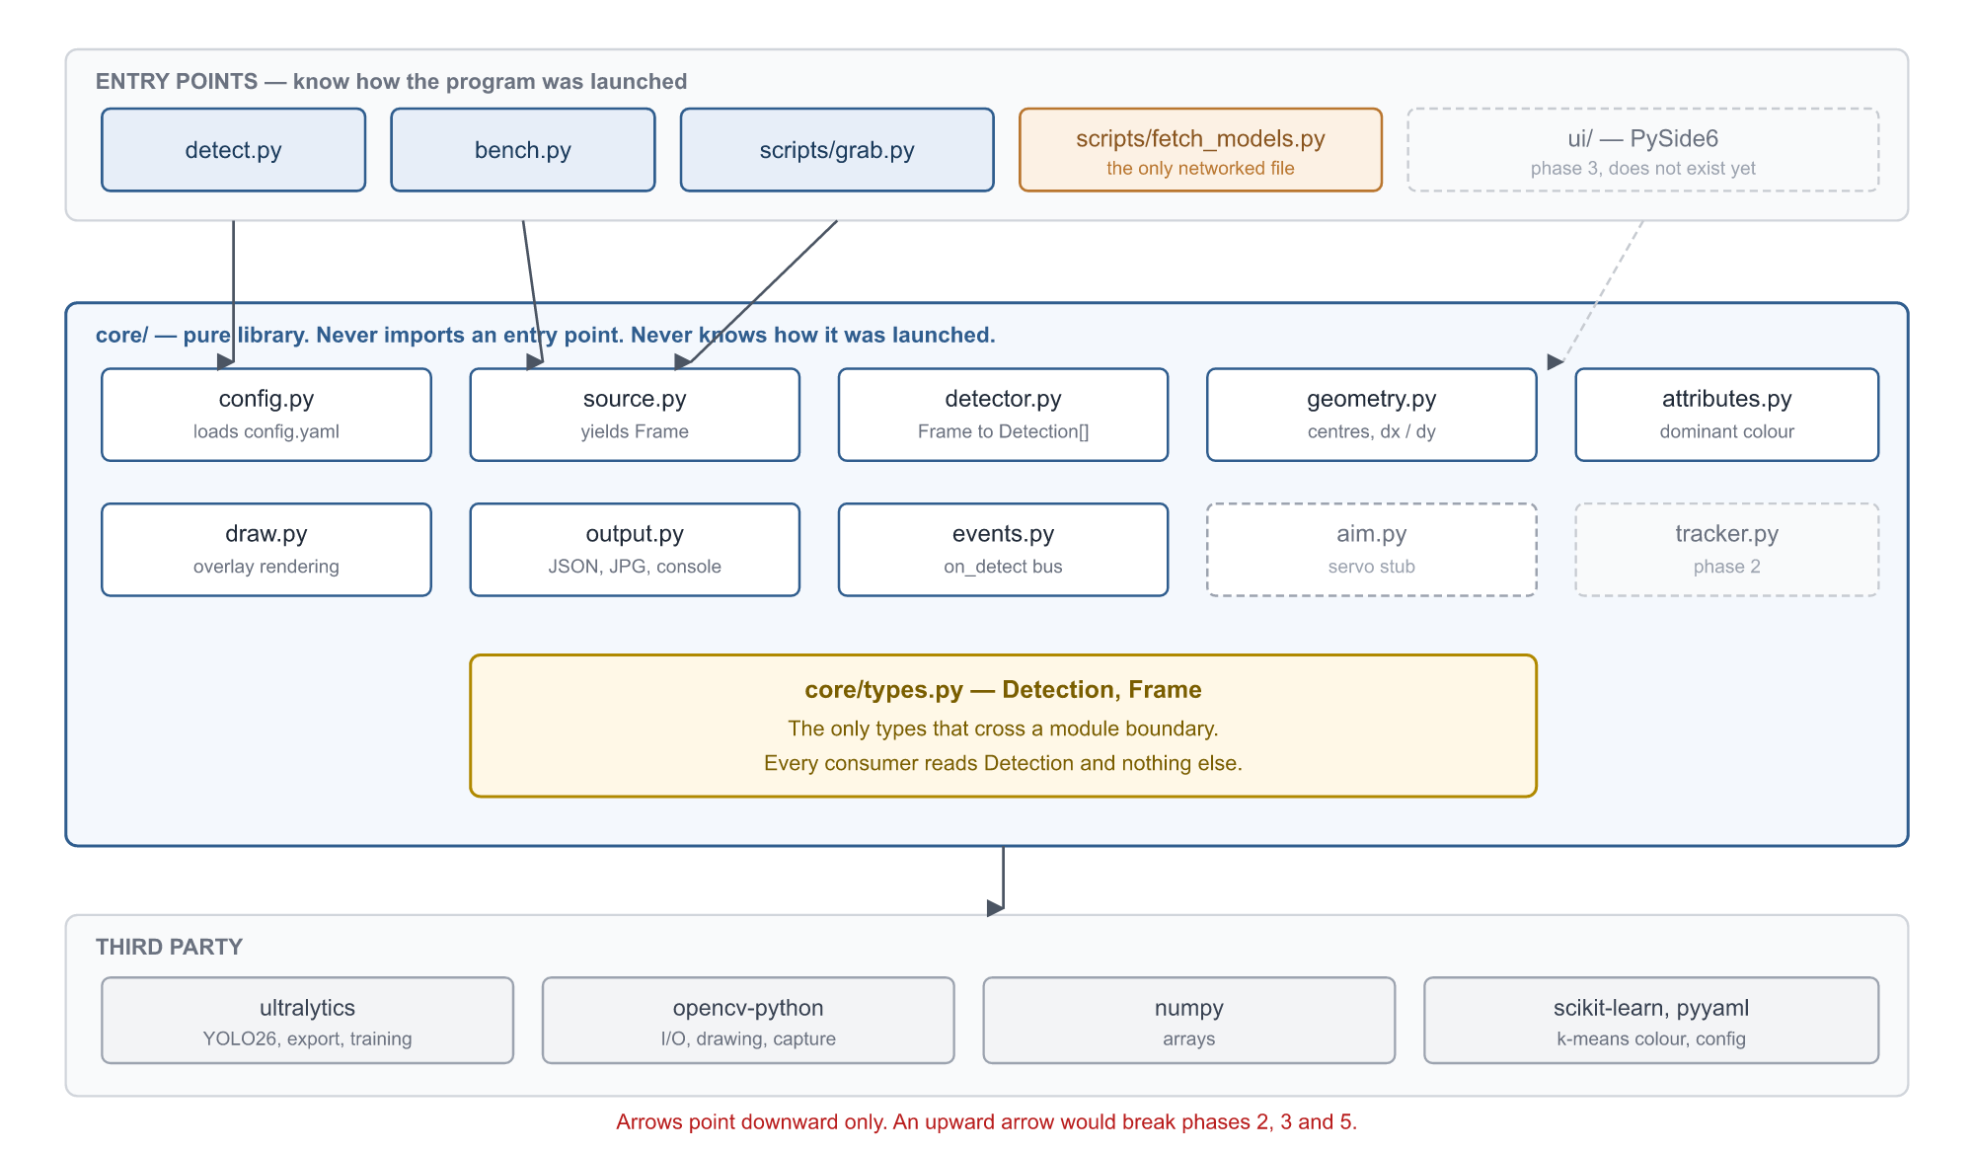
Figure 4 — Module structure and dependency direction. Dashed boxes do not exist yet.
The one structural rule
core/ must never import from ui/, from detect.py, or from anything that knows how the program was launched.
This rule is what makes phases 2, 3 and 5 additive instead of rewrites. It is the only architectural constraint worth enforcing strictly.

6.2 Repository layout
D:\Projects\Vision\
ARCHITECTURE.md design source of truth
PROJECT_PROMPT.md self-contained brief for a fresh session
README.md
config.yaml every tunable value
requirements.txt
.gitignore venv/, models/*.pt, out/, data/
detect.py CLI entry point (phase 1)
bench.py timing harness
scripts\
fetch_models.py explicit weight download + checksums
grab.py save webcam frames as images
core\
types.py Detection, Frame
config.py load and validate config.yaml
source.py image / folder / video / webcam / RTSP
detector.py YOLO wrapper: Frame -> list[Detection]
geometry.py centres, offsets from frame centre
attributes.py dominant colour (opt-in)
draw.py boxes, crosshair, labels, offsets
events.py event bus, user callback registration
output.py JSON, annotated image, console
aim.py servo stub: aim(dx, dy)
data\test_images\ owner-supplied photos
models\ weights + checksums.txt
out\ annotated images and JSON results
Roughly 700 lines for phase 1. The split looks finer than 700 lines warrants, and that is deliberate: it is what lets each later phase add a file rather than reopen one.

6.3 How the structure absorbs later phases
Phase | Files added | Files rewritten
2 — video | core/tracker.py, core/rules.py, plus a video branch inside source.py | None
3 — desktop app | ui/ package, importing core/ as a library | None
4 — custom classes | training/ package | One line of config.yaml
5 — Raspberry Pi | scripts/export_ncnn.py, FastAPI web UI | One line of detector.py

7 Detailed design

7.1 Data types
Detection is the only type that crosses a module boundary. Every consumer — drawing, JSON output, the event bus, and one day the servo controller — reads this and nothing else.
@dataclass
class Detection:
cls_id: int # model class index
cls_name: str # e.g. "person"
conf: float # 0..1
bbox: tuple # (x1, y1, x2, y2) in source-image pixels
center: tuple # (cx, cy)
dx: int # cx - frame_center_x; right is positive
dy: int # cy - frame_center_y; down is positive
dx_pct: float # dx / half frame width, -1..1
dy_pct: float # dy / half frame height, -1..1
color: str | None # dominant colour, only when --color is set

@dataclass
class Frame:
image: np.ndarray # BGR, as OpenCV returns it
source: str # file path, or "camera:0"
index: int # 0 for a still image, frame number for video

7.2 Processing pipeline
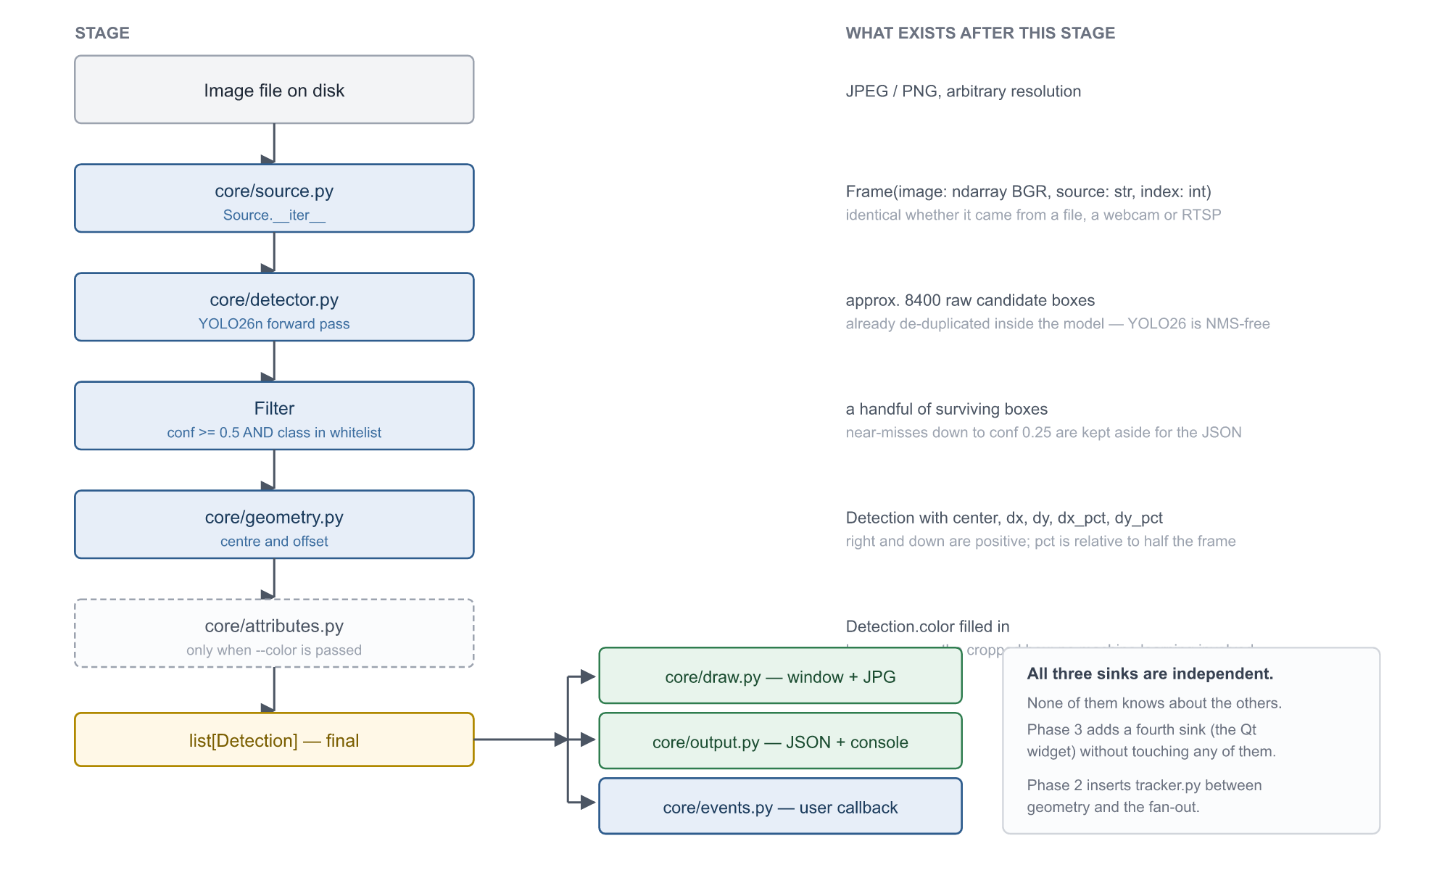
Figure 5 — The phase 1 pipeline, stage by stage, with the data that exists after each one.

7.3 Source
class Source:
def __iter__(self) -> Iterator[Frame]
One interface covers a single image, a folder of images, a video file, a webcam index and an RTSP URL. Phase 1 implements the first two. Everything downstream is written against the iterator and cannot tell which is in use — this is precisely what makes phase 2 nearly free.
Capture defaults to 1280 by 720 rather than 1080p. The extra pixels are scaled down to 640 by the model regardless, so decoding 1080p spends CPU for no benefit.

7.4 Detector
class Detector:
def __init__(self, cfg: Config) # fails loudly if weights are missing
def __call__(self, frame: Frame) -> list[Detection]
Responsibilities: load weights from an explicit local path, run inference, filter by confidence, filter against the class whitelist, and delegate geometry.
Required offline behaviour
config.yaml stores a path — "models/yolo26n.pt" — never a bare model name.
Detector.__init__ raises FileNotFoundError("run scripts/fetch_models.py first") when the file is absent.
It must never fall back to the network. This is the single most important implementation detail in the document.

7.5 Configuration
model:
weights: models/yolo26n.pt
imgsz: 640 # native training size; other values usually hurt
conf: 0.5 # display and event threshold
conf_debug: 0.25 # written to JSON but not drawn

classes: # whitelist; empty means all 80 COCO classes
- person
- cell phone
- bottle
- book
- laptop

display:
show_labels: true
show_offsets: true
crosshair: true

output:
save_json: true
save_image: true
dir: out

capture:
width: 1280
height: 720
Setting | Default | Why this value
imgsz | 640 | The size the model was trained at. Other values commonly reduce accuracy despite offering more resolution.
conf | 0.5 | Balanced. At 0.25, the YOLO default, the frame fills with false positives; at 0.7 small and partly hidden objects disappear.
conf_debug | 0.25 | Recording near-misses in the JSON while drawing only confident ones is the main debugging tool. It shows what the model nearly saw.
classes | whitelist | Drawing all 80 COCO classes turns the frame into a mess of boxes. The whitelist is also the exact mechanism that will later enable custom classes.
capture | 1280x720 | Higher capture resolution is discarded by the model and costs decode time.

7.6 Event bus
from core.events import on_detect

@on_detect(cls="person")
def handler(det: Detection):
print(det.cls_name, det.conf, det.bbox, det.dx, det.dy)
This is the owner’s extension point. Phase 1 keeps it deliberately plain: a synchronous call, one per detection, with no rules and no debouncing. Phase 2 layers rule evaluation and debouncing on top of the same bus without altering this signature.
Why debouncing waits until phase 2
A still image has no time axis, so there is nothing to debounce.
On video it becomes mandatory: a model oscillating around the threshold at 0.49 and 0.51 will otherwise emit hundreds of events within seconds.
Phase 2 adds confirmation across three consecutive frames followed by a five-second cooldown.

7.7 Servo stub
core/aim.py exposes aim(dx, dy) and currently does nothing but draw an arrow on the frame. Pan-tilt servo hardware is a future idea, not a current plan. The stub exists so that adding it later is one new file and no edits anywhere else.

7.8 Output and overlay
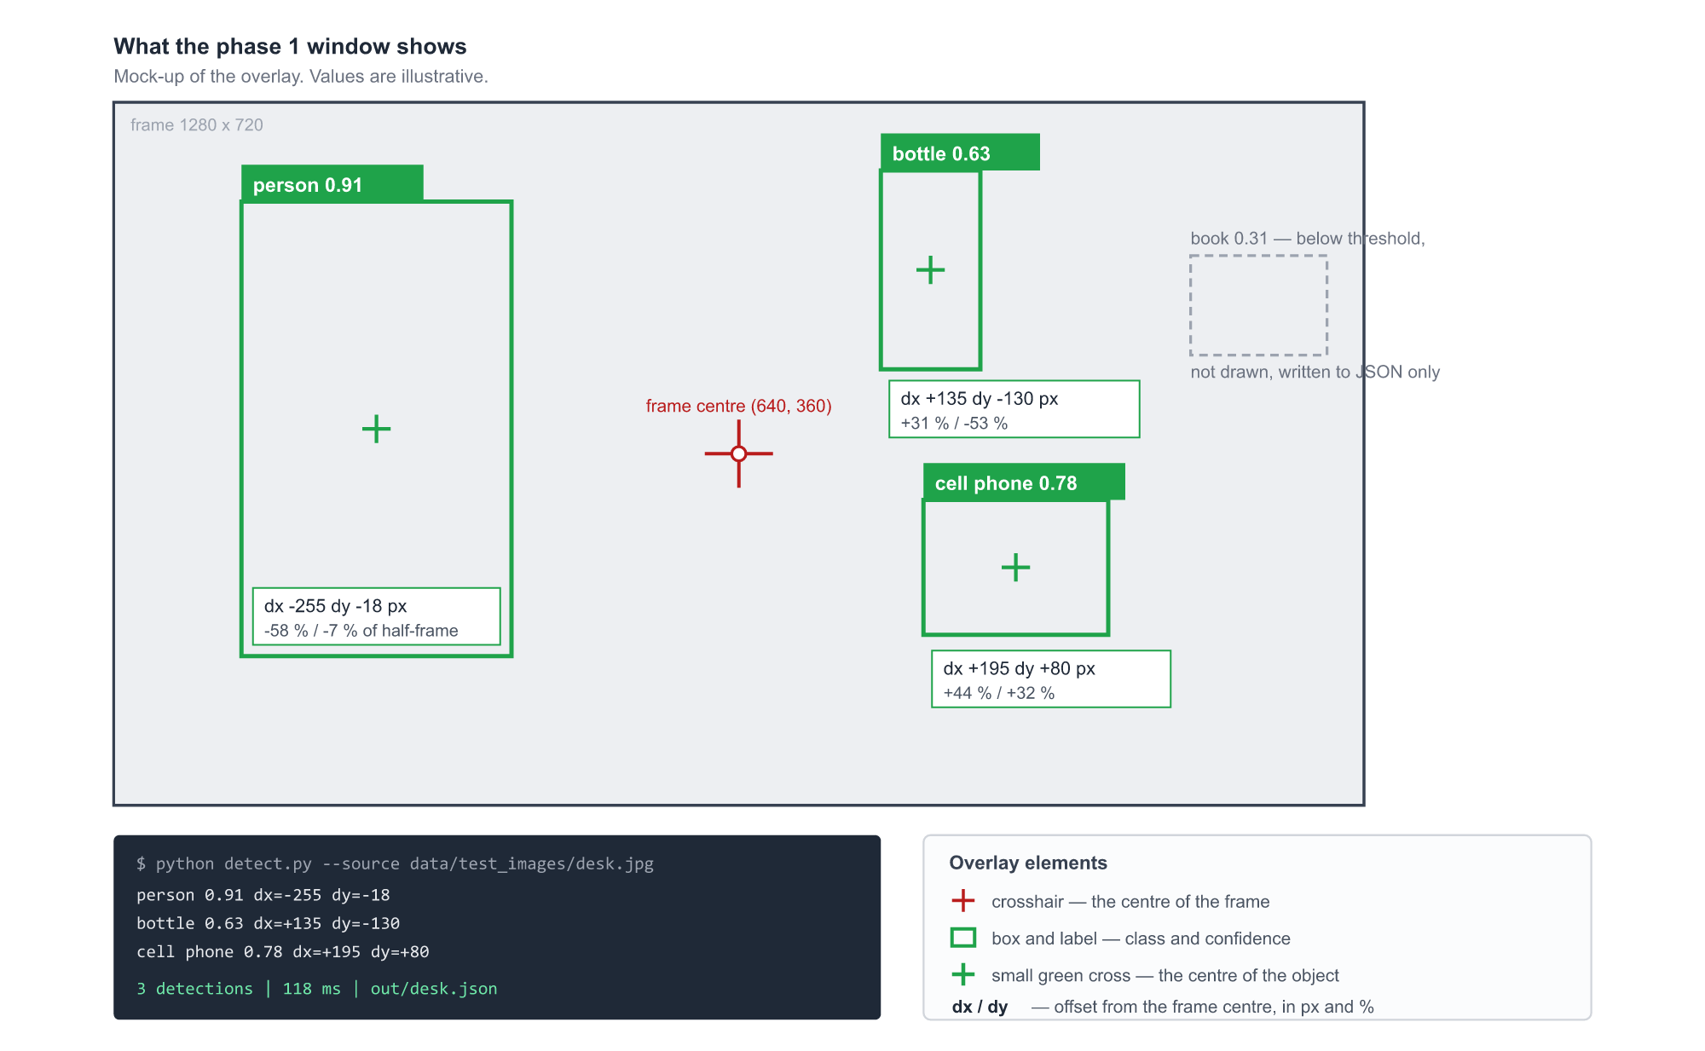
Figure 6 — The phase 1 overlay and console output. Values are illustrative.
The overlay draws a red crosshair at the centre of the frame, a box and label per object, a small green cross at each object centre, and the offset in pixels and percent inside the box. No line is drawn between the two centres — the numbers carry that information, and connecting lines clutter the frame as soon as several objects are present. Labels can be switched off: with ten or more objects the numbers overlap and become unreadable.
Offsets are computed per object. No tracking is involved and none is needed — that arrives in phase 2, when selecting a single target across time becomes meaningful.

8 Deployment view
One set of weights serves every target. What changes between them is the export format and the user-interface layer, never the detection code.
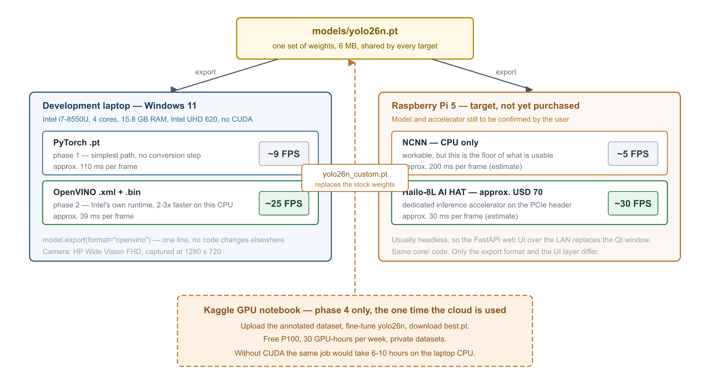
Figure 7 — Deployment targets. The same weights file is exported into three runtime formats.
Target | Runtime | Expected | Notes
Laptop, phase 1 | PyTorch .pt | ~9 FPS | Simplest path, no conversion step. Fine for still images, where throughput is irrelevant.
Laptop, phase 2 | OpenVINO | ~25 FPS | Intel's own runtime. One line: model.export(format="openvino").
Pi 5, CPU only | NCNN | ~5 FPS (est.) | Workable, but this is the floor of what feels usable.
Pi 5 + Hailo-8L | Hailo | ~30 FPS (est.) | Roughly USD 70 accelerator on the PCIe header. Not purchased.
The Pi is normally headless, so the FastAPI web interface over the local network replaces the Qt window there. The core library is identical on both.

9 Development plan
One model travels the whole road. The phases change its form — stock, then accelerated, then fine-tuned, then re-exported — never its identity.
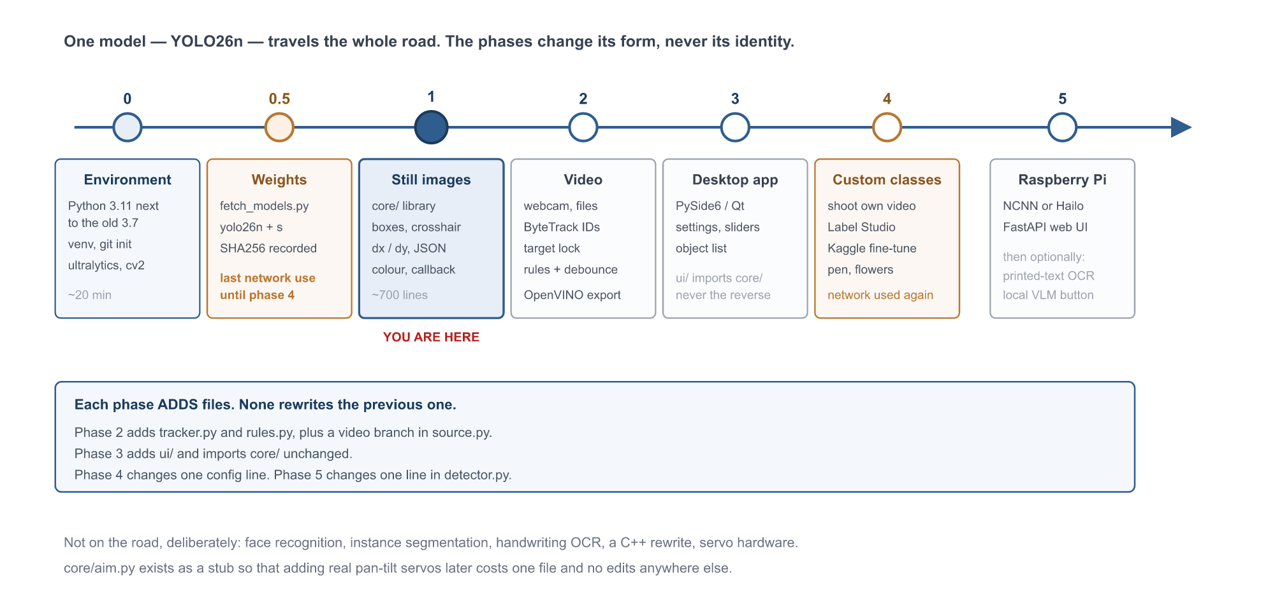
Figure 8 — Phase roadmap. Each phase adds files; none rewrites its predecessor.

9.1 Phase 0 — environment
Install Python 3.11 alongside the existing 3.7, deliberately not added to PATH so that 3.7 keeps working. Initialise git, write .gitignore, create a venv inside the project, and install ultralytics, opencv-python, pyyaml, numpy and scikit-learn.
Done when: python -c "import torch, cv2, ultralytics" succeeds. Roughly 20 minutes, most of it downloading.

9.2 Phase 0.5 — weights
scripts/fetch_models.py downloads yolo26n.pt (about 6 MB) and yolo26s.pt (about 18 MB) into models\, records SHA256 sums in models\checksums.txt, and prints a summary.
Done when: both files exist and their checksums are recorded. After this step the project needs no network until phase 4.

9.3 Phase 1 — still images
Everything specified in sections 6 and 7. Entry point:
python detect.py --source data/test_images/bus.jpg
Verification proceeds in a deliberate order, cheapest and most diagnostic first:
- A stock Ultralytics sample image. A failure here means a broken installation, not a hard problem.
- The owner’s own 10 to 20 photographs. This is where the truth about the idea appears.
- The flags: --color, the confidence threshold, the class whitelist.
- scripts/grab.py, capturing real frames from the actual webcam — this is what exposes lighting, focus and noise problems early, while they are still cheap to fix.
Done when: a photograph produces a window with boxes, centre dots, crosshair and offsets; out\*.json holds the numbers; bench.py prints seconds per frame. Acceptance is the owner’s visual judgement — no formal mAP target applies at this stage.
One agreed safeguard
The owner chose subjective acceptance for phase 1, which is reasonable for a first look.
bench.py is still built, because without a baseline number the later move to the Raspberry Pi has nothing to compare against, and "it feels slow" becomes guesswork.

9.4 Phase 2 — video and real time
Video and webcam branches in Source. ByteTrack supplies a stable track_id across frames. Target selection: click an object to lock onto it; otherwise auto-select whichever is nearest the frame centre. Export to OpenVINO and measure the gain against the phase 1 baseline.
rules.yaml arrives here: conditions (appeared, disappeared, present for N seconds, entered a zone), actions (log line, save frame, call a function) and debouncing.

9.5 Phase 3 — desktop application
PySide6: open a file or camera, live view, settings, an object list, a threshold slider. ui/ imports core/ and never the reverse. Note that PySide6 is a library, not a finished product — the windows are built here, either in code or visually in Qt Designer.

9.6 Phase 4 — custom classes
Needed only because "pen" and "flower" are absent from COCO. Method: shoot ten minutes of video of the object from many angles, keep every twentieth frame for roughly 900 images with natural variation in angle, blur and lighting, annotate in Label Studio, export YOLO format, fine-tune on Kaggle, download best.pt.
The two rules that decide whether phase 4 works
Shoot in the conditions the model will actually run in. A pen photographed as a studio product shot on white teaches nothing about a pen lying at an angle on a cluttered desk, two metres away, forty pixels tall, under a yellow lamp. This mismatch — the domain gap — is the most common reason a tutorial works and a real project does not. Internet images may be mixed in at around 20% for variety, but the core of the set must be the owner’s own frames.
Include negative frames: the desk with no pen, the room with no flowers. Without them the model finds pens everywhere.
Labour-saving method: annotate the first 50 images by hand, train a rough model, let it pre-annotate the remaining 450, then correct its mistakes. This saves roughly 70% of the time.
Before shooting anything, check whether the class already exists as a labelled dataset — Roboflow Universe, or Open Images V7 with its 600 classes. A ready labelled dataset is a pure win. Raw images scraped from a search engine are not: they still have to be annotated by hand, so they save only the shooting, which was never the tedious part.

9.7 Phase 5 — Raspberry Pi and extensions
Export to NCNN, or to Hailo if the accelerator is bought. A FastAPI web interface, because a Pi usually has no monitor and a browser over the local network is the only convenient option. Then, optionally, OCR of printed text on cropped detections using EasyOCR, PaddleOCR or Tesseract, all of which run locally.
A local vision-language model — Moondream2, Florence-2 or Qwen2.5-VL 3B — can sit behind a "describe this frame" button. Be precise about what that costs: it is a 1.7 to 8 GB language model taking 3 to 15 seconds per frame on this CPU. Acceptable for a button press on a still frame; not usable for streaming video on this hardware.

10 Out of scope
Each of the following was discussed and deliberately excluded. Recording why is as useful as recording what was included.
Excluded | Reasoning
Face recognition — identifying a specific person | Dropped by the owner. It is a separate subsystem: a face detector, an embedding model such as ArcFace, and a local identity database. Detecting that a face is present is ordinary detection; deciding whose face it is, is not.
Instance segmentation | Boxes only. Polygon annotation is 3 to 5 times slower than boxes and would dominate the effort in phase 4. Note the asymmetry: a polygon converts down to a box, a box does not convert up to a polygon. If precise shape ever becomes critical, annotate polygons from the start.
Handwriting OCR | Local models handle it poorly. Printed text only, and only in phase 5.
A C++ implementation | The ML ecosystem is Python, and the model already executes as compiled C++ internally. If the Pi runs out of headroom, only the inference layer is rewritten, never the application.
Servo hardware | A future idea rather than a current plan. core/aim.py is a stub so that adding it later costs one file.
rules.yaml in phase 1 | Deferred to phase 2, where time exists and debouncing makes rules meaningful.

11 Risk register
# | Risk | Severity | Mitigation
1 | No CUDA on the development machine | High | Structural, not fixable. The plan absorbs it: YOLO26n is chosen for CPU, training happens on Kaggle, OpenVINO recovers 2-3x on inference.
2 | A pen may be too hard for a nano model | High | Small, thin, low contrast against a desk — the hardest case. Escalation path in order: imgsz 960, then yolo26s, then shoot from closer. This is the most likely place the plan needs adjusting.
3 | Domain gap between training images and real frames | High | Mandate own footage for custom classes, shot in real conditions, with negative frames included. Internet images capped at roughly 20%.
4 | Pi 5 without an accelerator runs only nano models | Medium | Already reflected in the model choice. A Hailo-8L AI HAT at roughly USD 70 lifts throughput to about 30 FPS if needed.
5 | Ultralytics silently downloading weights | Medium | Explicit paths in config, a loud FileNotFoundError, and checksums recorded at download. Re-verify after any dependency upgrade.
6 | The dominant-colour feature may prove useless | Low | For a person it returns the shirt colour; for a flower, half the pot and the background. It sits behind --color in its own module, so removing it costs one command.
7 | AGPL-3.0 licence if the project ever turns commercial | Low | This is a personal and educational project, so the licence is acceptable as it stands. If that ever changes, the licence must be revisited before any distribution.

12 Open issues
# | Question | Blocks | Resolution path
1 | Which Raspberry Pi model, and whether a Hailo AI HAT is within budget | Phase 5 only | Owner to confirm. Deliberately deferred: buy hardware after the laptop work proves the approach and produces measured FPS requirements.
2 | Is YOLO26n accurate enough for a pen? | Phase 4 scope | Unknown until tested on the owner’s own photographs. Fallbacks documented in risk 2.
3 | Is the dominant-colour attribute useful in practice? | Nothing — it is optional | Judged on the owner’s real photos during phase 1. Removable without consequence.

Status
The design is agreed and complete for phases 0, 0.5 and 1. No code has been written yet.
The next action is phase 0: install Python 3.11, initialise the repository, and create the virtual environment.
ARCHITECTURE.md holds the same content in a form convenient for editing; PROJECT_PROMPT.md restates it as a self-contained brief for a fresh session.

