# DetectCorners

A program for finding the corner points of image elements.

This program was developed for educational purposes and is not used for commercial purposes.

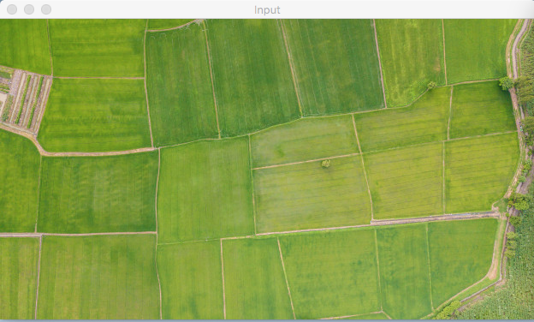

The program is developed in the Python language, using the openCV library https://docs.opencv.org/master/.

The application is created on the following principle:

First we use an algorithm to convert the image into a contour. We use a Holistically-Nested Edge Detection algorithm for maximum accuracy(https://www.pyimagesearch.com/2019/03/04/holistically-nested-edge-detection-with-opencv-and-deep-learning/#pyi-pyimagesearch-plus-optin-modal).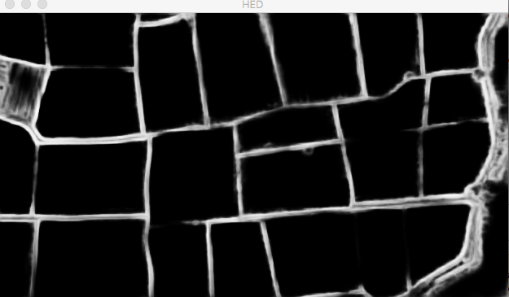

The next step is to find the angular points of the objects on the page using the Harris Corner Detector algorithm( https://opencv-python-tutroals.readthedocs.io/en/latest/py_tutorials/py_feature2d/py_features_harris/py_features_harris.html, superimposing these points on the image.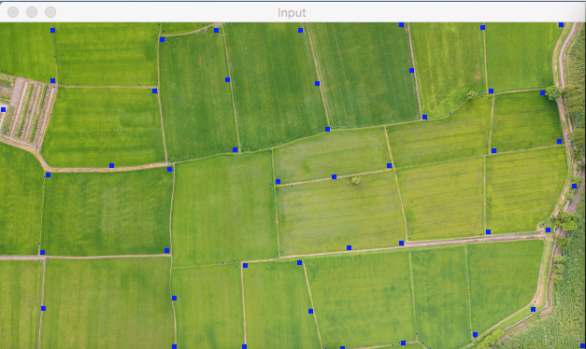

In test mode, the possibility of connecting points with each other also works, but needs refinement.