Министерство образования и науки Российской Федерации
Федеральное государственное автономное образовательное учреждение высшего образования
«Уральский федеральный университет имени первого Президента России Б.Н. Ельцина»

Лабораторная работа №4: Тестирование бэкенд приложения

Выполнила: студент 1 курса
магистратуры «Прикладной анализ данных»
Мансурова А.Р.

г. Екатеринубрг, 2025 г.

Цель работы: познакомится со способами тестирования приложения
Задачи:
- Изучить принципы тестирования REST API
- Освоить работу с pytest и асинхронным тестированием
- Понять архитектуру тестовой пирамиды для веб-приложений
- Изучить особенности тестирования с использованием SQLAlchemy и Litestar

1. Pytest fixture
Фикстура - это объект, который можно рассматривать, как набор условий необходимых тесту для выполнения, например, зачастую фикстуры создаются, чтобы генерировать какие-то данные еще до теста и возвращать их для использования в тесте или перед тестом, вот несколько примеров:

- Создавать подключение к базе данных перед тестом и отключаться от нее после завершения теста
- Инициализировать драйвер-браузера и закрывать сессию после завершения теста
- Авторизовываться перед запуском теста и не тратить время на логин
- Создавать новый аккаунт перед тестом, использовать его в тесте и по завершению теста удалять его т.д
Основные особенности фикстур:
- Декоратор @pytest.fixture: Любая функция, украшенная этим декоратором, становится фикстурой. При вызове тестовой функции Pytest ищет аргументы, совпадающие с именами фикстур, и автоматически передаёт их результаты в тест.
- Инъекция зависимостей: Тестовые функции могут принимать в качестве параметров одну или несколько фикстур, что позволяет организовать зависимости между ними. Например, фикстура может создавать базу данных или настраивать HTTP-клиент, который затем используется в нескольких тестах.
- Скоуп фикстур: Фикстуры можно настраивать по различным областям видимости (scope):
  - function (по умолчанию) – фикстура создаётся для каждого теста.
  - class – фикстура создаётся один раз для каждого класса тестов.
  - module – фикстура создаётся один раз для каждого модуля.
  - session – фикстура создаётся один раз для всей сессии тестирования. Это позволяет оптимизировать выполнение тестов, особенно когда подготовка ресурсов требует значительного времени.
- Автоматическое завершение (tear-down): Если необходимо выполнить очистку после использования фикстуры (например, закрыть соединение с базой данных или удалить временные файлы), можно использовать конструкцию yield внутри фикстуры. Код после yield будет выполнен после завершения теста, использующего эту фикстуру.
- Параметризованные фикстуры: Pytest поддерживает параметризацию фикстур, что позволяет запускать один и тот же тест с разными данными. Это особенно полезно для проверки работы функции в разных условиях без написания множества отдельных тестов.
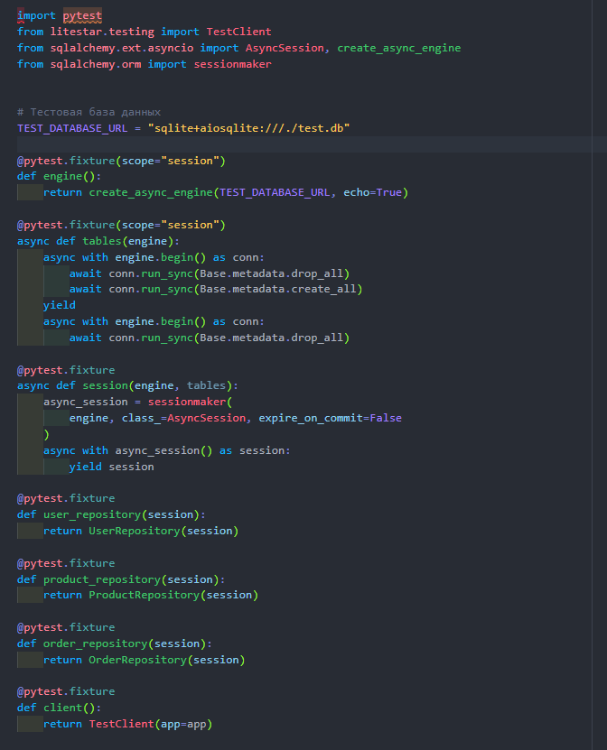
Мы создаём подключение к тестовой БД и создаём подключаем наши репозитории.
Перед продолжением работы, лучше убедиться, что в заказ можно добавлять несколько продуктов, также в продукции нужно добавить поле, отвечающее за количество продукции на складе.

import pytest
import pytest_asyncio
from litestar.testing import TestClient
from sqlalchemy.ext.asyncio import AsyncSession, create_async_engine
from sqlalchemy.orm import sessionmaker
from app.models.Base import Base
from app.repositories.OrderRepository import OrderRepository
from app.repositories.productReposutory import ProductRepository
from app.repositories.user_repository import UserRepository
from app.main import app
# Тестовая база данных
TEST_DATABASE_URL = "sqlite+aiosqlite:///./test.db"
@pytest_asyncio.fixture(scope="session")
def engine():
return create_async_engine(TEST_DATABASE_URL, echo=True)
@pytest_asyncio.fixture(scope="session")
async def tables(engine):
async with engine.begin() as conn:
await conn.run_sync(Base.metadata.drop_all)
await conn.run_sync(Base.metadata.create_all)
yield
async with engine.begin() as conn:
await conn.run_sync(Base.metadata.drop_all)
@pytest_asyncio.fixture
async def session(engine, tables):
async_session = sessionmaker(
engine, class_=AsyncSession, expire_on_commit=False
)
async with async_session() as session:
yield session
await session.rollback()
@pytest_asyncio.fixture
def user_repository():
return UserRepository()
@pytest_asyncio.fixture
def product_repository():
return ProductRepository()
@pytest_asyncio.fixture
def order_repository():
return OrderRepository()
@pytest.fixture
def client():
return TestClient(app=app)

2. Тестирование создания пользователя
Пробуем создать пользователя в БД

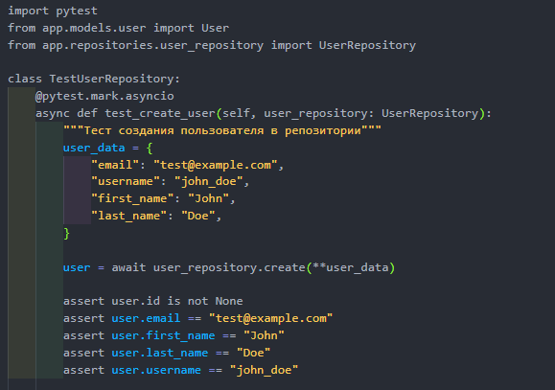
import pytest
from app.models.User import User
from app.repositories.user_repository import UserRepository
from app.User_schem import UserCreate, UserResponse
class TestUserRepository:
@pytest.mark.asyncio
async def test_create_user(self, session, user_repository: UserRepository):
"""Тест создания пользователя в репозитории"""
user_data = {
"email": "test@example.com",
"username": "john_doe",
"firstname": "John",
"lastname": "Doe",
}
user_create_schema = UserCreate(**user_data)
user = await user_repository.create(session, user_create_schema)
assert user.id is not None
assert user.email == "test@example.com"
assert user.username == "john_doe"
assert user.firstname == "John"
assert user.lastname == "Doe"
fetched_user = await session.get(User, user.id)
assert fetched_user is not None
assert fetched_user.id == user.id

Запустим тест.
Тест выполнился успешно:
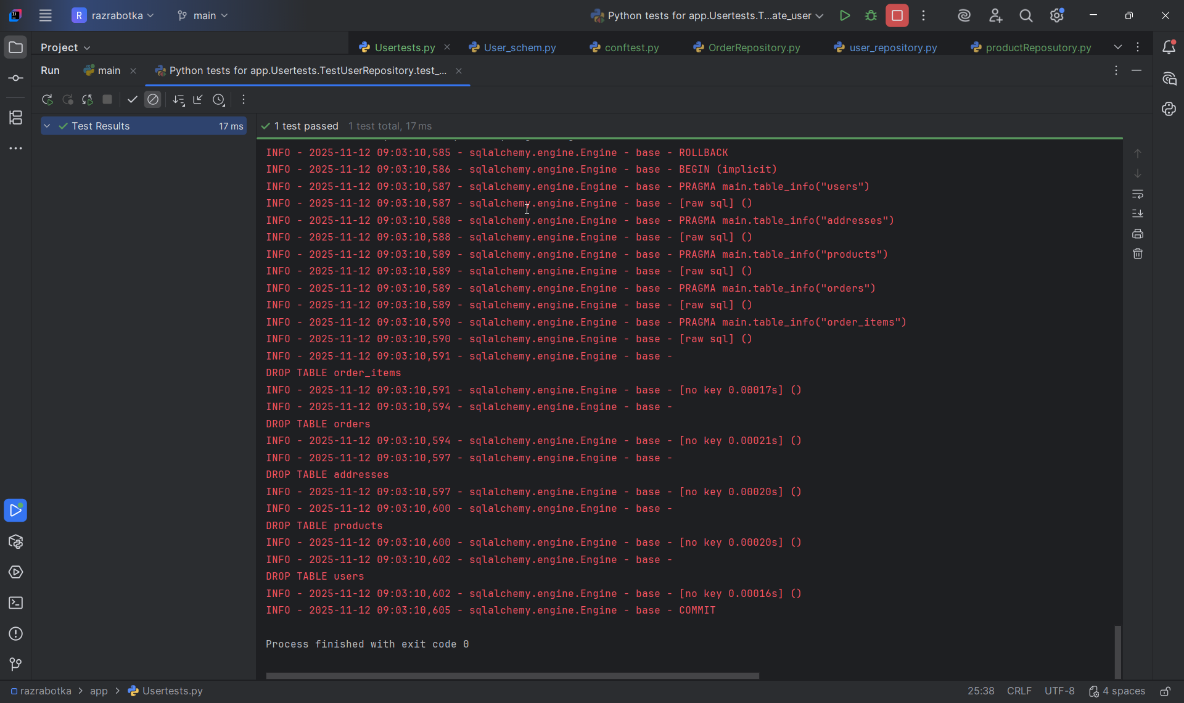
D:\Users\Alina\IdeaProjects\razrabotka\.venv\Scripts\python.exe C:/Users/Alina/AppData/Roaming/JetBrains/IdeaIC2025.2/plugins/python-ce/helpers/pycharm/_jb_pytest_runner.py --target app/Usertests.py::TestUserRepository.test_create_user
Testing started at 9:26 ...
Launching pytest with arguments app/Usertests.py::TestUserRepository::test_create_user --no-header --no-summary -q in D:\Users\Alina\IdeaProjects\razrabotka

============================= test session starts =============================
collecting ... collected 1 item

app/Usertests.py::TestUserRepository::test_create_user

======================== 1 passed, 1 warning in 0.16s =========================
2025-11-12 09:26:46,057 INFO sqlalchemy.engine.Engine BEGIN (implicit)
2025-11-12 09:26:46,058 INFO sqlalchemy.engine.Engine PRAGMA main.table_info("users")
2025-11-12 09:26:46,058 INFO sqlalchemy.engine.Engine [raw sql] ()
2025-11-12 09:26:46,059 INFO sqlalchemy.engine.Engine PRAGMA temp.table_info("users")
2025-11-12 09:26:46,059 INFO sqlalchemy.engine.Engine [raw sql] ()
2025-11-12 09:26:46,060 INFO sqlalchemy.engine.Engine PRAGMA main.table_info("addresses")
2025-11-12 09:26:46,060 INFO sqlalchemy.engine.Engine [raw sql] ()
2025-11-12 09:26:46,060 INFO sqlalchemy.engine.Engine PRAGMA temp.table_info("addresses")
2025-11-12 09:26:46,061 INFO sqlalchemy.engine.Engine [raw sql] ()
2025-11-12 09:26:46,061 INFO sqlalchemy.engine.Engine PRAGMA main.table_info("products")
2025-11-12 09:26:46,061 INFO sqlalchemy.engine.Engine [raw sql] ()
2025-11-12 09:26:46,062 INFO sqlalchemy.engine.Engine PRAGMA temp.table_info("products")
2025-11-12 09:26:46,062 INFO sqlalchemy.engine.Engine [raw sql] ()
2025-11-12 09:26:46,062 INFO sqlalchemy.engine.Engine PRAGMA main.table_info("orders")
2025-11-12 09:26:46,062 INFO sqlalchemy.engine.Engine [raw sql] ()
2025-11-12 09:26:46,063 INFO sqlalchemy.engine.Engine PRAGMA temp.table_info("orders")
2025-11-12 09:26:46,063 INFO sqlalchemy.engine.Engine [raw sql] ()
2025-11-12 09:26:46,064 INFO sqlalchemy.engine.Engine PRAGMA main.table_info("order_items")
2025-11-12 09:26:46,064 INFO sqlalchemy.engine.Engine [raw sql] ()
2025-11-12 09:26:46,065 INFO sqlalchemy.engine.Engine PRAGMA temp.table_info("order_items")
2025-11-12 09:26:46,065 INFO sqlalchemy.engine.Engine [raw sql] ()
2025-11-12 09:26:46,066 INFO sqlalchemy.engine.Engine PRAGMA main.table_info("users")
2025-11-12 09:26:46,066 INFO sqlalchemy.engine.Engine [raw sql] ()
2025-11-12 09:26:46,066 INFO sqlalchemy.engine.Engine PRAGMA temp.table_info("users")
2025-11-12 09:26:46,067 INFO sqlalchemy.engine.Engine [raw sql] ()
2025-11-12 09:26:46,067 INFO sqlalchemy.engine.Engine PRAGMA main.table_info("addresses")
2025-11-12 09:26:46,067 INFO sqlalchemy.engine.Engine [raw sql] ()
2025-11-12 09:26:46,068 INFO sqlalchemy.engine.Engine PRAGMA temp.table_info("addresses")
2025-11-12 09:26:46,068 INFO sqlalchemy.engine.Engine [raw sql] ()
2025-11-12 09:26:46,069 INFO sqlalchemy.engine.Engine PRAGMA main.table_info("products")
2025-11-12 09:26:46,069 INFO sqlalchemy.engine.Engine [raw sql] ()
2025-11-12 09:26:46,069 INFO sqlalchemy.engine.Engine PRAGMA temp.table_info("products")
2025-11-12 09:26:46,069 INFO sqlalchemy.engine.Engine [raw sql] ()
2025-11-12 09:26:46,070 INFO sqlalchemy.engine.Engine PRAGMA main.table_info("orders")
2025-11-12 09:26:46,070 INFO sqlalchemy.engine.Engine [raw sql] ()
2025-11-12 09:26:46,070 INFO sqlalchemy.engine.Engine PRAGMA temp.table_info("orders")
2025-11-12 09:26:46,070 INFO sqlalchemy.engine.Engine [raw sql] ()
2025-11-12 09:26:46,071 INFO sqlalchemy.engine.Engine PRAGMA main.table_info("order_items")
2025-11-12 09:26:46,071 INFO sqlalchemy.engine.Engine [raw sql] ()
2025-11-12 09:26:46,071 INFO sqlalchemy.engine.Engine PRAGMA temp.table_info("order_items")
2025-11-12 09:26:46,071 INFO sqlalchemy.engine.Engine [raw sql] ()
2025-11-12 09:26:46,072 INFO sqlalchemy.engine.Engine
CREATE TABLE users (
id VARCHAR(36) NOT NULL,
username VARCHAR NOT NULL,
firstname VARCHAR,
lastname VARCHAR,
email VARCHAR NOT NULL,
description TEXT,
created_at DATETIME NOT NULL,
updated_at DATETIME,
PRIMARY KEY (id),
UNIQUE (username),
UNIQUE (email)
)

2025-11-12 09:26:46,072 INFO sqlalchemy.engine.Engine [no key 0.00010s] ()
2025-11-12 09:26:46,076 INFO sqlalchemy.engine.Engine
CREATE TABLE products (
id VARCHAR(36) NOT NULL,
name VARCHAR NOT NULL,
price INTEGER NOT NULL,
description TEXT,
stock_quantity INTEGER NOT NULL,
PRIMARY KEY (id)
)

2025-11-12 09:26:46,076 INFO sqlalchemy.engine.Engine [no key 0.00020s] ()
2025-11-12 09:26:46,078 INFO sqlalchemy.engine.Engine
CREATE TABLE addresses (
id VARCHAR(36) NOT NULL,
user_id VARCHAR(36) NOT NULL,
street VARCHAR NOT NULL,
city VARCHAR NOT NULL,
state VARCHAR,
zip_code VARCHAR,
country VARCHAR NOT NULL,
is_primary BOOLEAN NOT NULL,
created_at DATETIME NOT NULL,
updated_at DATETIME,
PRIMARY KEY (id),
FOREIGN KEY(user_id) REFERENCES users (id)
)

2025-11-12 09:26:46,079 INFO sqlalchemy.engine.Engine [no key 0.00024s] ()
2025-11-12 09:26:46,081 INFO sqlalchemy.engine.Engine
CREATE TABLE orders (
id VARCHAR(36) NOT NULL,
user_id VARCHAR(36) NOT NULL,
address_id VARCHAR(36) NOT NULL,
created_at DATETIME NOT NULL,
PRIMARY KEY (id),
FOREIGN KEY(user_id) REFERENCES users (id),
FOREIGN KEY(address_id) REFERENCES addresses (id)
)

2025-11-12 09:26:46,081 INFO sqlalchemy.engine.Engine [no key 0.00017s] ()
2025-11-12 09:26:46,084 INFO sqlalchemy.engine.Engine
CREATE TABLE order_items (
id VARCHAR(36) NOT NULL,
order_id VARCHAR(36) NOT NULL,
product_id VARCHAR(36) NOT NULL,
quantity INTEGER NOT NULL,
PRIMARY KEY (id),
FOREIGN KEY(order_id) REFERENCES orders (id),
FOREIGN KEY(product_id) REFERENCES products (id)
)

2025-11-12 09:26:46,084 INFO sqlalchemy.engine.Engine [no key 0.00016s] ()
2025-11-12 09:26:46,086 INFO sqlalchemy.engine.Engine COMMIT
INFO - 2025-11-12 09:26:46,057 - sqlalchemy.engine.Engine - base - BEGIN (implicit)
INFO - 2025-11-12 09:26:46,058 - sqlalchemy.engine.Engine - base - PRAGMA main.table_info("users")
INFO - 2025-11-12 09:26:46,058 - sqlalchemy.engine.Engine - base - [raw sql] ()
INFO - 2025-11-12 09:26:46,059 - sqlalchemy.engine.Engine - base - PRAGMA temp.table_info("users")
INFO - 2025-11-12 09:26:46,059 - sqlalchemy.engine.Engine - base - [raw sql] ()
INFO - 2025-11-12 09:26:46,060 - sqlalchemy.engine.Engine - base - PRAGMA main.table_info("addresses")
INFO - 2025-11-12 09:26:46,060 - sqlalchemy.engine.Engine - base - [raw sql] ()
INFO - 2025-11-12 09:26:46,060 - sqlalchemy.engine.Engine - base - PRAGMA temp.table_info("addresses")
INFO - 2025-11-12 09:26:46,061 - sqlalchemy.engine.Engine - base - [raw sql] ()
INFO - 2025-11-12 09:26:46,061 - sqlalchemy.engine.Engine - base - PRAGMA main.table_info("products")
INFO - 2025-11-12 09:26:46,061 - sqlalchemy.engine.Engine - base - [raw sql] ()
INFO - 2025-11-12 09:26:46,062 - sqlalchemy.engine.Engine - base - PRAGMA temp.table_info("products")
INFO - 2025-11-12 09:26:46,062 - sqlalchemy.engine.Engine - base - [raw sql] ()
INFO - 2025-11-12 09:26:46,062 - sqlalchemy.engine.Engine - base - PRAGMA main.table_info("orders")
INFO - 2025-11-12 09:26:46,062 - sqlalchemy.engine.Engine - base - [raw sql] ()
INFO - 2025-11-12 09:26:46,063 - sqlalchemy.engine.Engine - base - PRAGMA temp.table_info("orders")
INFO - 2025-11-12 09:26:46,063 - sqlalchemy.engine.Engine - base - [raw sql] ()
INFO - 2025-11-12 09:26:46,064 - sqlalchemy.engine.Engine - base - PRAGMA main.table_info("order_items")
INFO - 2025-11-12 09:26:46,064 - sqlalchemy.engine.Engine - base - [raw sql] ()
INFO - 2025-11-12 09:26:46,065 - sqlalchemy.engine.Engine - base - PRAGMA temp.table_info("order_items")
INFO - 2025-11-12 09:26:46,065 - sqlalchemy.engine.Engine - base - [raw sql] ()
INFO - 2025-11-12 09:26:46,066 - sqlalchemy.engine.Engine - base - PRAGMA main.table_info("users")
INFO - 2025-11-12 09:26:46,066 - sqlalchemy.engine.Engine - base - [raw sql] ()
INFO - 2025-11-12 09:26:46,066 - sqlalchemy.engine.Engine - base - PRAGMA temp.table_info("users")
INFO - 2025-11-12 09:26:46,067 - sqlalchemy.engine.Engine - base - [raw sql] ()
INFO - 2025-11-12 09:26:46,067 - sqlalchemy.engine.Engine - base - PRAGMA main.table_info("addresses")
INFO - 2025-11-12 09:26:46,067 - sqlalchemy.engine.Engine - base - [raw sql] ()
INFO - 2025-11-12 09:26:46,068 - sqlalchemy.engine.Engine - base - PRAGMA temp.table_info("addresses")
INFO - 2025-11-12 09:26:46,068 - sqlalchemy.engine.Engine - base - [raw sql] ()
INFO - 2025-11-12 09:26:46,069 - sqlalchemy.engine.Engine - base - PRAGMA main.table_info("products")
INFO - 2025-11-12 09:26:46,069 - sqlalchemy.engine.Engine - base - [raw sql] ()
INFO - 2025-11-12 09:26:46,069 - sqlalchemy.engine.Engine - base - PRAGMA temp.table_info("products")
INFO - 2025-11-12 09:26:46,069 - sqlalchemy.engine.Engine - base - [raw sql] ()
INFO - 2025-11-12 09:26:46,070 - sqlalchemy.engine.Engine - base - PRAGMA main.table_info("orders")
INFO - 2025-11-12 09:26:46,070 - sqlalchemy.engine.Engine - base - [raw sql] ()
INFO - 2025-11-12 09:26:46,070 - sqlalchemy.engine.Engine - base - PRAGMA temp.table_info("orders")
INFO - 2025-11-12 09:26:46,070 - sqlalchemy.engine.Engine - base - [raw sql] ()
INFO - 2025-11-12 09:26:46,071 - sqlalchemy.engine.Engine - base - PRAGMA main.table_info("order_items")
INFO - 2025-11-12 09:26:46,071 - sqlalchemy.engine.Engine - base - [raw sql] ()
INFO - 2025-11-12 09:26:46,071 - sqlalchemy.engine.Engine - base - PRAGMA temp.table_info("order_items")
INFO - 2025-11-12 09:26:46,071 - sqlalchemy.engine.Engine - base - [raw sql] ()
INFO - 2025-11-12 09:26:46,072 - sqlalchemy.engine.Engine - base -
CREATE TABLE users (
id VARCHAR(36) NOT NULL,
username VARCHAR NOT NULL,
firstname VARCHAR,
lastname VARCHAR,
email VARCHAR NOT NULL,
description TEXT,
created_at DATETIME NOT NULL,
updated_at DATETIME,
PRIMARY KEY (id),
UNIQUE (username),
UNIQUE (email)
)

INFO - 2025-11-12 09:26:46,072 - sqlalchemy.engine.Engine - base - [no key 0.00010s] ()
INFO - 2025-11-12 09:26:46,076 - sqlalchemy.engine.Engine - base -
CREATE TABLE products (
id VARCHAR(36) NOT NULL,
name VARCHAR NOT NULL,
price INTEGER NOT NULL,
description TEXT,
stock_quantity INTEGER NOT NULL,
PRIMARY KEY (id)
)

INFO - 2025-11-12 09:26:46,076 - sqlalchemy.engine.Engine - base - [no key 0.00020s] ()
INFO - 2025-11-12 09:26:46,078 - sqlalchemy.engine.Engine - base -
CREATE TABLE addresses (
id VARCHAR(36) NOT NULL,
user_id VARCHAR(36) NOT NULL,
street VARCHAR NOT NULL,
city VARCHAR NOT NULL,
state VARCHAR,
zip_code VARCHAR,
country VARCHAR NOT NULL,
is_primary BOOLEAN NOT NULL,
created_at DATETIME NOT NULL,
updated_at DATETIME,
PRIMARY KEY (id),
FOREIGN KEY(user_id) REFERENCES users (id)
)

INFO - 2025-11-12 09:26:46,079 - sqlalchemy.engine.Engine - base - [no key 0.00024s] ()
INFO - 2025-11-12 09:26:46,081 - sqlalchemy.engine.Engine - base -
CREATE TABLE orders (
id VARCHAR(36) NOT NULL,
user_id VARCHAR(36) NOT NULL,
address_id VARCHAR(36) NOT NULL,
created_at DATETIME NOT NULL,
PRIMARY KEY (id),
FOREIGN KEY(user_id) REFERENCES users (id),
FOREIGN KEY(address_id) REFERENCES addresses (id)
)

INFO - 2025-11-12 09:26:46,081 - sqlalchemy.engine.Engine - base - [no key 0.00017s] ()
INFO - 2025-11-12 09:26:46,084 - sqlalchemy.engine.Engine - base -
CREATE TABLE order_items (
id VARCHAR(36) NOT NULL,
order_id VARCHAR(36) NOT NULL,
product_id VARCHAR(36) NOT NULL,
quantity INTEGER NOT NULL,
PRIMARY KEY (id),
FOREIGN KEY(order_id) REFERENCES orders (id),
FOREIGN KEY(product_id) REFERENCES products (id)
)

INFO - 2025-11-12 09:26:46,084 - sqlalchemy.engine.Engine - base - [no key 0.00016s] ()
INFO - 2025-11-12 09:26:46,086 - sqlalchemy.engine.Engine - base - COMMIT
PASSED [100%]2025-11-12 09:26:46,104 INFO sqlalchemy.engine.Engine BEGIN (implicit)
2025-11-12 09:26:46,106 INFO sqlalchemy.engine.Engine INSERT INTO users (id, username, firstname, lastname, email, description, created_at, updated_at) VALUES (?, ?, ?, ?, ?, ?, ?, ?)
2025-11-12 09:26:46,106 INFO sqlalchemy.engine.Engine [generated in 0.00034s] ('72360a8a-b150-43cd-8bbd-79512525bd6e', 'john_doe', 'John', 'Doe', 'test@example.com', None, '2025-11-12 04:26:46.106086', None)
2025-11-12 09:26:46,107 INFO sqlalchemy.engine.Engine COMMIT
2025-11-12 09:26:46,110 INFO sqlalchemy.engine.Engine BEGIN (implicit)
2025-11-12 09:26:46,112 INFO sqlalchemy.engine.Engine SELECT users.id, users.username, users.firstname, users.lastname, users.email, users.description, users.created_at, users.updated_at
FROM users
WHERE users.id = ?
2025-11-12 09:26:46,112 INFO sqlalchemy.engine.Engine [generated in 0.00020s] ('72360a8a-b150-43cd-8bbd-79512525bd6e',)
INFO - 2025-11-12 09:26:46,104 - sqlalchemy.engine.Engine - base - BEGIN (implicit)
INFO - 2025-11-12 09:26:46,106 - sqlalchemy.engine.Engine - base - INSERT INTO users (id, username, firstname, lastname, email, description, created_at, updated_at) VALUES (?, ?, ?, ?, ?, ?, ?, ?)
INFO - 2025-11-12 09:26:46,106 - sqlalchemy.engine.Engine - base - [generated in 0.00034s] ('72360a8a-b150-43cd-8bbd-79512525bd6e', 'john_doe', 'John', 'Doe', 'test@example.com', None, '2025-11-12 04:26:46.106086', None)
INFO - 2025-11-12 09:26:46,107 - sqlalchemy.engine.Engine - base - COMMIT
INFO - 2025-11-12 09:26:46,110 - sqlalchemy.engine.Engine - base - BEGIN (implicit)
INFO - 2025-11-12 09:26:46,112 - sqlalchemy.engine.Engine - base - SELECT users.id, users.username, users.firstname, users.lastname, users.email, users.description, users.created_at, users.updated_at
FROM users
WHERE users.id = ?
INFO - 2025-11-12 09:26:46,112 - sqlalchemy.engine.Engine - base - [generated in 0.00020s] ('72360a8a-b150-43cd-8bbd-79512525bd6e',)
2025-11-12 09:26:46,114 INFO sqlalchemy.engine.Engine ROLLBACK
2025-11-12 09:26:46,116 INFO sqlalchemy.engine.Engine BEGIN (implicit)
2025-11-12 09:26:46,116 INFO sqlalchemy.engine.Engine PRAGMA main.table_info("users")
2025-11-12 09:26:46,116 INFO sqlalchemy.engine.Engine [raw sql] ()
2025-11-12 09:26:46,117 INFO sqlalchemy.engine.Engine PRAGMA main.table_info("addresses")
2025-11-12 09:26:46,117 INFO sqlalchemy.engine.Engine [raw sql] ()
2025-11-12 09:26:46,117 INFO sqlalchemy.engine.Engine PRAGMA main.table_info("products")
2025-11-12 09:26:46,117 INFO sqlalchemy.engine.Engine [raw sql] ()
2025-11-12 09:26:46,118 INFO sqlalchemy.engine.Engine PRAGMA main.table_info("orders")
2025-11-12 09:26:46,118 INFO sqlalchemy.engine.Engine [raw sql] ()
2025-11-12 09:26:46,118 INFO sqlalchemy.engine.Engine PRAGMA main.table_info("order_items")
2025-11-12 09:26:46,118 INFO sqlalchemy.engine.Engine [raw sql] ()
2025-11-12 09:26:46,120 INFO sqlalchemy.engine.Engine
DROP TABLE order_items
2025-11-12 09:26:46,120 INFO sqlalchemy.engine.Engine [no key 0.00010s] ()
2025-11-12 09:26:46,122 INFO sqlalchemy.engine.Engine
DROP TABLE orders
2025-11-12 09:26:46,122 INFO sqlalchemy.engine.Engine [no key 0.00019s] ()
2025-11-12 09:26:46,125 INFO sqlalchemy.engine.Engine
DROP TABLE addresses
2025-11-12 09:26:46,125 INFO sqlalchemy.engine.Engine [no key 0.00018s] ()
2025-11-12 09:26:46,128 INFO sqlalchemy.engine.Engine
DROP TABLE products
2025-11-12 09:26:46,128 INFO sqlalchemy.engine.Engine [no key 0.00024s] ()
2025-11-12 09:26:46,130 INFO sqlalchemy.engine.Engine
DROP TABLE users
2025-11-12 09:26:46,131 INFO sqlalchemy.engine.Engine [no key 0.00015s] ()
2025-11-12 09:26:46,133 INFO sqlalchemy.engine.Engine COMMIT
INFO - 2025-11-12 09:26:46,114 - sqlalchemy.engine.Engine - base - ROLLBACK
INFO - 2025-11-12 09:26:46,116 - sqlalchemy.engine.Engine - base - BEGIN (implicit)
INFO - 2025-11-12 09:26:46,116 - sqlalchemy.engine.Engine - base - PRAGMA main.table_info("users")
INFO - 2025-11-12 09:26:46,116 - sqlalchemy.engine.Engine - base - [raw sql] ()
INFO - 2025-11-12 09:26:46,117 - sqlalchemy.engine.Engine - base - PRAGMA main.table_info("addresses")
INFO - 2025-11-12 09:26:46,117 - sqlalchemy.engine.Engine - base - [raw sql] ()
INFO - 2025-11-12 09:26:46,117 - sqlalchemy.engine.Engine - base - PRAGMA main.table_info("products")
INFO - 2025-11-12 09:26:46,117 - sqlalchemy.engine.Engine - base - [raw sql] ()
INFO - 2025-11-12 09:26:46,118 - sqlalchemy.engine.Engine - base - PRAGMA main.table_info("orders")
INFO - 2025-11-12 09:26:46,118 - sqlalchemy.engine.Engine - base - [raw sql] ()
INFO - 2025-11-12 09:26:46,118 - sqlalchemy.engine.Engine - base - PRAGMA main.table_info("order_items")
INFO - 2025-11-12 09:26:46,118 - sqlalchemy.engine.Engine - base - [raw sql] ()
INFO - 2025-11-12 09:26:46,120 - sqlalchemy.engine.Engine - base -
DROP TABLE order_items
INFO - 2025-11-12 09:26:46,120 - sqlalchemy.engine.Engine - base - [no key 0.00010s] ()
INFO - 2025-11-12 09:26:46,122 - sqlalchemy.engine.Engine - base -
DROP TABLE orders
INFO - 2025-11-12 09:26:46,122 - sqlalchemy.engine.Engine - base - [no key 0.00019s] ()
INFO - 2025-11-12 09:26:46,125 - sqlalchemy.engine.Engine - base -
DROP TABLE addresses
INFO - 2025-11-12 09:26:46,125 - sqlalchemy.engine.Engine - base - [no key 0.00018s] ()
INFO - 2025-11-12 09:26:46,128 - sqlalchemy.engine.Engine - base -
DROP TABLE products
INFO - 2025-11-12 09:26:46,128 - sqlalchemy.engine.Engine - base - [no key 0.00024s] ()
INFO - 2025-11-12 09:26:46,130 - sqlalchemy.engine.Engine - base -
DROP TABLE users
INFO - 2025-11-12 09:26:46,131 - sqlalchemy.engine.Engine - base - [no key 0.00015s] ()
INFO - 2025-11-12 09:26:46,133 - sqlalchemy.engine.Engine - base - COMMIT

Process finished with exit code 0

Также пробуем найти пользователя в базе данных и обновить данные пользователя
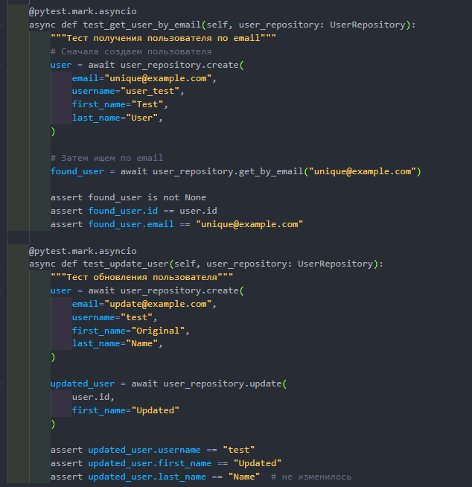
import pytest
from app.models.User import User
from app.repositories.user_repository import UserRepository
from app.User_schem import UserCreate, UserUpdate
class TestUserRepository:
@pytest.mark.asyncio
async def test_get_user_by_email(self, session, user_repository: UserRepository):
"""Тест получения пользователя по email"""
# Подготовим данные для создания
user_data = {
"email": "unique@example.com",
"username": "user_test",
"firstname": "Test",
"lastname": "User",
}
user_create_schema = UserCreate(**user_data)
user = await user_repository.create(session, user_create_schema)
found_user = await user_repository.get_by_id(session, user.id)
assert found_user is not None
assert found_user.id == user.id
assert found_user.email == "unique@example.com"
# --- Проверим новые поля ---
assert found_user.firstname == "Test"
assert found_user.lastname == "User"
# ---
@pytest.mark.asyncio
async def test_update_user(self, session, user_repository: UserRepository):
"""Тест обновления пользователя"""
# Подготовим данные для создания
user_data = {
"email": "update@example.com",
"username": "test",
"firstname": "Original",
"lastname": "Name",
}
user_create_schema = UserCreate(**user_data)
user = await user_repository.create(session, user_create_schema)
user_update_data = {
"firstname": "Updated"
}
user_update_schema = UserUpdate(**user_update_data)
updated_user = await user_repository.update(session, user.id, user_update_schema)
assert updated_user.username == "test"
assert updated_user.firstname == "Updated"
assert updated_user.lastname == "Name"

Запускаем тест.
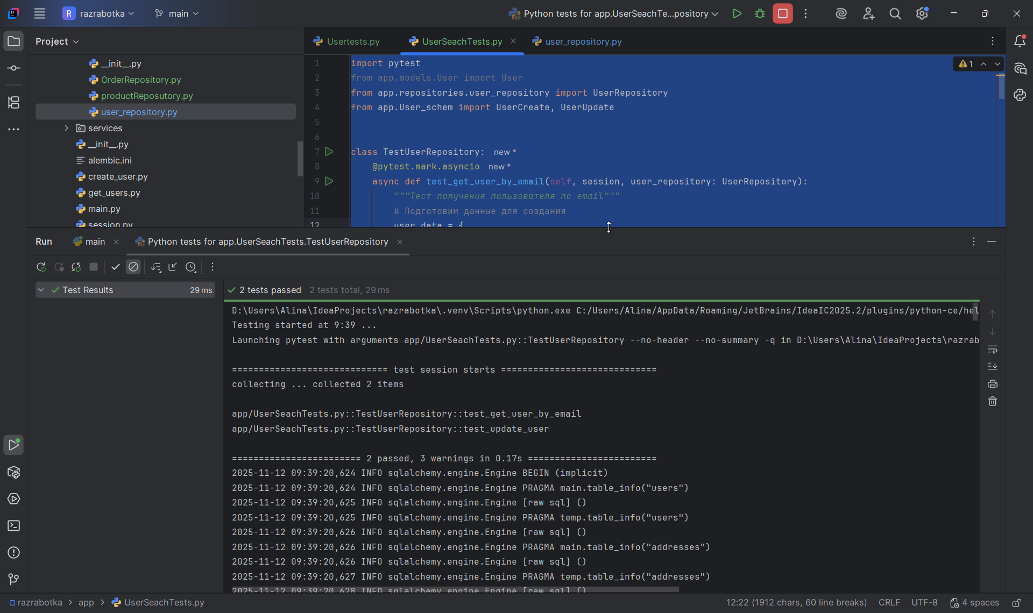
D:\Users\Alina\IdeaProjects\razrabotka\.venv\Scripts\python.exe C:/Users/Alina/AppData/Roaming/JetBrains/IdeaIC2025.2/plugins/python-ce/helpers/pycharm/_jb_pytest_runner.py --target app/UserSeachTests.py::TestUserRepository
Testing started at 9:39 ...
Launching pytest with arguments app/UserSeachTests.py::TestUserRepository --no-header --no-summary -q in D:\Users\Alina\IdeaProjects\razrabotka

============================= test session starts =============================
collecting ... collected 2 items

app/UserSeachTests.py::TestUserRepository::test_get_user_by_email
app/UserSeachTests.py::TestUserRepository::test_update_user

======================== 2 passed, 3 warnings in 0.17s ========================
2025-11-12 09:39:20,624 INFO sqlalchemy.engine.Engine BEGIN (implicit)
2025-11-12 09:39:20,624 INFO sqlalchemy.engine.Engine PRAGMA main.table_info("users")
2025-11-12 09:39:20,625 INFO sqlalchemy.engine.Engine [raw sql] ()
2025-11-12 09:39:20,625 INFO sqlalchemy.engine.Engine PRAGMA temp.table_info("users")
2025-11-12 09:39:20,626 INFO sqlalchemy.engine.Engine [raw sql] ()
2025-11-12 09:39:20,626 INFO sqlalchemy.engine.Engine PRAGMA main.table_info("addresses")
2025-11-12 09:39:20,626 INFO sqlalchemy.engine.Engine [raw sql] ()
2025-11-12 09:39:20,627 INFO sqlalchemy.engine.Engine PRAGMA temp.table_info("addresses")
2025-11-12 09:39:20,628 INFO sqlalchemy.engine.Engine [raw sql] ()
2025-11-12 09:39:20,629 INFO sqlalchemy.engine.Engine PRAGMA main.table_info("products")
2025-11-12 09:39:20,629 INFO sqlalchemy.engine.Engine [raw sql] ()
2025-11-12 09:39:20,629 INFO sqlalchemy.engine.Engine PRAGMA temp.table_info("products")
2025-11-12 09:39:20,629 INFO sqlalchemy.engine.Engine [raw sql] ()
2025-11-12 09:39:20,630 INFO sqlalchemy.engine.Engine PRAGMA main.table_info("orders")
2025-11-12 09:39:20,630 INFO sqlalchemy.engine.Engine [raw sql] ()
2025-11-12 09:39:20,631 INFO sqlalchemy.engine.Engine PRAGMA temp.table_info("orders")
2025-11-12 09:39:20,631 INFO sqlalchemy.engine.Engine [raw sql] ()
2025-11-12 09:39:20,631 INFO sqlalchemy.engine.Engine PRAGMA main.table_info("order_items")
2025-11-12 09:39:20,631 INFO sqlalchemy.engine.Engine [raw sql] ()
2025-11-12 09:39:20,632 INFO sqlalchemy.engine.Engine PRAGMA temp.table_info("order_items")
2025-11-12 09:39:20,632 INFO sqlalchemy.engine.Engine [raw sql] ()
2025-11-12 09:39:20,633 INFO sqlalchemy.engine.Engine PRAGMA main.table_info("users")
2025-11-12 09:39:20,633 INFO sqlalchemy.engine.Engine [raw sql] ()
2025-11-12 09:39:20,634 INFO sqlalchemy.engine.Engine PRAGMA temp.table_info("users")
2025-11-12 09:39:20,634 INFO sqlalchemy.engine.Engine [raw sql] ()
2025-11-12 09:39:20,634 INFO sqlalchemy.engine.Engine PRAGMA main.table_info("addresses")
2025-11-12 09:39:20,634 INFO sqlalchemy.engine.Engine [raw sql] ()
2025-11-12 09:39:20,635 INFO sqlalchemy.engine.Engine PRAGMA temp.table_info("addresses")
2025-11-12 09:39:20,635 INFO sqlalchemy.engine.Engine [raw sql] ()
2025-11-12 09:39:20,636 INFO sqlalchemy.engine.Engine PRAGMA main.table_info("products")
2025-11-12 09:39:20,636 INFO sqlalchemy.engine.Engine [raw sql] ()
2025-11-12 09:39:20,636 INFO sqlalchemy.engine.Engine PRAGMA temp.table_info("products")
2025-11-12 09:39:20,636 INFO sqlalchemy.engine.Engine [raw sql] ()
2025-11-12 09:39:20,636 INFO sqlalchemy.engine.Engine PRAGMA main.table_info("orders")
2025-11-12 09:39:20,637 INFO sqlalchemy.engine.Engine [raw sql] ()
2025-11-12 09:39:20,637 INFO sqlalchemy.engine.Engine PRAGMA temp.table_info("orders")
2025-11-12 09:39:20,637 INFO sqlalchemy.engine.Engine [raw sql] ()
2025-11-12 09:39:20,637 INFO sqlalchemy.engine.Engine PRAGMA main.table_info("order_items")
2025-11-12 09:39:20,638 INFO sqlalchemy.engine.Engine [raw sql] ()
2025-11-12 09:39:20,638 INFO sqlalchemy.engine.Engine PRAGMA temp.table_info("order_items")
2025-11-12 09:39:20,638 INFO sqlalchemy.engine.Engine [raw sql] ()
2025-11-12 09:39:20,639 INFO sqlalchemy.engine.Engine
CREATE TABLE users (
id VARCHAR(36) NOT NULL,
username VARCHAR NOT NULL,
firstname VARCHAR,
lastname VARCHAR,
email VARCHAR NOT NULL,
description TEXT,
created_at DATETIME NOT NULL,
updated_at DATETIME,
PRIMARY KEY (id),
UNIQUE (username),
UNIQUE (email)
)

2025-11-12 09:39:20,639 INFO sqlalchemy.engine.Engine [no key 0.00020s] ()
2025-11-12 09:39:20,643 INFO sqlalchemy.engine.Engine
CREATE TABLE products (
id VARCHAR(36) NOT NULL,
name VARCHAR NOT NULL,
price INTEGER NOT NULL,
description TEXT,
stock_quantity INTEGER NOT NULL,
PRIMARY KEY (id)
)

2025-11-12 09:39:20,643 INFO sqlalchemy.engine.Engine [no key 0.00018s] ()
2025-11-12 09:39:20,645 INFO sqlalchemy.engine.Engine
CREATE TABLE addresses (
id VARCHAR(36) NOT NULL,
user_id VARCHAR(36) NOT NULL,
street VARCHAR NOT NULL,
city VARCHAR NOT NULL,
state VARCHAR,
zip_code VARCHAR,
country VARCHAR NOT NULL,
is_primary BOOLEAN NOT NULL,
created_at DATETIME NOT NULL,
updated_at DATETIME,
PRIMARY KEY (id),
FOREIGN KEY(user_id) REFERENCES users (id)
)

2025-11-12 09:39:20,646 INFO sqlalchemy.engine.Engine [no key 0.00015s] ()
2025-11-12 09:39:20,648 INFO sqlalchemy.engine.Engine
CREATE TABLE orders (
id VARCHAR(36) NOT NULL,
user_id VARCHAR(36) NOT NULL,
address_id VARCHAR(36) NOT NULL,
created_at DATETIME NOT NULL,
PRIMARY KEY (id),
FOREIGN KEY(user_id) REFERENCES users (id),
FOREIGN KEY(address_id) REFERENCES addresses (id)
)

2025-11-12 09:39:20,648 INFO sqlalchemy.engine.Engine [no key 0.00021s] ()
2025-11-12 09:39:20,651 INFO sqlalchemy.engine.Engine
CREATE TABLE order_items (
id VARCHAR(36) NOT NULL,
order_id VARCHAR(36) NOT NULL,
product_id VARCHAR(36) NOT NULL,
quantity INTEGER NOT NULL,
PRIMARY KEY (id),
FOREIGN KEY(order_id) REFERENCES orders (id),
FOREIGN KEY(product_id) REFERENCES products (id)
)

2025-11-12 09:39:20,651 INFO sqlalchemy.engine.Engine [no key 0.00016s] ()
2025-11-12 09:39:20,653 INFO sqlalchemy.engine.Engine COMMIT
INFO - 2025-11-12 09:39:20,624 - sqlalchemy.engine.Engine - base - BEGIN (implicit)
INFO - 2025-11-12 09:39:20,624 - sqlalchemy.engine.Engine - base - PRAGMA main.table_info("users")
INFO - 2025-11-12 09:39:20,625 - sqlalchemy.engine.Engine - base - [raw sql] ()
INFO - 2025-11-12 09:39:20,625 - sqlalchemy.engine.Engine - base - PRAGMA temp.table_info("users")
INFO - 2025-11-12 09:39:20,626 - sqlalchemy.engine.Engine - base - [raw sql] ()
INFO - 2025-11-12 09:39:20,626 - sqlalchemy.engine.Engine - base - PRAGMA main.table_info("addresses")
INFO - 2025-11-12 09:39:20,626 - sqlalchemy.engine.Engine - base - [raw sql] ()
INFO - 2025-11-12 09:39:20,627 - sqlalchemy.engine.Engine - base - PRAGMA temp.table_info("addresses")
INFO - 2025-11-12 09:39:20,628 - sqlalchemy.engine.Engine - base - [raw sql] ()
INFO - 2025-11-12 09:39:20,629 - sqlalchemy.engine.Engine - base - PRAGMA main.table_info("products")
INFO - 2025-11-12 09:39:20,629 - sqlalchemy.engine.Engine - base - [raw sql] ()
INFO - 2025-11-12 09:39:20,629 - sqlalchemy.engine.Engine - base - PRAGMA temp.table_info("products")
INFO - 2025-11-12 09:39:20,629 - sqlalchemy.engine.Engine - base - [raw sql] ()
INFO - 2025-11-12 09:39:20,630 - sqlalchemy.engine.Engine - base - PRAGMA main.table_info("orders")
INFO - 2025-11-12 09:39:20,630 - sqlalchemy.engine.Engine - base - [raw sql] ()
INFO - 2025-11-12 09:39:20,631 - sqlalchemy.engine.Engine - base - PRAGMA temp.table_info("orders")
INFO - 2025-11-12 09:39:20,631 - sqlalchemy.engine.Engine - base - [raw sql] ()
INFO - 2025-11-12 09:39:20,631 - sqlalchemy.engine.Engine - base - PRAGMA main.table_info("order_items")
INFO - 2025-11-12 09:39:20,631 - sqlalchemy.engine.Engine - base - [raw sql] ()
INFO - 2025-11-12 09:39:20,632 - sqlalchemy.engine.Engine - base - PRAGMA temp.table_info("order_items")
INFO - 2025-11-12 09:39:20,632 - sqlalchemy.engine.Engine - base - [raw sql] ()
INFO - 2025-11-12 09:39:20,633 - sqlalchemy.engine.Engine - base - PRAGMA main.table_info("users")
INFO - 2025-11-12 09:39:20,633 - sqlalchemy.engine.Engine - base - [raw sql] ()
INFO - 2025-11-12 09:39:20,634 - sqlalchemy.engine.Engine - base - PRAGMA temp.table_info("users")
INFO - 2025-11-12 09:39:20,634 - sqlalchemy.engine.Engine - base - [raw sql] ()
INFO - 2025-11-12 09:39:20,634 - sqlalchemy.engine.Engine - base - PRAGMA main.table_info("addresses")
INFO - 2025-11-12 09:39:20,634 - sqlalchemy.engine.Engine - base - [raw sql] ()
INFO - 2025-11-12 09:39:20,635 - sqlalchemy.engine.Engine - base - PRAGMA temp.table_info("addresses")
INFO - 2025-11-12 09:39:20,635 - sqlalchemy.engine.Engine - base - [raw sql] ()
INFO - 2025-11-12 09:39:20,636 - sqlalchemy.engine.Engine - base - PRAGMA main.table_info("products")
INFO - 2025-11-12 09:39:20,636 - sqlalchemy.engine.Engine - base - [raw sql] ()
INFO - 2025-11-12 09:39:20,636 - sqlalchemy.engine.Engine - base - PRAGMA temp.table_info("products")
INFO - 2025-11-12 09:39:20,636 - sqlalchemy.engine.Engine - base - [raw sql] ()
INFO - 2025-11-12 09:39:20,636 - sqlalchemy.engine.Engine - base - PRAGMA main.table_info("orders")
INFO - 2025-11-12 09:39:20,637 - sqlalchemy.engine.Engine - base - [raw sql] ()
INFO - 2025-11-12 09:39:20,637 - sqlalchemy.engine.Engine - base - PRAGMA temp.table_info("orders")
INFO - 2025-11-12 09:39:20,637 - sqlalchemy.engine.Engine - base - [raw sql] ()
INFO - 2025-11-12 09:39:20,637 - sqlalchemy.engine.Engine - base - PRAGMA main.table_info("order_items")
INFO - 2025-11-12 09:39:20,638 - sqlalchemy.engine.Engine - base - [raw sql] ()
INFO - 2025-11-12 09:39:20,638 - sqlalchemy.engine.Engine - base - PRAGMA temp.table_info("order_items")
INFO - 2025-11-12 09:39:20,638 - sqlalchemy.engine.Engine - base - [raw sql] ()
INFO - 2025-11-12 09:39:20,639 - sqlalchemy.engine.Engine - base -
CREATE TABLE users (
id VARCHAR(36) NOT NULL,
username VARCHAR NOT NULL,
firstname VARCHAR,
lastname VARCHAR,
email VARCHAR NOT NULL,
description TEXT,
created_at DATETIME NOT NULL,
updated_at DATETIME,
PRIMARY KEY (id),
UNIQUE (username),
UNIQUE (email)
)

INFO - 2025-11-12 09:39:20,639 - sqlalchemy.engine.Engine - base - [no key 0.00020s] ()
INFO - 2025-11-12 09:39:20,643 - sqlalchemy.engine.Engine - base -
CREATE TABLE products (
id VARCHAR(36) NOT NULL,
name VARCHAR NOT NULL,
price INTEGER NOT NULL,
description TEXT,
stock_quantity INTEGER NOT NULL,
PRIMARY KEY (id)
)

INFO - 2025-11-12 09:39:20,643 - sqlalchemy.engine.Engine - base - [no key 0.00018s] ()
INFO - 2025-11-12 09:39:20,645 - sqlalchemy.engine.Engine - base -
CREATE TABLE addresses (
id VARCHAR(36) NOT NULL,
user_id VARCHAR(36) NOT NULL,
street VARCHAR NOT NULL,
city VARCHAR NOT NULL,
state VARCHAR,
zip_code VARCHAR,
country VARCHAR NOT NULL,
is_primary BOOLEAN NOT NULL,
created_at DATETIME NOT NULL,
updated_at DATETIME,
PRIMARY KEY (id),
FOREIGN KEY(user_id) REFERENCES users (id)
)

INFO - 2025-11-12 09:39:20,646 - sqlalchemy.engine.Engine - base - [no key 0.00015s] ()
INFO - 2025-11-12 09:39:20,648 - sqlalchemy.engine.Engine - base -
CREATE TABLE orders (
id VARCHAR(36) NOT NULL,
user_id VARCHAR(36) NOT NULL,
address_id VARCHAR(36) NOT NULL,
created_at DATETIME NOT NULL,
PRIMARY KEY (id),
FOREIGN KEY(user_id) REFERENCES users (id),
FOREIGN KEY(address_id) REFERENCES addresses (id)
)

INFO - 2025-11-12 09:39:20,648 - sqlalchemy.engine.Engine - base - [no key 0.00021s] ()
INFO - 2025-11-12 09:39:20,651 - sqlalchemy.engine.Engine - base -
CREATE TABLE order_items (
id VARCHAR(36) NOT NULL,
order_id VARCHAR(36) NOT NULL,
product_id VARCHAR(36) NOT NULL,
quantity INTEGER NOT NULL,
PRIMARY KEY (id),
FOREIGN KEY(order_id) REFERENCES orders (id),
FOREIGN KEY(product_id) REFERENCES products (id)
)

INFO - 2025-11-12 09:39:20,651 - sqlalchemy.engine.Engine - base - [no key 0.00016s] ()
INFO - 2025-11-12 09:39:20,653 - sqlalchemy.engine.Engine - base - COMMIT
PASSED [ 50%]2025-11-12 09:39:20,670 INFO sqlalchemy.engine.Engine BEGIN (implicit)
2025-11-12 09:39:20,672 INFO sqlalchemy.engine.Engine INSERT INTO users (id, username, firstname, lastname, email, description, created_at, updated_at) VALUES (?, ?, ?, ?, ?, ?, ?, ?)
2025-11-12 09:39:20,672 INFO sqlalchemy.engine.Engine [generated in 0.00024s] ('41f9e5e3-35d7-455c-b899-98fd693fa803', 'user_test', 'Test', 'User', 'unique@example.com', None, '2025-11-12 04:39:20.672143', None)
2025-11-12 09:39:20,674 INFO sqlalchemy.engine.Engine COMMIT
2025-11-12 09:39:20,676 INFO sqlalchemy.engine.Engine BEGIN (implicit)
2025-11-12 09:39:20,678 INFO sqlalchemy.engine.Engine SELECT users.id, users.username, users.firstname, users.lastname, users.email, users.description, users.created_at, users.updated_at
FROM users
WHERE users.id = ?
2025-11-12 09:39:20,678 INFO sqlalchemy.engine.Engine [generated in 0.00020s] ('41f9e5e3-35d7-455c-b899-98fd693fa803',)
2025-11-12 09:39:20,680 INFO sqlalchemy.engine.Engine SELECT users.id, users.username, users.firstname, users.lastname, users.email, users.description, users.created_at, users.updated_at
FROM users
WHERE users.id = ?
2025-11-12 09:39:20,680 INFO sqlalchemy.engine.Engine [generated in 0.00017s] ('41f9e5e3-35d7-455c-b899-98fd693fa803',)
INFO - 2025-11-12 09:39:20,670 - sqlalchemy.engine.Engine - base - BEGIN (implicit)
INFO - 2025-11-12 09:39:20,672 - sqlalchemy.engine.Engine - base - INSERT INTO users (id, username, firstname, lastname, email, description, created_at, updated_at) VALUES (?, ?, ?, ?, ?, ?, ?, ?)
INFO - 2025-11-12 09:39:20,672 - sqlalchemy.engine.Engine - base - [generated in 0.00024s] ('41f9e5e3-35d7-455c-b899-98fd693fa803', 'user_test', 'Test', 'User', 'unique@example.com', None, '2025-11-12 04:39:20.672143', None)
INFO - 2025-11-12 09:39:20,674 - sqlalchemy.engine.Engine - base - COMMIT
INFO - 2025-11-12 09:39:20,676 - sqlalchemy.engine.Engine - base - BEGIN (implicit)
INFO - 2025-11-12 09:39:20,678 - sqlalchemy.engine.Engine - base - SELECT users.id, users.username, users.firstname, users.lastname, users.email, users.description, users.created_at, users.updated_at
FROM users
WHERE users.id = ?
INFO - 2025-11-12 09:39:20,678 - sqlalchemy.engine.Engine - base - [generated in 0.00020s] ('41f9e5e3-35d7-455c-b899-98fd693fa803',)
INFO - 2025-11-12 09:39:20,680 - sqlalchemy.engine.Engine - base - SELECT users.id, users.username, users.firstname, users.lastname, users.email, users.description, users.created_at, users.updated_at
FROM users
WHERE users.id = ?
INFO - 2025-11-12 09:39:20,680 - sqlalchemy.engine.Engine - base - [generated in 0.00017s] ('41f9e5e3-35d7-455c-b899-98fd693fa803',)
2025-11-12 09:39:20,682 INFO sqlalchemy.engine.Engine ROLLBACK
INFO - 2025-11-12 09:39:20,682 - sqlalchemy.engine.Engine - base - ROLLBACK
PASSED [100%]2025-11-12 09:39:20,689 INFO sqlalchemy.engine.Engine BEGIN (implicit)
2025-11-12 09:39:20,690 INFO sqlalchemy.engine.Engine INSERT INTO users (id, username, firstname, lastname, email, description, created_at, updated_at) VALUES (?, ?, ?, ?, ?, ?, ?, ?)
2025-11-12 09:39:20,690 INFO sqlalchemy.engine.Engine [cached since 0.01817s ago] ('12158206-5cde-41d0-a18e-7187c52eafdf', 'test', 'Original', 'Name', 'update@example.com', None, '2025-11-12 04:39:20.690083', None)
2025-11-12 09:39:20,691 INFO sqlalchemy.engine.Engine COMMIT
2025-11-12 09:39:20,693 INFO sqlalchemy.engine.Engine BEGIN (implicit)
2025-11-12 09:39:20,693 INFO sqlalchemy.engine.Engine SELECT users.id, users.username, users.firstname, users.lastname, users.email, users.description, users.created_at, users.updated_at
FROM users
WHERE users.id = ?
2025-11-12 09:39:20,694 INFO sqlalchemy.engine.Engine [cached since 0.016s ago] ('12158206-5cde-41d0-a18e-7187c52eafdf',)
2025-11-12 09:39:20,694 INFO sqlalchemy.engine.Engine SELECT users.id, users.username, users.firstname, users.lastname, users.email, users.description, users.created_at, users.updated_at
FROM users
WHERE users.id = ?
2025-11-12 09:39:20,694 INFO sqlalchemy.engine.Engine [cached since 0.01474s ago] ('12158206-5cde-41d0-a18e-7187c52eafdf',)
2025-11-12 09:39:20,696 INFO sqlalchemy.engine.Engine UPDATE users SET firstname=?, updated_at=? WHERE users.id = ?
2025-11-12 09:39:20,696 INFO sqlalchemy.engine.Engine [generated in 0.00019s] ('Updated', '2025-11-12 04:39:20.696700', '12158206-5cde-41d0-a18e-7187c52eafdf')
2025-11-12 09:39:20,697 INFO sqlalchemy.engine.Engine COMMIT
2025-11-12 09:39:20,699 INFO sqlalchemy.engine.Engine BEGIN (implicit)
2025-11-12 09:39:20,700 INFO sqlalchemy.engine.Engine SELECT users.id, users.username, users.firstname, users.lastname, users.email, users.description, users.created_at, users.updated_at
FROM users
WHERE users.id = ?
2025-11-12 09:39:20,700 INFO sqlalchemy.engine.Engine [cached since 0.02211s ago] ('12158206-5cde-41d0-a18e-7187c52eafdf',)
INFO - 2025-11-12 09:39:20,689 - sqlalchemy.engine.Engine - base - BEGIN (implicit)
INFO - 2025-11-12 09:39:20,690 - sqlalchemy.engine.Engine - base - INSERT INTO users (id, username, firstname, lastname, email, description, created_at, updated_at) VALUES (?, ?, ?, ?, ?, ?, ?, ?)
INFO - 2025-11-12 09:39:20,690 - sqlalchemy.engine.Engine - base - [cached since 0.01817s ago] ('12158206-5cde-41d0-a18e-7187c52eafdf', 'test', 'Original', 'Name', 'update@example.com', None, '2025-11-12 04:39:20.690083', None)
INFO - 2025-11-12 09:39:20,691 - sqlalchemy.engine.Engine - base - COMMIT
INFO - 2025-11-12 09:39:20,693 - sqlalchemy.engine.Engine - base - BEGIN (implicit)
INFO - 2025-11-12 09:39:20,693 - sqlalchemy.engine.Engine - base - SELECT users.id, users.username, users.firstname, users.lastname, users.email, users.description, users.created_at, users.updated_at
FROM users
WHERE users.id = ?
INFO - 2025-11-12 09:39:20,694 - sqlalchemy.engine.Engine - base - [cached since 0.016s ago] ('12158206-5cde-41d0-a18e-7187c52eafdf',)
INFO - 2025-11-12 09:39:20,694 - sqlalchemy.engine.Engine - base - SELECT users.id, users.username, users.firstname, users.lastname, users.email, users.description, users.created_at, users.updated_at
FROM users
WHERE users.id = ?
INFO - 2025-11-12 09:39:20,694 - sqlalchemy.engine.Engine - base - [cached since 0.01474s ago] ('12158206-5cde-41d0-a18e-7187c52eafdf',)
INFO - 2025-11-12 09:39:20,696 - sqlalchemy.engine.Engine - base - UPDATE users SET firstname=?, updated_at=? WHERE users.id = ?
INFO - 2025-11-12 09:39:20,696 - sqlalchemy.engine.Engine - base - [generated in 0.00019s] ('Updated', '2025-11-12 04:39:20.696700', '12158206-5cde-41d0-a18e-7187c52eafdf')
INFO - 2025-11-12 09:39:20,697 - sqlalchemy.engine.Engine - base - COMMIT
INFO - 2025-11-12 09:39:20,699 - sqlalchemy.engine.Engine - base - BEGIN (implicit)
INFO - 2025-11-12 09:39:20,700 - sqlalchemy.engine.Engine - base - SELECT users.id, users.username, users.firstname, users.lastname, users.email, users.description, users.created_at, users.updated_at
FROM users
WHERE users.id = ?
INFO - 2025-11-12 09:39:20,700 - sqlalchemy.engine.Engine - base - [cached since 0.02211s ago] ('12158206-5cde-41d0-a18e-7187c52eafdf',)
2025-11-12 09:39:20,705 INFO sqlalchemy.engine.Engine ROLLBACK
2025-11-12 09:39:20,706 INFO sqlalchemy.engine.Engine BEGIN (implicit)
2025-11-12 09:39:20,706 INFO sqlalchemy.engine.Engine PRAGMA main.table_info("users")
2025-11-12 09:39:20,706 INFO sqlalchemy.engine.Engine [raw sql] ()
2025-11-12 09:39:20,707 INFO sqlalchemy.engine.Engine PRAGMA main.table_info("addresses")
2025-11-12 09:39:20,707 INFO sqlalchemy.engine.Engine [raw sql] ()
2025-11-12 09:39:20,708 INFO sqlalchemy.engine.Engine PRAGMA main.table_info("products")
2025-11-12 09:39:20,708 INFO sqlalchemy.engine.Engine [raw sql] ()
2025-11-12 09:39:20,709 INFO sqlalchemy.engine.Engine PRAGMA main.table_info("orders")
2025-11-12 09:39:20,709 INFO sqlalchemy.engine.Engine [raw sql] ()
2025-11-12 09:39:20,709 INFO sqlalchemy.engine.Engine PRAGMA main.table_info("order_items")
2025-11-12 09:39:20,710 INFO sqlalchemy.engine.Engine [raw sql] ()
2025-11-12 09:39:20,710 INFO sqlalchemy.engine.Engine
DROP TABLE order_items
2025-11-12 09:39:20,710 INFO sqlalchemy.engine.Engine [no key 0.00014s] ()
2025-11-12 09:39:20,713 INFO sqlalchemy.engine.Engine
DROP TABLE orders
2025-11-12 09:39:20,713 INFO sqlalchemy.engine.Engine [no key 0.00009s] ()
2025-11-12 09:39:20,715 INFO sqlalchemy.engine.Engine
DROP TABLE addresses
2025-11-12 09:39:20,715 INFO sqlalchemy.engine.Engine [no key 0.00016s] ()
2025-11-12 09:39:20,717 INFO sqlalchemy.engine.Engine
DROP TABLE products
2025-11-12 09:39:20,717 INFO sqlalchemy.engine.Engine [no key 0.00013s] ()
2025-11-12 09:39:20,719 INFO sqlalchemy.engine.Engine
DROP TABLE users
2025-11-12 09:39:20,719 INFO sqlalchemy.engine.Engine [no key 0.00009s] ()
2025-11-12 09:39:20,721 INFO sqlalchemy.engine.Engine COMMIT
INFO - 2025-11-12 09:39:20,705 - sqlalchemy.engine.Engine - base - ROLLBACK
INFO - 2025-11-12 09:39:20,706 - sqlalchemy.engine.Engine - base - BEGIN (implicit)
INFO - 2025-11-12 09:39:20,706 - sqlalchemy.engine.Engine - base - PRAGMA main.table_info("users")
INFO - 2025-11-12 09:39:20,706 - sqlalchemy.engine.Engine - base - [raw sql] ()
INFO - 2025-11-12 09:39:20,707 - sqlalchemy.engine.Engine - base - PRAGMA main.table_info("addresses")
INFO - 2025-11-12 09:39:20,707 - sqlalchemy.engine.Engine - base - [raw sql] ()
INFO - 2025-11-12 09:39:20,708 - sqlalchemy.engine.Engine - base - PRAGMA main.table_info("products")
INFO - 2025-11-12 09:39:20,708 - sqlalchemy.engine.Engine - base - [raw sql] ()
INFO - 2025-11-12 09:39:20,709 - sqlalchemy.engine.Engine - base - PRAGMA main.table_info("orders")
INFO - 2025-11-12 09:39:20,709 - sqlalchemy.engine.Engine - base - [raw sql] ()
INFO - 2025-11-12 09:39:20,709 - sqlalchemy.engine.Engine - base - PRAGMA main.table_info("order_items")
INFO - 2025-11-12 09:39:20,710 - sqlalchemy.engine.Engine - base - [raw sql] ()
INFO - 2025-11-12 09:39:20,710 - sqlalchemy.engine.Engine - base -
DROP TABLE order_items
INFO - 2025-11-12 09:39:20,710 - sqlalchemy.engine.Engine - base - [no key 0.00014s] ()
INFO - 2025-11-12 09:39:20,713 - sqlalchemy.engine.Engine - base -
DROP TABLE orders
INFO - 2025-11-12 09:39:20,713 - sqlalchemy.engine.Engine - base - [no key 0.00009s] ()
INFO - 2025-11-12 09:39:20,715 - sqlalchemy.engine.Engine - base -
DROP TABLE addresses
INFO - 2025-11-12 09:39:20,715 - sqlalchemy.engine.Engine - base - [no key 0.00016s] ()
INFO - 2025-11-12 09:39:20,717 - sqlalchemy.engine.Engine - base -
DROP TABLE products
INFO - 2025-11-12 09:39:20,717 - sqlalchemy.engine.Engine - base - [no key 0.00013s] ()
INFO - 2025-11-12 09:39:20,719 - sqlalchemy.engine.Engine - base -
DROP TABLE users
INFO - 2025-11-12 09:39:20,719 - sqlalchemy.engine.Engine - base - [no key 0.00009s] ()
INFO - 2025-11-12 09:39:20,721 - sqlalchemy.engine.Engine - base - COMMIT

Process finished with exit code 0

К этим тестам необходимо добавить удаление и получение списка пользователей. Для репозитория заказов и продукции необходимо добавить тесты создания, обновления, получения списка, получения конкретного заказа и удаления. При этом необходимо учитывать, что в заказе может находится не один продукт, а несколько.
Добавляем тест для удаления и получения списка пользователей.
import pytest
from app.models.User import User
from app.repositories.user_repository import UserRepository
from app.User_schem import UserCreate, UserUpdate
class TestUserRepository:
@pytest.mark.asyncio
async def test_create_user(self, session, user_repository: UserRepository):
"""Тест создания пользователя в репозитории"""
user_data = {
"email": "Leon@example.com",
"username": "Leon_duren",
"firstname": "Leon",
"lastname": "Duren",
}
user_create_schema = UserCreate(**user_data)
user = await user_repository.create(session, user_create_schema)
assert user.id is not None
assert user.email == "Leon@example.com"
assert user.username == "Leon_duren"
assert user.firstname == "Leon"
assert user.lastname == "Duren"
# Проверим, что пользователь действительно в БД
fetched_user = await session.get(User, user.id)
assert fetched_user is not None
assert fetched_user.id == user.id
@pytest.mark.asyncio
async def test_delete_user(self, session, user_repository: UserRepository):
"""Тест удаления пользователя"""
# Сначала создаём пользователя
user_data = {
"email": "delete@example.com",
"username": "delete_user",
"firstname": "Delete",
"lastname": "Me",
}
user_create_schema = UserCreate(**user_data)
user = await user_repository.create(session, user_create_schema)
# Проверим, что он существует
fetched_user = await session.get(User, user.id)
assert fetched_user is not None
# Удаляем
await user_repository.delete(session, user.id)
# Проверим, что его больше нет
deleted_user = await session.get(User, user.id)
assert deleted_user is None
@pytest.mark.asyncio
async def test_get_all_users(self, session, user_repository: UserRepository):
"""Тест получения списка пользователей"""
# Сначала создаём несколько пользователей
users_data = [
{
"email": "list1@example.com",
"username": "list_user1",
"firstname": "List",
"lastname": "One",
},
{
"email": "list2@example.com",
"username": "list_user2",
"firstname": "List",
"lastname": "Two",
},
]
created_users = []
for data in users_data:
user_create_schema = UserCreate(**data)
user = await user_repository.create(session, user_create_schema)
created_users.append(user)
# Получаем список
users_list = await user_repository.get_by_filter(session, count=10, page=1)
# Проверяем, что все созданные пользователи есть в списке
assert len(users_list) >= 2
user_ids = {u.id for u in users_list}
for user in created_users:
assert user.id in user_ids

Запускаем тест:
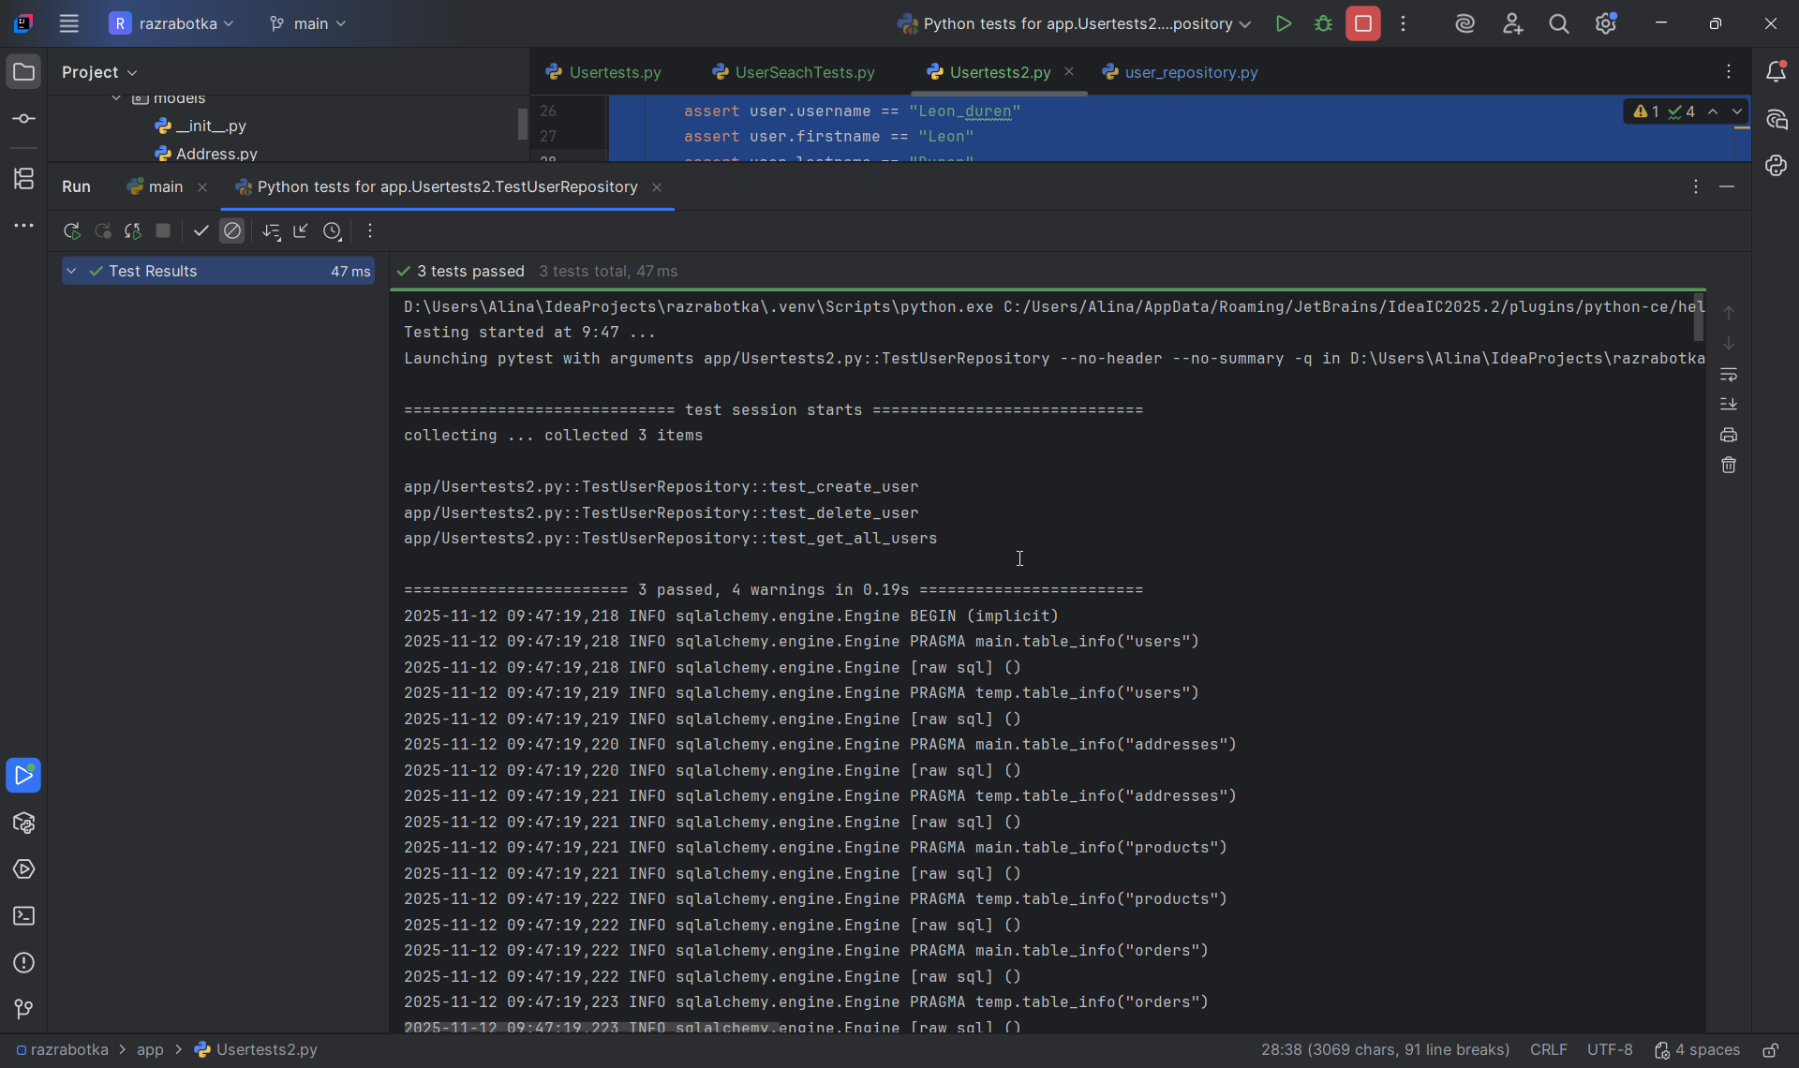
D:\Users\Alina\IdeaProjects\razrabotka\.venv\Scripts\python.exe C:/Users/Alina/AppData/Roaming/JetBrains/IdeaIC2025.2/plugins/python-ce/helpers/pycharm/_jb_pytest_runner.py --target app/Usertests2.py::TestUserRepository
Testing started at 9:47 ...
Launching pytest with arguments app/Usertests2.py::TestUserRepository --no-header --no-summary -q in D:\Users\Alina\IdeaProjects\razrabotka

============================= test session starts =============================
collecting ... collected 3 items

app/Usertests2.py::TestUserRepository::test_create_user
app/Usertests2.py::TestUserRepository::test_delete_user
app/Usertests2.py::TestUserRepository::test_get_all_users

======================== 3 passed, 4 warnings in 0.19s ========================
2025-11-12 09:47:19,218 INFO sqlalchemy.engine.Engine BEGIN (implicit)
2025-11-12 09:47:19,218 INFO sqlalchemy.engine.Engine PRAGMA main.table_info("users")
2025-11-12 09:47:19,218 INFO sqlalchemy.engine.Engine [raw sql] ()
2025-11-12 09:47:19,219 INFO sqlalchemy.engine.Engine PRAGMA temp.table_info("users")
2025-11-12 09:47:19,219 INFO sqlalchemy.engine.Engine [raw sql] ()
2025-11-12 09:47:19,220 INFO sqlalchemy.engine.Engine PRAGMA main.table_info("addresses")
2025-11-12 09:47:19,220 INFO sqlalchemy.engine.Engine [raw sql] ()
2025-11-12 09:47:19,221 INFO sqlalchemy.engine.Engine PRAGMA temp.table_info("addresses")
2025-11-12 09:47:19,221 INFO sqlalchemy.engine.Engine [raw sql] ()
2025-11-12 09:47:19,221 INFO sqlalchemy.engine.Engine PRAGMA main.table_info("products")
2025-11-12 09:47:19,221 INFO sqlalchemy.engine.Engine [raw sql] ()
2025-11-12 09:47:19,222 INFO sqlalchemy.engine.Engine PRAGMA temp.table_info("products")
2025-11-12 09:47:19,222 INFO sqlalchemy.engine.Engine [raw sql] ()
2025-11-12 09:47:19,222 INFO sqlalchemy.engine.Engine PRAGMA main.table_info("orders")
2025-11-12 09:47:19,222 INFO sqlalchemy.engine.Engine [raw sql] ()
2025-11-12 09:47:19,223 INFO sqlalchemy.engine.Engine PRAGMA temp.table_info("orders")
2025-11-12 09:47:19,223 INFO sqlalchemy.engine.Engine [raw sql] ()
2025-11-12 09:47:19,223 INFO sqlalchemy.engine.Engine PRAGMA main.table_info("order_items")
2025-11-12 09:47:19,223 INFO sqlalchemy.engine.Engine [raw sql] ()
2025-11-12 09:47:19,224 INFO sqlalchemy.engine.Engine PRAGMA temp.table_info("order_items")
2025-11-12 09:47:19,224 INFO sqlalchemy.engine.Engine [raw sql] ()
2025-11-12 09:47:19,225 INFO sqlalchemy.engine.Engine PRAGMA main.table_info("users")
2025-11-12 09:47:19,225 INFO sqlalchemy.engine.Engine [raw sql] ()
2025-11-12 09:47:19,225 INFO sqlalchemy.engine.Engine PRAGMA temp.table_info("users")
2025-11-12 09:47:19,225 INFO sqlalchemy.engine.Engine [raw sql] ()
2025-11-12 09:47:19,226 INFO sqlalchemy.engine.Engine PRAGMA main.table_info("addresses")
2025-11-12 09:47:19,226 INFO sqlalchemy.engine.Engine [raw sql] ()
2025-11-12 09:47:19,227 INFO sqlalchemy.engine.Engine PRAGMA temp.table_info("addresses")
2025-11-12 09:47:19,227 INFO sqlalchemy.engine.Engine [raw sql] ()
2025-11-12 09:47:19,227 INFO sqlalchemy.engine.Engine PRAGMA main.table_info("products")
2025-11-12 09:47:19,227 INFO sqlalchemy.engine.Engine [raw sql] ()
2025-11-12 09:47:19,227 INFO sqlalchemy.engine.Engine PRAGMA temp.table_info("products")
2025-11-12 09:47:19,228 INFO sqlalchemy.engine.Engine [raw sql] ()
2025-11-12 09:47:19,228 INFO sqlalchemy.engine.Engine PRAGMA main.table_info("orders")
2025-11-12 09:47:19,228 INFO sqlalchemy.engine.Engine [raw sql] ()
2025-11-12 09:47:19,229 INFO sqlalchemy.engine.Engine PRAGMA temp.table_info("orders")
2025-11-12 09:47:19,229 INFO sqlalchemy.engine.Engine [raw sql] ()
2025-11-12 09:47:19,229 INFO sqlalchemy.engine.Engine PRAGMA main.table_info("order_items")
2025-11-12 09:47:19,229 INFO sqlalchemy.engine.Engine [raw sql] ()
2025-11-12 09:47:19,230 INFO sqlalchemy.engine.Engine PRAGMA temp.table_info("order_items")
2025-11-12 09:47:19,230 INFO sqlalchemy.engine.Engine [raw sql] ()
2025-11-12 09:47:19,231 INFO sqlalchemy.engine.Engine
CREATE TABLE users (
id VARCHAR(36) NOT NULL,
username VARCHAR NOT NULL,
firstname VARCHAR,
lastname VARCHAR,
email VARCHAR NOT NULL,
description TEXT,
created_at DATETIME NOT NULL,
updated_at DATETIME,
PRIMARY KEY (id),
UNIQUE (username),
UNIQUE (email)
)

2025-11-12 09:47:19,231 INFO sqlalchemy.engine.Engine [no key 0.00016s] ()
2025-11-12 09:47:19,234 INFO sqlalchemy.engine.Engine
CREATE TABLE products (
id VARCHAR(36) NOT NULL,
name VARCHAR NOT NULL,
price INTEGER NOT NULL,
description TEXT,
stock_quantity INTEGER NOT NULL,
PRIMARY KEY (id)
)

2025-11-12 09:47:19,234 INFO sqlalchemy.engine.Engine [no key 0.00011s] ()
2025-11-12 09:47:19,236 INFO sqlalchemy.engine.Engine
CREATE TABLE addresses (
id VARCHAR(36) NOT NULL,
user_id VARCHAR(36) NOT NULL,
street VARCHAR NOT NULL,
city VARCHAR NOT NULL,
state VARCHAR,
zip_code VARCHAR,
country VARCHAR NOT NULL,
is_primary BOOLEAN NOT NULL,
created_at DATETIME NOT NULL,
updated_at DATETIME,
PRIMARY KEY (id),
FOREIGN KEY(user_id) REFERENCES users (id)
)

2025-11-12 09:47:19,236 INFO sqlalchemy.engine.Engine [no key 0.00015s] ()
2025-11-12 09:47:19,239 INFO sqlalchemy.engine.Engine
CREATE TABLE orders (
id VARCHAR(36) NOT NULL,
user_id VARCHAR(36) NOT NULL,
address_id VARCHAR(36) NOT NULL,
created_at DATETIME NOT NULL,
PRIMARY KEY (id),
FOREIGN KEY(user_id) REFERENCES users (id),
FOREIGN KEY(address_id) REFERENCES addresses (id)
)

2025-11-12 09:47:19,239 INFO sqlalchemy.engine.Engine [no key 0.00015s] ()
2025-11-12 09:47:19,241 INFO sqlalchemy.engine.Engine
CREATE TABLE order_items (
id VARCHAR(36) NOT NULL,
order_id VARCHAR(36) NOT NULL,
product_id VARCHAR(36) NOT NULL,
quantity INTEGER NOT NULL,
PRIMARY KEY (id),
FOREIGN KEY(order_id) REFERENCES orders (id),
FOREIGN KEY(product_id) REFERENCES products (id)
)

2025-11-12 09:47:19,241 INFO sqlalchemy.engine.Engine [no key 0.00010s] ()
2025-11-12 09:47:19,244 INFO sqlalchemy.engine.Engine COMMIT
INFO - 2025-11-12 09:47:19,218 - sqlalchemy.engine.Engine - base - BEGIN (implicit)
INFO - 2025-11-12 09:47:19,218 - sqlalchemy.engine.Engine - base - PRAGMA main.table_info("users")
INFO - 2025-11-12 09:47:19,218 - sqlalchemy.engine.Engine - base - [raw sql] ()
INFO - 2025-11-12 09:47:19,219 - sqlalchemy.engine.Engine - base - PRAGMA temp.table_info("users")
INFO - 2025-11-12 09:47:19,219 - sqlalchemy.engine.Engine - base - [raw sql] ()
INFO - 2025-11-12 09:47:19,220 - sqlalchemy.engine.Engine - base - PRAGMA main.table_info("addresses")
INFO - 2025-11-12 09:47:19,220 - sqlalchemy.engine.Engine - base - [raw sql] ()
INFO - 2025-11-12 09:47:19,221 - sqlalchemy.engine.Engine - base - PRAGMA temp.table_info("addresses")
INFO - 2025-11-12 09:47:19,221 - sqlalchemy.engine.Engine - base - [raw sql] ()
INFO - 2025-11-12 09:47:19,221 - sqlalchemy.engine.Engine - base - PRAGMA main.table_info("products")
INFO - 2025-11-12 09:47:19,221 - sqlalchemy.engine.Engine - base - [raw sql] ()
INFO - 2025-11-12 09:47:19,222 - sqlalchemy.engine.Engine - base - PRAGMA temp.table_info("products")
INFO - 2025-11-12 09:47:19,222 - sqlalchemy.engine.Engine - base - [raw sql] ()
INFO - 2025-11-12 09:47:19,222 - sqlalchemy.engine.Engine - base - PRAGMA main.table_info("orders")
INFO - 2025-11-12 09:47:19,222 - sqlalchemy.engine.Engine - base - [raw sql] ()
INFO - 2025-11-12 09:47:19,223 - sqlalchemy.engine.Engine - base - PRAGMA temp.table_info("orders")
INFO - 2025-11-12 09:47:19,223 - sqlalchemy.engine.Engine - base - [raw sql] ()
INFO - 2025-11-12 09:47:19,223 - sqlalchemy.engine.Engine - base - PRAGMA main.table_info("order_items")
INFO - 2025-11-12 09:47:19,223 - sqlalchemy.engine.Engine - base - [raw sql] ()
INFO - 2025-11-12 09:47:19,224 - sqlalchemy.engine.Engine - base - PRAGMA temp.table_info("order_items")
INFO - 2025-11-12 09:47:19,224 - sqlalchemy.engine.Engine - base - [raw sql] ()
INFO - 2025-11-12 09:47:19,225 - sqlalchemy.engine.Engine - base - PRAGMA main.table_info("users")
INFO - 2025-11-12 09:47:19,225 - sqlalchemy.engine.Engine - base - [raw sql] ()
INFO - 2025-11-12 09:47:19,225 - sqlalchemy.engine.Engine - base - PRAGMA temp.table_info("users")
INFO - 2025-11-12 09:47:19,225 - sqlalchemy.engine.Engine - base - [raw sql] ()
INFO - 2025-11-12 09:47:19,226 - sqlalchemy.engine.Engine - base - PRAGMA main.table_info("addresses")
INFO - 2025-11-12 09:47:19,226 - sqlalchemy.engine.Engine - base - [raw sql] ()
INFO - 2025-11-12 09:47:19,227 - sqlalchemy.engine.Engine - base - PRAGMA temp.table_info("addresses")
INFO - 2025-11-12 09:47:19,227 - sqlalchemy.engine.Engine - base - [raw sql] ()
INFO - 2025-11-12 09:47:19,227 - sqlalchemy.engine.Engine - base - PRAGMA main.table_info("products")
INFO - 2025-11-12 09:47:19,227 - sqlalchemy.engine.Engine - base - [raw sql] ()
INFO - 2025-11-12 09:47:19,227 - sqlalchemy.engine.Engine - base - PRAGMA temp.table_info("products")
INFO - 2025-11-12 09:47:19,228 - sqlalchemy.engine.Engine - base - [raw sql] ()
INFO - 2025-11-12 09:47:19,228 - sqlalchemy.engine.Engine - base - PRAGMA main.table_info("orders")
INFO - 2025-11-12 09:47:19,228 - sqlalchemy.engine.Engine - base - [raw sql] ()
INFO - 2025-11-12 09:47:19,229 - sqlalchemy.engine.Engine - base - PRAGMA temp.table_info("orders")
INFO - 2025-11-12 09:47:19,229 - sqlalchemy.engine.Engine - base - [raw sql] ()
INFO - 2025-11-12 09:47:19,229 - sqlalchemy.engine.Engine - base - PRAGMA main.table_info("order_items")
INFO - 2025-11-12 09:47:19,229 - sqlalchemy.engine.Engine - base - [raw sql] ()
INFO - 2025-11-12 09:47:19,230 - sqlalchemy.engine.Engine - base - PRAGMA temp.table_info("order_items")
INFO - 2025-11-12 09:47:19,230 - sqlalchemy.engine.Engine - base - [raw sql] ()
INFO - 2025-11-12 09:47:19,231 - sqlalchemy.engine.Engine - base -
CREATE TABLE users (
id VARCHAR(36) NOT NULL,
username VARCHAR NOT NULL,
firstname VARCHAR,
lastname VARCHAR,
email VARCHAR NOT NULL,
description TEXT,
created_at DATETIME NOT NULL,
updated_at DATETIME,
PRIMARY KEY (id),
UNIQUE (username),
UNIQUE (email)
)

INFO - 2025-11-12 09:47:19,231 - sqlalchemy.engine.Engine - base - [no key 0.00016s] ()
INFO - 2025-11-12 09:47:19,234 - sqlalchemy.engine.Engine - base -
CREATE TABLE products (
id VARCHAR(36) NOT NULL,
name VARCHAR NOT NULL,
price INTEGER NOT NULL,
description TEXT,
stock_quantity INTEGER NOT NULL,
PRIMARY KEY (id)
)

INFO - 2025-11-12 09:47:19,234 - sqlalchemy.engine.Engine - base - [no key 0.00011s] ()
INFO - 2025-11-12 09:47:19,236 - sqlalchemy.engine.Engine - base -
CREATE TABLE addresses (
id VARCHAR(36) NOT NULL,
user_id VARCHAR(36) NOT NULL,
street VARCHAR NOT NULL,
city VARCHAR NOT NULL,
state VARCHAR,
zip_code VARCHAR,
country VARCHAR NOT NULL,
is_primary BOOLEAN NOT NULL,
created_at DATETIME NOT NULL,
updated_at DATETIME,
PRIMARY KEY (id),
FOREIGN KEY(user_id) REFERENCES users (id)
)

INFO - 2025-11-12 09:47:19,236 - sqlalchemy.engine.Engine - base - [no key 0.00015s] ()
INFO - 2025-11-12 09:47:19,239 - sqlalchemy.engine.Engine - base -
CREATE TABLE orders (
id VARCHAR(36) NOT NULL,
user_id VARCHAR(36) NOT NULL,
address_id VARCHAR(36) NOT NULL,
created_at DATETIME NOT NULL,
PRIMARY KEY (id),
FOREIGN KEY(user_id) REFERENCES users (id),
FOREIGN KEY(address_id) REFERENCES addresses (id)
)

INFO - 2025-11-12 09:47:19,239 - sqlalchemy.engine.Engine - base - [no key 0.00015s] ()
INFO - 2025-11-12 09:47:19,241 - sqlalchemy.engine.Engine - base -
CREATE TABLE order_items (
id VARCHAR(36) NOT NULL,
order_id VARCHAR(36) NOT NULL,
product_id VARCHAR(36) NOT NULL,
quantity INTEGER NOT NULL,
PRIMARY KEY (id),
FOREIGN KEY(order_id) REFERENCES orders (id),
FOREIGN KEY(product_id) REFERENCES products (id)
)

INFO - 2025-11-12 09:47:19,241 - sqlalchemy.engine.Engine - base - [no key 0.00010s] ()
INFO - 2025-11-12 09:47:19,244 - sqlalchemy.engine.Engine - base - COMMIT
PASSED [ 33%]2025-11-12 09:47:19,259 INFO sqlalchemy.engine.Engine BEGIN (implicit)
2025-11-12 09:47:19,261 INFO sqlalchemy.engine.Engine INSERT INTO users (id, username, firstname, lastname, email, description, created_at, updated_at) VALUES (?, ?, ?, ?, ?, ?, ?, ?)
2025-11-12 09:47:19,261 INFO sqlalchemy.engine.Engine [generated in 0.00040s] ('b6b0233f-c759-451d-b8c5-bf07bad6959d', 'Leon_duren', 'Leon', 'Duren', 'Leon@example.com', None, '2025-11-12 04:47:19.261127', None)
2025-11-12 09:47:19,264 INFO sqlalchemy.engine.Engine COMMIT
2025-11-12 09:47:19,266 INFO sqlalchemy.engine.Engine BEGIN (implicit)
2025-11-12 09:47:19,268 INFO sqlalchemy.engine.Engine SELECT users.id, users.username, users.firstname, users.lastname, users.email, users.description, users.created_at, users.updated_at
FROM users
WHERE users.id = ?
2025-11-12 09:47:19,268 INFO sqlalchemy.engine.Engine [generated in 0.00020s] ('b6b0233f-c759-451d-b8c5-bf07bad6959d',)
INFO - 2025-11-12 09:47:19,259 - sqlalchemy.engine.Engine - base - BEGIN (implicit)
INFO - 2025-11-12 09:47:19,261 - sqlalchemy.engine.Engine - base - INSERT INTO users (id, username, firstname, lastname, email, description, created_at, updated_at) VALUES (?, ?, ?, ?, ?, ?, ?, ?)
INFO - 2025-11-12 09:47:19,261 - sqlalchemy.engine.Engine - base - [generated in 0.00040s] ('b6b0233f-c759-451d-b8c5-bf07bad6959d', 'Leon_duren', 'Leon', 'Duren', 'Leon@example.com', None, '2025-11-12 04:47:19.261127', None)
INFO - 2025-11-12 09:47:19,264 - sqlalchemy.engine.Engine - base - COMMIT
INFO - 2025-11-12 09:47:19,266 - sqlalchemy.engine.Engine - base - BEGIN (implicit)
INFO - 2025-11-12 09:47:19,268 - sqlalchemy.engine.Engine - base - SELECT users.id, users.username, users.firstname, users.lastname, users.email, users.description, users.created_at, users.updated_at
FROM users
WHERE users.id = ?
INFO - 2025-11-12 09:47:19,268 - sqlalchemy.engine.Engine - base - [generated in 0.00020s] ('b6b0233f-c759-451d-b8c5-bf07bad6959d',)
2025-11-12 09:47:19,270 INFO sqlalchemy.engine.Engine ROLLBACK
INFO - 2025-11-12 09:47:19,270 - sqlalchemy.engine.Engine - base - ROLLBACK
PASSED [ 66%]2025-11-12 09:47:19,277 INFO sqlalchemy.engine.Engine BEGIN (implicit)
2025-11-12 09:47:19,277 INFO sqlalchemy.engine.Engine INSERT INTO users (id, username, firstname, lastname, email, description, created_at, updated_at) VALUES (?, ?, ?, ?, ?, ?, ?, ?)
2025-11-12 09:47:19,277 INFO sqlalchemy.engine.Engine [cached since 0.01688s ago] ('e07c813d-ca1d-4093-88be-b9bad571842d', 'delete_user', 'Delete', 'Me', 'delete@example.com', None, '2025-11-12 04:47:19.277667', None)
2025-11-12 09:47:19,279 INFO sqlalchemy.engine.Engine COMMIT
2025-11-12 09:47:19,281 INFO sqlalchemy.engine.Engine BEGIN (implicit)
2025-11-12 09:47:19,281 INFO sqlalchemy.engine.Engine SELECT users.id, users.username, users.firstname, users.lastname, users.email, users.description, users.created_at, users.updated_at
FROM users
WHERE users.id = ?
2025-11-12 09:47:19,282 INFO sqlalchemy.engine.Engine [cached since 0.01423s ago] ('e07c813d-ca1d-4093-88be-b9bad571842d',)
2025-11-12 09:47:19,283 INFO sqlalchemy.engine.Engine SELECT users.id, users.username, users.firstname, users.lastname, users.email, users.description, users.created_at, users.updated_at
FROM users
WHERE users.id = ?
2025-11-12 09:47:19,283 INFO sqlalchemy.engine.Engine [generated in 0.00018s] ('e07c813d-ca1d-4093-88be-b9bad571842d',)
2025-11-12 09:47:19,285 INFO sqlalchemy.engine.Engine SELECT addresses.id AS addresses_id, addresses.user_id AS addresses_user_id, addresses.street AS addresses_street, addresses.city AS addresses_city, addresses.state AS addresses_state, addresses.zip_code AS addresses_zip_code, addresses.country AS addresses_country, addresses.is_primary AS addresses_is_primary, addresses.created_at AS addresses_created_at, addresses.updated_at AS addresses_updated_at
FROM addresses
WHERE ? = addresses.user_id
2025-11-12 09:47:19,285 INFO sqlalchemy.engine.Engine [generated in 0.00017s] ('e07c813d-ca1d-4093-88be-b9bad571842d',)
2025-11-12 09:47:19,287 INFO sqlalchemy.engine.Engine SELECT orders.id AS orders_id, orders.user_id AS orders_user_id, orders.address_id AS orders_address_id, orders.created_at AS orders_created_at
FROM orders
WHERE ? = orders.user_id
2025-11-12 09:47:19,287 INFO sqlalchemy.engine.Engine [generated in 0.00019s] ('e07c813d-ca1d-4093-88be-b9bad571842d',)
2025-11-12 09:47:19,288 INFO sqlalchemy.engine.Engine DELETE FROM users WHERE users.id = ?
2025-11-12 09:47:19,288 INFO sqlalchemy.engine.Engine [generated in 0.00011s] ('e07c813d-ca1d-4093-88be-b9bad571842d',)
2025-11-12 09:47:19,289 INFO sqlalchemy.engine.Engine COMMIT
2025-11-12 09:47:19,292 INFO sqlalchemy.engine.Engine BEGIN (implicit)
2025-11-12 09:47:19,292 INFO sqlalchemy.engine.Engine SELECT users.id AS users_id, users.username AS users_username, users.firstname AS users_firstname, users.lastname AS users_lastname, users.email AS users_email, users.description AS users_description, users.created_at AS users_created_at, users.updated_at AS users_updated_at
FROM users
WHERE users.id = ?
2025-11-12 09:47:19,293 INFO sqlalchemy.engine.Engine [generated in 0.00024s] ('e07c813d-ca1d-4093-88be-b9bad571842d',)
INFO - 2025-11-12 09:47:19,277 - sqlalchemy.engine.Engine - base - BEGIN (implicit)
INFO - 2025-11-12 09:47:19,277 - sqlalchemy.engine.Engine - base - INSERT INTO users (id, username, firstname, lastname, email, description, created_at, updated_at) VALUES (?, ?, ?, ?, ?, ?, ?, ?)
INFO - 2025-11-12 09:47:19,277 - sqlalchemy.engine.Engine - base - [cached since 0.01688s ago] ('e07c813d-ca1d-4093-88be-b9bad571842d', 'delete_user', 'Delete', 'Me', 'delete@example.com', None, '2025-11-12 04:47:19.277667', None)
INFO - 2025-11-12 09:47:19,279 - sqlalchemy.engine.Engine - base - COMMIT
INFO - 2025-11-12 09:47:19,281 - sqlalchemy.engine.Engine - base - BEGIN (implicit)
INFO - 2025-11-12 09:47:19,281 - sqlalchemy.engine.Engine - base - SELECT users.id, users.username, users.firstname, users.lastname, users.email, users.description, users.created_at, users.updated_at
FROM users
WHERE users.id = ?
INFO - 2025-11-12 09:47:19,282 - sqlalchemy.engine.Engine - base - [cached since 0.01423s ago] ('e07c813d-ca1d-4093-88be-b9bad571842d',)
INFO - 2025-11-12 09:47:19,283 - sqlalchemy.engine.Engine - base - SELECT users.id, users.username, users.firstname, users.lastname, users.email, users.description, users.created_at, users.updated_at
FROM users
WHERE users.id = ?
INFO - 2025-11-12 09:47:19,283 - sqlalchemy.engine.Engine - base - [generated in 0.00018s] ('e07c813d-ca1d-4093-88be-b9bad571842d',)
INFO - 2025-11-12 09:47:19,285 - sqlalchemy.engine.Engine - base - SELECT addresses.id AS addresses_id, addresses.user_id AS addresses_user_id, addresses.street AS addresses_street, addresses.city AS addresses_city, addresses.state AS addresses_state, addresses.zip_code AS addresses_zip_code, addresses.country AS addresses_country, addresses.is_primary AS addresses_is_primary, addresses.created_at AS addresses_created_at, addresses.updated_at AS addresses_updated_at
FROM addresses
WHERE ? = addresses.user_id
INFO - 2025-11-12 09:47:19,285 - sqlalchemy.engine.Engine - base - [generated in 0.00017s] ('e07c813d-ca1d-4093-88be-b9bad571842d',)
INFO - 2025-11-12 09:47:19,287 - sqlalchemy.engine.Engine - base - SELECT orders.id AS orders_id, orders.user_id AS orders_user_id, orders.address_id AS orders_address_id, orders.created_at AS orders_created_at
FROM orders
WHERE ? = orders.user_id
INFO - 2025-11-12 09:47:19,287 - sqlalchemy.engine.Engine - base - [generated in 0.00019s] ('e07c813d-ca1d-4093-88be-b9bad571842d',)
INFO - 2025-11-12 09:47:19,288 - sqlalchemy.engine.Engine - base - DELETE FROM users WHERE users.id = ?
INFO - 2025-11-12 09:47:19,288 - sqlalchemy.engine.Engine - base - [generated in 0.00011s] ('e07c813d-ca1d-4093-88be-b9bad571842d',)
INFO - 2025-11-12 09:47:19,289 - sqlalchemy.engine.Engine - base - COMMIT
INFO - 2025-11-12 09:47:19,292 - sqlalchemy.engine.Engine - base - BEGIN (implicit)
INFO - 2025-11-12 09:47:19,292 - sqlalchemy.engine.Engine - base - SELECT users.id AS users_id, users.username AS users_username, users.firstname AS users_firstname, users.lastname AS users_lastname, users.email AS users_email, users.description AS users_description, users.created_at AS users_created_at, users.updated_at AS users_updated_at
FROM users
WHERE users.id = ?
INFO - 2025-11-12 09:47:19,293 - sqlalchemy.engine.Engine - base - [generated in 0.00024s] ('e07c813d-ca1d-4093-88be-b9bad571842d',)
2025-11-12 09:47:19,295 INFO sqlalchemy.engine.Engine ROLLBACK
INFO - 2025-11-12 09:47:19,295 - sqlalchemy.engine.Engine - base - ROLLBACK
PASSED [100%]2025-11-12 09:47:19,297 INFO sqlalchemy.engine.Engine BEGIN (implicit)
2025-11-12 09:47:19,298 INFO sqlalchemy.engine.Engine INSERT INTO users (id, username, firstname, lastname, email, description, created_at, updated_at) VALUES (?, ?, ?, ?, ?, ?, ?, ?)
2025-11-12 09:47:19,298 INFO sqlalchemy.engine.Engine [cached since 0.03738s ago] ('4283a408-d2fc-40ef-b9b9-c8bc00931235', 'list_user1', 'List', 'One', 'list1@example.com', None, '2025-11-12 04:47:19.298270', None)
2025-11-12 09:47:19,299 INFO sqlalchemy.engine.Engine COMMIT
2025-11-12 09:47:19,301 INFO sqlalchemy.engine.Engine BEGIN (implicit)
2025-11-12 09:47:19,301 INFO sqlalchemy.engine.Engine SELECT users.id, users.username, users.firstname, users.lastname, users.email, users.description, users.created_at, users.updated_at
FROM users
WHERE users.id = ?
2025-11-12 09:47:19,302 INFO sqlalchemy.engine.Engine [cached since 0.03405s ago] ('4283a408-d2fc-40ef-b9b9-c8bc00931235',)
2025-11-12 09:47:19,303 INFO sqlalchemy.engine.Engine INSERT INTO users (id, username, firstname, lastname, email, description, created_at, updated_at) VALUES (?, ?, ?, ?, ?, ?, ?, ?)
2025-11-12 09:47:19,303 INFO sqlalchemy.engine.Engine [cached since 0.04211s ago] ('9634e3d6-d998-4639-8a29-25c5fb2de561', 'list_user2', 'List', 'Two', 'list2@example.com', None, '2025-11-12 04:47:19.302996', None)
2025-11-12 09:47:19,304 INFO sqlalchemy.engine.Engine COMMIT
2025-11-12 09:47:19,306 INFO sqlalchemy.engine.Engine BEGIN (implicit)
2025-11-12 09:47:19,306 INFO sqlalchemy.engine.Engine SELECT users.id, users.username, users.firstname, users.lastname, users.email, users.description, users.created_at, users.updated_at
FROM users
WHERE users.id = ?
2025-11-12 09:47:19,306 INFO sqlalchemy.engine.Engine [cached since 0.03894s ago] ('9634e3d6-d998-4639-8a29-25c5fb2de561',)
2025-11-12 09:47:19,308 INFO sqlalchemy.engine.Engine SELECT users.id, users.username, users.firstname, users.lastname, users.email, users.description, users.created_at, users.updated_at
FROM users ORDER BY users.created_at
LIMIT ? OFFSET ?
2025-11-12 09:47:19,308 INFO sqlalchemy.engine.Engine [generated in 0.00019s] (10, 0)
INFO - 2025-11-12 09:47:19,297 - sqlalchemy.engine.Engine - base - BEGIN (implicit)
INFO - 2025-11-12 09:47:19,298 - sqlalchemy.engine.Engine - base - INSERT INTO users (id, username, firstname, lastname, email, description, created_at, updated_at) VALUES (?, ?, ?, ?, ?, ?, ?, ?)
INFO - 2025-11-12 09:47:19,298 - sqlalchemy.engine.Engine - base - [cached since 0.03738s ago] ('4283a408-d2fc-40ef-b9b9-c8bc00931235', 'list_user1', 'List', 'One', 'list1@example.com', None, '2025-11-12 04:47:19.298270', None)
INFO - 2025-11-12 09:47:19,299 - sqlalchemy.engine.Engine - base - COMMIT
INFO - 2025-11-12 09:47:19,301 - sqlalchemy.engine.Engine - base - BEGIN (implicit)
INFO - 2025-11-12 09:47:19,301 - sqlalchemy.engine.Engine - base - SELECT users.id, users.username, users.firstname, users.lastname, users.email, users.description, users.created_at, users.updated_at
FROM users
WHERE users.id = ?
INFO - 2025-11-12 09:47:19,302 - sqlalchemy.engine.Engine - base - [cached since 0.03405s ago] ('4283a408-d2fc-40ef-b9b9-c8bc00931235',)
INFO - 2025-11-12 09:47:19,303 - sqlalchemy.engine.Engine - base - INSERT INTO users (id, username, firstname, lastname, email, description, created_at, updated_at) VALUES (?, ?, ?, ?, ?, ?, ?, ?)
INFO - 2025-11-12 09:47:19,303 - sqlalchemy.engine.Engine - base - [cached since 0.04211s ago] ('9634e3d6-d998-4639-8a29-25c5fb2de561', 'list_user2', 'List', 'Two', 'list2@example.com', None, '2025-11-12 04:47:19.302996', None)
INFO - 2025-11-12 09:47:19,304 - sqlalchemy.engine.Engine - base - COMMIT
INFO - 2025-11-12 09:47:19,306 - sqlalchemy.engine.Engine - base - BEGIN (implicit)
INFO - 2025-11-12 09:47:19,306 - sqlalchemy.engine.Engine - base - SELECT users.id, users.username, users.firstname, users.lastname, users.email, users.description, users.created_at, users.updated_at
FROM users
WHERE users.id = ?
INFO - 2025-11-12 09:47:19,306 - sqlalchemy.engine.Engine - base - [cached since 0.03894s ago] ('9634e3d6-d998-4639-8a29-25c5fb2de561',)
INFO - 2025-11-12 09:47:19,308 - sqlalchemy.engine.Engine - base - SELECT users.id, users.username, users.firstname, users.lastname, users.email, users.description, users.created_at, users.updated_at
FROM users ORDER BY users.created_at
LIMIT ? OFFSET ?
INFO - 2025-11-12 09:47:19,308 - sqlalchemy.engine.Engine - base - [generated in 0.00019s] (10, 0)
2025-11-12 09:47:19,312 INFO sqlalchemy.engine.Engine ROLLBACK
2025-11-12 09:47:19,314 INFO sqlalchemy.engine.Engine BEGIN (implicit)
2025-11-12 09:47:19,314 INFO sqlalchemy.engine.Engine PRAGMA main.table_info("users")
2025-11-12 09:47:19,314 INFO sqlalchemy.engine.Engine [raw sql] ()
2025-11-12 09:47:19,315 INFO sqlalchemy.engine.Engine PRAGMA main.table_info("addresses")
2025-11-12 09:47:19,315 INFO sqlalchemy.engine.Engine [raw sql] ()
2025-11-12 09:47:19,316 INFO sqlalchemy.engine.Engine PRAGMA main.table_info("products")
2025-11-12 09:47:19,316 INFO sqlalchemy.engine.Engine [raw sql] ()
2025-11-12 09:47:19,316 INFO sqlalchemy.engine.Engine PRAGMA main.table_info("orders")
2025-11-12 09:47:19,316 INFO sqlalchemy.engine.Engine [raw sql] ()
2025-11-12 09:47:19,317 INFO sqlalchemy.engine.Engine PRAGMA main.table_info("order_items")
2025-11-12 09:47:19,317 INFO sqlalchemy.engine.Engine [raw sql] ()
2025-11-12 09:47:19,318 INFO sqlalchemy.engine.Engine
DROP TABLE order_items
2025-11-12 09:47:19,318 INFO sqlalchemy.engine.Engine [no key 0.00014s] ()
2025-11-12 09:47:19,320 INFO sqlalchemy.engine.Engine
DROP TABLE orders
2025-11-12 09:47:19,321 INFO sqlalchemy.engine.Engine [no key 0.00016s] ()
2025-11-12 09:47:19,324 INFO sqlalchemy.engine.Engine
DROP TABLE addresses
2025-11-12 09:47:19,324 INFO sqlalchemy.engine.Engine [no key 0.00016s] ()
2025-11-12 09:47:19,326 INFO sqlalchemy.engine.Engine
DROP TABLE products
2025-11-12 09:47:19,326 INFO sqlalchemy.engine.Engine [no key 0.00010s] ()
2025-11-12 09:47:19,328 INFO sqlalchemy.engine.Engine
DROP TABLE users
2025-11-12 09:47:19,329 INFO sqlalchemy.engine.Engine [no key 0.00016s] ()
2025-11-12 09:47:19,331 INFO sqlalchemy.engine.Engine COMMIT
INFO - 2025-11-12 09:47:19,312 - sqlalchemy.engine.Engine - base - ROLLBACK
INFO - 2025-11-12 09:47:19,314 - sqlalchemy.engine.Engine - base - BEGIN (implicit)
INFO - 2025-11-12 09:47:19,314 - sqlalchemy.engine.Engine - base - PRAGMA main.table_info("users")
INFO - 2025-11-12 09:47:19,314 - sqlalchemy.engine.Engine - base - [raw sql] ()
INFO - 2025-11-12 09:47:19,315 - sqlalchemy.engine.Engine - base - PRAGMA main.table_info("addresses")
INFO - 2025-11-12 09:47:19,315 - sqlalchemy.engine.Engine - base - [raw sql] ()
INFO - 2025-11-12 09:47:19,316 - sqlalchemy.engine.Engine - base - PRAGMA main.table_info("products")
INFO - 2025-11-12 09:47:19,316 - sqlalchemy.engine.Engine - base - [raw sql] ()
INFO - 2025-11-12 09:47:19,316 - sqlalchemy.engine.Engine - base - PRAGMA main.table_info("orders")
INFO - 2025-11-12 09:47:19,316 - sqlalchemy.engine.Engine - base - [raw sql] ()
INFO - 2025-11-12 09:47:19,317 - sqlalchemy.engine.Engine - base - PRAGMA main.table_info("order_items")
INFO - 2025-11-12 09:47:19,317 - sqlalchemy.engine.Engine - base - [raw sql] ()
INFO - 2025-11-12 09:47:19,318 - sqlalchemy.engine.Engine - base -
DROP TABLE order_items
INFO - 2025-11-12 09:47:19,318 - sqlalchemy.engine.Engine - base - [no key 0.00014s] ()
INFO - 2025-11-12 09:47:19,320 - sqlalchemy.engine.Engine - base -
DROP TABLE orders
INFO - 2025-11-12 09:47:19,321 - sqlalchemy.engine.Engine - base - [no key 0.00016s] ()
INFO - 2025-11-12 09:47:19,324 - sqlalchemy.engine.Engine - base -
DROP TABLE addresses
INFO - 2025-11-12 09:47:19,324 - sqlalchemy.engine.Engine - base - [no key 0.00016s] ()
INFO - 2025-11-12 09:47:19,326 - sqlalchemy.engine.Engine - base -
DROP TABLE products
INFO - 2025-11-12 09:47:19,326 - sqlalchemy.engine.Engine - base - [no key 0.00010s] ()
INFO - 2025-11-12 09:47:19,328 - sqlalchemy.engine.Engine - base -
DROP TABLE users
INFO - 2025-11-12 09:47:19,329 - sqlalchemy.engine.Engine - base - [no key 0.00016s] ()
INFO - 2025-11-12 09:47:19,331 - sqlalchemy.engine.Engine - base - COMMIT

Process finished with exit code 0

Для репозитория заказов и продукции необходимо добавить тесты создания, обновления, получения списка, получения конкретного заказа и удаления. При этом необходимо учитывать, что в заказе может находится не один продукт, а несколько.
Добавляем тесты:
import pytest
from app.models.Product import Product
from app.repositories.productReposutory import ProductRepository
from app.User_schem import ProductCreate, ProductUpdate
class TestProductRepository:
@pytest.mark.asyncio
async def test_create_product(self, session, product_repository: ProductRepository):
"""Тест создания продукта"""
product_data = {
"name": "Test Product",
"price": 1000,
"description": "A test product",
"stock_quantity": 50,
}
product_create_schema = ProductCreate(**product_data)
product = await product_repository.create(session, product_create_schema)
assert product.id is not None
assert product.name == "Test Product"
assert product.price == 1000
assert product.stock_quantity == 50
# Проверим, что продукт действительно в БД
fetched_product = await session.get(Product, product.id)
assert fetched_product is not None
assert fetched_product.id == product.id
@pytest.mark.asyncio
async def test_update_product(self, session, product_repository: ProductRepository):
"""Тест обновления продукта"""
# Сначала создаём продукт
product_data = {
"name": "Original Product",
"price": 500,
"description": "Original description",
"stock_quantity": 10,
}
product_create_schema = ProductCreate(**product_data)
product = await product_repository.create(session, product_create_schema)
# Подготовим данные для обновления
update_data = {
"name": "Updated Product",
"stock_quantity": 20,
}
product_update_schema = ProductUpdate(**update_data)
# Обновляем
updated_product = await product_repository.update(session, product.id, product_update_schema)
assert updated_product.name == "Updated Product"
assert updated_product.price == 500 # не изменилось
assert updated_product.stock_quantity == 20
@pytest.mark.asyncio
async def test_get_all_products(self, session, product_repository: ProductRepository):
"""Тест получения списка продуктов"""
# Сначала создаём несколько продуктов
products_data = [
{
"name": "Product One",
"price": 100,
"description": "First product",
"stock_quantity": 5,
},
{
"name": "Product Two",
"price": 200,
"description": "Second product",
"stock_quantity": 10,
},
]
created_products = []
for data in products_data:
product_create_schema = ProductCreate(**data)
product = await product_repository.create(session, product_create_schema)
created_products.append(product)
# Получаем список
products_list = await product_repository.get_by_filter(session, count=10, page=1)
# Проверяем, что все созданные продукты есть в списке
assert len(products_list) >= 2
product_ids = {p.id for p in products_list}
for product in created_products:
assert product.id in product_ids
@pytest.mark.asyncio
async def test_get_product_by_id(self, session, product_repository: ProductRepository):
"""Тест получения продукта по ID"""
# Сначала создаём продукт
product_data = {
"name": "Find Me Product",
"price": 300,
"description": "Findable product",
"stock_quantity": 15,
}
product_create_schema = ProductCreate(**product_data)
product = await product_repository.create(session, product_create_schema)
# Получаем по ID
fetched_product = await product_repository.get_by_id(session, product.id)
assert fetched_product is not None
assert fetched_product.id == product.id
assert fetched_product.name == "Find Me Product"
@pytest.mark.asyncio
async def test_delete_product(self, session, product_repository: ProductRepository):
"""Тест удаления продукта"""
# Сначала создаём продукт
product_data = {
"name": "Delete Me Product",
"price": 400,
"description": "To be deleted",
"stock_quantity": 1,
}
product_create_schema = ProductCreate(**product_data)
product = await product_repository.create(session, product_create_schema)
# Проверим, что он существует
fetched_product = await session.get(Product, product.id)
assert fetched_product is not None
# Удаляем
await product_repository.delete(session, product.id)
# Проверим, что его больше нет
deleted_product = await session.get(Product, product.id)
assert deleted_product is None

Запускаем тест:
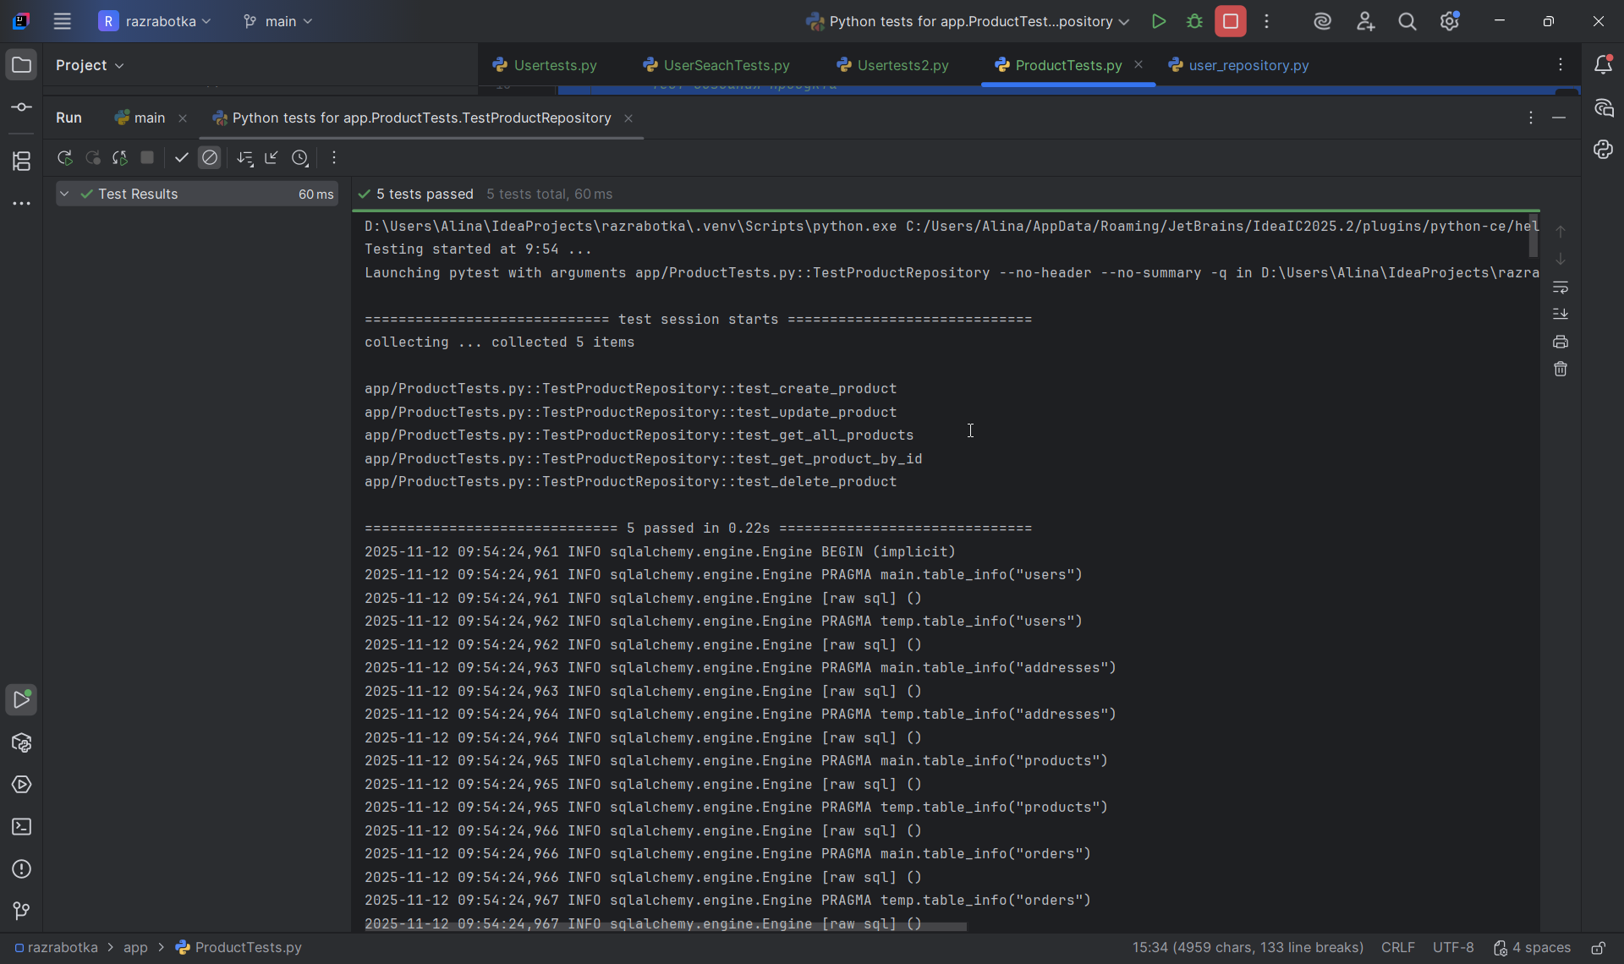
D:\Users\Alina\IdeaProjects\razrabotka\.venv\Scripts\python.exe C:/Users/Alina/AppData/Roaming/JetBrains/IdeaIC2025.2/plugins/python-ce/helpers/pycharm/_jb_pytest_runner.py --target app/ProductTests.py::TestProductRepository
Testing started at 9:54 ...
Launching pytest with arguments app/ProductTests.py::TestProductRepository --no-header --no-summary -q in D:\Users\Alina\IdeaProjects\razrabotka

============================= test session starts =============================
collecting ... collected 5 items

app/ProductTests.py::TestProductRepository::test_create_product
app/ProductTests.py::TestProductRepository::test_update_product
app/ProductTests.py::TestProductRepository::test_get_all_products
app/ProductTests.py::TestProductRepository::test_get_product_by_id
app/ProductTests.py::TestProductRepository::test_delete_product

============================== 5 passed in 0.22s ==============================
2025-11-12 09:54:24,961 INFO sqlalchemy.engine.Engine BEGIN (implicit)
2025-11-12 09:54:24,961 INFO sqlalchemy.engine.Engine PRAGMA main.table_info("users")
2025-11-12 09:54:24,961 INFO sqlalchemy.engine.Engine [raw sql] ()
2025-11-12 09:54:24,962 INFO sqlalchemy.engine.Engine PRAGMA temp.table_info("users")
2025-11-12 09:54:24,962 INFO sqlalchemy.engine.Engine [raw sql] ()
2025-11-12 09:54:24,963 INFO sqlalchemy.engine.Engine PRAGMA main.table_info("addresses")
2025-11-12 09:54:24,963 INFO sqlalchemy.engine.Engine [raw sql] ()
2025-11-12 09:54:24,964 INFO sqlalchemy.engine.Engine PRAGMA temp.table_info("addresses")
2025-11-12 09:54:24,964 INFO sqlalchemy.engine.Engine [raw sql] ()
2025-11-12 09:54:24,965 INFO sqlalchemy.engine.Engine PRAGMA main.table_info("products")
2025-11-12 09:54:24,965 INFO sqlalchemy.engine.Engine [raw sql] ()
2025-11-12 09:54:24,965 INFO sqlalchemy.engine.Engine PRAGMA temp.table_info("products")
2025-11-12 09:54:24,966 INFO sqlalchemy.engine.Engine [raw sql] ()
2025-11-12 09:54:24,966 INFO sqlalchemy.engine.Engine PRAGMA main.table_info("orders")
2025-11-12 09:54:24,966 INFO sqlalchemy.engine.Engine [raw sql] ()
2025-11-12 09:54:24,967 INFO sqlalchemy.engine.Engine PRAGMA temp.table_info("orders")
2025-11-12 09:54:24,967 INFO sqlalchemy.engine.Engine [raw sql] ()
2025-11-12 09:54:24,967 INFO sqlalchemy.engine.Engine PRAGMA main.table_info("order_items")
2025-11-12 09:54:24,968 INFO sqlalchemy.engine.Engine [raw sql] ()
2025-11-12 09:54:24,968 INFO sqlalchemy.engine.Engine PRAGMA temp.table_info("order_items")
2025-11-12 09:54:24,968 INFO sqlalchemy.engine.Engine [raw sql] ()
2025-11-12 09:54:24,969 INFO sqlalchemy.engine.Engine PRAGMA main.table_info("users")
2025-11-12 09:54:24,969 INFO sqlalchemy.engine.Engine [raw sql] ()
2025-11-12 09:54:24,970 INFO sqlalchemy.engine.Engine PRAGMA temp.table_info("users")
2025-11-12 09:54:24,970 INFO sqlalchemy.engine.Engine [raw sql] ()
2025-11-12 09:54:24,970 INFO sqlalchemy.engine.Engine PRAGMA main.table_info("addresses")
2025-11-12 09:54:24,970 INFO sqlalchemy.engine.Engine [raw sql] ()
2025-11-12 09:54:24,971 INFO sqlalchemy.engine.Engine PRAGMA temp.table_info("addresses")
2025-11-12 09:54:24,971 INFO sqlalchemy.engine.Engine [raw sql] ()
2025-11-12 09:54:24,972 INFO sqlalchemy.engine.Engine PRAGMA main.table_info("products")
2025-11-12 09:54:24,972 INFO sqlalchemy.engine.Engine [raw sql] ()
2025-11-12 09:54:24,972 INFO sqlalchemy.engine.Engine PRAGMA temp.table_info("products")
2025-11-12 09:54:24,972 INFO sqlalchemy.engine.Engine [raw sql] ()
2025-11-12 09:54:24,973 INFO sqlalchemy.engine.Engine PRAGMA main.table_info("orders")
2025-11-12 09:54:24,973 INFO sqlalchemy.engine.Engine [raw sql] ()
2025-11-12 09:54:24,974 INFO sqlalchemy.engine.Engine PRAGMA temp.table_info("orders")
2025-11-12 09:54:24,974 INFO sqlalchemy.engine.Engine [raw sql] ()
2025-11-12 09:54:24,974 INFO sqlalchemy.engine.Engine PRAGMA main.table_info("order_items")
2025-11-12 09:54:24,974 INFO sqlalchemy.engine.Engine [raw sql] ()
2025-11-12 09:54:24,975 INFO sqlalchemy.engine.Engine PRAGMA temp.table_info("order_items")
2025-11-12 09:54:24,975 INFO sqlalchemy.engine.Engine [raw sql] ()
2025-11-12 09:54:24,976 INFO sqlalchemy.engine.Engine
CREATE TABLE users (
id VARCHAR(36) NOT NULL,
username VARCHAR NOT NULL,
firstname VARCHAR,
lastname VARCHAR,
email VARCHAR NOT NULL,
description TEXT,
created_at DATETIME NOT NULL,
updated_at DATETIME,
PRIMARY KEY (id),
UNIQUE (username),
UNIQUE (email)
)

2025-11-12 09:54:24,976 INFO sqlalchemy.engine.Engine [no key 0.00015s] ()
2025-11-12 09:54:24,980 INFO sqlalchemy.engine.Engine
CREATE TABLE products (
id VARCHAR(36) NOT NULL,
name VARCHAR NOT NULL,
price INTEGER NOT NULL,
description TEXT,
stock_quantity INTEGER NOT NULL,
PRIMARY KEY (id)
)

2025-11-12 09:54:24,981 INFO sqlalchemy.engine.Engine [no key 0.00018s] ()
2025-11-12 09:54:24,983 INFO sqlalchemy.engine.Engine
CREATE TABLE addresses (
id VARCHAR(36) NOT NULL,
user_id VARCHAR(36) NOT NULL,
street VARCHAR NOT NULL,
city VARCHAR NOT NULL,
state VARCHAR,
zip_code VARCHAR,
country VARCHAR NOT NULL,
is_primary BOOLEAN NOT NULL,
created_at DATETIME NOT NULL,
updated_at DATETIME,
PRIMARY KEY (id),
FOREIGN KEY(user_id) REFERENCES users (id)
)

2025-11-12 09:54:24,984 INFO sqlalchemy.engine.Engine [no key 0.00018s] ()
2025-11-12 09:54:24,986 INFO sqlalchemy.engine.Engine
CREATE TABLE orders (
id VARCHAR(36) NOT NULL,
user_id VARCHAR(36) NOT NULL,
address_id VARCHAR(36) NOT NULL,
created_at DATETIME NOT NULL,
PRIMARY KEY (id),
FOREIGN KEY(user_id) REFERENCES users (id),
FOREIGN KEY(address_id) REFERENCES addresses (id)
)

2025-11-12 09:54:24,987 INFO sqlalchemy.engine.Engine [no key 0.00018s] ()
2025-11-12 09:54:24,989 INFO sqlalchemy.engine.Engine
CREATE TABLE order_items (
id VARCHAR(36) NOT NULL,
order_id VARCHAR(36) NOT NULL,
product_id VARCHAR(36) NOT NULL,
quantity INTEGER NOT NULL,
PRIMARY KEY (id),
FOREIGN KEY(order_id) REFERENCES orders (id),
FOREIGN KEY(product_id) REFERENCES products (id)
)

2025-11-12 09:54:24,990 INFO sqlalchemy.engine.Engine [no key 0.00021s] ()
2025-11-12 09:54:24,992 INFO sqlalchemy.engine.Engine COMMIT
INFO - 2025-11-12 09:54:24,961 - sqlalchemy.engine.Engine - base - BEGIN (implicit)
INFO - 2025-11-12 09:54:24,961 - sqlalchemy.engine.Engine - base - PRAGMA main.table_info("users")
INFO - 2025-11-12 09:54:24,961 - sqlalchemy.engine.Engine - base - [raw sql] ()
INFO - 2025-11-12 09:54:24,962 - sqlalchemy.engine.Engine - base - PRAGMA temp.table_info("users")
INFO - 2025-11-12 09:54:24,962 - sqlalchemy.engine.Engine - base - [raw sql] ()
INFO - 2025-11-12 09:54:24,963 - sqlalchemy.engine.Engine - base - PRAGMA main.table_info("addresses")
INFO - 2025-11-12 09:54:24,963 - sqlalchemy.engine.Engine - base - [raw sql] ()
INFO - 2025-11-12 09:54:24,964 - sqlalchemy.engine.Engine - base - PRAGMA temp.table_info("addresses")
INFO - 2025-11-12 09:54:24,964 - sqlalchemy.engine.Engine - base - [raw sql] ()
INFO - 2025-11-12 09:54:24,965 - sqlalchemy.engine.Engine - base - PRAGMA main.table_info("products")
INFO - 2025-11-12 09:54:24,965 - sqlalchemy.engine.Engine - base - [raw sql] ()
INFO - 2025-11-12 09:54:24,965 - sqlalchemy.engine.Engine - base - PRAGMA temp.table_info("products")
INFO - 2025-11-12 09:54:24,966 - sqlalchemy.engine.Engine - base - [raw sql] ()
INFO - 2025-11-12 09:54:24,966 - sqlalchemy.engine.Engine - base - PRAGMA main.table_info("orders")
INFO - 2025-11-12 09:54:24,966 - sqlalchemy.engine.Engine - base - [raw sql] ()
INFO - 2025-11-12 09:54:24,967 - sqlalchemy.engine.Engine - base - PRAGMA temp.table_info("orders")
INFO - 2025-11-12 09:54:24,967 - sqlalchemy.engine.Engine - base - [raw sql] ()
INFO - 2025-11-12 09:54:24,967 - sqlalchemy.engine.Engine - base - PRAGMA main.table_info("order_items")
INFO - 2025-11-12 09:54:24,968 - sqlalchemy.engine.Engine - base - [raw sql] ()
INFO - 2025-11-12 09:54:24,968 - sqlalchemy.engine.Engine - base - PRAGMA temp.table_info("order_items")
INFO - 2025-11-12 09:54:24,968 - sqlalchemy.engine.Engine - base - [raw sql] ()
INFO - 2025-11-12 09:54:24,969 - sqlalchemy.engine.Engine - base - PRAGMA main.table_info("users")
INFO - 2025-11-12 09:54:24,969 - sqlalchemy.engine.Engine - base - [raw sql] ()
INFO - 2025-11-12 09:54:24,970 - sqlalchemy.engine.Engine - base - PRAGMA temp.table_info("users")
INFO - 2025-11-12 09:54:24,970 - sqlalchemy.engine.Engine - base - [raw sql] ()
INFO - 2025-11-12 09:54:24,970 - sqlalchemy.engine.Engine - base - PRAGMA main.table_info("addresses")
INFO - 2025-11-12 09:54:24,970 - sqlalchemy.engine.Engine - base - [raw sql] ()
INFO - 2025-11-12 09:54:24,971 - sqlalchemy.engine.Engine - base - PRAGMA temp.table_info("addresses")
INFO - 2025-11-12 09:54:24,971 - sqlalchemy.engine.Engine - base - [raw sql] ()
INFO - 2025-11-12 09:54:24,972 - sqlalchemy.engine.Engine - base - PRAGMA main.table_info("products")
INFO - 2025-11-12 09:54:24,972 - sqlalchemy.engine.Engine - base - [raw sql] ()
INFO - 2025-11-12 09:54:24,972 - sqlalchemy.engine.Engine - base - PRAGMA temp.table_info("products")
INFO - 2025-11-12 09:54:24,972 - sqlalchemy.engine.Engine - base - [raw sql] ()
INFO - 2025-11-12 09:54:24,973 - sqlalchemy.engine.Engine - base - PRAGMA main.table_info("orders")
INFO - 2025-11-12 09:54:24,973 - sqlalchemy.engine.Engine - base - [raw sql] ()
INFO - 2025-11-12 09:54:24,974 - sqlalchemy.engine.Engine - base - PRAGMA temp.table_info("orders")
INFO - 2025-11-12 09:54:24,974 - sqlalchemy.engine.Engine - base - [raw sql] ()
INFO - 2025-11-12 09:54:24,974 - sqlalchemy.engine.Engine - base - PRAGMA main.table_info("order_items")
INFO - 2025-11-12 09:54:24,974 - sqlalchemy.engine.Engine - base - [raw sql] ()
INFO - 2025-11-12 09:54:24,975 - sqlalchemy.engine.Engine - base - PRAGMA temp.table_info("order_items")
INFO - 2025-11-12 09:54:24,975 - sqlalchemy.engine.Engine - base - [raw sql] ()
INFO - 2025-11-12 09:54:24,976 - sqlalchemy.engine.Engine - base -
CREATE TABLE users (
id VARCHAR(36) NOT NULL,
username VARCHAR NOT NULL,
firstname VARCHAR,
lastname VARCHAR,
email VARCHAR NOT NULL,
description TEXT,
created_at DATETIME NOT NULL,
updated_at DATETIME,
PRIMARY KEY (id),
UNIQUE (username),
UNIQUE (email)
)

INFO - 2025-11-12 09:54:24,976 - sqlalchemy.engine.Engine - base - [no key 0.00015s] ()
INFO - 2025-11-12 09:54:24,980 - sqlalchemy.engine.Engine - base -
CREATE TABLE products (
id VARCHAR(36) NOT NULL,
name VARCHAR NOT NULL,
price INTEGER NOT NULL,
description TEXT,
stock_quantity INTEGER NOT NULL,
PRIMARY KEY (id)
)

INFO - 2025-11-12 09:54:24,981 - sqlalchemy.engine.Engine - base - [no key 0.00018s] ()
INFO - 2025-11-12 09:54:24,983 - sqlalchemy.engine.Engine - base -
CREATE TABLE addresses (
id VARCHAR(36) NOT NULL,
user_id VARCHAR(36) NOT NULL,
street VARCHAR NOT NULL,
city VARCHAR NOT NULL,
state VARCHAR,
zip_code VARCHAR,
country VARCHAR NOT NULL,
is_primary BOOLEAN NOT NULL,
created_at DATETIME NOT NULL,
updated_at DATETIME,
PRIMARY KEY (id),
FOREIGN KEY(user_id) REFERENCES users (id)
)

INFO - 2025-11-12 09:54:24,984 - sqlalchemy.engine.Engine - base - [no key 0.00018s] ()
INFO - 2025-11-12 09:54:24,986 - sqlalchemy.engine.Engine - base -
CREATE TABLE orders (
id VARCHAR(36) NOT NULL,
user_id VARCHAR(36) NOT NULL,
address_id VARCHAR(36) NOT NULL,
created_at DATETIME NOT NULL,
PRIMARY KEY (id),
FOREIGN KEY(user_id) REFERENCES users (id),
FOREIGN KEY(address_id) REFERENCES addresses (id)
)

INFO - 2025-11-12 09:54:24,987 - sqlalchemy.engine.Engine - base - [no key 0.00018s] ()
INFO - 2025-11-12 09:54:24,989 - sqlalchemy.engine.Engine - base -
CREATE TABLE order_items (
id VARCHAR(36) NOT NULL,
order_id VARCHAR(36) NOT NULL,
product_id VARCHAR(36) NOT NULL,
quantity INTEGER NOT NULL,
PRIMARY KEY (id),
FOREIGN KEY(order_id) REFERENCES orders (id),
FOREIGN KEY(product_id) REFERENCES products (id)
)

INFO - 2025-11-12 09:54:24,990 - sqlalchemy.engine.Engine - base - [no key 0.00021s] ()
INFO - 2025-11-12 09:54:24,992 - sqlalchemy.engine.Engine - base - COMMIT
PASSED [ 20%]2025-11-12 09:54:25,009 INFO sqlalchemy.engine.Engine BEGIN (implicit)
2025-11-12 09:54:25,010 INFO sqlalchemy.engine.Engine INSERT INTO products (id, name, price, description, stock_quantity) VALUES (?, ?, ?, ?, ?)
2025-11-12 09:54:25,010 INFO sqlalchemy.engine.Engine [generated in 0.00035s] ('9e590385-efd2-4a3b-b8aa-8bfbcfe5f4be', 'Test Product', 1000, 'A test product', 50)
2025-11-12 09:54:25,012 INFO sqlalchemy.engine.Engine COMMIT
2025-11-12 09:54:25,014 INFO sqlalchemy.engine.Engine BEGIN (implicit)
2025-11-12 09:54:25,015 INFO sqlalchemy.engine.Engine SELECT products.id, products.name, products.price, products.description, products.stock_quantity
FROM products
WHERE products.id = ?
2025-11-12 09:54:25,016 INFO sqlalchemy.engine.Engine [generated in 0.00020s] ('9e590385-efd2-4a3b-b8aa-8bfbcfe5f4be',)
INFO - 2025-11-12 09:54:25,009 - sqlalchemy.engine.Engine - base - BEGIN (implicit)
INFO - 2025-11-12 09:54:25,010 - sqlalchemy.engine.Engine - base - INSERT INTO products (id, name, price, description, stock_quantity) VALUES (?, ?, ?, ?, ?)
INFO - 2025-11-12 09:54:25,010 - sqlalchemy.engine.Engine - base - [generated in 0.00035s] ('9e590385-efd2-4a3b-b8aa-8bfbcfe5f4be', 'Test Product', 1000, 'A test product', 50)
INFO - 2025-11-12 09:54:25,012 - sqlalchemy.engine.Engine - base - COMMIT
INFO - 2025-11-12 09:54:25,014 - sqlalchemy.engine.Engine - base - BEGIN (implicit)
INFO - 2025-11-12 09:54:25,015 - sqlalchemy.engine.Engine - base - SELECT products.id, products.name, products.price, products.description, products.stock_quantity
FROM products
WHERE products.id = ?
INFO - 2025-11-12 09:54:25,016 - sqlalchemy.engine.Engine - base - [generated in 0.00020s] ('9e590385-efd2-4a3b-b8aa-8bfbcfe5f4be',)
2025-11-12 09:54:25,018 INFO sqlalchemy.engine.Engine ROLLBACK
INFO - 2025-11-12 09:54:25,018 - sqlalchemy.engine.Engine - base - ROLLBACK
PASSED [ 40%]2025-11-12 09:54:25,021 INFO sqlalchemy.engine.Engine BEGIN (implicit)
2025-11-12 09:54:25,022 INFO sqlalchemy.engine.Engine INSERT INTO products (id, name, price, description, stock_quantity) VALUES (?, ?, ?, ?, ?)
2025-11-12 09:54:25,022 INFO sqlalchemy.engine.Engine [cached since 0.0123s ago] ('f80d483d-526e-4117-9c1c-fc2900f6440c', 'Original Product', 500, 'Original description', 10)
2025-11-12 09:54:25,023 INFO sqlalchemy.engine.Engine COMMIT
2025-11-12 09:54:25,025 INFO sqlalchemy.engine.Engine BEGIN (implicit)
2025-11-12 09:54:25,026 INFO sqlalchemy.engine.Engine SELECT products.id, products.name, products.price, products.description, products.stock_quantity
FROM products
WHERE products.id = ?
2025-11-12 09:54:25,026 INFO sqlalchemy.engine.Engine [cached since 0.01066s ago] ('f80d483d-526e-4117-9c1c-fc2900f6440c',)
2025-11-12 09:54:25,028 INFO sqlalchemy.engine.Engine SELECT products.id, products.name, products.price, products.description, products.stock_quantity
FROM products
WHERE products.id = ?
2025-11-12 09:54:25,028 INFO sqlalchemy.engine.Engine [generated in 0.00018s] ('f80d483d-526e-4117-9c1c-fc2900f6440c',)
2025-11-12 09:54:25,029 INFO sqlalchemy.engine.Engine UPDATE products SET name=?, stock_quantity=? WHERE products.id = ?
2025-11-12 09:54:25,030 INFO sqlalchemy.engine.Engine [generated in 0.00013s] ('Updated Product', 20, 'f80d483d-526e-4117-9c1c-fc2900f6440c')
2025-11-12 09:54:25,031 INFO sqlalchemy.engine.Engine COMMIT
2025-11-12 09:54:25,033 INFO sqlalchemy.engine.Engine BEGIN (implicit)
2025-11-12 09:54:25,033 INFO sqlalchemy.engine.Engine SELECT products.id, products.name, products.price, products.description, products.stock_quantity
FROM products
WHERE products.id = ?
2025-11-12 09:54:25,033 INFO sqlalchemy.engine.Engine [cached since 0.01792s ago] ('f80d483d-526e-4117-9c1c-fc2900f6440c',)
INFO - 2025-11-12 09:54:25,021 - sqlalchemy.engine.Engine - base - BEGIN (implicit)
INFO - 2025-11-12 09:54:25,022 - sqlalchemy.engine.Engine - base - INSERT INTO products (id, name, price, description, stock_quantity) VALUES (?, ?, ?, ?, ?)
INFO - 2025-11-12 09:54:25,022 - sqlalchemy.engine.Engine - base - [cached since 0.0123s ago] ('f80d483d-526e-4117-9c1c-fc2900f6440c', 'Original Product', 500, 'Original description', 10)
INFO - 2025-11-12 09:54:25,023 - sqlalchemy.engine.Engine - base - COMMIT
INFO - 2025-11-12 09:54:25,025 - sqlalchemy.engine.Engine - base - BEGIN (implicit)
INFO - 2025-11-12 09:54:25,026 - sqlalchemy.engine.Engine - base - SELECT products.id, products.name, products.price, products.description, products.stock_quantity
FROM products
WHERE products.id = ?
INFO - 2025-11-12 09:54:25,026 - sqlalchemy.engine.Engine - base - [cached since 0.01066s ago] ('f80d483d-526e-4117-9c1c-fc2900f6440c',)
INFO - 2025-11-12 09:54:25,028 - sqlalchemy.engine.Engine - base - SELECT products.id, products.name, products.price, products.description, products.stock_quantity
FROM products
WHERE products.id = ?
INFO - 2025-11-12 09:54:25,028 - sqlalchemy.engine.Engine - base - [generated in 0.00018s] ('f80d483d-526e-4117-9c1c-fc2900f6440c',)
INFO - 2025-11-12 09:54:25,029 - sqlalchemy.engine.Engine - base - UPDATE products SET name=?, stock_quantity=? WHERE products.id = ?
INFO - 2025-11-12 09:54:25,030 - sqlalchemy.engine.Engine - base - [generated in 0.00013s] ('Updated Product', 20, 'f80d483d-526e-4117-9c1c-fc2900f6440c')
INFO - 2025-11-12 09:54:25,031 - sqlalchemy.engine.Engine - base - COMMIT
INFO - 2025-11-12 09:54:25,033 - sqlalchemy.engine.Engine - base - BEGIN (implicit)
INFO - 2025-11-12 09:54:25,033 - sqlalchemy.engine.Engine - base - SELECT products.id, products.name, products.price, products.description, products.stock_quantity
FROM products
WHERE products.id = ?
INFO - 2025-11-12 09:54:25,033 - sqlalchemy.engine.Engine - base - [cached since 0.01792s ago] ('f80d483d-526e-4117-9c1c-fc2900f6440c',)
2025-11-12 09:54:25,039 INFO sqlalchemy.engine.Engine ROLLBACK
INFO - 2025-11-12 09:54:25,039 - sqlalchemy.engine.Engine - base - ROLLBACK
PASSED [ 60%]2025-11-12 09:54:25,042 INFO sqlalchemy.engine.Engine BEGIN (implicit)
2025-11-12 09:54:25,042 INFO sqlalchemy.engine.Engine INSERT INTO products (id, name, price, description, stock_quantity) VALUES (?, ?, ?, ?, ?)
2025-11-12 09:54:25,042 INFO sqlalchemy.engine.Engine [cached since 0.03241s ago] ('420d984e-3c80-4cfc-af36-20dd6fa7534c', 'Product One', 100, 'First product', 5)
2025-11-12 09:54:25,043 INFO sqlalchemy.engine.Engine COMMIT
2025-11-12 09:54:25,045 INFO sqlalchemy.engine.Engine BEGIN (implicit)
2025-11-12 09:54:25,046 INFO sqlalchemy.engine.Engine SELECT products.id, products.name, products.price, products.description, products.stock_quantity
FROM products
WHERE products.id = ?
2025-11-12 09:54:25,046 INFO sqlalchemy.engine.Engine [cached since 0.0305s ago] ('420d984e-3c80-4cfc-af36-20dd6fa7534c',)
2025-11-12 09:54:25,047 INFO sqlalchemy.engine.Engine INSERT INTO products (id, name, price, description, stock_quantity) VALUES (?, ?, ?, ?, ?)
2025-11-12 09:54:25,047 INFO sqlalchemy.engine.Engine [cached since 0.03733s ago] ('9ceb9db3-c4e9-470b-8b4f-860ea3f8c441', 'Product Two', 200, 'Second product', 10)
2025-11-12 09:54:25,048 INFO sqlalchemy.engine.Engine COMMIT
2025-11-12 09:54:25,050 INFO sqlalchemy.engine.Engine BEGIN (implicit)
2025-11-12 09:54:25,051 INFO sqlalchemy.engine.Engine SELECT products.id, products.name, products.price, products.description, products.stock_quantity
FROM products
WHERE products.id = ?
2025-11-12 09:54:25,051 INFO sqlalchemy.engine.Engine [cached since 0.03552s ago] ('9ceb9db3-c4e9-470b-8b4f-860ea3f8c441',)
2025-11-12 09:54:25,053 INFO sqlalchemy.engine.Engine SELECT products.id, products.name, products.price, products.description, products.stock_quantity
FROM products
LIMIT ? OFFSET ?
2025-11-12 09:54:25,053 INFO sqlalchemy.engine.Engine [generated in 0.00025s] (10, 0)
INFO - 2025-11-12 09:54:25,042 - sqlalchemy.engine.Engine - base - BEGIN (implicit)
INFO - 2025-11-12 09:54:25,042 - sqlalchemy.engine.Engine - base - INSERT INTO products (id, name, price, description, stock_quantity) VALUES (?, ?, ?, ?, ?)
INFO - 2025-11-12 09:54:25,042 - sqlalchemy.engine.Engine - base - [cached since 0.03241s ago] ('420d984e-3c80-4cfc-af36-20dd6fa7534c', 'Product One', 100, 'First product', 5)
INFO - 2025-11-12 09:54:25,043 - sqlalchemy.engine.Engine - base - COMMIT
INFO - 2025-11-12 09:54:25,045 - sqlalchemy.engine.Engine - base - BEGIN (implicit)
INFO - 2025-11-12 09:54:25,046 - sqlalchemy.engine.Engine - base - SELECT products.id, products.name, products.price, products.description, products.stock_quantity
FROM products
WHERE products.id = ?
INFO - 2025-11-12 09:54:25,046 - sqlalchemy.engine.Engine - base - [cached since 0.0305s ago] ('420d984e-3c80-4cfc-af36-20dd6fa7534c',)
INFO - 2025-11-12 09:54:25,047 - sqlalchemy.engine.Engine - base - INSERT INTO products (id, name, price, description, stock_quantity) VALUES (?, ?, ?, ?, ?)
INFO - 2025-11-12 09:54:25,047 - sqlalchemy.engine.Engine - base - [cached since 0.03733s ago] ('9ceb9db3-c4e9-470b-8b4f-860ea3f8c441', 'Product Two', 200, 'Second product', 10)
INFO - 2025-11-12 09:54:25,048 - sqlalchemy.engine.Engine - base - COMMIT
INFO - 2025-11-12 09:54:25,050 - sqlalchemy.engine.Engine - base - BEGIN (implicit)
INFO - 2025-11-12 09:54:25,051 - sqlalchemy.engine.Engine - base - SELECT products.id, products.name, products.price, products.description, products.stock_quantity
FROM products
WHERE products.id = ?
INFO - 2025-11-12 09:54:25,051 - sqlalchemy.engine.Engine - base - [cached since 0.03552s ago] ('9ceb9db3-c4e9-470b-8b4f-860ea3f8c441',)
INFO - 2025-11-12 09:54:25,053 - sqlalchemy.engine.Engine - base - SELECT products.id, products.name, products.price, products.description, products.stock_quantity
FROM products
LIMIT ? OFFSET ?
INFO - 2025-11-12 09:54:25,053 - sqlalchemy.engine.Engine - base - [generated in 0.00025s] (10, 0)
2025-11-12 09:54:25,058 INFO sqlalchemy.engine.Engine ROLLBACK
INFO - 2025-11-12 09:54:25,058 - sqlalchemy.engine.Engine - base - ROLLBACK
PASSED [ 80%]2025-11-12 09:54:25,062 INFO sqlalchemy.engine.Engine BEGIN (implicit)
2025-11-12 09:54:25,062 INFO sqlalchemy.engine.Engine INSERT INTO products (id, name, price, description, stock_quantity) VALUES (?, ?, ?, ?, ?)
2025-11-12 09:54:25,062 INFO sqlalchemy.engine.Engine [cached since 0.05244s ago] ('4e95ff3f-f5b8-44c6-af5a-7f7172094a47', 'Find Me Product', 300, 'Findable product', 15)
2025-11-12 09:54:25,063 INFO sqlalchemy.engine.Engine COMMIT
2025-11-12 09:54:25,066 INFO sqlalchemy.engine.Engine BEGIN (implicit)
2025-11-12 09:54:25,066 INFO sqlalchemy.engine.Engine SELECT products.id, products.name, products.price, products.description, products.stock_quantity
FROM products
WHERE products.id = ?
2025-11-12 09:54:25,066 INFO sqlalchemy.engine.Engine [cached since 0.05064s ago] ('4e95ff3f-f5b8-44c6-af5a-7f7172094a47',)
2025-11-12 09:54:25,067 INFO sqlalchemy.engine.Engine SELECT products.id, products.name, products.price, products.description, products.stock_quantity
FROM products
WHERE products.id = ?
2025-11-12 09:54:25,067 INFO sqlalchemy.engine.Engine [cached since 0.03952s ago] ('4e95ff3f-f5b8-44c6-af5a-7f7172094a47',)
INFO - 2025-11-12 09:54:25,062 - sqlalchemy.engine.Engine - base - BEGIN (implicit)
INFO - 2025-11-12 09:54:25,062 - sqlalchemy.engine.Engine - base - INSERT INTO products (id, name, price, description, stock_quantity) VALUES (?, ?, ?, ?, ?)
INFO - 2025-11-12 09:54:25,062 - sqlalchemy.engine.Engine - base - [cached since 0.05244s ago] ('4e95ff3f-f5b8-44c6-af5a-7f7172094a47', 'Find Me Product', 300, 'Findable product', 15)
INFO - 2025-11-12 09:54:25,063 - sqlalchemy.engine.Engine - base - COMMIT
INFO - 2025-11-12 09:54:25,066 - sqlalchemy.engine.Engine - base - BEGIN (implicit)
INFO - 2025-11-12 09:54:25,066 - sqlalchemy.engine.Engine - base - SELECT products.id, products.name, products.price, products.description, products.stock_quantity
FROM products
WHERE products.id = ?
INFO - 2025-11-12 09:54:25,066 - sqlalchemy.engine.Engine - base - [cached since 0.05064s ago] ('4e95ff3f-f5b8-44c6-af5a-7f7172094a47',)
INFO - 2025-11-12 09:54:25,067 - sqlalchemy.engine.Engine - base - SELECT products.id, products.name, products.price, products.description, products.stock_quantity
FROM products
WHERE products.id = ?
INFO - 2025-11-12 09:54:25,067 - sqlalchemy.engine.Engine - base - [cached since 0.03952s ago] ('4e95ff3f-f5b8-44c6-af5a-7f7172094a47',)
2025-11-12 09:54:25,069 INFO sqlalchemy.engine.Engine ROLLBACK
INFO - 2025-11-12 09:54:25,069 - sqlalchemy.engine.Engine - base - ROLLBACK
PASSED [100%]2025-11-12 09:54:25,073 INFO sqlalchemy.engine.Engine BEGIN (implicit)
2025-11-12 09:54:25,073 INFO sqlalchemy.engine.Engine INSERT INTO products (id, name, price, description, stock_quantity) VALUES (?, ?, ?, ?, ?)
2025-11-12 09:54:25,074 INFO sqlalchemy.engine.Engine [cached since 0.06376s ago] ('f569fe70-6ffa-441d-b8b7-9821d33d6407', 'Delete Me Product', 400, 'To be deleted', 1)
2025-11-12 09:54:25,075 INFO sqlalchemy.engine.Engine COMMIT
2025-11-12 09:54:25,077 INFO sqlalchemy.engine.Engine BEGIN (implicit)
2025-11-12 09:54:25,077 INFO sqlalchemy.engine.Engine SELECT products.id, products.name, products.price, products.description, products.stock_quantity
FROM products
WHERE products.id = ?
2025-11-12 09:54:25,077 INFO sqlalchemy.engine.Engine [cached since 0.06197s ago] ('f569fe70-6ffa-441d-b8b7-9821d33d6407',)
2025-11-12 09:54:25,078 INFO sqlalchemy.engine.Engine SELECT products.id, products.name, products.price, products.description, products.stock_quantity
FROM products
WHERE products.id = ?
2025-11-12 09:54:25,078 INFO sqlalchemy.engine.Engine [cached since 0.05083s ago] ('f569fe70-6ffa-441d-b8b7-9821d33d6407',)
2025-11-12 09:54:25,080 INFO sqlalchemy.engine.Engine SELECT order_items.id AS order_items_id, order_items.order_id AS order_items_order_id, order_items.product_id AS order_items_product_id, order_items.quantity AS order_items_quantity
FROM order_items
WHERE ? = order_items.product_id
2025-11-12 09:54:25,080 INFO sqlalchemy.engine.Engine [generated in 0.00014s] ('f569fe70-6ffa-441d-b8b7-9821d33d6407',)
2025-11-12 09:54:25,082 INFO sqlalchemy.engine.Engine DELETE FROM products WHERE products.id = ?
2025-11-12 09:54:25,082 INFO sqlalchemy.engine.Engine [generated in 0.00020s] ('f569fe70-6ffa-441d-b8b7-9821d33d6407',)
2025-11-12 09:54:25,082 INFO sqlalchemy.engine.Engine COMMIT
2025-11-12 09:54:25,084 INFO sqlalchemy.engine.Engine BEGIN (implicit)
2025-11-12 09:54:25,085 INFO sqlalchemy.engine.Engine SELECT products.id AS products_id, products.name AS products_name, products.price AS products_price, products.description AS products_description, products.stock_quantity AS products_stock_quantity
FROM products
WHERE products.id = ?
2025-11-12 09:54:25,085 INFO sqlalchemy.engine.Engine [generated in 0.00019s] ('f569fe70-6ffa-441d-b8b7-9821d33d6407',)
INFO - 2025-11-12 09:54:25,073 - sqlalchemy.engine.Engine - base - BEGIN (implicit)
INFO - 2025-11-12 09:54:25,073 - sqlalchemy.engine.Engine - base - INSERT INTO products (id, name, price, description, stock_quantity) VALUES (?, ?, ?, ?, ?)
INFO - 2025-11-12 09:54:25,074 - sqlalchemy.engine.Engine - base - [cached since 0.06376s ago] ('f569fe70-6ffa-441d-b8b7-9821d33d6407', 'Delete Me Product', 400, 'To be deleted', 1)
INFO - 2025-11-12 09:54:25,075 - sqlalchemy.engine.Engine - base - COMMIT
INFO - 2025-11-12 09:54:25,077 - sqlalchemy.engine.Engine - base - BEGIN (implicit)
INFO - 2025-11-12 09:54:25,077 - sqlalchemy.engine.Engine - base - SELECT products.id, products.name, products.price, products.description, products.stock_quantity
FROM products
WHERE products.id = ?
INFO - 2025-11-12 09:54:25,077 - sqlalchemy.engine.Engine - base - [cached since 0.06197s ago] ('f569fe70-6ffa-441d-b8b7-9821d33d6407',)
INFO - 2025-11-12 09:54:25,078 - sqlalchemy.engine.Engine - base - SELECT products.id, products.name, products.price, products.description, products.stock_quantity
FROM products
WHERE products.id = ?
INFO - 2025-11-12 09:54:25,078 - sqlalchemy.engine.Engine - base - [cached since 0.05083s ago] ('f569fe70-6ffa-441d-b8b7-9821d33d6407',)
INFO - 2025-11-12 09:54:25,080 - sqlalchemy.engine.Engine - base - SELECT order_items.id AS order_items_id, order_items.order_id AS order_items_order_id, order_items.product_id AS order_items_product_id, order_items.quantity AS order_items_quantity
FROM order_items
WHERE ? = order_items.product_id
INFO - 2025-11-12 09:54:25,080 - sqlalchemy.engine.Engine - base - [generated in 0.00014s] ('f569fe70-6ffa-441d-b8b7-9821d33d6407',)
INFO - 2025-11-12 09:54:25,082 - sqlalchemy.engine.Engine - base - DELETE FROM products WHERE products.id = ?
INFO - 2025-11-12 09:54:25,082 - sqlalchemy.engine.Engine - base - [generated in 0.00020s] ('f569fe70-6ffa-441d-b8b7-9821d33d6407',)
INFO - 2025-11-12 09:54:25,082 - sqlalchemy.engine.Engine - base - COMMIT
INFO - 2025-11-12 09:54:25,084 - sqlalchemy.engine.Engine - base - BEGIN (implicit)
INFO - 2025-11-12 09:54:25,085 - sqlalchemy.engine.Engine - base - SELECT products.id AS products_id, products.name AS products_name, products.price AS products_price, products.description AS products_description, products.stock_quantity AS products_stock_quantity
FROM products
WHERE products.id = ?
INFO - 2025-11-12 09:54:25,085 - sqlalchemy.engine.Engine - base - [generated in 0.00019s] ('f569fe70-6ffa-441d-b8b7-9821d33d6407',)
2025-11-12 09:54:25,090 INFO sqlalchemy.engine.Engine ROLLBACK
2025-11-12 09:54:25,091 INFO sqlalchemy.engine.Engine BEGIN (implicit)
2025-11-12 09:54:25,091 INFO sqlalchemy.engine.Engine PRAGMA main.table_info("users")
2025-11-12 09:54:25,091 INFO sqlalchemy.engine.Engine [raw sql] ()
2025-11-12 09:54:25,092 INFO sqlalchemy.engine.Engine PRAGMA main.table_info("addresses")
2025-11-12 09:54:25,092 INFO sqlalchemy.engine.Engine [raw sql] ()
2025-11-12 09:54:25,093 INFO sqlalchemy.engine.Engine PRAGMA main.table_info("products")
2025-11-12 09:54:25,093 INFO sqlalchemy.engine.Engine [raw sql] ()
2025-11-12 09:54:25,093 INFO sqlalchemy.engine.Engine PRAGMA main.table_info("orders")
2025-11-12 09:54:25,093 INFO sqlalchemy.engine.Engine [raw sql] ()
2025-11-12 09:54:25,094 INFO sqlalchemy.engine.Engine PRAGMA main.table_info("order_items")
2025-11-12 09:54:25,094 INFO sqlalchemy.engine.Engine [raw sql] ()
2025-11-12 09:54:25,094 INFO sqlalchemy.engine.Engine
DROP TABLE order_items
2025-11-12 09:54:25,094 INFO sqlalchemy.engine.Engine [no key 0.00011s] ()
2025-11-12 09:54:25,096 INFO sqlalchemy.engine.Engine
DROP TABLE orders
2025-11-12 09:54:25,097 INFO sqlalchemy.engine.Engine [no key 0.00009s] ()
2025-11-12 09:54:25,098 INFO sqlalchemy.engine.Engine
DROP TABLE addresses
2025-11-12 09:54:25,099 INFO sqlalchemy.engine.Engine [no key 0.00016s] ()
2025-11-12 09:54:25,101 INFO sqlalchemy.engine.Engine
DROP TABLE products
2025-11-12 09:54:25,101 INFO sqlalchemy.engine.Engine [no key 0.00016s] ()
2025-11-12 09:54:25,103 INFO sqlalchemy.engine.Engine
DROP TABLE users
2025-11-12 09:54:25,103 INFO sqlalchemy.engine.Engine [no key 0.00016s] ()
2025-11-12 09:54:25,106 INFO sqlalchemy.engine.Engine COMMIT
INFO - 2025-11-12 09:54:25,090 - sqlalchemy.engine.Engine - base - ROLLBACK
INFO - 2025-11-12 09:54:25,091 - sqlalchemy.engine.Engine - base - BEGIN (implicit)
INFO - 2025-11-12 09:54:25,091 - sqlalchemy.engine.Engine - base - PRAGMA main.table_info("users")
INFO - 2025-11-12 09:54:25,091 - sqlalchemy.engine.Engine - base - [raw sql] ()
INFO - 2025-11-12 09:54:25,092 - sqlalchemy.engine.Engine - base - PRAGMA main.table_info("addresses")
INFO - 2025-11-12 09:54:25,092 - sqlalchemy.engine.Engine - base - [raw sql] ()
INFO - 2025-11-12 09:54:25,093 - sqlalchemy.engine.Engine - base - PRAGMA main.table_info("products")
INFO - 2025-11-12 09:54:25,093 - sqlalchemy.engine.Engine - base - [raw sql] ()
INFO - 2025-11-12 09:54:25,093 - sqlalchemy.engine.Engine - base - PRAGMA main.table_info("orders")
INFO - 2025-11-12 09:54:25,093 - sqlalchemy.engine.Engine - base - [raw sql] ()
INFO - 2025-11-12 09:54:25,094 - sqlalchemy.engine.Engine - base - PRAGMA main.table_info("order_items")
INFO - 2025-11-12 09:54:25,094 - sqlalchemy.engine.Engine - base - [raw sql] ()
INFO - 2025-11-12 09:54:25,094 - sqlalchemy.engine.Engine - base -
DROP TABLE order_items
INFO - 2025-11-12 09:54:25,094 - sqlalchemy.engine.Engine - base - [no key 0.00011s] ()
INFO - 2025-11-12 09:54:25,096 - sqlalchemy.engine.Engine - base -
DROP TABLE orders
INFO - 2025-11-12 09:54:25,097 - sqlalchemy.engine.Engine - base - [no key 0.00009s] ()
INFO - 2025-11-12 09:54:25,098 - sqlalchemy.engine.Engine - base -
DROP TABLE addresses
INFO - 2025-11-12 09:54:25,099 - sqlalchemy.engine.Engine - base - [no key 0.00016s] ()
INFO - 2025-11-12 09:54:25,101 - sqlalchemy.engine.Engine - base -
DROP TABLE products
INFO - 2025-11-12 09:54:25,101 - sqlalchemy.engine.Engine - base - [no key 0.00016s] ()
INFO - 2025-11-12 09:54:25,103 - sqlalchemy.engine.Engine - base -
DROP TABLE users
INFO - 2025-11-12 09:54:25,103 - sqlalchemy.engine.Engine - base - [no key 0.00016s] ()
INFO - 2025-11-12 09:54:25,106 - sqlalchemy.engine.Engine - base - COMMIT

Process finished with exit code 0

3. Тестируем сервисный слой
Mock (мок) в Python — это инструмент для тестирования кода, который заменяет реальные объекты контролируемыми имитациями.
Используя мок мы можем проверить как работает сервисный слой не взаимодействуя с БД.

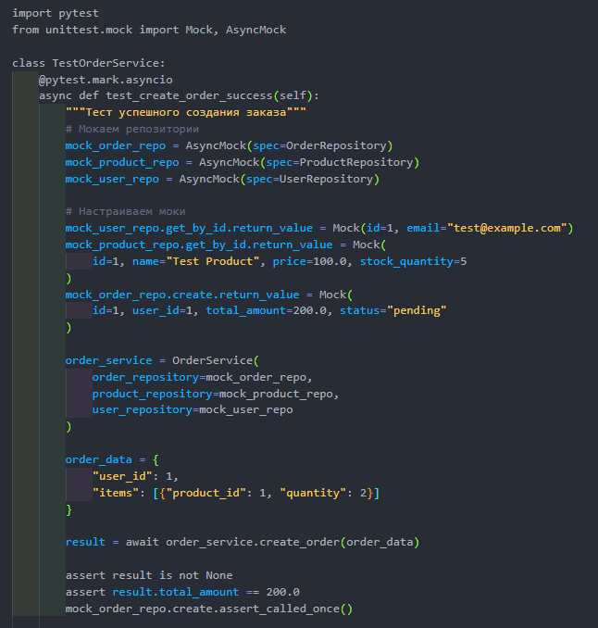
import pytest
from unittest.mock import Mock, AsyncMock
from app.repositories.OrderRepository import OrderRepository
from app.repositories.productReposutory import ProductRepository
from app.repositories.user_repository import UserRepository
from app.services.order_service import OrderService # Убедитесь, что путь правильный
from app.User_schem import OrderCreate, OrderItemCreate
class TestOrderService:
@pytest.mark.asyncio
async def test_create_order_success(self, session, order_repository, product_repository, user_repository):
"""Тест успешного создания заказа через OrderService"""
# Мокаем репозитории
mock_order_repo = AsyncMock(spec=OrderRepository)
mock_product_repo = AsyncMock(spec=ProductRepository)
mock_user_repo = AsyncMock(spec=UserRepository)
# Настраиваем моки
mock_user_repo.get_by_id.return_value = Mock(id="1", email="test@example.com") # id тоже строка
mock_product_repo.get_by_id.return_value = Mock(
id="1", name="Test Product", price=100.0, stock_quantity=5
)
mock_order_repo.create.return_value = Mock(
id="1", user_id="1", total_amount=200.0, status="pending"
)
order_service = OrderService(
order_repository=mock_order_repo,
product_repository=mock_product_repo,
user_repository=mock_user_repo
)
# Подготовим данные заказа как Pydantic-схему
order_item_data = OrderItemCreate(product_id="1", quantity=2)
order_data = OrderCreate(
user_id="1",
address_id="1",
items=[order_item_data]
)
result = await order_service.create_order(session, order_data)
# Проверки
assert result is not None
assert result.total_amount == 200.0
assert result.user_id == "1"
# Проверим, что метод create был вызван у репозитория
mock_order_repo.create.assert_called_once()

Запустим тест
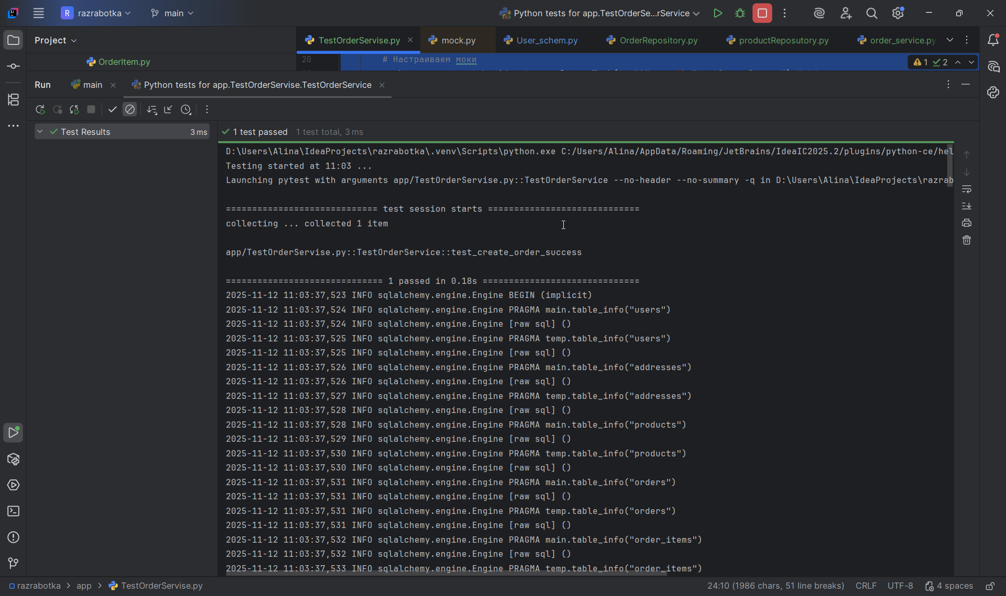
D:\Users\Alina\IdeaProjects\razrabotka\.venv\Scripts\python.exe C:/Users/Alina/AppData/Roaming/JetBrains/IdeaIC2025.2/plugins/python-ce/helpers/pycharm/_jb_pytest_runner.py --target app/TestOrderServise.py::TestOrderService
Testing started at 11:03 ...
Launching pytest with arguments app/TestOrderServise.py::TestOrderService --no-header --no-summary -q in D:\Users\Alina\IdeaProjects\razrabotka

============================= test session starts =============================
collecting ... collected 1 item

app/TestOrderServise.py::TestOrderService::test_create_order_success

============================== 1 passed in 0.18s ==============================
2025-11-12 11:03:37,523 INFO sqlalchemy.engine.Engine BEGIN (implicit)
2025-11-12 11:03:37,524 INFO sqlalchemy.engine.Engine PRAGMA main.table_info("users")
2025-11-12 11:03:37,524 INFO sqlalchemy.engine.Engine [raw sql] ()
2025-11-12 11:03:37,525 INFO sqlalchemy.engine.Engine PRAGMA temp.table_info("users")
2025-11-12 11:03:37,525 INFO sqlalchemy.engine.Engine [raw sql] ()
2025-11-12 11:03:37,526 INFO sqlalchemy.engine.Engine PRAGMA main.table_info("addresses")
2025-11-12 11:03:37,526 INFO sqlalchemy.engine.Engine [raw sql] ()
2025-11-12 11:03:37,527 INFO sqlalchemy.engine.Engine PRAGMA temp.table_info("addresses")
2025-11-12 11:03:37,528 INFO sqlalchemy.engine.Engine [raw sql] ()
2025-11-12 11:03:37,528 INFO sqlalchemy.engine.Engine PRAGMA main.table_info("products")
2025-11-12 11:03:37,529 INFO sqlalchemy.engine.Engine [raw sql] ()
2025-11-12 11:03:37,530 INFO sqlalchemy.engine.Engine PRAGMA temp.table_info("products")
2025-11-12 11:03:37,530 INFO sqlalchemy.engine.Engine [raw sql] ()
2025-11-12 11:03:37,531 INFO sqlalchemy.engine.Engine PRAGMA main.table_info("orders")
2025-11-12 11:03:37,531 INFO sqlalchemy.engine.Engine [raw sql] ()
2025-11-12 11:03:37,531 INFO sqlalchemy.engine.Engine PRAGMA temp.table_info("orders")
2025-11-12 11:03:37,531 INFO sqlalchemy.engine.Engine [raw sql] ()
2025-11-12 11:03:37,532 INFO sqlalchemy.engine.Engine PRAGMA main.table_info("order_items")
2025-11-12 11:03:37,532 INFO sqlalchemy.engine.Engine [raw sql] ()
2025-11-12 11:03:37,533 INFO sqlalchemy.engine.Engine PRAGMA temp.table_info("order_items")
2025-11-12 11:03:37,533 INFO sqlalchemy.engine.Engine [raw sql] ()
2025-11-12 11:03:37,535 INFO sqlalchemy.engine.Engine PRAGMA main.table_info("users")
2025-11-12 11:03:37,535 INFO sqlalchemy.engine.Engine [raw sql] ()
2025-11-12 11:03:37,535 INFO sqlalchemy.engine.Engine PRAGMA temp.table_info("users")
2025-11-12 11:03:37,536 INFO sqlalchemy.engine.Engine [raw sql] ()
2025-11-12 11:03:37,536 INFO sqlalchemy.engine.Engine PRAGMA main.table_info("addresses")
2025-11-12 11:03:37,536 INFO sqlalchemy.engine.Engine [raw sql] ()
2025-11-12 11:03:37,537 INFO sqlalchemy.engine.Engine PRAGMA temp.table_info("addresses")
2025-11-12 11:03:37,537 INFO sqlalchemy.engine.Engine [raw sql] ()
2025-11-12 11:03:37,537 INFO sqlalchemy.engine.Engine PRAGMA main.table_info("products")
2025-11-12 11:03:37,537 INFO sqlalchemy.engine.Engine [raw sql] ()
2025-11-12 11:03:37,538 INFO sqlalchemy.engine.Engine PRAGMA temp.table_info("products")
2025-11-12 11:03:37,538 INFO sqlalchemy.engine.Engine [raw sql] ()
2025-11-12 11:03:37,539 INFO sqlalchemy.engine.Engine PRAGMA main.table_info("orders")
2025-11-12 11:03:37,539 INFO sqlalchemy.engine.Engine [raw sql] ()
2025-11-12 11:03:37,539 INFO sqlalchemy.engine.Engine PRAGMA temp.table_info("orders")
2025-11-12 11:03:37,539 INFO sqlalchemy.engine.Engine [raw sql] ()
2025-11-12 11:03:37,540 INFO sqlalchemy.engine.Engine PRAGMA main.table_info("order_items")
2025-11-12 11:03:37,540 INFO sqlalchemy.engine.Engine [raw sql] ()
2025-11-12 11:03:37,540 INFO sqlalchemy.engine.Engine PRAGMA temp.table_info("order_items")
2025-11-12 11:03:37,541 INFO sqlalchemy.engine.Engine [raw sql] ()
2025-11-12 11:03:37,542 INFO sqlalchemy.engine.Engine
CREATE TABLE users (
id VARCHAR(36) NOT NULL,
username VARCHAR NOT NULL,
firstname VARCHAR,
lastname VARCHAR,
email VARCHAR NOT NULL,
description TEXT,
created_at DATETIME NOT NULL,
updated_at DATETIME,
PRIMARY KEY (id),
UNIQUE (username),
UNIQUE (email)
)

2025-11-12 11:03:37,542 INFO sqlalchemy.engine.Engine [no key 0.00025s] ()
2025-11-12 11:03:37,545 INFO sqlalchemy.engine.Engine
CREATE TABLE products (
id VARCHAR(36) NOT NULL,
name VARCHAR NOT NULL,
price INTEGER NOT NULL,
description TEXT,
stock_quantity INTEGER NOT NULL,
PRIMARY KEY (id)
)

2025-11-12 11:03:37,545 INFO sqlalchemy.engine.Engine [no key 0.00019s] ()
2025-11-12 11:03:37,549 INFO sqlalchemy.engine.Engine
CREATE TABLE addresses (
id VARCHAR(36) NOT NULL,
user_id VARCHAR(36) NOT NULL,
street VARCHAR NOT NULL,
city VARCHAR NOT NULL,
state VARCHAR,
zip_code VARCHAR,
country VARCHAR NOT NULL,
is_primary BOOLEAN NOT NULL,
created_at DATETIME NOT NULL,
updated_at DATETIME,
PRIMARY KEY (id),
FOREIGN KEY(user_id) REFERENCES users (id)
)

2025-11-12 11:03:37,549 INFO sqlalchemy.engine.Engine [no key 0.00033s] ()
2025-11-12 11:03:37,552 INFO sqlalchemy.engine.Engine
CREATE TABLE orders (
id VARCHAR(36) NOT NULL,
user_id VARCHAR(36) NOT NULL,
address_id VARCHAR(36) NOT NULL,
created_at DATETIME NOT NULL,
PRIMARY KEY (id),
FOREIGN KEY(user_id) REFERENCES users (id),
FOREIGN KEY(address_id) REFERENCES addresses (id)
)

2025-11-12 11:03:37,552 INFO sqlalchemy.engine.Engine [no key 0.00021s] ()
2025-11-12 11:03:37,556 INFO sqlalchemy.engine.Engine
CREATE TABLE order_items (
id VARCHAR(36) NOT NULL,
order_id VARCHAR(36) NOT NULL,
product_id VARCHAR(36) NOT NULL,
quantity INTEGER NOT NULL,
PRIMARY KEY (id),
FOREIGN KEY(order_id) REFERENCES orders (id),
FOREIGN KEY(product_id) REFERENCES products (id)
)

2025-11-12 11:03:37,556 INFO sqlalchemy.engine.Engine [no key 0.00032s] ()
2025-11-12 11:03:37,559 INFO sqlalchemy.engine.Engine COMMIT
INFO - 2025-11-12 11:03:37,523 - sqlalchemy.engine.Engine - base - BEGIN (implicit)
INFO - 2025-11-12 11:03:37,524 - sqlalchemy.engine.Engine - base - PRAGMA main.table_info("users")
INFO - 2025-11-12 11:03:37,524 - sqlalchemy.engine.Engine - base - [raw sql] ()
INFO - 2025-11-12 11:03:37,525 - sqlalchemy.engine.Engine - base - PRAGMA temp.table_info("users")
INFO - 2025-11-12 11:03:37,525 - sqlalchemy.engine.Engine - base - [raw sql] ()
INFO - 2025-11-12 11:03:37,526 - sqlalchemy.engine.Engine - base - PRAGMA main.table_info("addresses")
INFO - 2025-11-12 11:03:37,526 - sqlalchemy.engine.Engine - base - [raw sql] ()
INFO - 2025-11-12 11:03:37,527 - sqlalchemy.engine.Engine - base - PRAGMA temp.table_info("addresses")
INFO - 2025-11-12 11:03:37,528 - sqlalchemy.engine.Engine - base - [raw sql] ()
INFO - 2025-11-12 11:03:37,528 - sqlalchemy.engine.Engine - base - PRAGMA main.table_info("products")
INFO - 2025-11-12 11:03:37,529 - sqlalchemy.engine.Engine - base - [raw sql] ()
INFO - 2025-11-12 11:03:37,530 - sqlalchemy.engine.Engine - base - PRAGMA temp.table_info("products")
INFO - 2025-11-12 11:03:37,530 - sqlalchemy.engine.Engine - base - [raw sql] ()
INFO - 2025-11-12 11:03:37,531 - sqlalchemy.engine.Engine - base - PRAGMA main.table_info("orders")
INFO - 2025-11-12 11:03:37,531 - sqlalchemy.engine.Engine - base - [raw sql] ()
INFO - 2025-11-12 11:03:37,531 - sqlalchemy.engine.Engine - base - PRAGMA temp.table_info("orders")
INFO - 2025-11-12 11:03:37,531 - sqlalchemy.engine.Engine - base - [raw sql] ()
INFO - 2025-11-12 11:03:37,532 - sqlalchemy.engine.Engine - base - PRAGMA main.table_info("order_items")
INFO - 2025-11-12 11:03:37,532 - sqlalchemy.engine.Engine - base - [raw sql] ()
INFO - 2025-11-12 11:03:37,533 - sqlalchemy.engine.Engine - base - PRAGMA temp.table_info("order_items")
INFO - 2025-11-12 11:03:37,533 - sqlalchemy.engine.Engine - base - [raw sql] ()
INFO - 2025-11-12 11:03:37,535 - sqlalchemy.engine.Engine - base - PRAGMA main.table_info("users")
INFO - 2025-11-12 11:03:37,535 - sqlalchemy.engine.Engine - base - [raw sql] ()
INFO - 2025-11-12 11:03:37,535 - sqlalchemy.engine.Engine - base - PRAGMA temp.table_info("users")
INFO - 2025-11-12 11:03:37,536 - sqlalchemy.engine.Engine - base - [raw sql] ()
INFO - 2025-11-12 11:03:37,536 - sqlalchemy.engine.Engine - base - PRAGMA main.table_info("addresses")
INFO - 2025-11-12 11:03:37,536 - sqlalchemy.engine.Engine - base - [raw sql] ()
INFO - 2025-11-12 11:03:37,537 - sqlalchemy.engine.Engine - base - PRAGMA temp.table_info("addresses")
INFO - 2025-11-12 11:03:37,537 - sqlalchemy.engine.Engine - base - [raw sql] ()
INFO - 2025-11-12 11:03:37,537 - sqlalchemy.engine.Engine - base - PRAGMA main.table_info("products")
INFO - 2025-11-12 11:03:37,537 - sqlalchemy.engine.Engine - base - [raw sql] ()
INFO - 2025-11-12 11:03:37,538 - sqlalchemy.engine.Engine - base - PRAGMA temp.table_info("products")
INFO - 2025-11-12 11:03:37,538 - sqlalchemy.engine.Engine - base - [raw sql] ()
INFO - 2025-11-12 11:03:37,539 - sqlalchemy.engine.Engine - base - PRAGMA main.table_info("orders")
INFO - 2025-11-12 11:03:37,539 - sqlalchemy.engine.Engine - base - [raw sql] ()
INFO - 2025-11-12 11:03:37,539 - sqlalchemy.engine.Engine - base - PRAGMA temp.table_info("orders")
INFO - 2025-11-12 11:03:37,539 - sqlalchemy.engine.Engine - base - [raw sql] ()
INFO - 2025-11-12 11:03:37,540 - sqlalchemy.engine.Engine - base - PRAGMA main.table_info("order_items")
INFO - 2025-11-12 11:03:37,540 - sqlalchemy.engine.Engine - base - [raw sql] ()
INFO - 2025-11-12 11:03:37,540 - sqlalchemy.engine.Engine - base - PRAGMA temp.table_info("order_items")
INFO - 2025-11-12 11:03:37,541 - sqlalchemy.engine.Engine - base - [raw sql] ()
INFO - 2025-11-12 11:03:37,542 - sqlalchemy.engine.Engine - base -
CREATE TABLE users (
id VARCHAR(36) NOT NULL,
username VARCHAR NOT NULL,
firstname VARCHAR,
lastname VARCHAR,
email VARCHAR NOT NULL,
description TEXT,
created_at DATETIME NOT NULL,
updated_at DATETIME,
PRIMARY KEY (id),
UNIQUE (username),
UNIQUE (email)
)

INFO - 2025-11-12 11:03:37,542 - sqlalchemy.engine.Engine - base - [no key 0.00025s] ()
INFO - 2025-11-12 11:03:37,545 - sqlalchemy.engine.Engine - base -
CREATE TABLE products (
id VARCHAR(36) NOT NULL,
name VARCHAR NOT NULL,
price INTEGER NOT NULL,
description TEXT,
stock_quantity INTEGER NOT NULL,
PRIMARY KEY (id)
)

INFO - 2025-11-12 11:03:37,545 - sqlalchemy.engine.Engine - base - [no key 0.00019s] ()
INFO - 2025-11-12 11:03:37,549 - sqlalchemy.engine.Engine - base -
CREATE TABLE addresses (
id VARCHAR(36) NOT NULL,
user_id VARCHAR(36) NOT NULL,
street VARCHAR NOT NULL,
city VARCHAR NOT NULL,
state VARCHAR,
zip_code VARCHAR,
country VARCHAR NOT NULL,
is_primary BOOLEAN NOT NULL,
created_at DATETIME NOT NULL,
updated_at DATETIME,
PRIMARY KEY (id),
FOREIGN KEY(user_id) REFERENCES users (id)
)

INFO - 2025-11-12 11:03:37,549 - sqlalchemy.engine.Engine - base - [no key 0.00033s] ()
INFO - 2025-11-12 11:03:37,552 - sqlalchemy.engine.Engine - base -
CREATE TABLE orders (
id VARCHAR(36) NOT NULL,
user_id VARCHAR(36) NOT NULL,
address_id VARCHAR(36) NOT NULL,
created_at DATETIME NOT NULL,
PRIMARY KEY (id),
FOREIGN KEY(user_id) REFERENCES users (id),
FOREIGN KEY(address_id) REFERENCES addresses (id)
)

INFO - 2025-11-12 11:03:37,552 - sqlalchemy.engine.Engine - base - [no key 0.00021s] ()
INFO - 2025-11-12 11:03:37,556 - sqlalchemy.engine.Engine - base -
CREATE TABLE order_items (
id VARCHAR(36) NOT NULL,
order_id VARCHAR(36) NOT NULL,
product_id VARCHAR(36) NOT NULL,
quantity INTEGER NOT NULL,
PRIMARY KEY (id),
FOREIGN KEY(order_id) REFERENCES orders (id),
FOREIGN KEY(product_id) REFERENCES products (id)
)

INFO - 2025-11-12 11:03:37,556 - sqlalchemy.engine.Engine - base - [no key 0.00032s] ()
INFO - 2025-11-12 11:03:37,559 - sqlalchemy.engine.Engine - base - COMMIT
PASSED [100%]2025-11-12 11:03:37,572 INFO sqlalchemy.engine.Engine BEGIN (implicit)
2025-11-12 11:03:37,573 INFO sqlalchemy.engine.Engine PRAGMA main.table_info("users")
2025-11-12 11:03:37,573 INFO sqlalchemy.engine.Engine [raw sql] ()
2025-11-12 11:03:37,574 INFO sqlalchemy.engine.Engine PRAGMA main.table_info("addresses")
2025-11-12 11:03:37,574 INFO sqlalchemy.engine.Engine [raw sql] ()
2025-11-12 11:03:37,574 INFO sqlalchemy.engine.Engine PRAGMA main.table_info("products")
2025-11-12 11:03:37,574 INFO sqlalchemy.engine.Engine [raw sql] ()
2025-11-12 11:03:37,575 INFO sqlalchemy.engine.Engine PRAGMA main.table_info("orders")
2025-11-12 11:03:37,575 INFO sqlalchemy.engine.Engine [raw sql] ()
2025-11-12 11:03:37,576 INFO sqlalchemy.engine.Engine PRAGMA main.table_info("order_items")
2025-11-12 11:03:37,576 INFO sqlalchemy.engine.Engine [raw sql] ()
2025-11-12 11:03:37,577 INFO sqlalchemy.engine.Engine
DROP TABLE order_items
2025-11-12 11:03:37,577 INFO sqlalchemy.engine.Engine [no key 0.00018s] ()
2025-11-12 11:03:37,579 INFO sqlalchemy.engine.Engine
DROP TABLE orders
2025-11-12 11:03:37,580 INFO sqlalchemy.engine.Engine [no key 0.00018s] ()
2025-11-12 11:03:37,582 INFO sqlalchemy.engine.Engine
DROP TABLE addresses
2025-11-12 11:03:37,582 INFO sqlalchemy.engine.Engine [no key 0.00021s] ()
2025-11-12 11:03:37,585 INFO sqlalchemy.engine.Engine
DROP TABLE products
2025-11-12 11:03:37,585 INFO sqlalchemy.engine.Engine [no key 0.00025s] ()
2025-11-12 11:03:37,588 INFO sqlalchemy.engine.Engine
DROP TABLE users
2025-11-12 11:03:37,588 INFO sqlalchemy.engine.Engine [no key 0.00045s] ()
2025-11-12 11:03:37,592 INFO sqlalchemy.engine.Engine COMMIT
INFO - 2025-11-12 11:03:37,572 - sqlalchemy.engine.Engine - base - BEGIN (implicit)
INFO - 2025-11-12 11:03:37,573 - sqlalchemy.engine.Engine - base - PRAGMA main.table_info("users")
INFO - 2025-11-12 11:03:37,573 - sqlalchemy.engine.Engine - base - [raw sql] ()
INFO - 2025-11-12 11:03:37,574 - sqlalchemy.engine.Engine - base - PRAGMA main.table_info("addresses")
INFO - 2025-11-12 11:03:37,574 - sqlalchemy.engine.Engine - base - [raw sql] ()
INFO - 2025-11-12 11:03:37,574 - sqlalchemy.engine.Engine - base - PRAGMA main.table_info("products")
INFO - 2025-11-12 11:03:37,574 - sqlalchemy.engine.Engine - base - [raw sql] ()
INFO - 2025-11-12 11:03:37,575 - sqlalchemy.engine.Engine - base - PRAGMA main.table_info("orders")
INFO - 2025-11-12 11:03:37,575 - sqlalchemy.engine.Engine - base - [raw sql] ()
INFO - 2025-11-12 11:03:37,576 - sqlalchemy.engine.Engine - base - PRAGMA main.table_info("order_items")
INFO - 2025-11-12 11:03:37,576 - sqlalchemy.engine.Engine - base - [raw sql] ()
INFO - 2025-11-12 11:03:37,577 - sqlalchemy.engine.Engine - base -
DROP TABLE order_items
INFO - 2025-11-12 11:03:37,577 - sqlalchemy.engine.Engine - base - [no key 0.00018s] ()
INFO - 2025-11-12 11:03:37,579 - sqlalchemy.engine.Engine - base -
DROP TABLE orders
INFO - 2025-11-12 11:03:37,580 - sqlalchemy.engine.Engine - base - [no key 0.00018s] ()
INFO - 2025-11-12 11:03:37,582 - sqlalchemy.engine.Engine - base -
DROP TABLE addresses
INFO - 2025-11-12 11:03:37,582 - sqlalchemy.engine.Engine - base - [no key 0.00021s] ()
INFO - 2025-11-12 11:03:37,585 - sqlalchemy.engine.Engine - base -
DROP TABLE products
INFO - 2025-11-12 11:03:37,585 - sqlalchemy.engine.Engine - base - [no key 0.00025s] ()
INFO - 2025-11-12 11:03:37,588 - sqlalchemy.engine.Engine - base -
DROP TABLE users
INFO - 2025-11-12 11:03:37,588 - sqlalchemy.engine.Engine - base - [no key 0.00045s] ()
INFO - 2025-11-12 11:03:37,592 - sqlalchemy.engine.Engine - base - COMMIT

Process finished with exit code 0

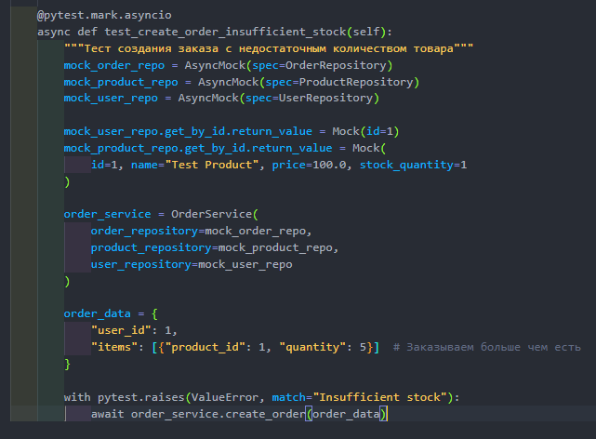
import pytest
from unittest.mock import Mock, AsyncMock
from app.repositories.OrderRepository import OrderRepository
from app.repositories.productReposutory import ProductRepository
from app.repositories.user_repository import UserRepository
from app.services import order_service
from app.services.order_service import OrderService
from app.User_schem import OrderCreate, OrderItemCreate
class TestOrderService2:
@pytest.mark.asyncio
async def test_create_order_insufficient_stock(self, session):
"""Тест создания заказа с недостаточным количеством товара"""
# Мокаем репозитории
mock_order_repo = AsyncMock(spec=OrderRepository)
mock_product_repo = AsyncMock(spec=ProductRepository)
mock_user_repo = AsyncMock(spec=UserRepository)
# Настраиваем моки
mock_user_repo.get_by_id.return_value = Mock(id="1")
mock_product_repo.get_by_id.return_value = Mock(
id="1", name="Test Product", price=100.0, stock_quantity=1
)
order_service = OrderService(
order_repository=mock_order_repo,
product_repository=mock_product_repo,
user_repository=mock_user_repo
)
# Подготовим данные заказа как Pydantic-схему
order_item_data = OrderItemCreate(product_id="1", quantity=5)
order_data = OrderCreate(
user_id="1",
address_id="1",
items=[order_item_data]
)
with pytest.raises(ValueError, match="Not enough stock"):
await order_service.create_order(session, order_data)

Запускаем тест
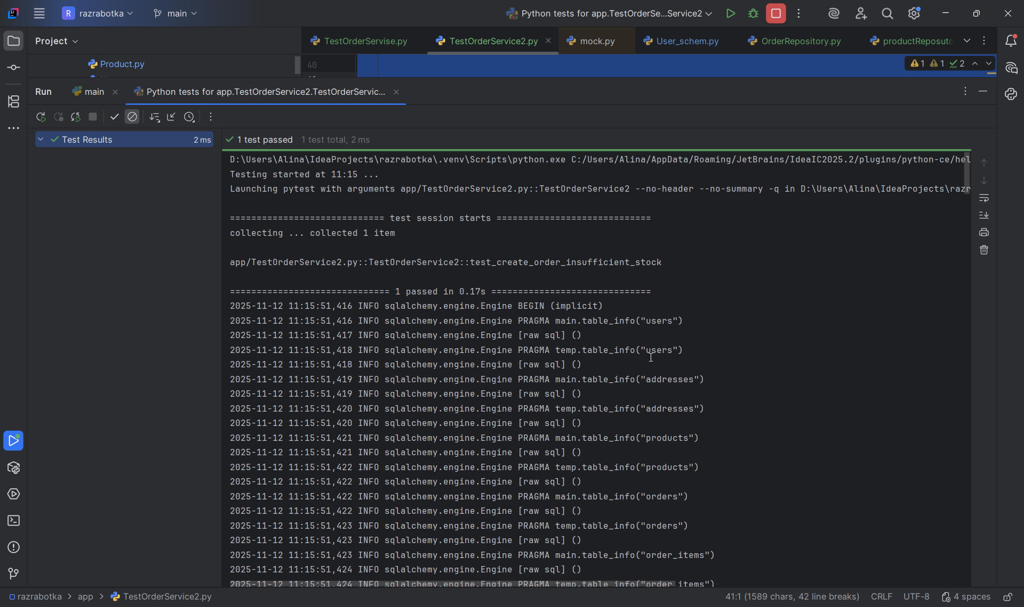
D:\Users\Alina\IdeaProjects\razrabotka\.venv\Scripts\python.exe C:/Users/Alina/AppData/Roaming/JetBrains/IdeaIC2025.2/plugins/python-ce/helpers/pycharm/_jb_pytest_runner.py --target app/TestOrderService2.py::TestOrderService2
Testing started at 11:15 ...
Launching pytest with arguments app/TestOrderService2.py::TestOrderService2 --no-header --no-summary -q in D:\Users\Alina\IdeaProjects\razrabotka

============================= test session starts =============================
collecting ... collected 1 item

app/TestOrderService2.py::TestOrderService2::test_create_order_insufficient_stock

============================== 1 passed in 0.17s ==============================
2025-11-12 11:15:51,416 INFO sqlalchemy.engine.Engine BEGIN (implicit)
2025-11-12 11:15:51,416 INFO sqlalchemy.engine.Engine PRAGMA main.table_info("users")
2025-11-12 11:15:51,417 INFO sqlalchemy.engine.Engine [raw sql] ()
2025-11-12 11:15:51,418 INFO sqlalchemy.engine.Engine PRAGMA temp.table_info("users")
2025-11-12 11:15:51,418 INFO sqlalchemy.engine.Engine [raw sql] ()
2025-11-12 11:15:51,419 INFO sqlalchemy.engine.Engine PRAGMA main.table_info("addresses")
2025-11-12 11:15:51,419 INFO sqlalchemy.engine.Engine [raw sql] ()
2025-11-12 11:15:51,420 INFO sqlalchemy.engine.Engine PRAGMA temp.table_info("addresses")
2025-11-12 11:15:51,420 INFO sqlalchemy.engine.Engine [raw sql] ()
2025-11-12 11:15:51,421 INFO sqlalchemy.engine.Engine PRAGMA main.table_info("products")
2025-11-12 11:15:51,421 INFO sqlalchemy.engine.Engine [raw sql] ()
2025-11-12 11:15:51,422 INFO sqlalchemy.engine.Engine PRAGMA temp.table_info("products")
2025-11-12 11:15:51,422 INFO sqlalchemy.engine.Engine [raw sql] ()
2025-11-12 11:15:51,422 INFO sqlalchemy.engine.Engine PRAGMA main.table_info("orders")
2025-11-12 11:15:51,422 INFO sqlalchemy.engine.Engine [raw sql] ()
2025-11-12 11:15:51,423 INFO sqlalchemy.engine.Engine PRAGMA temp.table_info("orders")
2025-11-12 11:15:51,423 INFO sqlalchemy.engine.Engine [raw sql] ()
2025-11-12 11:15:51,423 INFO sqlalchemy.engine.Engine PRAGMA main.table_info("order_items")
2025-11-12 11:15:51,424 INFO sqlalchemy.engine.Engine [raw sql] ()
2025-11-12 11:15:51,424 INFO sqlalchemy.engine.Engine PRAGMA temp.table_info("order_items")
2025-11-12 11:15:51,424 INFO sqlalchemy.engine.Engine [raw sql] ()
2025-11-12 11:15:51,425 INFO sqlalchemy.engine.Engine PRAGMA main.table_info("users")
2025-11-12 11:15:51,425 INFO sqlalchemy.engine.Engine [raw sql] ()
2025-11-12 11:15:51,425 INFO sqlalchemy.engine.Engine PRAGMA temp.table_info("users")
2025-11-12 11:15:51,426 INFO sqlalchemy.engine.Engine [raw sql] ()
2025-11-12 11:15:51,426 INFO sqlalchemy.engine.Engine PRAGMA main.table_info("addresses")
2025-11-12 11:15:51,426 INFO sqlalchemy.engine.Engine [raw sql] ()
2025-11-12 11:15:51,427 INFO sqlalchemy.engine.Engine PRAGMA temp.table_info("addresses")
2025-11-12 11:15:51,427 INFO sqlalchemy.engine.Engine [raw sql] ()
2025-11-12 11:15:51,427 INFO sqlalchemy.engine.Engine PRAGMA main.table_info("products")
2025-11-12 11:15:51,427 INFO sqlalchemy.engine.Engine [raw sql] ()
2025-11-12 11:15:51,428 INFO sqlalchemy.engine.Engine PRAGMA temp.table_info("products")
2025-11-12 11:15:51,428 INFO sqlalchemy.engine.Engine [raw sql] ()
2025-11-12 11:15:51,428 INFO sqlalchemy.engine.Engine PRAGMA main.table_info("orders")
2025-11-12 11:15:51,429 INFO sqlalchemy.engine.Engine [raw sql] ()
2025-11-12 11:15:51,429 INFO sqlalchemy.engine.Engine PRAGMA temp.table_info("orders")
2025-11-12 11:15:51,429 INFO sqlalchemy.engine.Engine [raw sql] ()
2025-11-12 11:15:51,429 INFO sqlalchemy.engine.Engine PRAGMA main.table_info("order_items")
2025-11-12 11:15:51,430 INFO sqlalchemy.engine.Engine [raw sql] ()
2025-11-12 11:15:51,430 INFO sqlalchemy.engine.Engine PRAGMA temp.table_info("order_items")
2025-11-12 11:15:51,430 INFO sqlalchemy.engine.Engine [raw sql] ()
2025-11-12 11:15:51,431 INFO sqlalchemy.engine.Engine
CREATE TABLE users (
id VARCHAR(36) NOT NULL,
username VARCHAR NOT NULL,
firstname VARCHAR,
lastname VARCHAR,
email VARCHAR NOT NULL,
description TEXT,
created_at DATETIME NOT NULL,
updated_at DATETIME,
PRIMARY KEY (id),
UNIQUE (username),
UNIQUE (email)
)

2025-11-12 11:15:51,431 INFO sqlalchemy.engine.Engine [no key 0.00010s] ()
2025-11-12 11:15:51,433 INFO sqlalchemy.engine.Engine
CREATE TABLE products (
id VARCHAR(36) NOT NULL,
name VARCHAR NOT NULL,
price INTEGER NOT NULL,
description TEXT,
stock_quantity INTEGER NOT NULL,
PRIMARY KEY (id)
)

2025-11-12 11:15:51,434 INFO sqlalchemy.engine.Engine [no key 0.00014s] ()
2025-11-12 11:15:51,437 INFO sqlalchemy.engine.Engine
CREATE TABLE addresses (
id VARCHAR(36) NOT NULL,
user_id VARCHAR(36) NOT NULL,
street VARCHAR NOT NULL,
city VARCHAR NOT NULL,
state VARCHAR,
zip_code VARCHAR,
country VARCHAR NOT NULL,
is_primary BOOLEAN NOT NULL,
created_at DATETIME NOT NULL,
updated_at DATETIME,
PRIMARY KEY (id),
FOREIGN KEY(user_id) REFERENCES users (id)
)

2025-11-12 11:15:51,437 INFO sqlalchemy.engine.Engine [no key 0.00053s] ()
2025-11-12 11:15:51,440 INFO sqlalchemy.engine.Engine
CREATE TABLE orders (
id VARCHAR(36) NOT NULL,
user_id VARCHAR(36) NOT NULL,
address_id VARCHAR(36) NOT NULL,
created_at DATETIME NOT NULL,
PRIMARY KEY (id),
FOREIGN KEY(user_id) REFERENCES users (id),
FOREIGN KEY(address_id) REFERENCES addresses (id)
)

2025-11-12 11:15:51,440 INFO sqlalchemy.engine.Engine [no key 0.00021s] ()
2025-11-12 11:15:51,443 INFO sqlalchemy.engine.Engine
CREATE TABLE order_items (
id VARCHAR(36) NOT NULL,
order_id VARCHAR(36) NOT NULL,
product_id VARCHAR(36) NOT NULL,
quantity INTEGER NOT NULL,
PRIMARY KEY (id),
FOREIGN KEY(order_id) REFERENCES orders (id),
FOREIGN KEY(product_id) REFERENCES products (id)
)

2025-11-12 11:15:51,444 INFO sqlalchemy.engine.Engine [no key 0.00019s] ()
2025-11-12 11:15:51,446 INFO sqlalchemy.engine.Engine COMMIT
INFO - 2025-11-12 11:15:51,416 - sqlalchemy.engine.Engine - base - BEGIN (implicit)
INFO - 2025-11-12 11:15:51,416 - sqlalchemy.engine.Engine - base - PRAGMA main.table_info("users")
INFO - 2025-11-12 11:15:51,417 - sqlalchemy.engine.Engine - base - [raw sql] ()
INFO - 2025-11-12 11:15:51,418 - sqlalchemy.engine.Engine - base - PRAGMA temp.table_info("users")
INFO - 2025-11-12 11:15:51,418 - sqlalchemy.engine.Engine - base - [raw sql] ()
INFO - 2025-11-12 11:15:51,419 - sqlalchemy.engine.Engine - base - PRAGMA main.table_info("addresses")
INFO - 2025-11-12 11:15:51,419 - sqlalchemy.engine.Engine - base - [raw sql] ()
INFO - 2025-11-12 11:15:51,420 - sqlalchemy.engine.Engine - base - PRAGMA temp.table_info("addresses")
INFO - 2025-11-12 11:15:51,420 - sqlalchemy.engine.Engine - base - [raw sql] ()
INFO - 2025-11-12 11:15:51,421 - sqlalchemy.engine.Engine - base - PRAGMA main.table_info("products")
INFO - 2025-11-12 11:15:51,421 - sqlalchemy.engine.Engine - base - [raw sql] ()
INFO - 2025-11-12 11:15:51,422 - sqlalchemy.engine.Engine - base - PRAGMA temp.table_info("products")
INFO - 2025-11-12 11:15:51,422 - sqlalchemy.engine.Engine - base - [raw sql] ()
INFO - 2025-11-12 11:15:51,422 - sqlalchemy.engine.Engine - base - PRAGMA main.table_info("orders")
INFO - 2025-11-12 11:15:51,422 - sqlalchemy.engine.Engine - base - [raw sql] ()
INFO - 2025-11-12 11:15:51,423 - sqlalchemy.engine.Engine - base - PRAGMA temp.table_info("orders")
INFO - 2025-11-12 11:15:51,423 - sqlalchemy.engine.Engine - base - [raw sql] ()
INFO - 2025-11-12 11:15:51,423 - sqlalchemy.engine.Engine - base - PRAGMA main.table_info("order_items")
INFO - 2025-11-12 11:15:51,424 - sqlalchemy.engine.Engine - base - [raw sql] ()
INFO - 2025-11-12 11:15:51,424 - sqlalchemy.engine.Engine - base - PRAGMA temp.table_info("order_items")
INFO - 2025-11-12 11:15:51,424 - sqlalchemy.engine.Engine - base - [raw sql] ()
INFO - 2025-11-12 11:15:51,425 - sqlalchemy.engine.Engine - base - PRAGMA main.table_info("users")
INFO - 2025-11-12 11:15:51,425 - sqlalchemy.engine.Engine - base - [raw sql] ()
INFO - 2025-11-12 11:15:51,425 - sqlalchemy.engine.Engine - base - PRAGMA temp.table_info("users")
INFO - 2025-11-12 11:15:51,426 - sqlalchemy.engine.Engine - base - [raw sql] ()
INFO - 2025-11-12 11:15:51,426 - sqlalchemy.engine.Engine - base - PRAGMA main.table_info("addresses")
INFO - 2025-11-12 11:15:51,426 - sqlalchemy.engine.Engine - base - [raw sql] ()
INFO - 2025-11-12 11:15:51,427 - sqlalchemy.engine.Engine - base - PRAGMA temp.table_info("addresses")
INFO - 2025-11-12 11:15:51,427 - sqlalchemy.engine.Engine - base - [raw sql] ()
INFO - 2025-11-12 11:15:51,427 - sqlalchemy.engine.Engine - base - PRAGMA main.table_info("products")
INFO - 2025-11-12 11:15:51,427 - sqlalchemy.engine.Engine - base - [raw sql] ()
INFO - 2025-11-12 11:15:51,428 - sqlalchemy.engine.Engine - base - PRAGMA temp.table_info("products")
INFO - 2025-11-12 11:15:51,428 - sqlalchemy.engine.Engine - base - [raw sql] ()
INFO - 2025-11-12 11:15:51,428 - sqlalchemy.engine.Engine - base - PRAGMA main.table_info("orders")
INFO - 2025-11-12 11:15:51,429 - sqlalchemy.engine.Engine - base - [raw sql] ()
INFO - 2025-11-12 11:15:51,429 - sqlalchemy.engine.Engine - base - PRAGMA temp.table_info("orders")
INFO - 2025-11-12 11:15:51,429 - sqlalchemy.engine.Engine - base - [raw sql] ()
INFO - 2025-11-12 11:15:51,429 - sqlalchemy.engine.Engine - base - PRAGMA main.table_info("order_items")
INFO - 2025-11-12 11:15:51,430 - sqlalchemy.engine.Engine - base - [raw sql] ()
INFO - 2025-11-12 11:15:51,430 - sqlalchemy.engine.Engine - base - PRAGMA temp.table_info("order_items")
INFO - 2025-11-12 11:15:51,430 - sqlalchemy.engine.Engine - base - [raw sql] ()
INFO - 2025-11-12 11:15:51,431 - sqlalchemy.engine.Engine - base -
CREATE TABLE users (
id VARCHAR(36) NOT NULL,
username VARCHAR NOT NULL,
firstname VARCHAR,
lastname VARCHAR,
email VARCHAR NOT NULL,
description TEXT,
created_at DATETIME NOT NULL,
updated_at DATETIME,
PRIMARY KEY (id),
UNIQUE (username),
UNIQUE (email)
)

INFO - 2025-11-12 11:15:51,431 - sqlalchemy.engine.Engine - base - [no key 0.00010s] ()
INFO - 2025-11-12 11:15:51,433 - sqlalchemy.engine.Engine - base -
CREATE TABLE products (
id VARCHAR(36) NOT NULL,
name VARCHAR NOT NULL,
price INTEGER NOT NULL,
description TEXT,
stock_quantity INTEGER NOT NULL,
PRIMARY KEY (id)
)

INFO - 2025-11-12 11:15:51,434 - sqlalchemy.engine.Engine - base - [no key 0.00014s] ()
INFO - 2025-11-12 11:15:51,437 - sqlalchemy.engine.Engine - base -
CREATE TABLE addresses (
id VARCHAR(36) NOT NULL,
user_id VARCHAR(36) NOT NULL,
street VARCHAR NOT NULL,
city VARCHAR NOT NULL,
state VARCHAR,
zip_code VARCHAR,
country VARCHAR NOT NULL,
is_primary BOOLEAN NOT NULL,
created_at DATETIME NOT NULL,
updated_at DATETIME,
PRIMARY KEY (id),
FOREIGN KEY(user_id) REFERENCES users (id)
)

INFO - 2025-11-12 11:15:51,437 - sqlalchemy.engine.Engine - base - [no key 0.00053s] ()
INFO - 2025-11-12 11:15:51,440 - sqlalchemy.engine.Engine - base -
CREATE TABLE orders (
id VARCHAR(36) NOT NULL,
user_id VARCHAR(36) NOT NULL,
address_id VARCHAR(36) NOT NULL,
created_at DATETIME NOT NULL,
PRIMARY KEY (id),
FOREIGN KEY(user_id) REFERENCES users (id),
FOREIGN KEY(address_id) REFERENCES addresses (id)
)

INFO - 2025-11-12 11:15:51,440 - sqlalchemy.engine.Engine - base - [no key 0.00021s] ()
INFO - 2025-11-12 11:15:51,443 - sqlalchemy.engine.Engine - base -
CREATE TABLE order_items (
id VARCHAR(36) NOT NULL,
order_id VARCHAR(36) NOT NULL,
product_id VARCHAR(36) NOT NULL,
quantity INTEGER NOT NULL,
PRIMARY KEY (id),
FOREIGN KEY(order_id) REFERENCES orders (id),
FOREIGN KEY(product_id) REFERENCES products (id)
)

INFO - 2025-11-12 11:15:51,444 - sqlalchemy.engine.Engine - base - [no key 0.00019s] ()
INFO - 2025-11-12 11:15:51,446 - sqlalchemy.engine.Engine - base - COMMIT
PASSED [100%]2025-11-12 11:15:51,461 INFO sqlalchemy.engine.Engine BEGIN (implicit)
2025-11-12 11:15:51,461 INFO sqlalchemy.engine.Engine PRAGMA main.table_info("users")
2025-11-12 11:15:51,461 INFO sqlalchemy.engine.Engine [raw sql] ()
2025-11-12 11:15:51,462 INFO sqlalchemy.engine.Engine PRAGMA main.table_info("addresses")
2025-11-12 11:15:51,462 INFO sqlalchemy.engine.Engine [raw sql] ()
2025-11-12 11:15:51,463 INFO sqlalchemy.engine.Engine PRAGMA main.table_info("products")
2025-11-12 11:15:51,463 INFO sqlalchemy.engine.Engine [raw sql] ()
2025-11-12 11:15:51,463 INFO sqlalchemy.engine.Engine PRAGMA main.table_info("orders")
2025-11-12 11:15:51,463 INFO sqlalchemy.engine.Engine [raw sql] ()
2025-11-12 11:15:51,464 INFO sqlalchemy.engine.Engine PRAGMA main.table_info("order_items")
2025-11-12 11:15:51,464 INFO sqlalchemy.engine.Engine [raw sql] ()
2025-11-12 11:15:51,465 INFO sqlalchemy.engine.Engine
DROP TABLE order_items
2025-11-12 11:15:51,465 INFO sqlalchemy.engine.Engine [no key 0.00010s] ()
2025-11-12 11:15:51,468 INFO sqlalchemy.engine.Engine
DROP TABLE orders
2025-11-12 11:15:51,468 INFO sqlalchemy.engine.Engine [no key 0.00024s] ()
2025-11-12 11:15:51,471 INFO sqlalchemy.engine.Engine
DROP TABLE addresses
2025-11-12 11:15:51,471 INFO sqlalchemy.engine.Engine [no key 0.00018s] ()
2025-11-12 11:15:51,474 INFO sqlalchemy.engine.Engine
DROP TABLE products
2025-11-12 11:15:51,474 INFO sqlalchemy.engine.Engine [no key 0.00027s] ()
2025-11-12 11:15:51,477 INFO sqlalchemy.engine.Engine
DROP TABLE users
2025-11-12 11:15:51,477 INFO sqlalchemy.engine.Engine [no key 0.00015s] ()
2025-11-12 11:15:51,480 INFO sqlalchemy.engine.Engine COMMIT
INFO - 2025-11-12 11:15:51,461 - sqlalchemy.engine.Engine - base - BEGIN (implicit)
INFO - 2025-11-12 11:15:51,461 - sqlalchemy.engine.Engine - base - PRAGMA main.table_info("users")
INFO - 2025-11-12 11:15:51,461 - sqlalchemy.engine.Engine - base - [raw sql] ()
INFO - 2025-11-12 11:15:51,462 - sqlalchemy.engine.Engine - base - PRAGMA main.table_info("addresses")
INFO - 2025-11-12 11:15:51,462 - sqlalchemy.engine.Engine - base - [raw sql] ()
INFO - 2025-11-12 11:15:51,463 - sqlalchemy.engine.Engine - base - PRAGMA main.table_info("products")
INFO - 2025-11-12 11:15:51,463 - sqlalchemy.engine.Engine - base - [raw sql] ()
INFO - 2025-11-12 11:15:51,463 - sqlalchemy.engine.Engine - base - PRAGMA main.table_info("orders")
INFO - 2025-11-12 11:15:51,463 - sqlalchemy.engine.Engine - base - [raw sql] ()
INFO - 2025-11-12 11:15:51,464 - sqlalchemy.engine.Engine - base - PRAGMA main.table_info("order_items")
INFO - 2025-11-12 11:15:51,464 - sqlalchemy.engine.Engine - base - [raw sql] ()
INFO - 2025-11-12 11:15:51,465 - sqlalchemy.engine.Engine - base -
DROP TABLE order_items
INFO - 2025-11-12 11:15:51,465 - sqlalchemy.engine.Engine - base - [no key 0.00010s] ()
INFO - 2025-11-12 11:15:51,468 - sqlalchemy.engine.Engine - base -
DROP TABLE orders
INFO - 2025-11-12 11:15:51,468 - sqlalchemy.engine.Engine - base - [no key 0.00024s] ()
INFO - 2025-11-12 11:15:51,471 - sqlalchemy.engine.Engine - base -
DROP TABLE addresses
INFO - 2025-11-12 11:15:51,471 - sqlalchemy.engine.Engine - base - [no key 0.00018s] ()
INFO - 2025-11-12 11:15:51,474 - sqlalchemy.engine.Engine - base -
DROP TABLE products
INFO - 2025-11-12 11:15:51,474 - sqlalchemy.engine.Engine - base - [no key 0.00027s] ()
INFO - 2025-11-12 11:15:51,477 - sqlalchemy.engine.Engine - base -
DROP TABLE users
INFO - 2025-11-12 11:15:51,477 - sqlalchemy.engine.Engine - base - [no key 0.00015s] ()
INFO - 2025-11-12 11:15:51,480 - sqlalchemy.engine.Engine - base - COMMIT

Process finished with exit code 0

4. Тестируем API
Также независимо от других слоёв приложений мы можем протестировать работу наших эндпоинтов.

Если у нас есть приложение вида
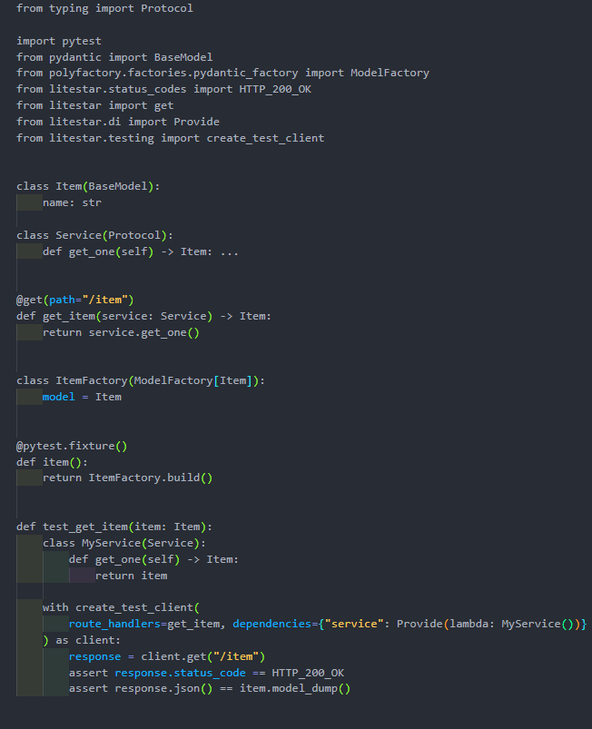
from typing import Protocol
from typing_extensions import runtime_checkable
import pytest
from pydantic import BaseModel
from polyfactory.factories.pydantic_factory import ModelFactory
from litestar.status_codes import HTTP_200_OK
from litestar import get
from litestar.di import Provide
from litestar.testing import create_test_client
class Item(BaseModel):
name: str
@runtime_checkable
class Service(Protocol):
def get_one(self) -> Item:
...
@get(path="/item")
def get_item(service: Service) -> Item:
return service.get_one()
class ItemFactory(ModelFactory[Item]):
model = Item
@pytest.fixture()
def item():
return ItemFactory.build()
def test_get_item(item: Item):
class MyService(Service):
def get_one(self) -> Item:
return item
with create_test_client(
route_handlers=get_item, dependencies={"service": Provide(lambda: MyService())}
) as client:
response = client.get("/item")
assert response.status_code == HTTP_200_OK
assert response.json() == item.model_dump()

Запустим тест
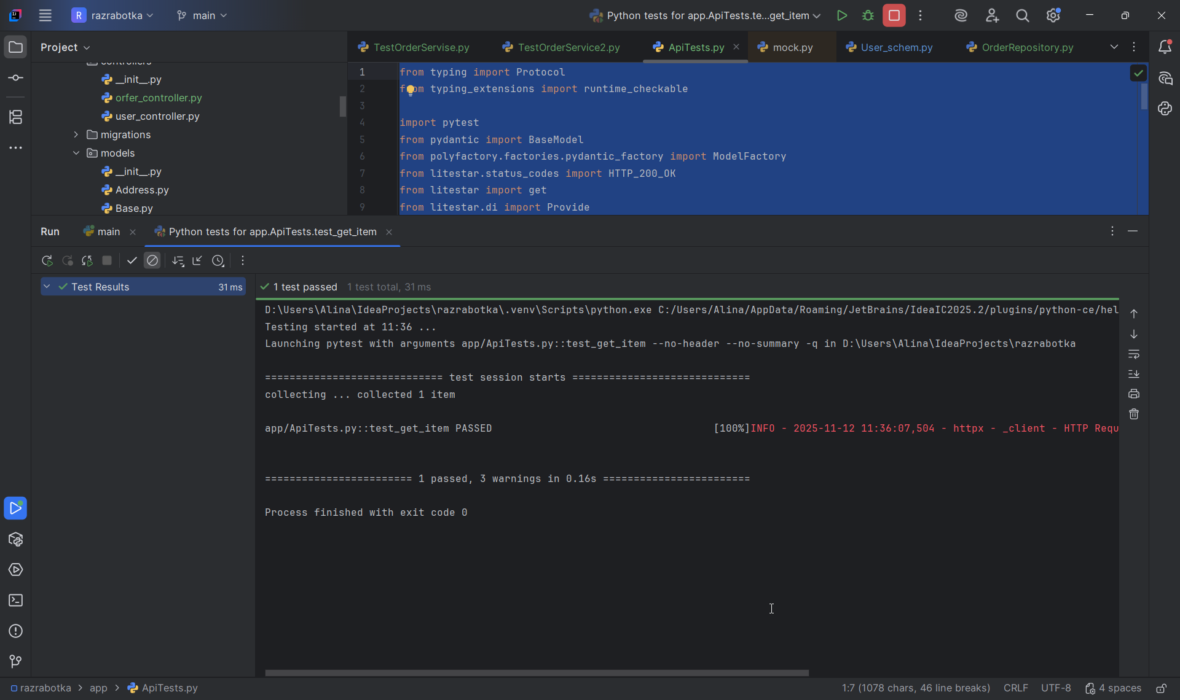
D:\Users\Alina\IdeaProjects\razrabotka\.venv\Scripts\python.exe C:/Users/Alina/AppData/Roaming/JetBrains/IdeaIC2025.2/plugins/python-ce/helpers/pycharm/_jb_pytest_runner.py --target app/ApiTests.py::test_get_item
Testing started at 11:36 ...
Launching pytest with arguments app/ApiTests.py::test_get_item --no-header --no-summary -q in D:\Users\Alina\IdeaProjects\razrabotka

============================= test session starts =============================
collecting ... collected 1 item

app/ApiTests.py::test_get_item PASSED [100%]INFO - 2025-11-12 11:36:07,504 - httpx - _client - HTTP Request: GET http://testserver.local/item "HTTP/1.1 200 OK"

======================== 1 passed, 3 warnings in 0.16s ========================

Process finished with exit code 0

К этим тестам добавляем проверки оставшихся эндпоинтов.
import pytest
import uuid
from litestar.testing import AsyncTestClient
from app.main import app
from app.User_schem import UserCreate, UserUpdate, UserResponse
from app.models.User import User
@pytest.mark.asyncio
async def test_create_user(session):
"""Тест создания пользователя через API"""
user_data = {
"username": "test_user_api",
"email": "test_api@example.com",
"firstname": "Test",
"lastname": "User",
}
async with AsyncTestClient(app=app) as ac:
response = await ac.post("/users/", json=user_data)
print("Status Code:", response.status_code)
print("Response Body:", response.text)
assert response.status_code == 201, f"Expected 201, got {response.status_code}. Response: {response.text}"
user_response = response.json()
assert user_response["username"] == "test_user_api"
assert user_response["email"] == "test_api@example.com"
assert user_response["firstname"] == "Test"
assert user_response["lastname"] == "User"
assert "id" in user_response
# Проверим, что пользователь действительно в БД
fetched_user = await session.get(User, user_response["id"])
assert fetched_user is not None
assert fetched_user.id == user_response["id"]
return user_response["id"] # Возвращаем ID для использования в других тестах
@pytest.mark.asyncio
async def test_get_all_users(session):
"""Тест получения списка всех пользователей"""
# Сначала создадим несколько пользователей
users_data = [
{
"username": "user1",
"email": "user1@example.com",
"firstname": "User",
"lastname": "One",
},
{
"username": "user2",
"email": "user2@example.com",
"firstname": "User",
"lastname": "Two",
}
]
async with AsyncTestClient(app=app) as ac:
# Создаем пользователей
for user_data in users_data:
await ac.post("/users/", json=user_data)
# Получаем список пользователей
response = await ac.get("/users/", params={"count": 10, "page": 1})
print("Get All Users Status Code:", response.status_code)
print("Get All Users Response:", response.text)
assert response.status_code == 200
response_data = response.json()
assert "users" in response_data
assert "total_count" in response_data
assert isinstance(response_data["users"], list)
assert response_data["total_count"] >= 2 # Как минимум 2 созданных пользователя
# Проверяем структуру ответа
if len(response_data["users"]) > 0:
user = response_data["users"][0]
assert "id" in user
assert "username" in user
assert "email" in user
assert "firstname" in user
assert "lastname" in user
@pytest.mark.asyncio
async def test_get_user_by_id(session):
"""Тест получения пользователя по ID"""
# Сначала создаем пользователя
user_data = {
"username": "get_user_test",
"email": "get_user@example.com",
"firstname": "Get",
"lastname": "User",
}
async with AsyncTestClient(app=app) as ac:
create_response = await ac.post("/users/", json=user_data)
assert create_response.status_code == 201
user_id = create_response.json()["id"]
# Получаем пользователя по ID
response = await ac.get(f"/users/{user_id}")
print("Get User By ID Status Code:", response.status_code)
print("Get User By ID Response:", response.text)
assert response.status_code == 200
user_response = response.json()
assert user_response["id"] == user_id
assert user_response["username"] == "get_user_test"
assert user_response["email"] == "get_user@example.com"
assert user_response["firstname"] == "Get"
assert user_response["lastname"] == "User"
@pytest.mark.asyncio
async def test_get_user_by_id_not_found(session):
"""Тест получения несуществующего пользователя"""
non_existent_id = str(uuid.uuid4())
async with AsyncTestClient(app=app) as ac:
response = await ac.get(f"/users/{non_existent_id}")
print("Get Non-existent User Status Code:", response.status_code)
print("Get Non-existent User Response:", response.text)
assert response.status_code == 404
error_response = response.json()
assert "detail" in error_response
assert f"User with ID {non_existent_id} not found" in error_response["detail"]
@pytest.mark.asyncio
async def test_update_user(session):
"""Тест обновления пользователя"""
# Сначала создаем пользователя
user_data = {
"username": "update_user_test",
"email": "update_user@example.com",
"firstname": "Before",
"lastname": "Update",
}
async with AsyncTestClient(app=app) as ac:
create_response = await ac.post("/users/", json=user_data)
assert create_response.status_code == 201
user_id = create_response.json()["id"]
# Обновляем пользователя
update_data = {
"firstname": "After",
"lastname": "Updated",
"email": "updated@example.com"
}
response = await ac.put(f"/users/{user_id}", json=update_data)
print("Update User Status Code:", response.status_code)
print("Update User Response:", response.text)
assert response.status_code == 200
user_response = response.json()
assert user_response["id"] == user_id
assert user_response["username"] == "update_user_test" # username не менялся
assert user_response["email"] == "updated@example.com" # email обновился
assert user_response["firstname"] == "After" # firstname обновился
assert user_response["lastname"] == "Updated" # lastname обновился
@pytest.mark.asyncio
async def test_update_user_not_found(session):
"""Тест обновления несуществующего пользователя"""
non_existent_id = str(uuid.uuid4())
update_data = {
"firstname": "Test",
"lastname": "User"
}
async with AsyncTestClient(app=app) as ac:
response = await ac.put(f"/users/{non_existent_id}", json=update_data)
print("Update Non-existent User Status Code:", response.status_code)
print("Update Non-existent User Response:", response.text)
assert response.status_code == 404
error_response = response.json()
assert "detail" in error_response
@pytest.mark.asyncio
async def test_delete_user(session):
"""Тест удаления пользователя"""
# Сначала создаем пользователя
user_data = {
"username": "delete_user_test",
"email": "delete_user@example.com",
"firstname": "Delete",
"lastname": "User",
}
async with AsyncTestClient(app=app) as ac:
create_response = await ac.post("/users/", json=user_data)
assert create_response.status_code == 201
user_id = create_response.json()["id"]
# Удаляем пользователя
response = await ac.delete(f"/users/{user_id}")
print("Delete User Status Code:", response.status_code)
assert response.status_code == 204 # No Content
# Проверяем, что пользователь действительно удален из БД
deleted_user = await session.get(User, user_id)
assert deleted_user is None
@pytest.mark.asyncio
async def test_delete_user_not_found(session):
"""Тест удаления несуществующего пользователя"""
non_existent_id = str(uuid.uuid4())
async with AsyncTestClient(app=app) as ac:
response = await ac.delete(f"/users/{non_existent_id}")
print("Delete Non-existent User Status Code:", response.status_code)
print("Delete Non-existent User Response:", response.text)
assert response.status_code == 404
error_response = response.json()
assert "detail" in error_response
запускаем тесты:
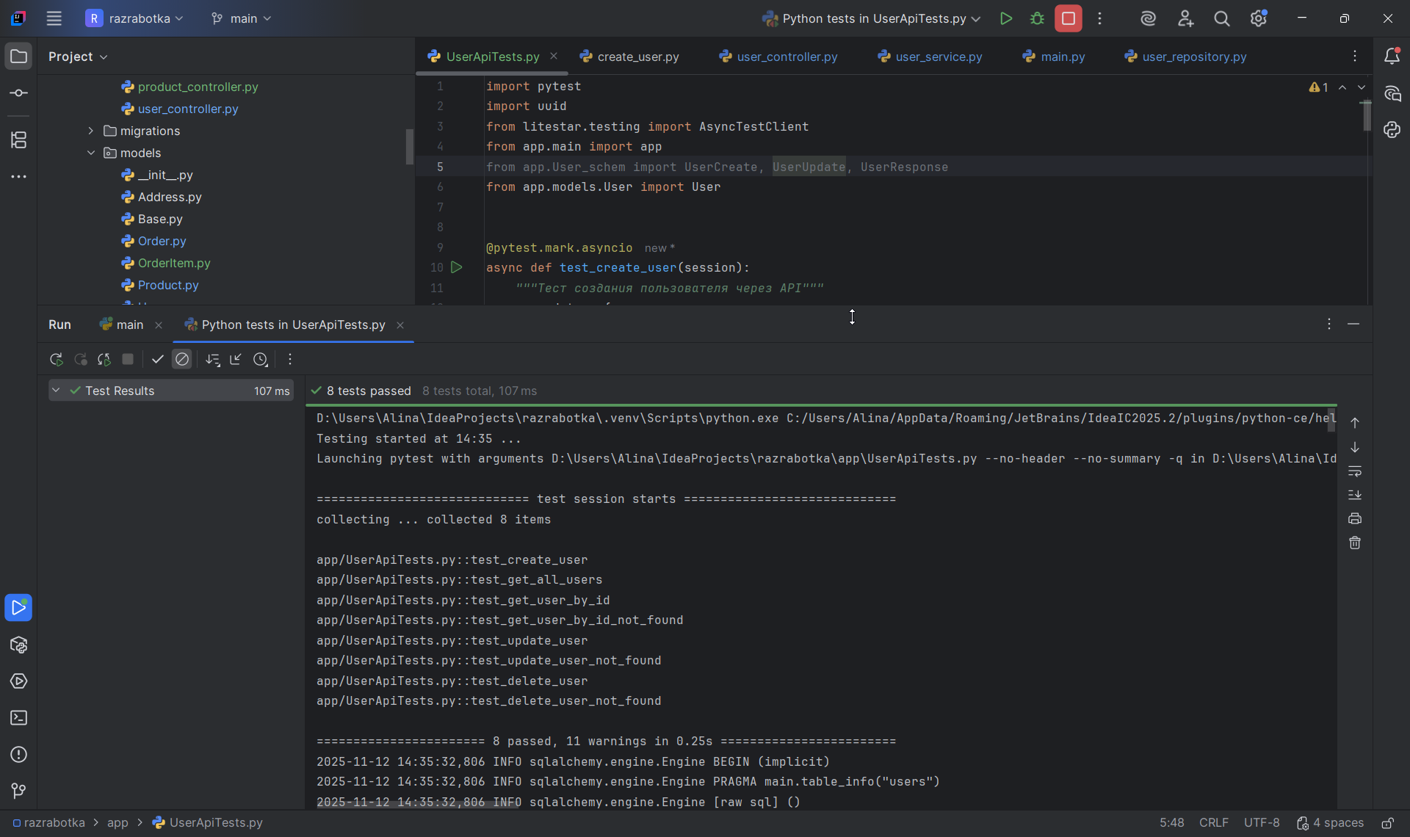

import pytest
import uuid
from litestar.testing import AsyncTestClient
from app.main import app
from app.models.Product import Product
@pytest.mark.asyncio
async def test_create_product(session):
"""Тест создания продукта"""
product_data = {
"name": "Test Product",
"price": 1000,
"description": "Test description",
"stock_quantity": 50
}
async with AsyncTestClient(app=app) as ac:
response = await ac.post("/products/", json=product_data)
print("Create Product Status:", response.status_code)
print("Create Product Response:", response.text)
assert response.status_code == 201
product_response = response.json()
assert product_response["name"] == "Test Product"
assert product_response["price"] == 1000
assert product_response["description"] == "Test description"
assert product_response["stock_quantity"] == 50
assert "id" in product_response
# Проверка в БД
fetched_product = await session.get(Product, product_response["id"])
assert fetched_product is not None
return product_response["id"]
@pytest.mark.asyncio
async def test_get_all_products(session):
"""Тест получения всех продуктов"""
async with AsyncTestClient(app=app) as ac:
response = await ac.get("/products/", params={"count": 10, "page": 1})
print("Get All Products Status:", response.status_code)
assert response.status_code == 200
response_data = response.json()
assert "products" in response_data
assert "total_count" in response_data
assert isinstance(response_data["products"], list)
# Проверяем структуру продуктов
if response_data["products"]:
product = response_data["products"][0]
assert "id" in product
assert "name" in product
assert "price" in product
assert "stock_quantity" in product
@pytest.mark.asyncio
async def test_get_all_products_default_params(session):
"""Тест получения продуктов с параметрами по умолчанию"""
async with AsyncTestClient(app=app) as ac:
response = await ac.get("/products/")
print("Get Products Default Params Status:", response.status_code)
assert response.status_code == 200
response_data = response.json()
assert "products" in response_data
assert "total_count" in response_data
@pytest.mark.asyncio
async def test_get_product_by_id(session):
"""Тест получения продукта по ID"""
# Сначала создаем продукт
product_data = {
"name": "Get By ID Product",
"price": 2000,
"description": "Get by ID description",
"stock_quantity": 25
}
async with AsyncTestClient(app=app) as ac:
create_response = await ac.post("/products/", json=product_data)
assert create_response.status_code == 201
product_id = create_response.json()["id"]
# Получаем по ID
response = await ac.get(f"/products/{product_id}")
print("Get Product By ID Status:", response.status_code)
assert response.status_code == 200
product_response = response.json()
assert product_response["id"] == product_id
assert product_response["name"] == "Get By ID Product"
assert product_response["price"] == 2000
assert product_response["stock_quantity"] == 25
@pytest.mark.asyncio
async def test_update_product(session):
"""Тест обновления продукта"""
product_data = {
"name": "Update Product",
"price": 1000,
"description": "Before update",
"stock_quantity": 10
}
async with AsyncTestClient(app=app) as ac:
create_response = await ac.post("/products/", json=product_data)
assert create_response.status_code == 201
product_id = create_response.json()["id"]
# Обновляем
update_data = {
"name": "Updated Product",
"price": 1500,
"description": "After update",
"stock_quantity": 20
}
response = await ac.put(f"/products/{product_id}", json=update_data)
print("Update Product Status:", response.status_code)
assert response.status_code == 200
product_response = response.json()
assert product_response["name"] == "Updated Product"
assert product_response["price"] == 1500
assert product_response["description"] == "After update"
assert product_response["stock_quantity"] == 20
Запускаем тесты:
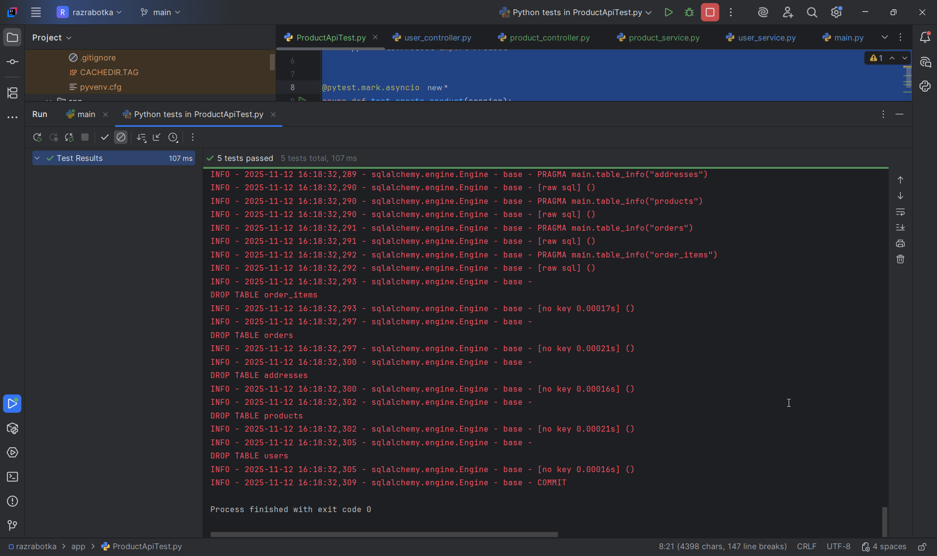

import pytest
import uuid
from litestar.testing import AsyncTestClient
from app.main import app
from app.models.Order import Order
from app.models.User import User
from app.models.Product import Product
from app.models.Address import Address
@pytest.mark.asyncio
async def test_create_order(session):
"""Тест создания заказа"""
# Сначала создаем пользователя, адрес и продукты
user_data = {
"username": "order_user",
"email": "order@example.com",
"firstname": "Order",
"lastname": "User",
}
product_data = {
"name": "Order Product",
"price": 1000,
"description": "Product for order",
"stock_quantity": 50
}
async with AsyncTestClient(app=app) as ac:
# Создаем пользователя
user_response = await ac.post("/users/", json=user_data)
assert user_response.status_code == 201
user_id = user_response.json()["id"]
# Создаем продукт
product_response = await ac.post("/products/", json=product_data)
assert product_response.status_code == 201
product_id = product_response.json()["id"]
# Создаем заказ
order_data = {
"user_id": user_id,
"address_id": "test-address-id",
"items": [
{
"product_id": product_id,
"quantity": 2
}
]
}
response = await ac.post("/orders/", json=order_data)
print("Create Order Status:", response.status_code)
print("Create Order Response:", response.text)
# Может быть 201 или 400/404 если адрес не существует
assert response.status_code in [201, 400, 404, 422]
if response.status_code == 201:
order_response = response.json()
assert "id" in order_response
assert order_response["user_id"] == user_id
assert "items" in order_response
assert len(order_response["items"]) == 1
return order_response["id"]
@pytest.mark.asyncio
async def test_get_all_orders(session):
"""Тест получения всех заказов"""
async with AsyncTestClient(app=app) as ac:
response = await ac.get("/orders/", params={"count": 10, "page": 1})
print("Get All Orders Status:", response.status_code)
assert response.status_code == 200
response_data = response.json()
assert "orders" in response_data
assert "total_count" in response_data
assert isinstance(response_data["orders"], list)
# Проверяем структуру заказов
if response_data["orders"]:
order = response_data["orders"][0]
assert "id" in order
assert "user_id" in order
assert "created_at" in order
assert "items" in order
@pytest.mark.asyncio
async def test_get_order_by_id(session):
"""Тест получения заказа по ID"""
# Сначала создаем заказ
user_data = {
"username": "get_order_user",
"email": "getorder@example.com",
"firstname": "Get",
"lastname": "Order",
}
product_data = {
"name": "Get Order Product",
"price": 1500,
"stock_quantity": 10
}
async with AsyncTestClient(app=app) as ac:
# Создаем пользователя и продукт
user_response = await ac.post("/users/", json=user_data)
assert user_response.status_code == 201
user_id = user_response.json()["id"]
product_response = await ac.post("/products/", json=product_data)
assert product_response.status_code == 201
product_id = product_response.json()["id"]
# Создаем заказ
order_data = {
"user_id": user_id,
"address_id": "test-address-id",
"items": [{"product_id": product_id, "quantity": 1}]
}
create_response = await ac.post("/orders/", json=order_data)
if create_response.status_code == 201:
order_id = create_response.json()["id"]
# Получаем заказ по ID
response = await ac.get(f"/orders/{order_id}")
print("Get Order By ID Status:", response.status_code)
assert response.status_code == 200
order_response = response.json()
assert order_response["id"] == order_id
assert order_response["user_id"] == user_id
assert len(order_response["items"]) == 1
@pytest.mark.asyncio
async def test_update_order(session):
"""Тест обновления заказа"""
# Создаем заказ для обновления
user_data = {
"username": "update_order_user",
"email": "updateorder@example.com",
"firstname": "Update",
"lastname": "Order",
}
product_data = {
"name": "Update Order Product",
"price": 2000,
"stock_quantity": 15
}
async with AsyncTestClient(app=app) as ac:
# Создаем пользователя и продукт
user_response = await ac.post("/users/", json=user_data)
assert user_response.status_code == 201
user_id = user_response.json()["id"]
product_response = await ac.post("/products/", json=product_data)
assert product_response.status_code == 201
product_id = product_response.json()["id"]
# Создаем заказ
order_data = {
"user_id": user_id,
"address_id": "address-1",
"items": [{"product_id": product_id, "quantity": 1}]
}
create_response = await ac.post("/orders/", json=order_data)
if create_response.status_code == 201:
order_id = create_response.json()["id"]
# Обновляем заказ
update_data = {
"address_id": "address-2" # Меняем адрес
}
response = await ac.put(f"/orders/{order_id}", json=update_data)
print("Update Order Status:", response.status_code)
if response.status_code == 200:
order_response = response.json()
# Проверяем, что заказ обновлен
assert order_response["id"] == order_id
@pytest.mark.asyncio
async def test_delete_order(session):
"""Тест удаления заказа"""
# Создаем заказ для удаления
user_data = {
"username": "delete_order_user",
"email": "deleteorder@example.com",
"firstname": "Delete",
"lastname": "Order",
}
product_data = {
"name": "Delete Order Product",
"price": 3000,
"stock_quantity": 8
}
async with AsyncTestClient(app=app) as ac:
# Создаем пользователя и продукт
user_response = await ac.post("/users/", json=user_data)
assert user_response.status_code == 201
user_id = user_response.json()["id"]
product_response = await ac.post("/products/", json=product_data)
assert product_response.status_code == 201
product_id = product_response.json()["id"]
# Создаем заказ
order_data = {
"user_id": user_id,
"address_id": "delete-address",
"items": [{"product_id": product_id, "quantity": 1}]
}
create_response = await ac.post("/orders/", json=order_data)
if create_response.status_code == 201:
order_id = create_response.json()["id"]
# Удаляем заказ
response = await ac.delete(f"/orders/{order_id}")
print("Delete Order Status:", response.status_code)
assert response.status_code == 204
# Проверяем, что заказ удален
get_response = await ac.get(f"/orders/{order_id}")
assert get_response.status_code == 404
Запускаем тесты:
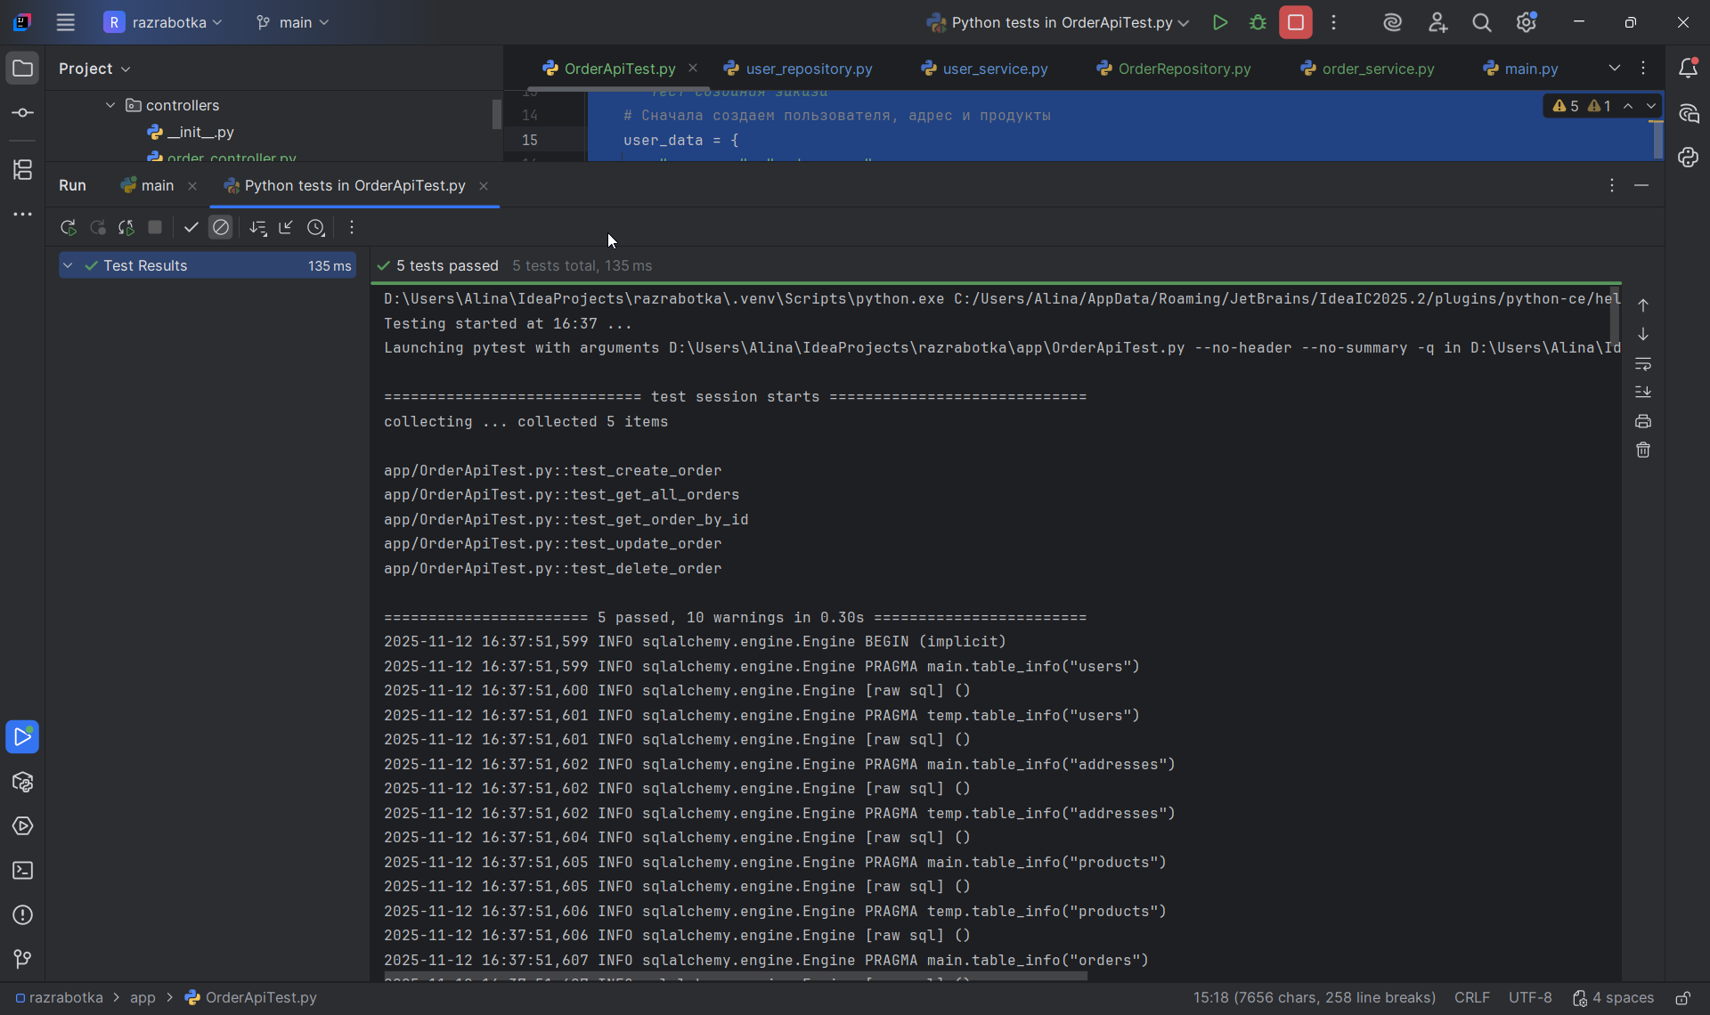

Вопросы
- Почему в тестах мы используем отдельную тестовую базу данных (SQLite in-memory)? Какие проблемы могут возникнуть при использовании production базы данных для тестирования?
Проблемы при использовании production БД:
Потеря данных - тесты могут удалить/изменить реальные данные
Непредсказуемость - данные между тестами влияют друг на друга
Безопасность - тесты могут содержать чувствительные данные
Производительность - нагрузка на продакшен БД
Воспроизводимость - тесты могут падать из-за изменений в реальных данных
- Как работает TestClient в Litestar? Какие преимущества он дает по сравнению с обычными HTTP-запросами?
from litestar.testing import AsyncTestClient
async def test_example():
async with AsyncTestClient(app=app) as client:
# Внутренний вызов без сетевых запросов
response = await client.get("/users/")

Преимущества:
1. Нет сетевых задержек
2. Не нужен запущенный сервер
3. Легкая отладка
4. Изоляция тестов

- При тестировании сервиса заказов, какие edge cases (граничные случаи) нужно учитывать? Напишите к ним тесты
import pytest
from litestar.testing import AsyncTestClient
from app.main import app
from app.User_schem import OrderCreate, OrderItemCreate
from app.models.User import User
from app.models.Product import Product
from app.models.Order import Order

@pytest.mark.asyncio
async def test_create_order_with_nonexistent_user(session, order_repository, user_repository, product_repository):
"""Тест: создание заказа с несуществующим user_id"""
product_data = {
"name": "Test Product",
"price": 1000,
"description": "For testing",
"stock_quantity": 10,
}
product_create_schema = ProductCreate(**product_data)
product = await product_repository.create(session, product_create_schema)

order_data = {
"user_id": "nonexistent-user-id",
"address_id": "fake-addr",
"items": [
{"product_id": product.id, "quantity": 1},
]
}

with AsyncTestClient(app=app) as ac:
response = ac.post("/orders", json=order_data)

assert response.status_code == 400 # или 404, в зависимости от логики

@pytest.mark.asyncio
async def test_create_order_insufficient_stock(session, order_repository, user_repository, product_repository):
"""Тест: создание заказа с недостаточным количеством товара"""
# Создаём пользователя и продукт
user_data = {
"username": "test_user",
"email": "order_test@example.com",
"firstname": "Order",
"lastname": "Test",
}
user_create_schema = UserCreate(**user_data)
user = await user_repository.create(session, user_create_schema)

product_data = {
"name": "Low Stock Product",
"price": 100,
"description": "Low stock",
"stock_quantity": 1,
}
product_create_schema = ProductCreate(**product_data)
product = await product_repository.create(session, product_create_schema)

- Как бы вы протестировали метод, который должен отправлять email при смене статуса заказа на "shipped"?
Можно испольщовать unittest.mock или pytest-mock для "подмены" реального email-сервиса на фиктивный (mock), который не отправляет настоящие письма, но позволяет проверить, был ли вызван метод и с какими аргументами.

- Напишите тест для проверки пагинации товаров. Какие параметры должны проверяться?
Количество товаров на странице
Номер страницы
Общее количество товаров в БД.

import pytest
from litestar.testing import AsyncTestClient
from app.main import app
from app.User_schem import ProductCreate

@pytest.mark.asyncio
async def test_get_products_pagination(session, product_repository):
"""Тест пагинации товаров"""
# Сначала создаём 25 продуктов
for i in range(25):
product_data = {
"name": f"Product {i}",
"price": 100,
"description": f"Description for product {i}",
"stock_quantity": 10,
}
product_create_schema = ProductCreate(**product_data)
await product_repository.create(session, product_create_schema)

# Запрашиваем 10 на первой странице
with AsyncTestClient(app=app) as ac:
response = ac.get("/products?count=10&page=1")

assert response.status_code == 200
data = response.json()
assert len(data["products"]) == 10
assert data["total_count"] == 25

# Запрашиваем страницу, которой не существует
with AsyncTestClient(app=app) as ac:
response = ac.get("/products?count=10&page=100")

assert response.status_code == 200 # или 404, в зависимости от логики
data = response.json()
assert len(data["products"]) == 0

- Как обеспечить изоляцию тестов друг от друга? Почему это важно?
Почему важно:
- Повторяемость: тест должен давать одинаковый результат при каждом запуске.
- Независимость: тесты не должны зависеть от порядка выполнения.
- Надёжность: если тест падает, это не из-за состояния от другого теста.
Как обеспечить:
- Тестовая БД: используйте отдельную БД (например, in-memory SQLite).
- Транзакции с rollback: после каждого теста откатывайте транзакцию (session.rollback()).
- Фикстуры с scope="function": чтобы создавать новые объекты для каждого теста.
- @pytest.mark.asyncio: для асинхронных тестов.
- AsyncTestClient: для изоляции HTTP-уровня.

