#9

Auto = read.csv("Auto.csv", na.strings = "?", stringsAsFactors = T)

summary(Auto)

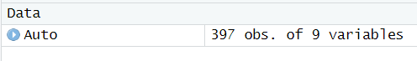

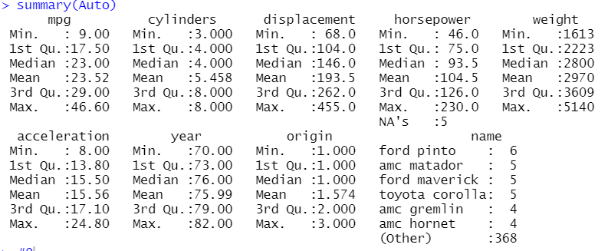

#9a

pairs(Auto)

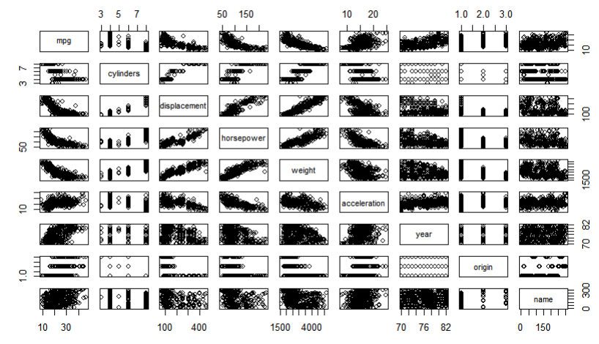

#9b

cor(subset(Auto, select = -name))

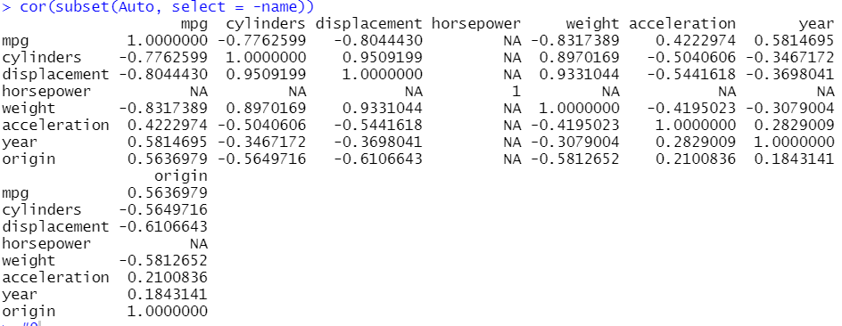

#9c

lm.fit <- lm(mpg ~ . -name, data = Auto)

summary(lm.fit)

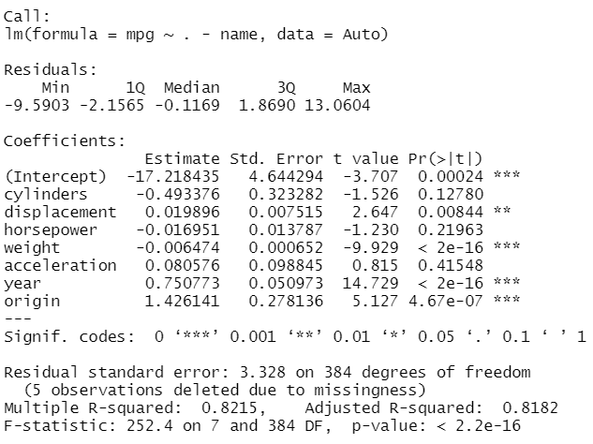

#I

#Yes. There is a relationship between the predictors and the response (mpg)

#Since p-value is very small and F-statistic is >1, we reject the null

#hypothesis and conclude the relationship between response and predictors.

#II

#Weight, year, origin, and displacement have statistically significant

#relationship to the response. Whereas cylinders, acceleration, and horsepower

#are not statistically significant.

#III

#The coefficient for the year variable is 0.750773. It means that every year

#mpg increases by 0.750773, and becomes more efficient.

#9d

par(mfrow = c(2, 2))

plot(lm.fit)

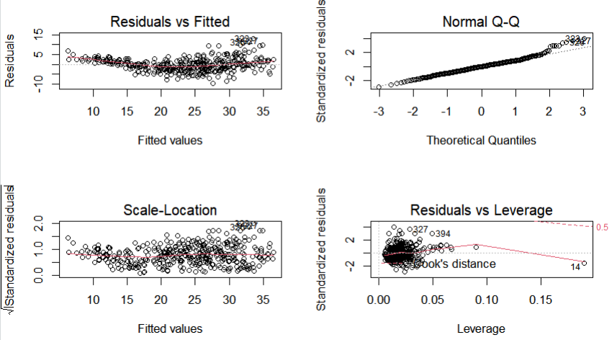

#As we can see from the plot, the fit is not accurate.If we look at the plot

#leverage, we can see that a point 14 has high leverage but not high residual.

par(mfrow = c(1, 1))

plot(predict(lm.fit), rstudent(lm.fit))

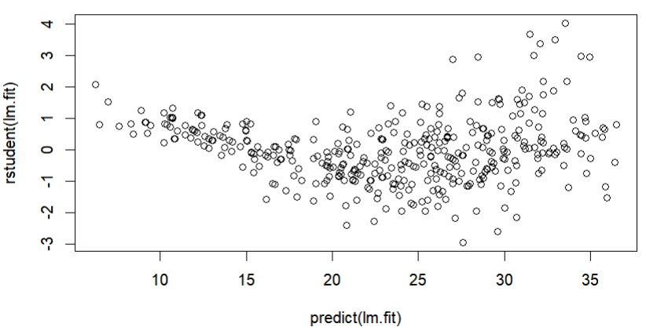

#Values greater than 3 indicate outliers.

#9e

lm.fit = lm(Auto$mpg ~ Auto$cylinders \* Auto$displacement + Auto$displacement \* Auto$weight)

summary(lm.fit)

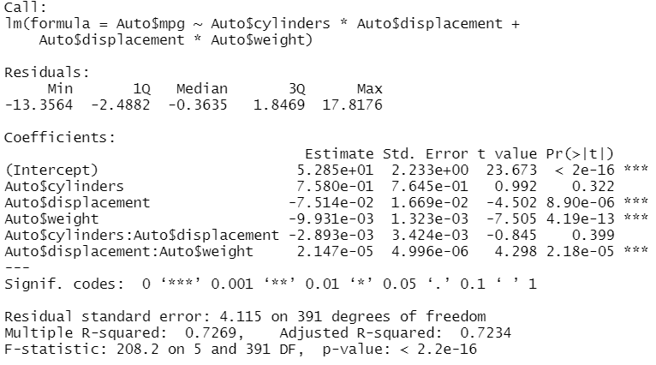

#Interaction between displacement and weight is statistically significant,

#Interaction between cylinders and displacement is not significant.

#9f

lm.fit = lm(Auto$mpg ~ log(Auto$weight) + sqrt(Auto$horsepower) + Auto$acceleration + I(Auto$acceleration^2))

summary(lm.fit)

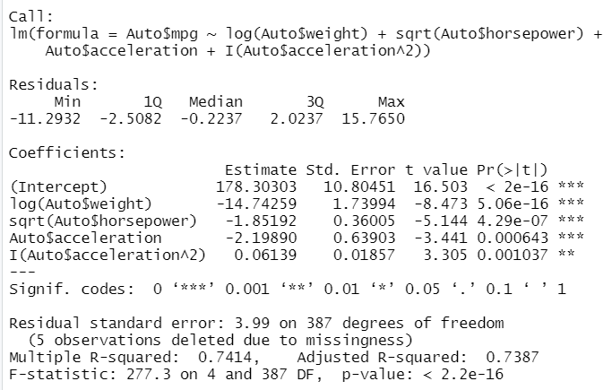

par(mfrow = c(2, 2))

plot(lm.fit)

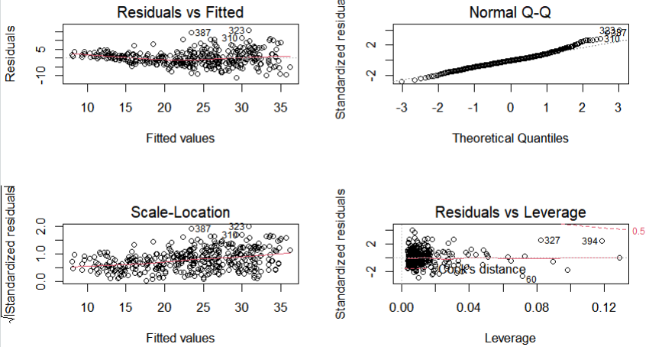

par(mfrow = c(1, 1))

plot(predict(lm.fit), rstudent(lm.fit))

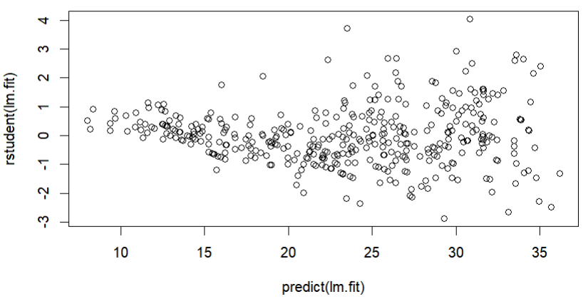

lm.fit = lm(Auto$mpg ~ Auto$weight + log(Auto$horsepower) + Auto$acceleration + I(Auto$acceleration^2))

summary(lm.fit)

par(mfrow = c(2, 2))

plot(lm.fit)

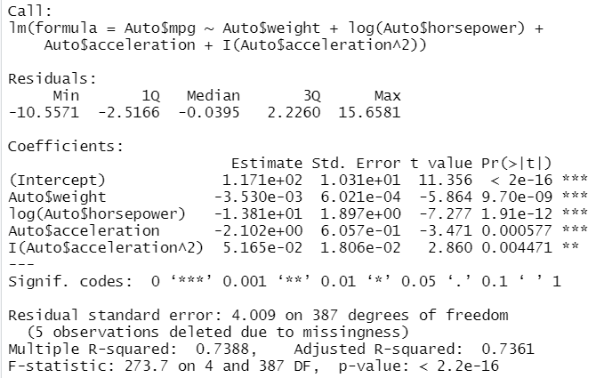

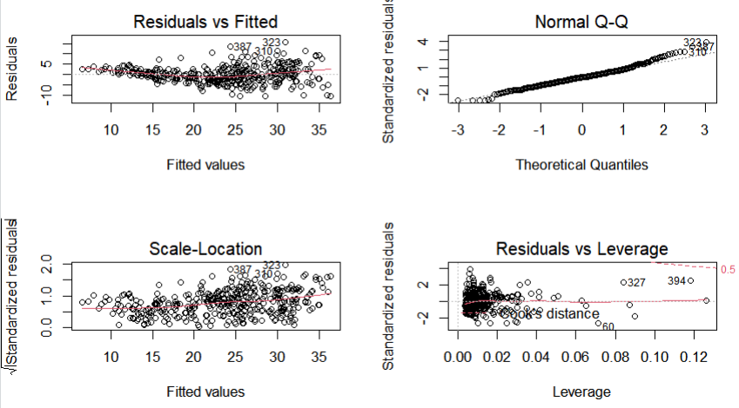

par(mfrow = c(1, 1))

plot(predict(lm.fit), rstudent(lm.fit))

