#10

library("ISLR2")

Carseats

?Carseats

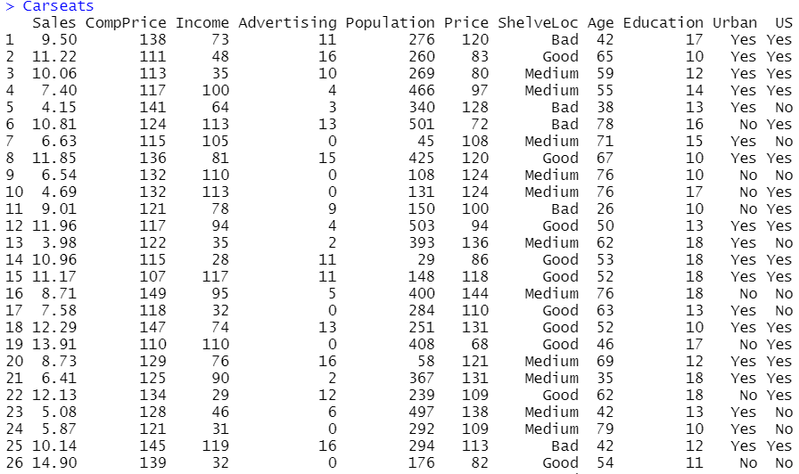

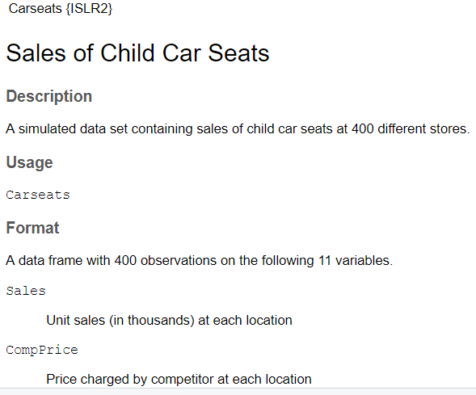

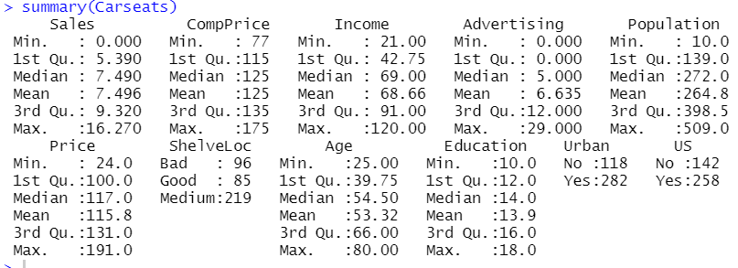

#10a

lm.fit = lm(Carseats$Sales ~ Carseats$Price + Carseats$Urban + Carseats$US)

summary(lm.fit)



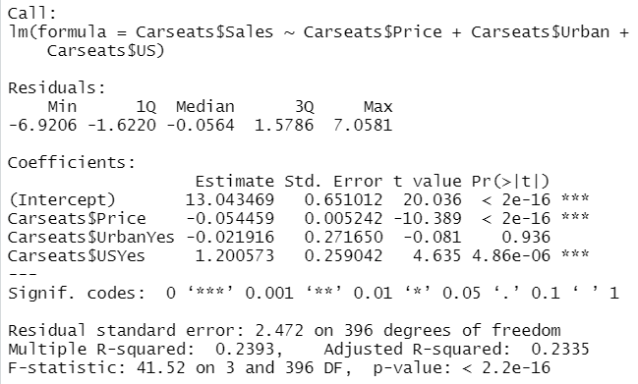

#10b

#Price. The linear regression indicates relationship between price and sale.

#This relationship is negative as we can say from the negative coefficient.

#p-value is low. Sales decrease as price increases.

#Urban. p-value is high, what means that there is no relationship between

#sales and locations of the stores.

#US. p-value is low, what indicates a relationship between US and sales.

#This relationship is negative, since if the store is in the US, sales

#increase and vice versa.

#10c

#Sales = 13.043469 + -0.054459 Price + -0.021916 Urban + 1.200573 US

#10d

lm.fit = lm(Carseats$Sales ~ Carseats$Price + Carseats$US)

summary(lm.fit)

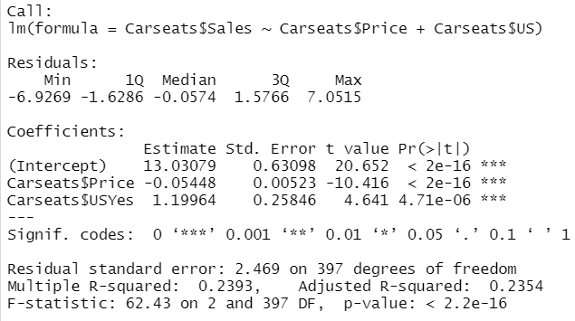

#10e

#Both of them fit data the same way.

#10f

confint(lm.fit)

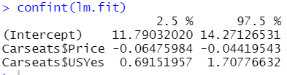

#10g

plot(predict(lm.fit), rstudent(lm.fit))

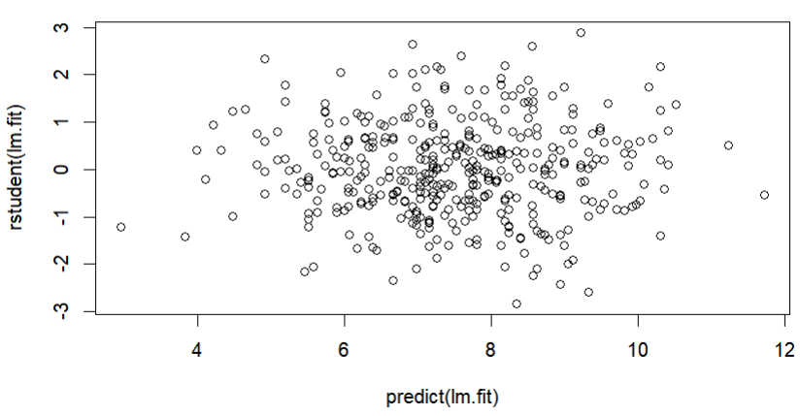

#All studentized residuals are bounded by -3 to 3, and this means that there

#are no potential outliers suggested from the linear regression.

par(mfrow=c(2, 2))

plot(lm.fit)

