#9

Auto = read.csv("Auto.csv", na.strings = "?", stringsAsFactors = T)

Auto = na.omit(Auto)

dim(Auto)

summary(Auto)

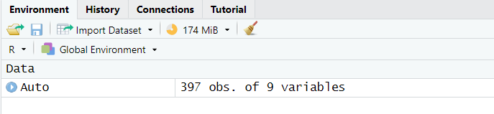

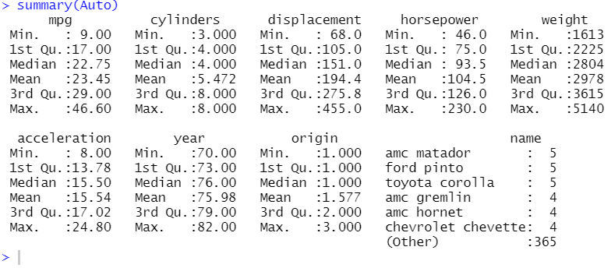

#9.a

Quantitative predictors:

* Mpg
* Cylinders
* Displacement
* Horsepower
* Weight
* Acceleration
* Year

Qualitative predictors:

* Name
* Origin

#9.b

sapply(Auto[, 1:7], range)

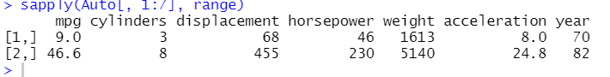

#9.c

sapply(Auto[, 1:7], mean)



sapply(Auto[, 1:7], sd)



#9.d

Auto_1 = Auto[-(10:85),]

dim(Auto_1) == dim(Auto) - c(76,0)

Auto_1[9,] == Auto[9,]

Auto_1[10,] == Auto[86,]

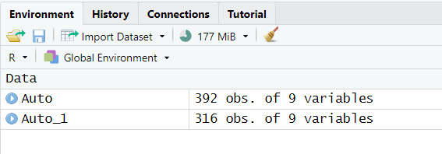

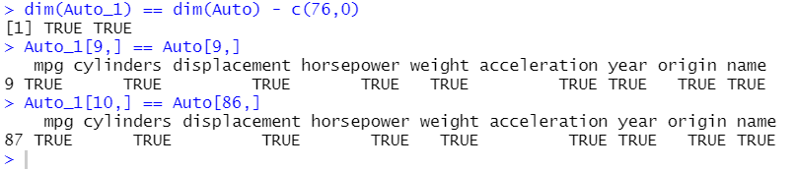

sapply(Auto_1[, 1:7], range)

sapply(Auto_1[, 1:7], mean)

sapply(Auto_1[, 1:7], sd)

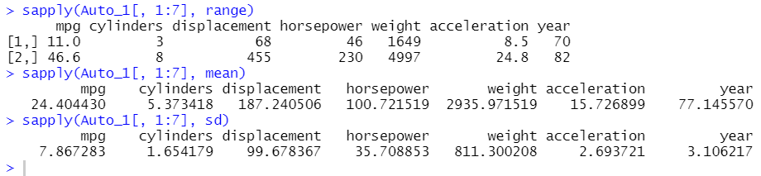

#9.e

pairs(Auto)

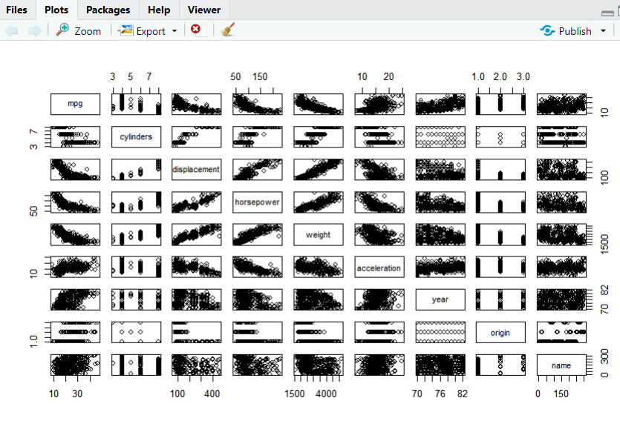

plot(Auto$mpg, Auto$horsepower)

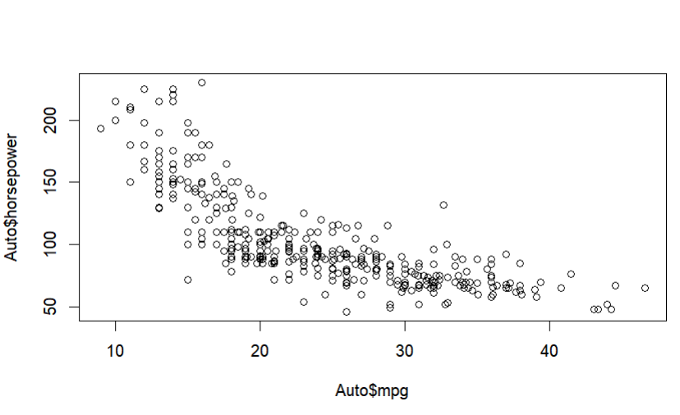

plot(Auto$mpg, Auto$weight)

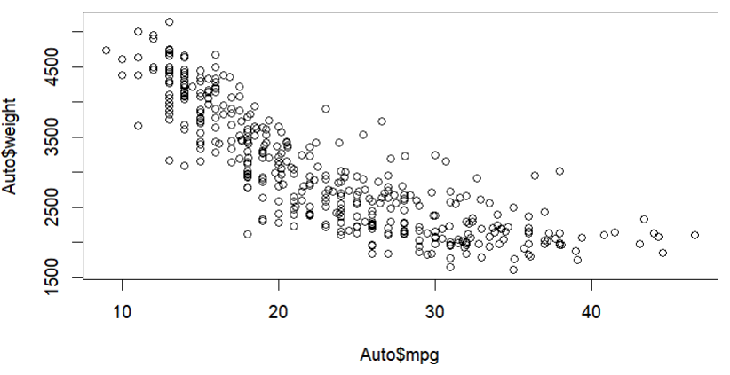

plot(Auto$mpg, Auto$acceleration)

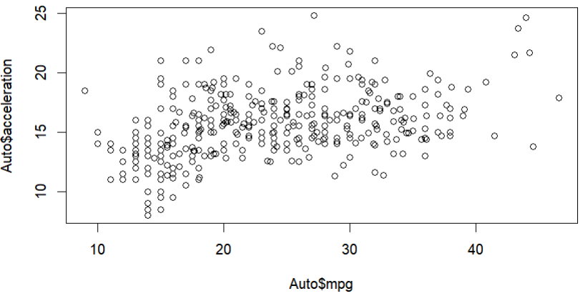

#9.f

#These plots indicate that gas mileage could be predicted

#on basis of the other variables. For example,

#the more years a car is used, the bigger mileage it has.

#the bigger horsepower, the less mileage.