#8

Auto = read.csv("Auto.csv", na.strings = "?", stringsAsFactors = T)

summary(Auto)

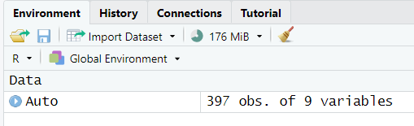

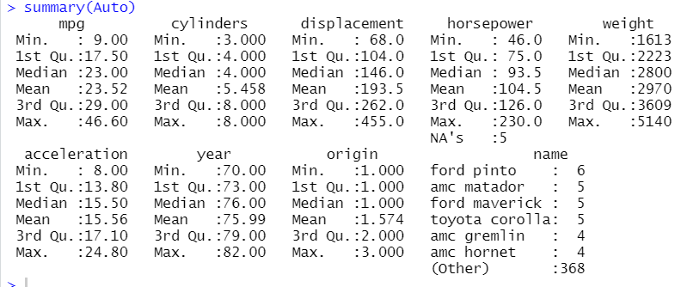

View(Auto)

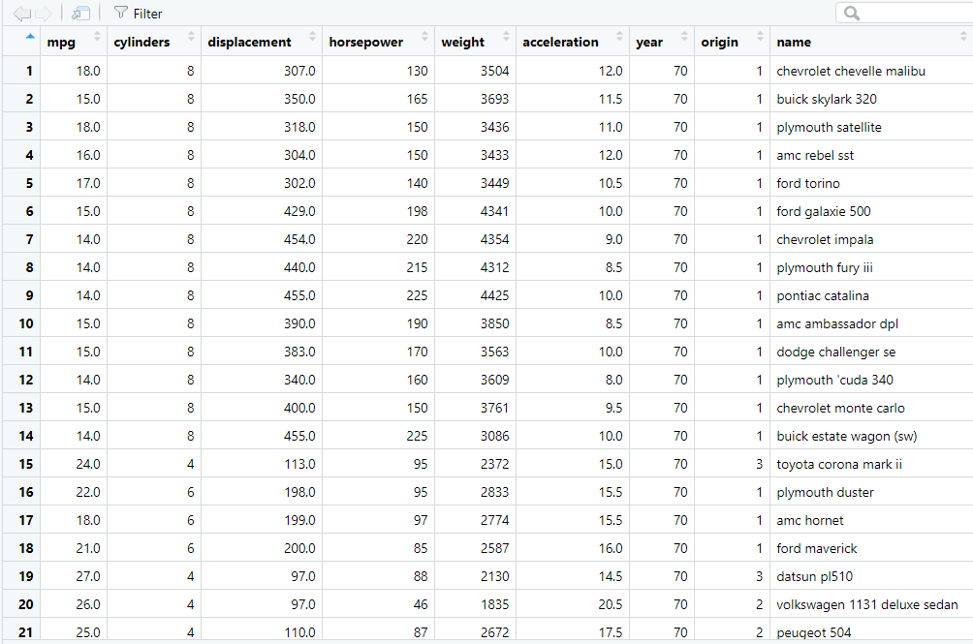

#8a

lm.fit <- lm(Auto$mpg ~ Auto$horsepower)

summary(lm.fit)

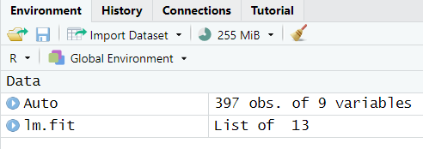

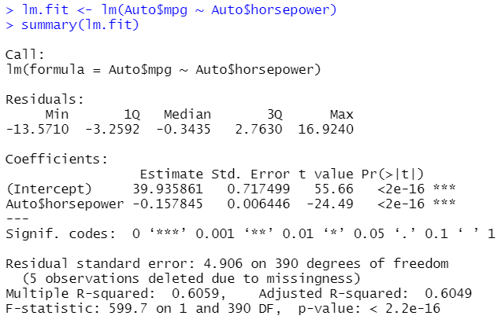

#I

#Yes. There is a relationship between the predictor (horsepower) and

#the response (mpg). The less horsepower, the more mpg.

#In this case we can reject the null-hypothesis and accept

#the alternative hypothesis, which will show that horsepower and mpg

#are interconnected.

#II

#In order to calculate the RSE of the response, we need to calculate

#the mean of mpg. Mean(mpg) = 23.52. The RSE calculated by lm()-function

#is 4.906. R^2 = 0.6059

#III

#The relationship between horsepower and mpg is negative, since

#the bigger horsepower, the less mpg.

#IV









#8b

plot(Auto$horsepower, Auto$mpg)

abline(lm.fit)

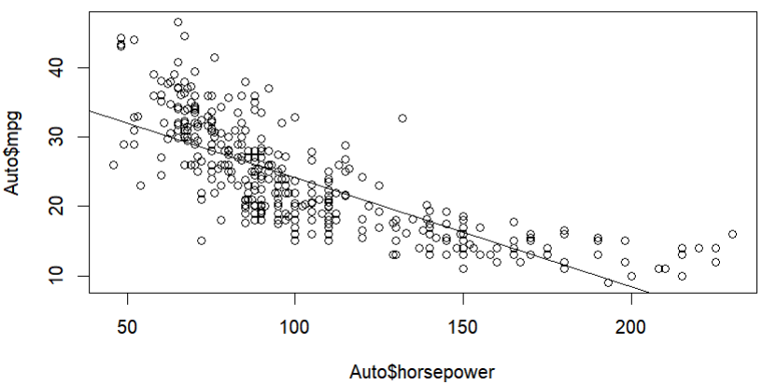

#8c

par(mfrow=c(2,2))

plot(lm.fit)

