install.packages("ISLR2")

#10

library("ISLR2")

Boston

?Boston

#There are 506 rows and 13 columns in this data set

#The rows represent a set of houses in Boston

#the columns represent different characteristics of a particular house

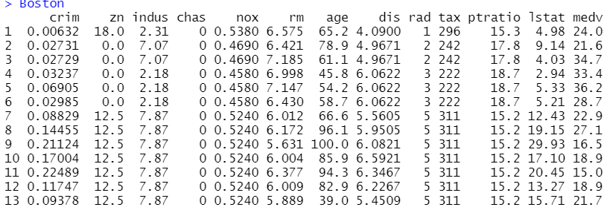

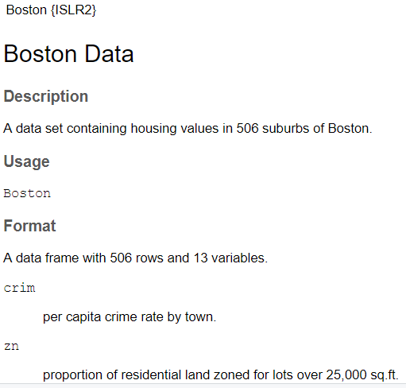

#10 b

pairs(Boston)

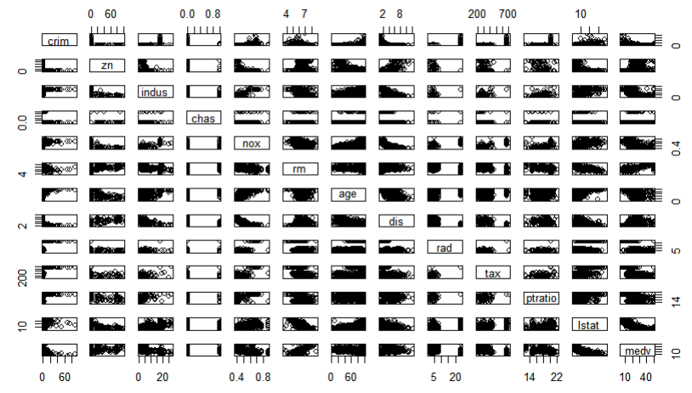

#higher tax means the higher price of the house => less crime rate in

#more expensive neighborhoods

plot(Boston$crim, Boston$tax)

|  |
| --- |
|  |

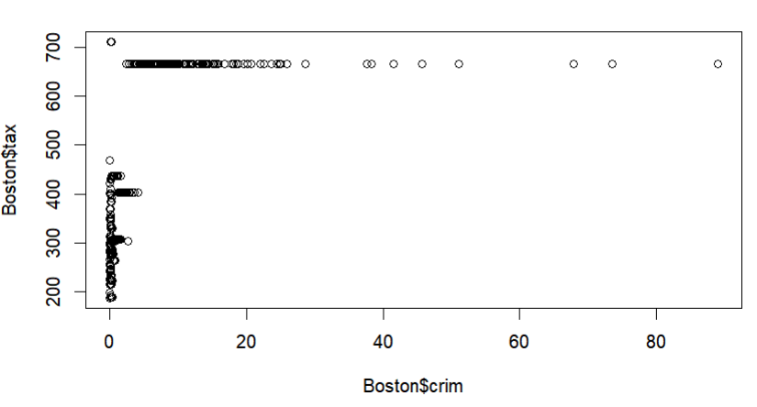

#a number of rooms is bigger in residential areas where parents with

#children live. This means that the number of rooms correlates with

#pupil-teacher ratio

plot(Boston$rm, Boston$ptratio)

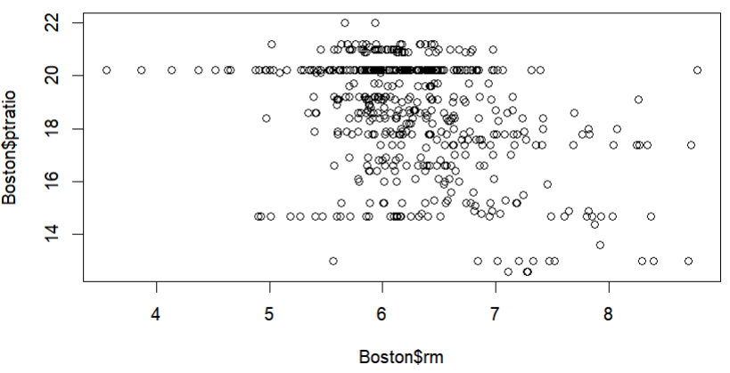

#tax correlates with an age of a house

plot(Boston$tax, Boston$age)

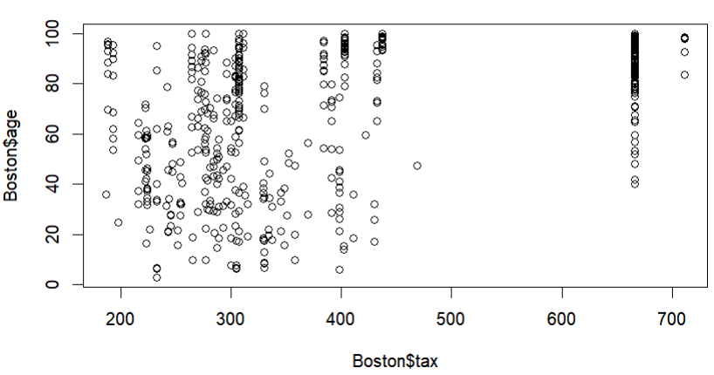

#10.c

#the older houses in the neighborhood, the higher crime rate

plot(Boston$age, Boston$crim)

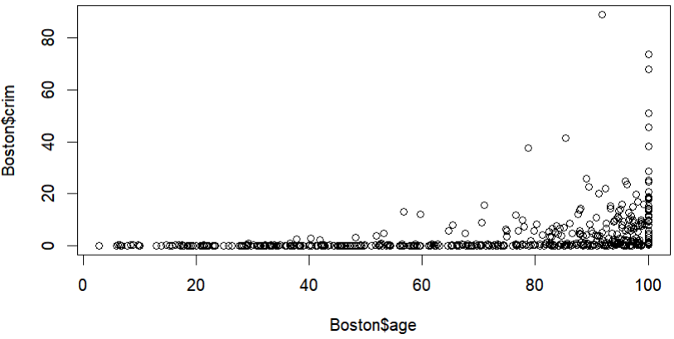

#the higher tax rate, the higher crime rate

plot(Boston$tax, Boston$crim)

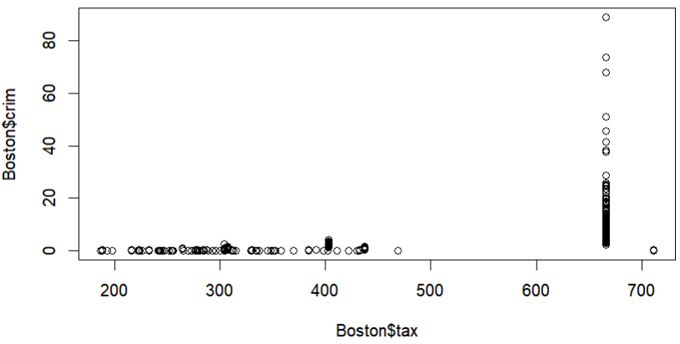

#the close to radial roads, the higher crime rate

plot(Boston$rad, Boston$crim)

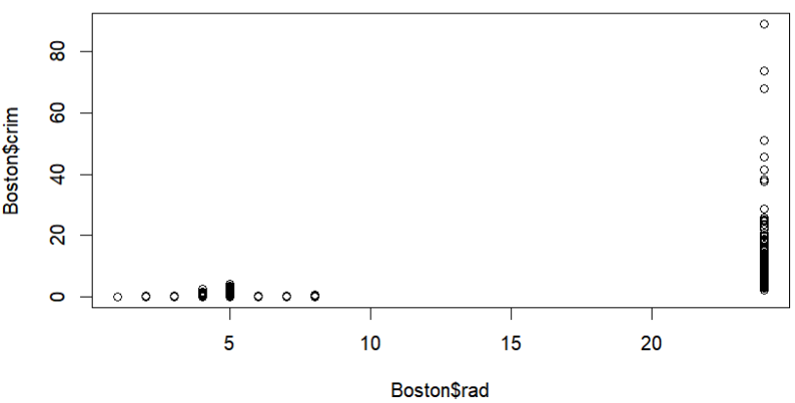

#10.d

#regarding the crime rate, it is not high in the majority of the areas

par(mfrow=c(1,3))

hist(Boston$crim[Boston$crim > 1], breaks = 25)

#the lowest value of the tax rate is 222, the highest value is 469

#what is twice as much

hist(Boston$tax, breaks = 25)

#pupil-teacher ratio is not high and varies between 15 and 21

hist(Boston$ptratio, breaks = 25)

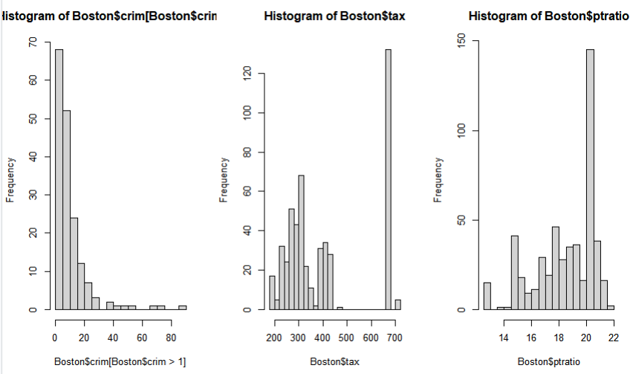

#10.e

dim(subset(Boston, chas == 1))



35 areas

#10.f

median(Boston$ptratio)



Median = 19.05

#10.g

median(Boston$crim) #0.25651

median(Boston$zn) #0

median(Boston$indus) #9.69

median(Boston$chas) #0

median(Boston$nox) #0.538

median(Boston$rm) #6.2085

median(Boston$age) #77.5

median(Boston$dis) #3.20745

median(Boston$rad) #5

median(Boston$tax) #330

median(Boston$ptratio)#19.05

median(Boston$lstat) #11.36

median(Boston$medv) #21.2

t(subset(Boston, medv == min(Boston$medv)))

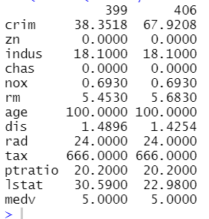

#crim high value

#zn min

#indus low enough

#chas min

#nox min

#rm very low

#age high

#dis min

#rad in first quarter

#tax greater than half

#ptratio in first quarter

#lstat border of 1st and 2nd quarter

#medv low

#This area has a high level of a crime rate, high level of old houses,

#high level of the tax rate. This indicates that this area is not good

#for living.

summary(Boston)

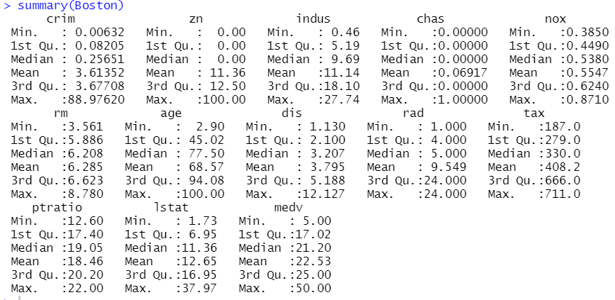

#10g

dim(subset(Boston, rm > 7))



dim(subset(Boston, rm > 8))



#There are 64 houses with more than 7 rooms

#There are 13 houses with more that 8 rooms

summary(subset(Boston, rm > 8))

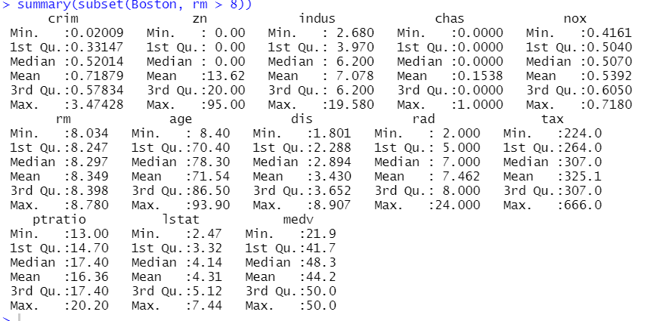

summary(Boston)

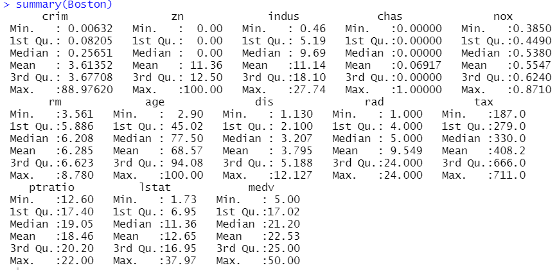

#The houses where more than 8 rooms are mostly older houses

#located in the areas with relatively low

#crime rate. Tax rates vary from lowest to highest.