#8.a

college = read.csv("College.csv", na.strings = "?", stringsAsFactors = T)

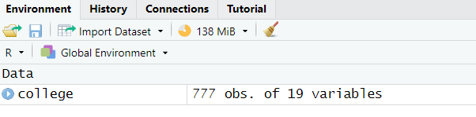

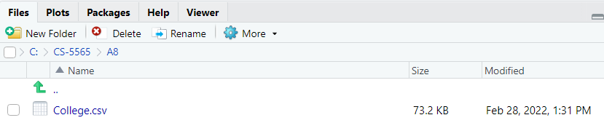

#8.b

rownames(college) <- college[, 1]

View(college)

college <- college[, -1]

View(college)

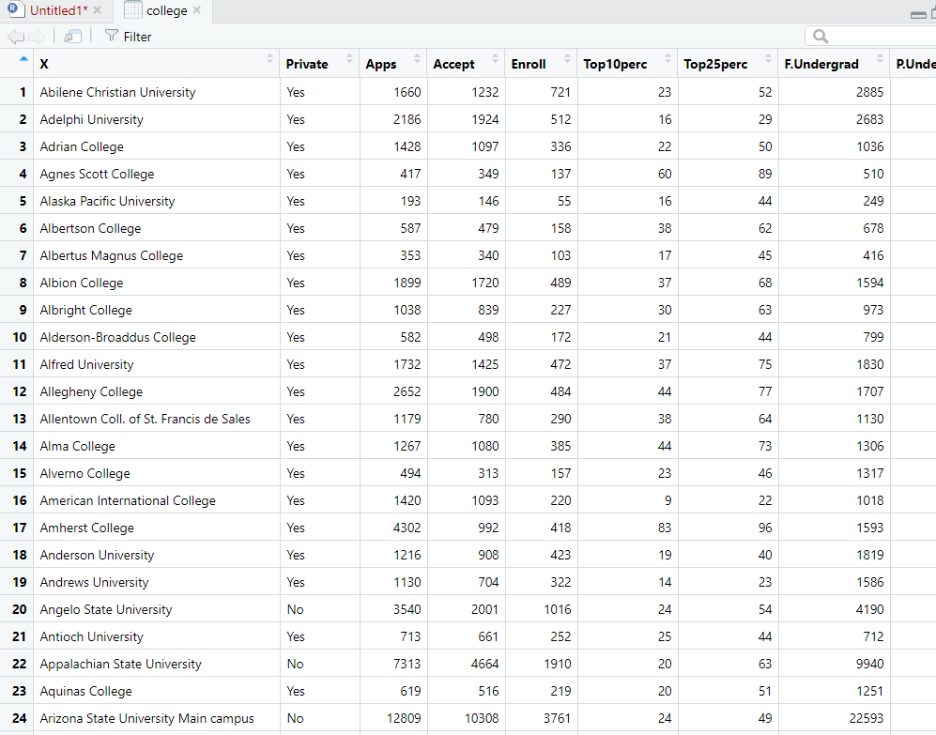

#8.c.I

summary(college)

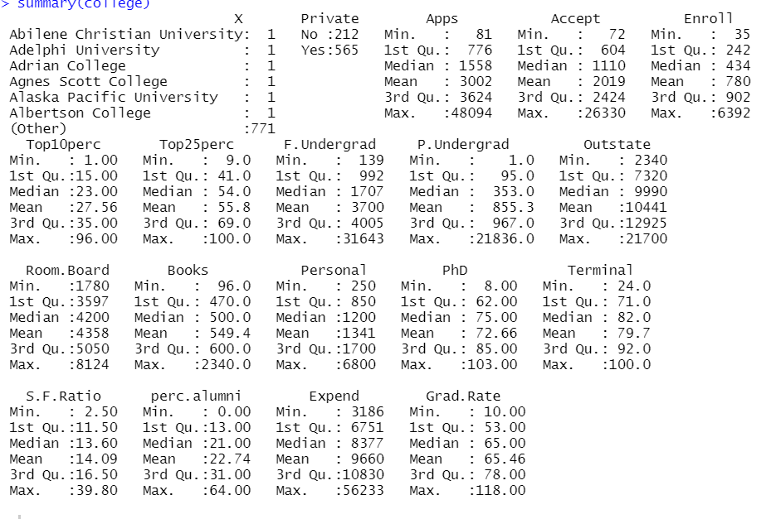

#8.c.II

pairs(college)

college[,1:10]

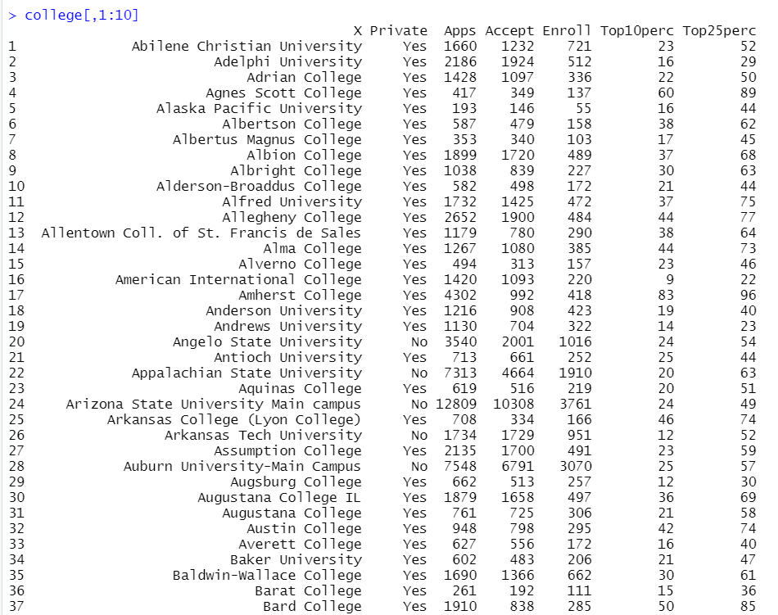

#8.c.III

plot(college$Private, college$Outstate)

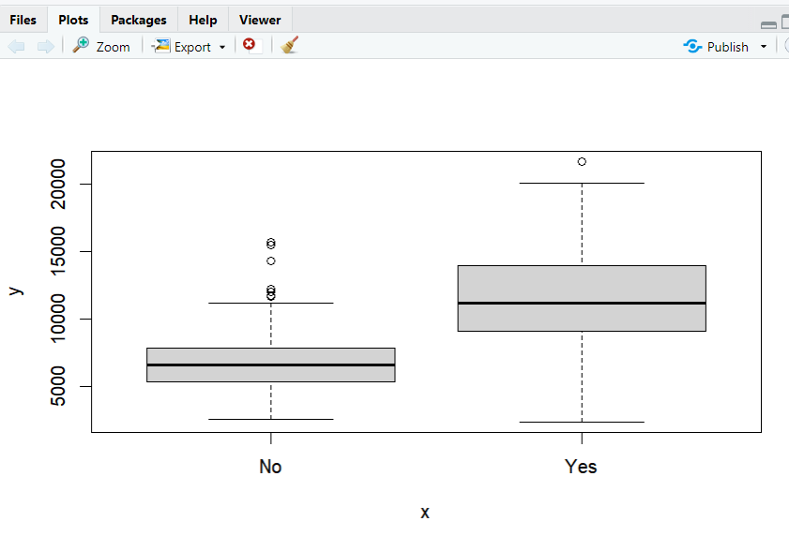

#8.c.IV

Elite <- rep("No", nrow(college))

Elite[college$Top10perc > 50] = "Yes"

Elite <- as.factor(Elite)

college <- data.frame(college, Elite)

summary(college$Elite)

plot(college$Elite, college$Outstate)

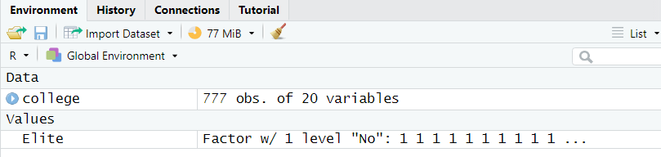

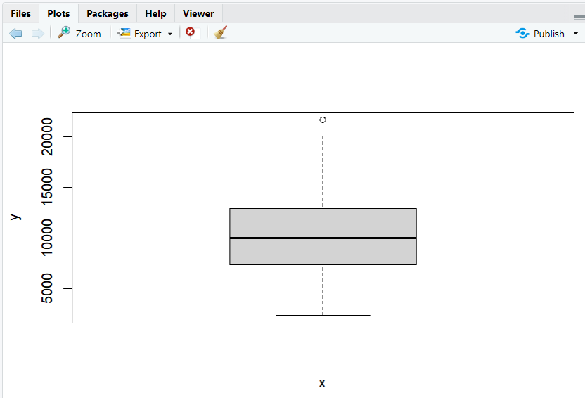

#8.c.V

par(mfrow = c(2, 2))

hist(college$Enroll, col = 5)

hist(college$Accept, col=2)

hist(college$Grad.Rate, col=3)

hist(college$F.Undergrad, col = 4)

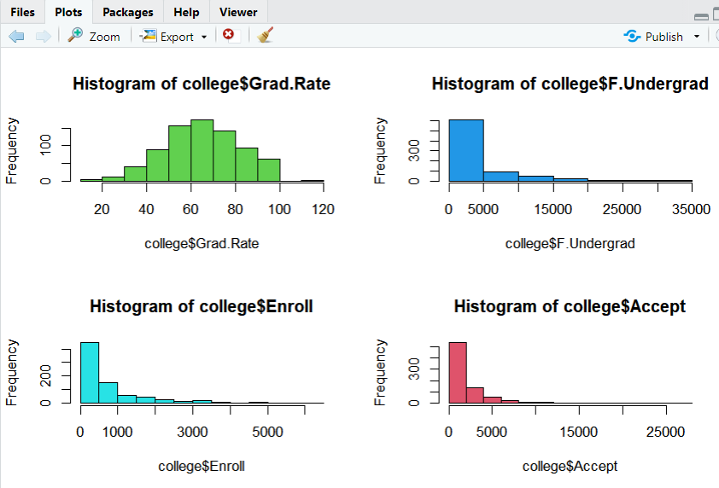

8.c.VI

par(mfrow=c(1,2))

plot(college$Outstate, college$Grad.Rate)

plot(college$Apps, college$Enroll)

