**ID** VoliaTV01

**Summary** - When a user zoom in / out the video with fingers, the size of the video on the screen does not change

**Preconditions** – To have the mobile Volia TV app on the phone

**Steps**

1 Open the mobile Volia TV app

2 Press the Search button

3 Enter the movie – Maleficent

4 Press on the movie poster

5 Press the trailer button

6 Spread fingers on the screen to zoom in

7 Swipe your fingers on the screen together to zoom out

**Expected result** – A video size increases / decreases

**Actual result** – The size of the video on the screen does not change

**Severity** - Minor

**Priority** - Low

**Type** - Usability

**Assigned to** - Dev

**Environment –** iPhone 7 iOS 14.7.1

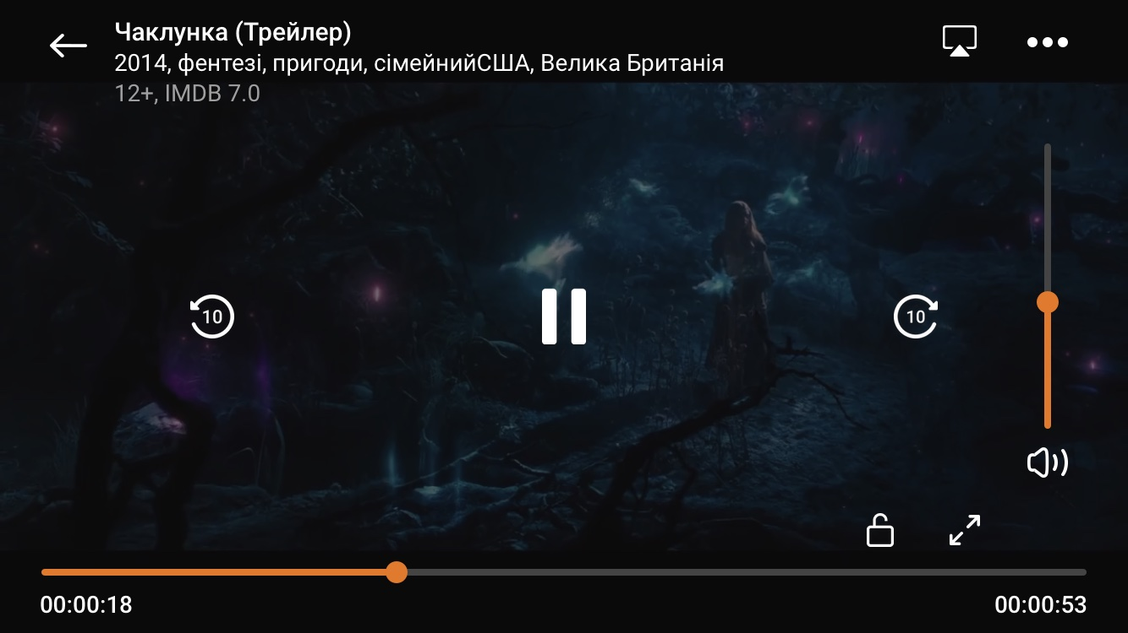

**ID** VoliaTV02

**Summary** - When a user zoom in / out the video with the button on the screen, the size of the video on the screen does not change

**Preconditions** – To have the mobile Volia TV app on the phone

**Steps**

1 Open the mobile Volia TV app

2 Press the Search button

3 Enter the movie – Maleficent

4 Press on the movie poster

5 Press the trailer button

6 Press the size change button to zoom out

7 Press the size change button to zoom in

**Expected result** – A video size increases / decreases

**Actual result** – The size of the video on the screen does not change

**Severity** - Minor

**Priority** - Low

**Type** - Usability

**Assigned to** - Dev

**Environment –** iPhone 7 iOS 14.7.1

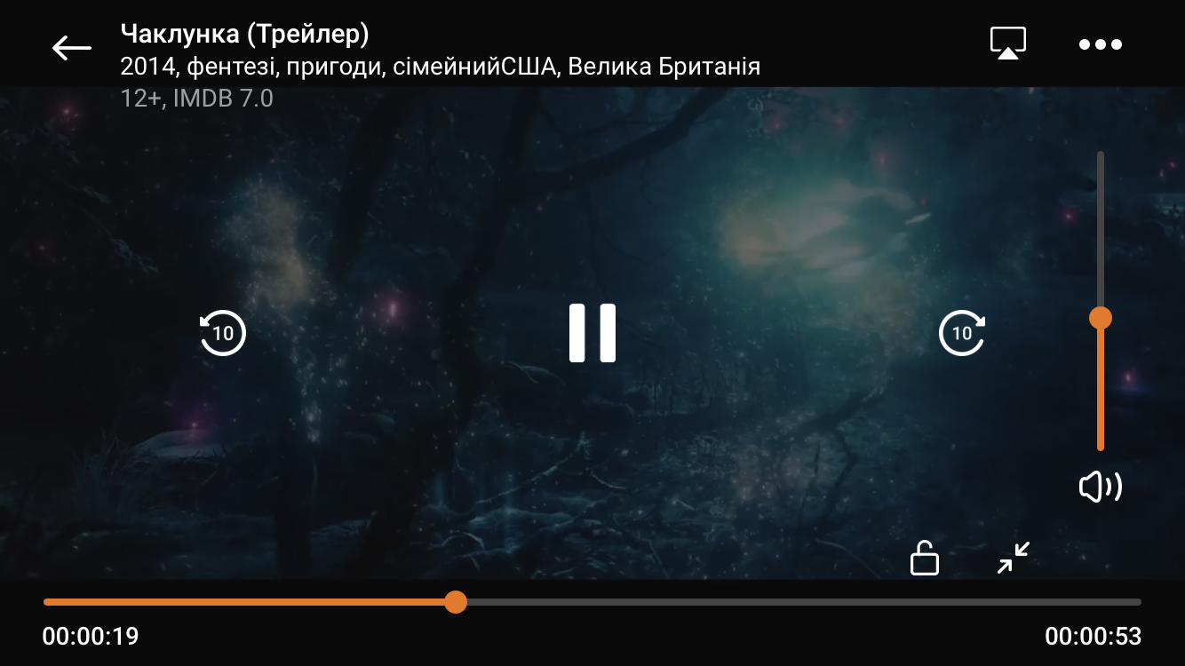

**ID** VoliaTV03

**Summary** - When a user flips the phone screen with video player vertically, the video remains horizontal

**Preconditions** – To have the mobile Volia TV app on the phone

**Steps**

1 Open the mobile Volia TV app

2 Press the Search button

3 Enter the movie – Maleficent

4 Press on the movie poster

5 Press the trailer button

6 Flip the phone screen with video vertically

**Expected result** – The video is flipped and displayed vertically

**Actual result** – The video remains horizontal

**Severity** - Minor

**Priority** - Low

**Type** - Usability

**Assigned to** - Dev

**Environment –** iPhone 7 iOS 14.7.1

