Responsive

**DEADLINE:** 04.01.2022

## FOLDER STRUCTURE

|  |  |
| --- | --- |
| FL18_HW12/*     └─ task/**      └─ FL18_HW12.docx**      └─ examples/**  └─ desktop.png**  └─ mobile.png**  └─ tablet.png**  └─ homework/*     └─ img/*      └─ contact_image.jpg *  └─ lady.jpg *  └─ logo.png *  └─ pricing_bg.jpg *  └─ services_bg.jpg *  └─ tools.png *     └─ icons/*     └─ cardiology.jpg     └─ dentistry.jpg     └─ laboratory.jpg     └─ oftalmology.jpg     └─ pediatrics.jpg     └─ radiology.jpg     └─ css/*  └─ styles.css*  └─ index.html* | * - required  ** - restricted (no need to submit) |

## TASK

In this homework, you should create a web page and provide styles for specific screen resolutions as shown in the pictures (pixel perfect is not required):

* *examples/desktop.png* - shows how the page should look like on 1280px
* *examples/tablet.png* - shows how the page should look like on 768px
* *examples/mobile.png* - shows how the page should look like on 414px

**Requirements:**

* The @media query breakpoints that are used in the example:

1. Mobile: < 768px
2. Tablet: minimal width is 768px
3. Desktop minimal width is 1280px

* 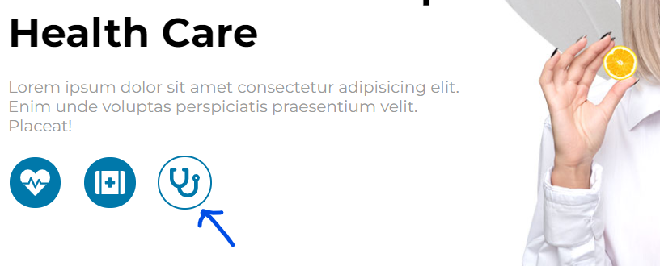All links and buttons should have **hover effect** (see screenshots below)

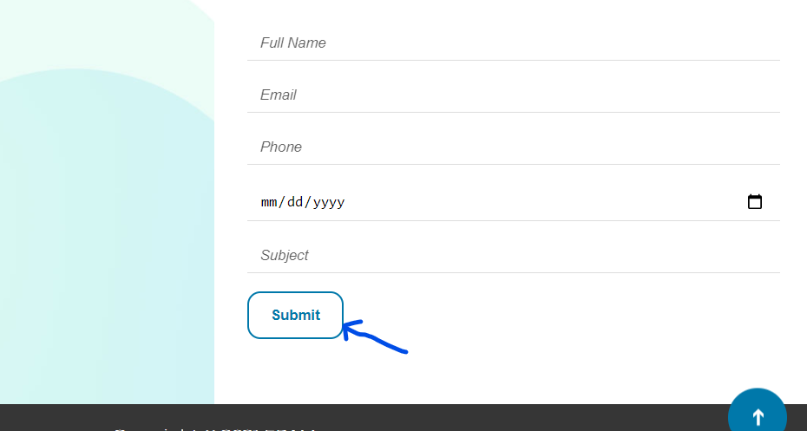

* Navigation menu should be **fixed** during the page scroll.
* Click on any of menu items should **move you smoothly** to the appropriate section on the page. Logo should move you **to the top**, the same for the “Up” button (should be also **fixed**)
* Form should include **date picker** and **dropdown with** **autocomplete** function.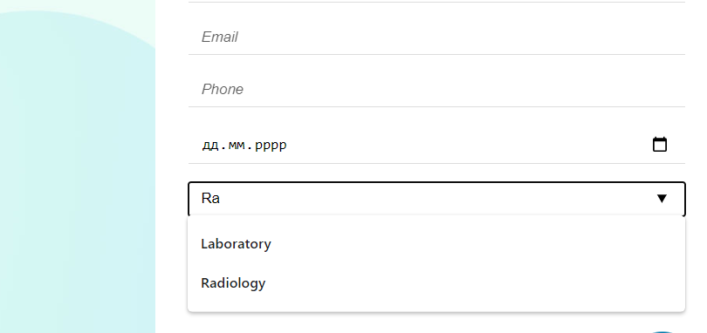

## RESTRICTIONS

* Please use pure CSS only, without any preprocessors;
* For icons use [FontAwesome](https://fontawesome.com/) (you can download icon in SVG format)
* Don’t use any 3rd party tools or libs (e.g. Bootstrap);
* Use only styles.css file for your CSS code without splitting it;
* Usage of **JavaScript** is forbidden;
* Adding **task/** and **examples/** folders is forbidden. Do not push it to repository (only homework/ folder should be pushed);
* No requirements for browser support (should work properly in Google Chrome last version).

## BEFORE SUBMIT

* Verify that all functionality is implemented according to requirements;
* Format your code (remove redundant spaces, lines of code etc.);
* Add only related to your code, valid comments;
* Validate in <https://validator.w3.org/> and <https://jigsaw.w3.org/css-validator/> ;
* Make sure your GitLab folder structure meets the required one (without **task** and **examples** folders)

## SUBMIT

* The **FL18_HW12** folder should be uploaded to GitLab repository **“FL-18”** into **main** branch

## USEFUL LINKS

* <https://developer.mozilla.org/en-US/docs/Web/CSS/position>
* <https://developer.mozilla.org/en-US/docs/Web/CSS/@media>
* <https://css-tricks.com/snippets/css/a-guide-to-flexbox/>
* <https://css-tricks.com/snippets/css/complete-guide-grid/>