OLENA SAIENKO
+380502721857 (mob) helen.saenko@gmail.com
https://www.linkedin.com/in/olena-saienko-84b1a650/
Kyiv, Ukraine

OBJECTIVE: obtain position of Financial Analyst in international company 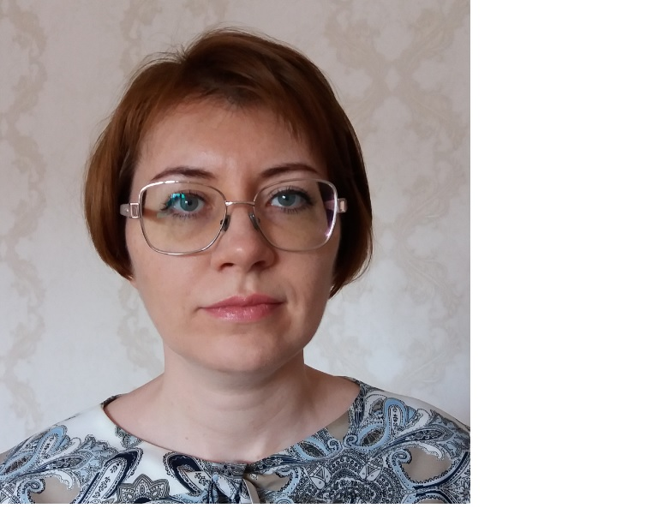

PROFESSIONAL SUMMARY:
- More than 20 years of professional experience in Financial Controlling covering all aspects of group financial reporting to parent company, management reporting, preparation of financial statements to NBU (quarterly interim financial statements and annual report of the bank to NBU audited by external auditors ), accounting at the enterprise in program “1S: Enterprise 7.7”; 11+ years of experience in international bank (ING bank Ukraine), including short-term (6 months) assignment in Head Office (in Amsterdam, the Netherlands); almost 2 years of experience in international bank (Credit Europe Bank Ukraine)
- Execution of function of Financial Control (investigations, corrections of operational mistakes of other departments, daily sanity checks for nostro accounts, receivables and payables), control and approval of invoices for payment
- Upper intermediate level of English
- Program “1S: Accounting 8.3”, “1S: Enterprise 7.7”
- Program “QuickBooks Online Plus”
- Basic knowledge of IFRS
- Knowledge of local GAAP in banking
- Basic knowledge of local GAAP in LE
- Basic knowledge of SQL-requests
- Intermediate level of knowledge of Power BI
- Financial analysis and accounting in Microsoft Excel
- Intermediate level of knowledge of Power Query & Power Pivot
- Basic knowledge of VBA
- MS Power Point Professional
- Investment analysis
- Investment modelling
- Financial modelling

PROFESSIONAL EXPERIENCE:

 | 16.10.2024 –  present  21.11.2023 -  09.10.2024  10.07.2023 –  18.07.2023  Sep’2021 – Mar’2023  Mar’2021 –  Jul’2021  Sept’2018 –  Jul’2020  Nov’ 2006  –  May’2018  Sept’2016 -  Feb’2017  Sept’ 2006 – Nov’ 2006  May’2004 – Aug’ 2006  2003 – 2004  1999 – 2003  2009  22.03.2010-25.03.2010  2015, 2016  11.08.2018-04.11.2018  03.09.2020-23.09.2020  13.12.2020-  27.12.2020  23.07.2023-  17.09.2023  02.10.2023-  06.11.2023  17.12.2023-  21.01.2024  03.02.2024-  30.03.2024  21.04.2024-  12.05.2024  16.09.2024-  20.09.2024 | Citibank, Kyiv, Ukraine  International bank https://www.citibank.com/icg/sa/emea/ukraine/  Financial Analyst of Finance Department  - Intercompany BS, P&L (23AB Covered Transactions)  - Checker of adjustments, US GAAP Adjustments, Adjustments control  - ICSA Attestation  - Control File  - Central Bank Reserves  - YE Closure  - ICAAP (Model Risk Management)  - Manual recalculation of NBU statistical reports  - Oversight of ECL  - Balance Sheet Forum  Key achievements:  - Automation with formulas, Power Query in Excel and VBA code of reporting files  National Bank of Ukraine, Kyiv, Ukraine  Central Bank of Ukraine https://bank.gov.ua/en/  Senior Specialist of the Financial Risk Methodology Department of the Risk Management Department  - Financial and liquidity analysis of banks  - Control of uploading quotes and rates of securities into the system  - Calculation of fair value of interest rate SWAPs  - Calculation of banks’ credit ratings  - Calculation of fair value of government bonds  - Calculation of yield to maturity curves  Key achievements:  - Automation with formulas, Power Query in Excel and VBA code of reports and regulations  Credit Agricole Bank, Kyiv, Ukraine  International bank https://credit-agricole.ua/  Financial Analyst of Financial controlling Department  - Acquaintance with the activities and functional responsibilities of the colleagues of the Financial Department and the department of financial controlling  - Acquaintance with the direct functional responsibilities of the position held  - Acquaintance with the technical architecture and complex of systems and programs  ProCredit Bank, Kyiv, Ukraine  International bank https://www.procreditbank.com.ua/  Analyst of Reporting and financial controlling Department  • Group financial reporting to parent company  • Participation in preparation of Business Plan (BMA or SREP) to NBU  • Participation in filling of Financial Statements in XBRL-format (Taxonomy) to NBU (2020, 2021 years)  • Participation in preparation of Stand-Alone FS for 2021 year to NBU (BS, P&L, Equity, other Notes) and interaction  with external auditors  • Reconciliation of BS and P&L XBRL-format (Taxonomy) vs Annual Report  • Interaction with developers of system InfoWare, DealWare, Scrooge-Analytics  Key achievements:  • Automation with Excel formulas of working files for group financial reporting to parent company  • Revision of clients’ data base in CW.Net to increase quality of data in BRP (Bundesbank Reporting Package)  report, reduce the number of manual adjustments  • Organization and participation in automation of download of types of economic activities from CW.Net to IW  1 SAFETY AGENCY SHOULD CREDITS LLC, Kyiv, Ukraine  Head of Department of consolidation and financial control  - Filling of P&L, Cash-Flow, BS for Group company from Account Card,  Turnover-Balance Sheet reports from Program 1S  - Filling of plan data on General & Administrative expense in P&L for international financial company  - Development of template and its filling with data upon consolidated liabilities and daily consolidated liquidity  - Filling of actual data into block Operation, P&L, Cash-Flow  - Development and maintaining a register of intragroup loan agreements  - Processing data on services from suppliers to fill in Operational expenses  - Development and preparation of daily CRM-Bank Statements reconciliation  - Accounting, calculation and accrual of interest upon intragroup loans in QuickBooks Online Plus  - Design and filling of a register of agreements with suppliers  - Control of calculation of costs for services received from vendors  Credit Europe Bank, Kyiv, Ukraine  International bank http://www.crediteurope.com.ua/ua/  Head of Financial Control Department  - Group financial reporting to parent bank  - Management reporting (Financial and Risk Management Review to bank Board and to Supervisory Board)  - Development of credit risk and interest rate risk stress-tests (before resolution #64 of NBU)  - Function of financial control (daily sanity checks, investigations and corrections under preparation of group  financial reporting to parent company, payment invoices control)  - Financial reporting to NBU (quarterly interim financial statements and annual report of the bank to NBU audited by  external auditors, partial preparation of business plan for 3 years to NBU)  Key achievements:  - Automation with Excel formulas of working files which are used as data basis for group financial  reporting to parent company  - Preparation of quarterly interim financial reporting to NBU  - Preparation of annual report of the bank to NBU  - Implementation of full financial control function in Credit Europe Bank Ukraine  ING Bank Ukraine, Kyiv, Ukraine  International bank https://www.ingbankukraine.com/ua/home  Senior Financial Controller  - Prepared group financial reporting to parent bank  - Executed Intercompany Reconciliation  - Performed Finance to Risk Reconciliation  - Processed LLP (Loan Loss Provisions)  - Consulted, participated in correspondence with contact persons from GBS Support Team (Head Office)  - Consulted local MRM (Market Risk Management), CRM (Credit Risk Management), FM (Financial Markets) and other back offices on respective questions  - Verified relevant manual entries in GBS (general ledger, data basis for GFRS – Global Financial Reporting System)  - Executed B2 (local general ledger, data base for the NBU’s reporting) - GBS - GFRS BS (Balance Sheet) and P&L monthly reconciliation  - Performed duties of secretary of LPC (Local Parameters Committee)  - Assisted and interacted with local rating agency “Credit-Rating”  - Assisted and interacted with external audit company “Ernst & Young”, “KPMG”  - Performed analysis of major competitors (market position analysis)  - Prepared MASS (management reporting) data for ING Lease Ukraine  Key achievements:  - Active and successful participation in the projects on the opening and closure of ING Bank Retail  - Active and successful participation in implementation of IFRS 9  - Participation in organization and transfer of group financial reporting to HUB (Manila) according to Head Office’s project  of centralization  Internship  ING Bank N.V. (parent company), Amsterdam, the Netherlands  Supervisor for group financial reporting for ING branches in London, Dublin, Austria  - Monitored, controlled and checked group financial reporting of respective ING branches  - Consulted and supported contact persons in appropriate ING branches  - Assisted and interacted with GFRS Support and GFRA Support (HO)  - Assisted, supported and interacted with other HO contacts from Financial Consolidation Services Division  Alfa-Bank (Ukraine), Kyiv, Ukraine  Leading economist of budgeting and control  - Executed accounting of intra company transactions and administrative costs  - Controlled budget utilization with respect to administrative costs  - Calculated limits / thresholds of administrative costs  - Prepared internal use reporting  Credit – Dnipro Bank, Kyiv, Ukraine  Economist of financial and economic department (Kyiv branch)  - Monitored budget utilization  - Prepared BS and P&L reports  - Controlled administrative costs  - Monitored balances on current accounts of legal entities  - Calculated liquidity gap  - Forecasted corporate customers’ balances on current accounts  - Calculated and supported reserve on correspondent account in the NBU  - Executed an interbranch lending, accounting  EDUCATION:  Ukrainian academy of banking, economic faculty  Master degree in Banking  Diploma with honors of Master of Banking, medal of the National Bank of Ukraine  Ukrainian academy of banking, economic faculty  Bachelor degree in Banking  Diploma with honors of Bachelor of Banking  TRAININGS:  Negotiation Skills (Amsterdam)  Customer Centric Lean Six Sigma Green Belt Training (Amsterdam) - Certificate  Microsoft Excel  Courses “Basics of accounting. “1S: Accounting 8.3”. Chief Accountant: Financial and Tax reporting at  enterprise. Electronic reporting” - Certificate  Courses “Financial reporting according to IFRS” - Certificate  Courses “Data basis MS SQL Server” - Certificate  Courses “Microsoft Power BI” – Certificate  Courses “Financial analysis and accounting in Microsoft Excel” – Certificate  Courses “Power Query & Power Pivot” – Certificate  Courses “VBA Excel” – Electronic Certificate  Courses “MS Power Point Professional” – Certificate  International workshop “Performance measurement, attribution and reporting” at The World Bank (Washington, D.C.) – Certificate
ADDITIONAL INFORMATION:
- Language skills: Ukrainian – native; English – upper intermediate
- DOB: 05.11.1981
- PC skills: Microsoft Excel, Word, Power Point, specialized banking software: ABS “GBS”, “B2”, StorQM, GFRS,
GFRA, Vantage: Vortex, GRID, ACR (CRS), Mkt Data, BRP Tool, “1S: Enterprise 7.7”, “1S: Accounting 8.3”, QuickBooks Online Plus, InfoWare (IW), CustomWare (CW.Net), Scrooge, Scrooge-Analytics,
M.E.Doc in the context of preparation of Taxonomy FS to NBU, OLAP-cubes in Excel, Microsoft SQL Server
Management Studio, SED NBU ASKOD, SAP Fiori, Omnitracker, ABS BARS “Millenium”, SAO “RM”, “MictoStrategy” (BI system), basic knowledge of SQL-requests, intermediate level of knowledge of Power BI, intermediate level of knowledge of Power Query & Power Pivot, basic knowledge of VBA, MS Power Point Professional, Flexcube, Full Suite, Pearl, e-recon, e-Sourcing, Business Objects, KNIME, Tableau (basic level)
- Professionl skills: basic knowledge of IFRS, knowledge of local GAAP in banking, basic knowledge of local GAAP in LE, Financial analysis and accounting in Microsoft Excel, Investment analysis, Financial modelling

