Next part of notes on neural networks for neuromorphic:
- https://doi.org/10.3390/photonics12030278 - (2025 , recent) - Chen, R.; Ma, Y.; Wang, Z.;
Sun, S. Incoherent Optical Neural Networks for Passive and Delay-Free Inference in Natural Light.
we propose a diffraction algorithm for incoherent light based on mutual intensity propagation
Check their refs 37, 38, 39 (linear intensity transformation), 40, 41 partially coherent
mutual intensity propagation 42-44; outputting the light intensity at the detection
surface
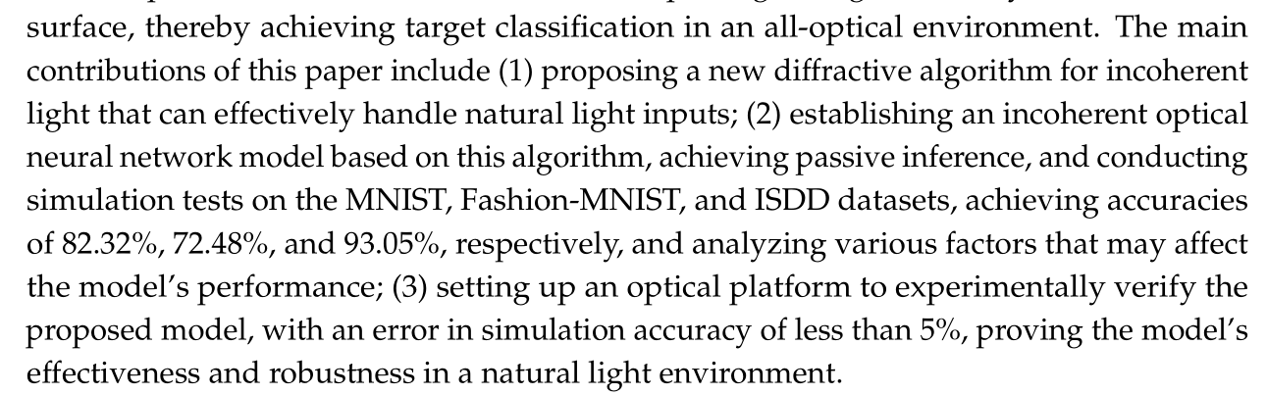
Main ideas – propagation of non-coherent light, weighted summation of final intensities. Several related theorems and formulas, plus application of Fourier transform – might be useful for us to mention. But hardly doable now, more like look aside.

- Wang et al. Light: Science & Applications (2025) 14:245, https://doi.org/10.1038/s41377-025-01927-6
Optical next generation reservoir computing.
Idea – optically generate linear and nonlinear parts to make time series next-generation reservoir computing predictions. For nonlinearity they use phase encoding, SLM. So in exponent. This represents the same idea as before in Yildirim and Ginan papers. Reservoir computing – interesting idea itself, especially with this approach. Good for our benchmark purposes.
- https://doi.org/10.1038/s41467-025-65356-0 - Hundred-layer photonic deep learning

- 2601.15340 – physical KAN

Important ideas – how to train 2 nonlinearities to make one KAN in parallel. We could show the same if we have frequency dependence or something like that or two graphene parts controlled / strained differently. Good benchmarking, testing on experiment and also good ideas on how to make more multi-variate functions. Out-of-chip optimization as well. And here we have analogue of some quadratic splines.
- Cho2025 -

