**Signing In Telegram**

1. Go to <https://my.telegram.org/auth>
2. Fill in your phone number

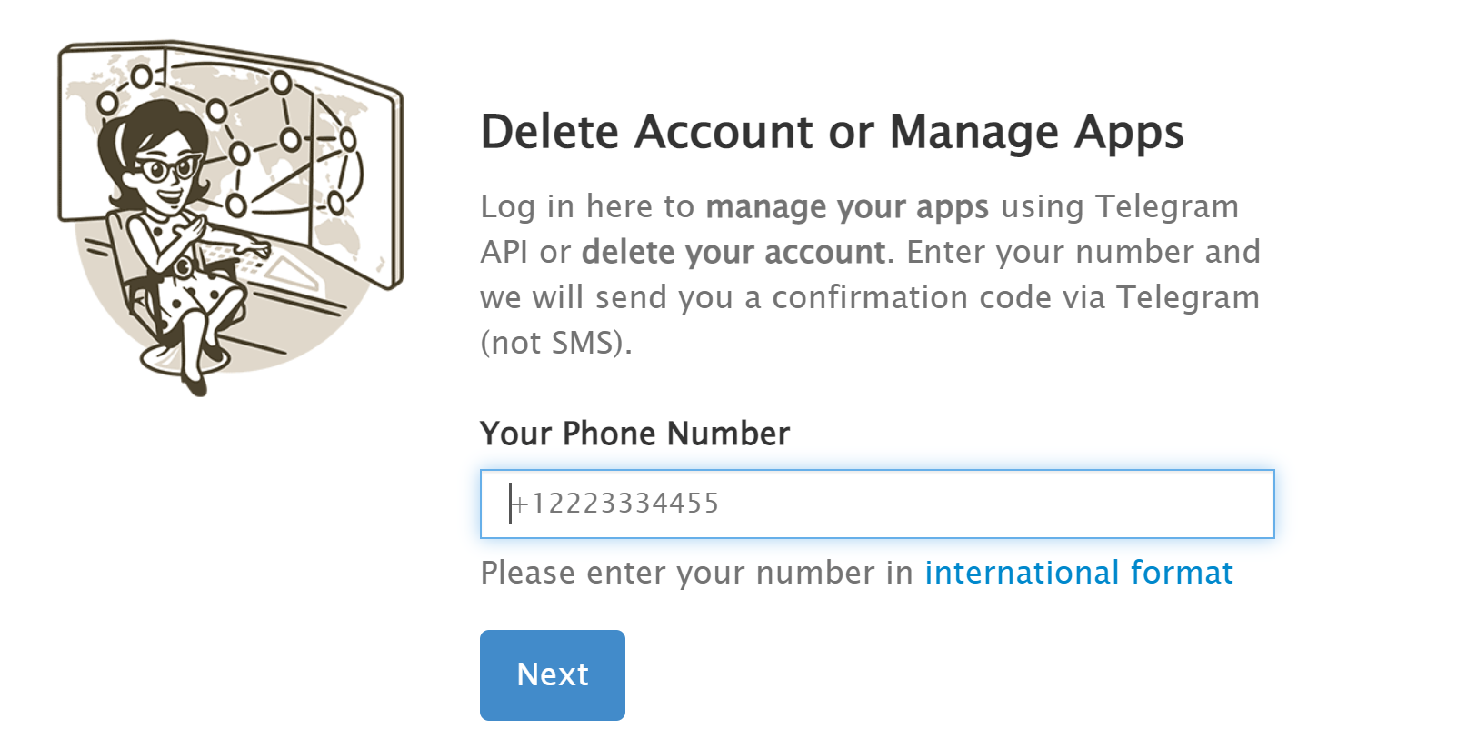

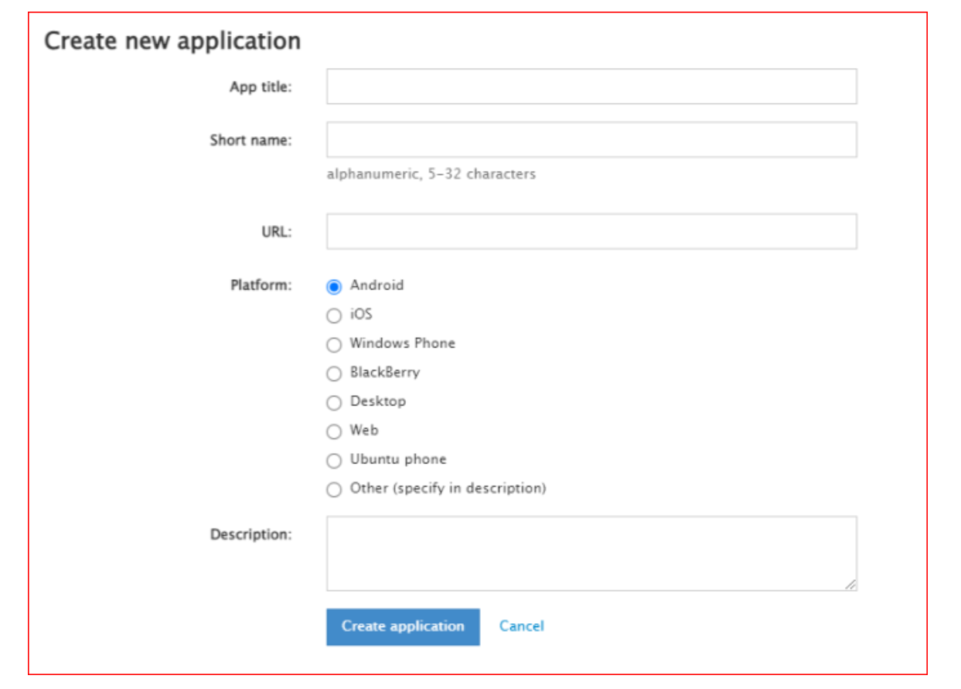

* **App title** – fill in a name of your application (any);
* **Short name** - any;
* **URL** - optional;
* **Platform**- Other (specify in description);
* **Description**– optional
* Create application

1. You’ll get App configuration, save it. You’ll need api_id and api_hash later.

