# Homework

(any task from each section)

## Conditional statements

1. Write console or WF (Windows Form) application, which:
   1. Asks user to enter year value,
   2. Check entered value (if it is not integer, user should see error message and asked to enter year value once again),
   3. Show message if entered year is a leap year or not.
2. Write console or WF (Windows Form) application, which:
   1. Asks user to enter three numbers,
   2. Check entered value (if it is not number, user should see error message and asked to enter number once again),
   3. Find the biggest number and show message with it.
3. Write console or WF (Windows Form) application, which:
   1. Asks user to enter two digits, which are XY coordinates,
   2. Check entered value (if it is not number, user should see error message and asked to enter number once again),
   3. Define the quadrant where the coordinates are located.

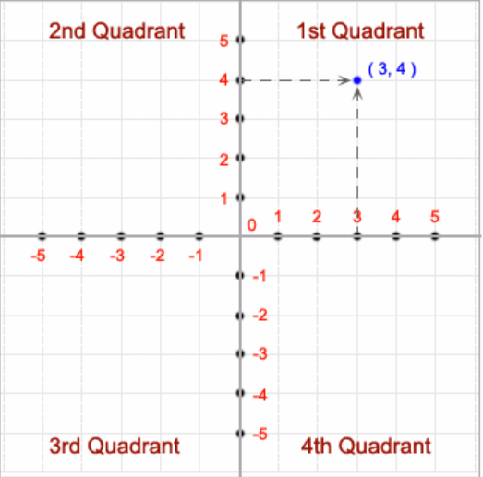

## Loops

1. Write console or WF (Windows Form) application, which:
   1. Asks user to enter lines amount,
   2. Check entered value (if it is not number, user should see error message and asked to enter number once again),
   3. Depends on entered amount of line , application should draw pyramid with numbers increased by 1.

Example: user entered 4 (4 lines should be drawn)

1

2 3

4 5 6

7 8 9 10

1. Write console or WF (Windows Form) application, which:
   1. Asks user to enter number,
   2. Check entered value (if it is not number, user should see error message and asked to enter number once again),
   3. Show sum of series 1+11+111+1111+..., where series amount is entered number.

## Arrays

1. Write console or WF (Windows Form) application, which:
   1. Asks user to enter array length (do check for entered value),
   2. Asks user to enter all array elements (do check for entered values),
   3. Show array element in ascending order.
2. Write console or WF (Windows Form) application, which:
   1. Asks user to enter array length (do check for entered value),
   2. Asks user to enter all array elements (do check for entered values),
   3. Show array element in descending order.