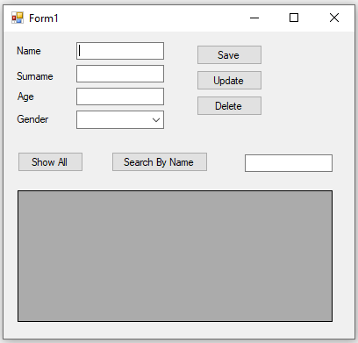

1. Save button: should save data from text fields to DB
2. Show All button: should show all records retrieved from DB
3. Search By Name: should show records with Name according to search criteria
4. Update button: should update record selected inthe grid
5. Delete button: should delete selected rows from grid