**Class:** CIT-243 – Android Programming

**Participating students:**

Aliaksei Petrusevich Olga [last_name] Shawn [last_name]

**Professor:** William R. Cronin

**Topic:** Network Messenger

Android OS is one of the most popular operating systems developed specifically for mobile devices such as cell phones and tablets. Increasing popularity of smartphones and portable computers fostered the development of many Android based applications – banking applications, messengers, games, and many more. It is predicted that the demand for this field will continue growing as well as the demand for android developers.

Our team has decided to develop an instant messenger system for Android. The project will implement the fundamental knowledge of Java, Android Studio, and other major concepts of computer science. The general view of the project is the following. Each user will have client app installed on their device. The app will require the user to register or log in. After registration (or successful login attempt) the user may proceed to his list of contacts. In the list of contacts user may be able to select an existing contact or add new. After selecting a contact, the user may send this contact a message.

During current state of development, the general view of the app will be the following:

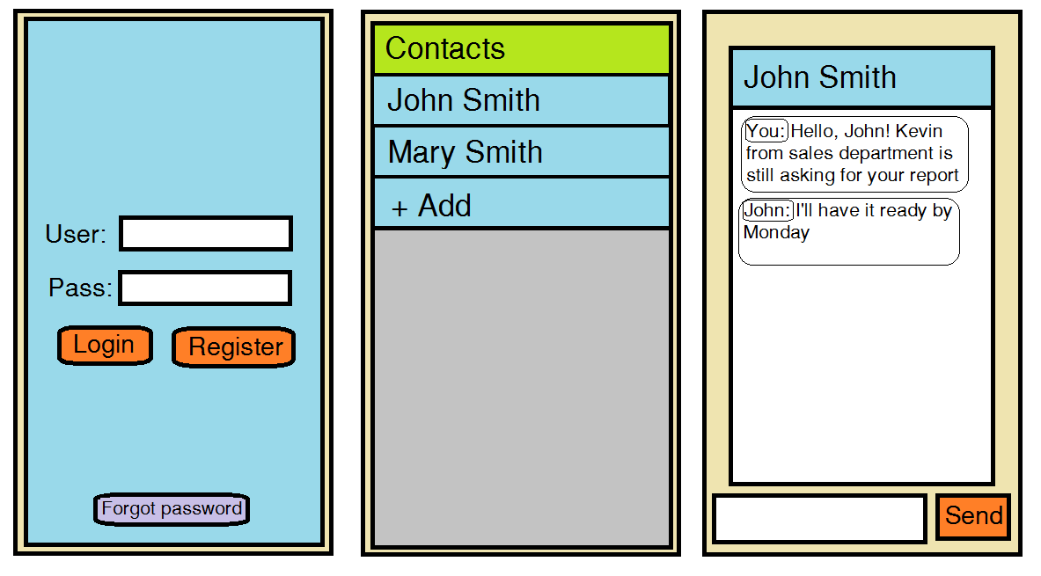

Although it is possible that our approach to this project may change, it is clear that the project will implement the following concepts:

* Activities called from another activity
* Fragments placed on activities (or multiple fragments on landscape layout)
* Recycler view for contacts
* Passing data between client and a server
* Mobile database
* Designated server to store all user data

The project is expected to summarize our knowledge of Java and major computer science concepts, as well as develop team working skills and project management experience using GitHub.