Olga Mjakinkova
LOGICAL DATA MODEL OF SUBWAY

Contents
1 TASK Description 3
1.1 The benefits of implementing a database 3
2 Model description 4
2.1 Definitions & Acronyms 4
2.2 Logical Scheme 4
2.3 Objects 5
3 CONCLUSION 13

TASK Description

For this task should be designed a data model of a subway.
There wasn’t provided any specific tamplate so all the table names and column names was created by the author. All the connection between tables was created by the author.
To complete this task should be followed next rewurments:
- The model should be in 3rd normal form (3NF).
- Your model should include 10-15 tables (relations).
- Your model should include at least one many-to-many relationship (think about how to implement this relationship).
- All relationships should be graphically indicated on the diagram
- Сheck that the visualization of relationship matches the logic
- The correct data types should be specified.
- Keys and other constraints should be specified.
- The names of the tables and columns should be clear (adhere to the coding standards).

The benefits of implementing a database

The subway system faces challenges such as inefficient scheduling, unpredictable delays, a lack of tools for maintenance tracking, and limited insights into ticket sales and route performance.
The proposed 13-table database is structured and organized to help the management team track all necessary information on a daily basis. This database is built using the data that the subway system relies on every day. By providing a well-structured system, it enhances decision-making capabilities.
- Solving Scheduling Inefficiencies: The Arrivals_departures table provides real-time monitoring of train schedules, resolving delays and optimizing service, while Train_assignment ensures efficient crew allocation.
- Managing Delays: Train_delays, linked to Arrival_departures infromation, helps track delay causes and durations, enabling quick responses and performance improvements.
- Improving Maintenance: Infrastructure and Maintenance_records tables track asset conditions and repair history, preventing failures and ensuring safety.
- Revenue Insights: Tickets and Ticket_purchases, offer route-specific pricing and sales data, aiding revenue optimization.
- Route Planning: Routes and Lines data supports strategic route adjustments and capacity planning.
- Optional Tracking: Managers can monitor daily subway operations based on their own KPIs.

This database resolves key operational challenges, providing the management team with actionable data to improve reliability, safety, and profitability.

Model description

Definitions & Acronyms
For this model was used colors.
Color coding:
- Blue: Station-related tables (Stations, Lines, Routs).
- Green: Employee-related tables (Employees, Train_assignments).
- Red: Train-related tables (Trains, Arrivals_Departures, Train_Delays).
- Purple: Infrastructure-related tables (Infrastructure, Maintenance_records).
- Orange: Ticketing-related tables (Tickets, Ticket_Purchases).
- Table without colour shows bridge table connections ( LineStations).

Description of the following acronyms that appear in the scheme:
PK – Primary Key
FK Foreign Key

Logical Scheme
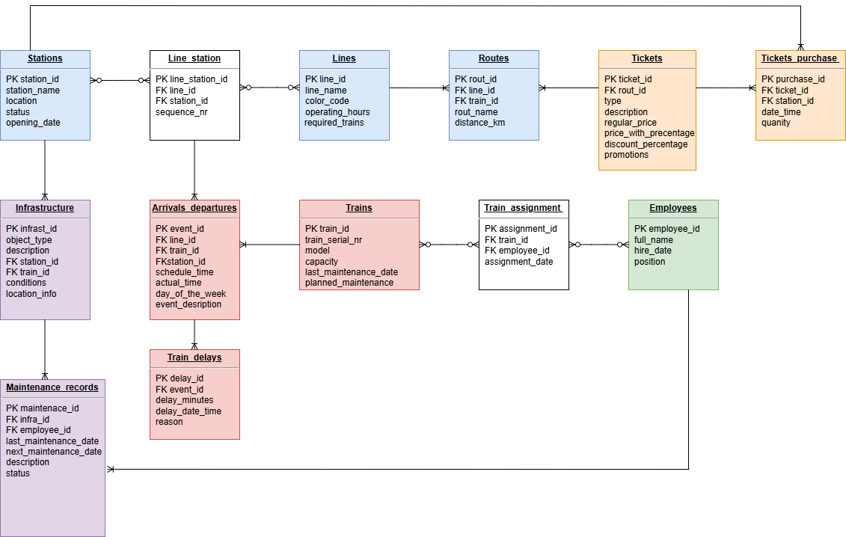

Objects
Table 1 Description
The Station table contains information about subway station names, station locations, station status (open, closed), and station opening date.

Stations | Field name | Field Description | Data Type
Table 1 | station_id | PK | Int
 | station_name | The name of the station. | VARCHAR
 | location | Information about station location. | VARCHAR
 | status | Information about station status. Open or closed. | Text
 | opening_date | The date when station was opened. | Date

Relationships:
Many-to-Many relationships with Line_station. This column is used as a bridge column.
One-to-Many with Infrastructure.
One-to-Many with Arrivals_departures via Line_station bridge table.

Example with data

station_id | station_name | location | status | Opening_date
1 | Central station | North district | open | 11.03.1992

Table 2 Description
The Line_station table is used as a Bridge Table for Lines and Stations. It manages the many-to-many relationship between Lines and Stations, tracking which stations belong to which lines and their order.

Line_station | Field name | Field Description | Data Type
Table 2 | line_station_id | PK | Int
 | line_id | FK | Int
 | station_id | FK | Int
 | sequence_nr | The order of the station along the line | Int

Relationships:
Many-to-Many with Lines and Stations.
Many-to-One with Arrivals_departures.

line_station_id | line_id | Station_id | sequence_nr
1 | 2 | 101 | 3
Example with data

Table 3 Description
The Line table defines subway lines with operational parameters.

Lines | Field name | Field Description | Data Type
Table 3 | line_id | PK | Int
 | line_name | FK | Varchar
 | color_code | FK | Varchar
 | operating_hours | Information about lines working hours | Time
 | required_trains | Number of required trains per line | Int

Relationships:
Many-to-Many with Lines_station bridge table.
One-to-Many with Routes.
One-to-Many with Arrivals_departures via Lines_station bridge table.

Example with data
Line_id | line_name | color_code | operating_hours | required_trains
1 | Red Line | #FF0000 | 05:00 - 23:30 | 20

Table 4 Description
The routes table provides detailed route information for lines.

Routes | Field name | Field Description | Data Type
Table 4 | rout_id | PK | Int
 | line_id | FK | Int
 | train_id | FK | Int
 | rout_name | Information about rout naming | Text
 | distance_km | Displays rout distance in km | DECIMAL
Relationships:
Many-to-One with Lines.
Many-to-One with Tickets.

Example with data

rout_id | line_id | train_id | rout_name | distance_km
1 | 2 | 5 | Local Route B | 15.75

Table 5 Description
The Ticket table defines ticket types with optional route association

Tickets | Field name | Field Description | Data Type
Table 5 | ticket_id | PK | Int
 | rout_id | FK | Int
 | type | Represnet ticket type | VARCHAR
 | description | The order of the station along the line | VARCHAR
 | regular_price | Tickets costs infromation | DECIMAL
 | price_with_precentage | Added procentage to the price | DECIMAL
 | discount_precentage | Applicable discount | DECIMAL
 | promotions | Information about any promotions that were available for the tickets | Text

Relationships:
One-to-Many with Routs and Tickets_purchase.

ticket_id | rout_id | type | description | Regular_price | price_with_precentage | discount_precentage | promotions
1001 | 1 | One-Way | Standart | 3.5 | 3.15 | 10% | Weekend-promo
Example with data
Table 6 Description
The Tickets_purchase table tracks ticket sales linked to stations.

Tickets_purchase | Field name | Field Description | Data Type
Table 6 | purchase_id | PK | Int
 | ticket_id | FK | Int
 | station_id | FK | Int
 | date_time | Represent purchase infromation on date and time level | DATETIME
 | quantity | Infromation about sold amount | DECIMAL

Relationships:
Many-to-One with Tickets and Stations.

purchase_id | ticket_id | station_id | date_time | quanity
5001 | 1001 | 101 | 2025-03-10 14:30:00 | 2
Example with data

Table 7 Description
The Infrastructure manage subway infrastructure components for maintenance. Including stairs,tunnels and etc.

Infrastructure | Field name | Field Description | Data Type
Table 7 | infrast_id | PK | Int
 | object_type | Infromation about object | VARCHAR
 | description | Object description | TEXT
 | train_id | FK | Int
 | conditions | Additional information about object condition | VARCHAR
 | location_info | Infromation about specifict object location | VARCHAR

Relationships:
Many-to-One with Stations.
One-to-Many with Maintenance_records.

infrast_id | object_type | description | train_id | conditions | location_info
301 | Tunnel | Main tunnel section under 5th Ave | NULL | Needs ventilation upgrade | Central Station, Entrance B
Example with data

Tabl 8 Description
The Arrivals_depeartures table records train arrival and departure events.

Arrivals_departures | Field name | Field Description | Data Type
Table 8 | event_id | PK | Int
 | line_id | FK | Int
 | train_id | FK | Int
 | station_id | FK | Int
 | schedule_time | Information about the regular train schedule (planned time) | DATETIME
 | actual_time | The actual recorded arrival or departure time of the train | DATETIME
 | day_of_the_week | The specific day of the week when the schedule applies | VARCHAR
 | event_description | Description of the event (e.g., Arrival, Departure, Delay) | VARCHAR

Relationships:
Many-to-One with Line,Trains,Stations via Line_station bridge table.
One-to-Many with Train_delays.
Example with data
event_id | line_id | train_id | station_id | schedule_time | actual_time | day_of_the_week
801 | 2 | 5 | 101 | 2025-03-10 08:30:00 | 2025-03-10 08:35:00 | Monday

Table 9 Description
The Trains table manages train details.

Trains | Field name | Field Description | Data Type
Table 9 | train_id | PK | Int
 | train_serial_nr | Unique serial number assigned to the train | VARCHAR
 | model | Train model | VARCHAR
 | capacity | Maximum number of passengers the train can accommodate | Int
 | last_maintenance_date | Date of the last performed maintenance | DATETIME
 | planned_maintenance | Scheduled date for the next maintenance check | DATETIME

Relationships:
One-to-Many with Arrivals_departures, Train_assignments.
Many-to-Many part of the Employees relationship via Train_assignments.

Example with data
train_id | train_serial_nr | model | capacity | last_maintenance_date | planned_maintenance
5 | SN-2025-456 | Metro Express 2d | 200 | 2025-02-15 10:00:00 | 2025-06-20 09:00:00

Table 10 Description
The Train_assignments table is a bridge table between Trains and Employee tables.
It manages the many-to-many relationship between Trains and Employees, and tracks which employees are assigned to which trains on specific dates.

Train_assignments | Field name | Field Description | Data Type
Table 10 | assignment_id | PK | Int
 | train_id | FK | Int
 | employee_id | FK | Int
 | assignment_date | The date when the employee was assigned to the train | DATETIME
Relationships:
Many-to-Many with Trains and Employees. ( A train can have multiple employees assigned to it, and an employee can be assigned to multiple trains).
Example with data
assignment_id | train_id | employee_id | assignment_date
601 | 5 | 823 | 2025-03-10 06:00:00

Table 11 Description
The Employee table contains details about subway employees responsible for operations and maintenance.

Employees | Field name | Field Description | Data Type
Table 11 | employee_id | PK | Int
 | full_name | Employee full name first name and surname | VARCHAR
 | hire_date | Date when emplyee was hired | DATETIME
 | position | Emplotyee position | VARCHAR
Relationships:
Many-to-Many with Trains relationship via bridge column Train_assignment.
Example with data
employee_id | full_name | hire_date | position
502 | John Johnson | 2022-06-15 | Train operator

Table 12 Description
The Train_delays table is created to tracks train delays with linked events and optional reporting.

Train_delays | Field name | Field Description | Data Type
Table 12 | delay_id | PK | Int
 | event_id | FK | Int
 | delay_minutes | Number of minutes the train was delayed | Int
 | delay_date_time | The date and time when the delay occurred | DATETIME
 | reson | Explanation of the cause of the delay | VARCHAR
Relationships:
Many-to-One with Arrival_departures.

Example with data
delay_id | event_id | delay_minutes | delay_date | reason
801 | 1205 | 15 | 2025-03-10 08:45:00 | Technical issue

Table 13 Description
The Maintenance_record table is created to tracks repair activities and assignment persons to this activities.

Maintenance_record | Field name | Field Description | Data Type
Table 13 | maintenance_id | PK | Int
 | infra_id | FK | Int
 | employee_id | FK | Int
 | last_maintenance_date | The date of the last maintenance check | VARCHAR
 | next_maintenance_date | The scheduled date for the next maintenance | DATETIME
 | description | Additional details about the maintenance work | Text
 | status | Current status of the maintenance ( Completed, Scheduled, In Progress) | VARCHAR
Relationships:
Many-to-One with Infrastructure and Employees.
Example with data
maintenance_id | infra_id | employee_id | last_maintenance_date | next_maintenance_date | description | status
3324 | 301 | 502 | 2025-02-15 10:00:00 | 2027-01-10 08:00:00 | Signal system check | scheduled

CONCLUSION
This database empowers the management team with powerful tools for real-time monitoring, proactive maintenance, and data-driven decision-making. Features like route-specific ticketing, detailed delay tracking, and infrastructure condition analysis provide actionable insights, improving passenger satisfaction, safety, and profitability. Designed in 3rd Normal Form (3NF), the schema guarantees data integrity and adaptability, positioning the subway system for future growth and technological advancements.

