**FARMER MARKET APP**

**ADMINISTRATOR GUIDE**

DESCRIPTION

«Farmer market» application is devoted to US farmer markets.

It gives opportunity to:

* search for markets by name, city, state or zip;
* order results by name from A to Z or Z to A, by city, state, ranks and votes;
* read information about the market;
* read and add comments and ranks;
* change and delete comments and ranks, if you log in using password;
* search for markets situated in the radius of N miles from chosen market.

REQUIREMENTS

* MSSQL
* Integrated development environment for Python
* pyodbc module
* flask module

DEPLOYMENT

After downloading «market_app_deployment.py» file and «farmer_market_app» folder, run «market_app_deployment.py» file and follow instructions:

1. Enter «y» if you have MSSQL and pyodbc module;
2. Enter the server name of your MSSQL instance;
3. Enter the username of your MSSQL instance;
4. Enter the password for the user;
5. Enter the name of the database to be created or used;
6. Enter «y» for full deployment. If you are using the application for the first time, choose full deployment. Enter any other symbol to run the application immediately.

During the deployment the application checks if the database exists. If not, we recommend choosing full deployment. Otherwise, you will quit the application.

**Full deployment:**

If you choose full deployment and the database does not exist, full deployment will create and populate the database and then run the application.

If you choose full deployment and the database already exists, the application will ask you if you want to drop it and create anew. If yes, full deployment will drop existing database and create and populate a new one and then run the application. Otherwise, the application will run immediately using the existing database.

**Not full deployment:**

If you choose not full deployment and the database does not exist, you will quit the application.

If you choose not full deployment and the database exists, the application will run immediately using the existing database.

**Configuration file:**

Default configuration file does not contain any passwords or usernames. All information for connection to MSSQL and the database (server name, user name, user password and database name) is written into «config.py» file during the deployment. If you exit the application using «Exit» label (see Picture 1. «Exit» label) in the upper right corner, «config.py» file will be rewritten with default set of parameters. If application is shut down without using «Exit» label, «config.py» file will save the information (server name, user name, user password and database name) of this session. To change it, in the next session shut down the application using «Exit» label, run «market_app_deployment.py» file again and enter new data.

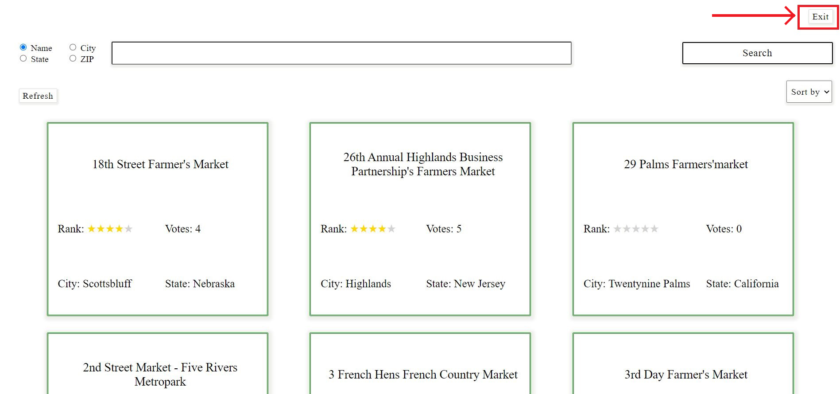

Picture 1. «Exit» label