Learning about R Markdown

#Header 1

##Header 2

###Header 3

####Header 4

List:

* **Bold**
* *Italics*

Numbered List:

1. Item
2. Item
3. Item
4. Item

This other list:

1. Item
2. Item

Superscript

Subscript

Block quotes

Footnote[1]

[Link to google](https://google.com)

# Tables

|  |  |
| --- | --- |
| Column Header | Column Header |
| Text here | More text |
| Another row | More text in this row |

# Code chunks

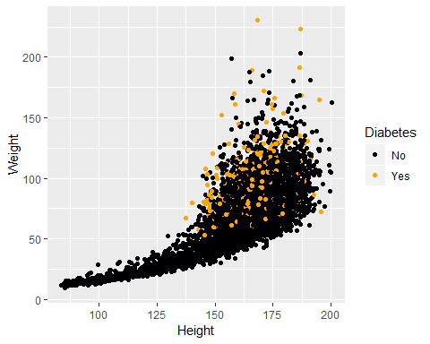

Scatter plot of weight and height by diabetes

Mean BMI by diabetes status over time

|  |  |  |
| --- | --- | --- |
| Diabetes | 2009_10 | 2011_12 |
| No | 26.37582 | 25.94804 |
| Yes | 32.58843 | 32.53279 |
| NA | 40.76000 | 22.20000 |

Including inline R code 36.7421.



They said: [@Kim2018a]

#References:

1. This is the footnote.