**OLGA TSUPRIK**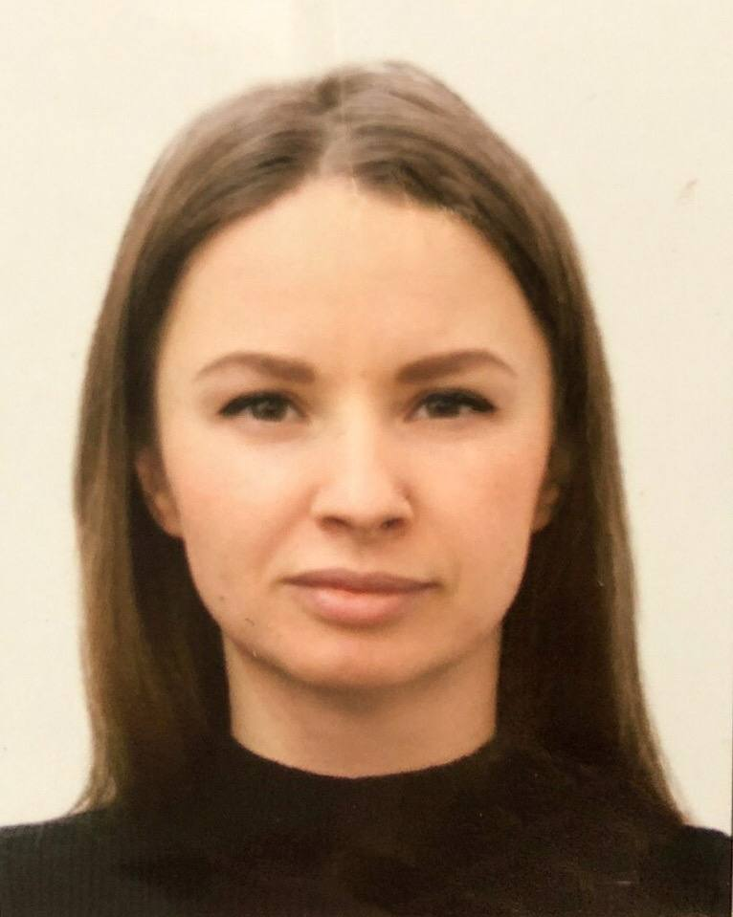

**Phone:** +375 (44) 788-27-22

**Email:** tt.olia@mail.ru

**Skype**: tt.olia@mail.ru

**GitHub/Gitlab/Others: https://github.com/OlgaTsuprik**

**LinkedIn:** https://www.linkedin.com/in/olga-tsuprik-678928209

**Objective**

Junior iOS Developer

**Skills**

Programming Language: Swift

Architecture patterns: MVC, MVVM

Frameworks: UIKit, Foundation, SnapKit, Alamofire, Firebase, SwiftLint

Database: CoreData, Realm, SQLite

Control version: Git, GitHub, SourceTree

Package managers: Cocoapods, Carthage, SPM

English:  Intermediate, free speaking and written communication

**Short descriptions of your knowledge**

Got the experience of creating apps and projects with Xcode 12.4, using Carthage and CocoaPods, Sourcetree and GitHub.

**Courses**

**Development of iOS applications. IT-Academy (2020-Oct-12 – 2021-March-15)**

Program:

1. Swift (OOP, Data types, Control Flow, Functions, Protocols, Extensions, Generics)
2. IOS (GitHub, Xcode, App lifecycle, Interface, Architecture, Libraries, Frameworks, Network, Concurrency, Multithreading, Persistence, Reverse Engineering(Debugging), Memory, MapKit, Localization)

**Основы Computer Science. IT-Academy(2020-Sep)**

**Development of iOS applications. IT-Academy**

October 2020 – March, 2021

Minsk, Belarus

5 months

**Developer**

**Projects**

«Week Fitness Marathon» - fitness application

Technologies:

* Frameworks: UIKit, Foundation, Snapkit
* MVC architectural design pattern.
* Worked with Api
* Used Firebase etc.
* UI building approach: storyboard / in code
* Experience with Figma
* Project Management Tools

Responsibilities:

* Team code review / personal code reviews
* Bugfix

*<https://github.com/OlgaTsuprik/FinalProject>*

**Work experience**

**Stone Rose, Minsk, Belarus**

Deputy Director

Apr 2016– Oct 2020

Responsibilities:

* *Creating and management of art space. In a period of 3 month I made and organised design of pottery studio, made repairs, created all concept of pottery school, made an opening event and started pottery lessons with pottery teacher in studio.*

**Dalidovich, Minsk, Belarus**

Financial Manager

Sep 2012– Nov 2015

Responsibilities:

* Identifying of business needs and goals, planning activities to reach implemented goals. Integrating CRM systems to departures of company’s branches.

**Education**

Development of iOS applications. IT-Academy (2020-Oct-12 – 2021-March-15)

MSc in Economy, 2009

Belarusian State Economic University, Faculty of International Relationships

**Profile**

I decided to become IOS developer because it is great to create something that you made useful or joyful for people, integrate it to their life, make it better and and see the result of your work in people's daily lives. I also keen in UI/UX design to make the app the best way for user. I have and experience working in a team, but also I am well organised and can work separately. I am open and sociable person and not afraid to take responsibility for myself.