**Task 1.** Show all info about the employee with ID 8.

SELECT *

FROM Employees

WHERE EmployeeID = '8'



**Task 2.** Show the list of first and last names of the employees from London.

SELECT LastName, FirstName

FROM Employees

WHERE City = 'London'

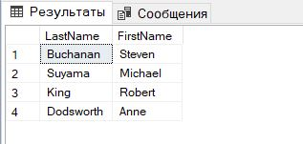

**Task 3.** Show the list of first and last names of the employees whose first name begins with letter A.

SELECT LastName, FirstName

FROM Employees

WHERE FirstName LIKE 'A%'

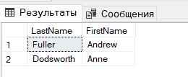

**Task 4.** Show the list of first, last names and ages of the employees whose age is greater than 55. The result should be sorted by last name.

SELECT LastName, FirstName, DATEDIFF(YEAR, BirthDate, GETDATE()) AS Age

FROM Employees

WHERE DATEDIFF(YEAR, BirthDate, GETDATE()) > 55

ORDER BY LastName

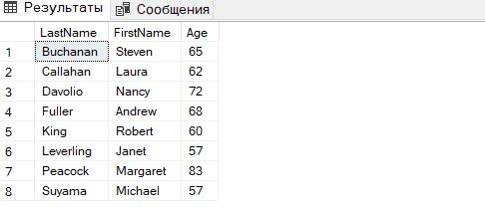

**Task 5.** Calculate the count of employees from London.

SELECT COUNT(*) As amount

FROM Employees

WHERE City = 'London'

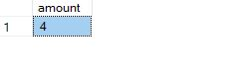

**Task 6.** Calculate the greatest, the smallest and the average age among the employees from London.

SELECT MAX(DATEDIFF(YEAR, BirthDate, GETDATE())) AS Maximum, MIN(DATEDIFF(YEAR, BirthDate, GETDATE())) AS Minimum, AVG(DATEDIFF(YEAR, BirthDate, GETDATE())) AS Minimum

FROM Employees

WHERE City = 'London'

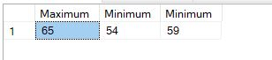

**Task 7.** Calculate the greatest, the smallest and the average age of the employees for each city.

SELECT City, MAX(DATEDIFF(YEAR, BirthDate, GETDATE())) AS Maximum, MIN(DATEDIFF(YEAR, BirthDate, GETDATE())) AS Minimum, AVG(DATEDIFF(YEAR, BirthDate, GETDATE())) AS Average

FROM Employees

GROUP BY City

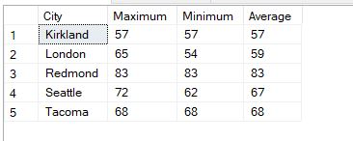

**Task 8.** Show the list of cities in which the average age of employees is greater than 60 (the average age is also to be shown).

SELECT City, AVG(DATEDIFF(YEAR, BirthDate, GETDATE())) AS Average

FROM Employees

GROUP BY City

HAVING AVG(DATEDIFF(YEAR, BirthDate, GETDATE())) > 60

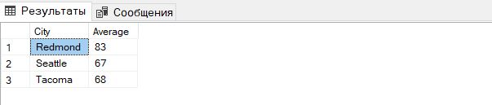

**Task 9.** Show the first and last name(s) of the eldest employee(s). Use a subquery.

SELECT LastName, FirstName

FROM Employees

WHERE BirthDate = (SELECT MIN(BirthDate) FROM Employees)

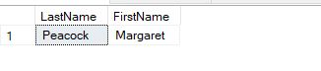

**Task 10.** Show first, last names and ages of 3 eldest employees.

SELECT LastName, FirstName, DATEDIFF(YEAR, BirthDate, GETDATE()) AS Age

FROM Employees

WHERE BirthDate IN (SELECT TOP (3) BirthDate FROM Employees GROUP BY BirthDate)

ORDER BY Age

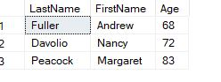

**Task 11.** Show the list of all cities where the employees are from.

SELECT DISTINCT City

FROM Employees

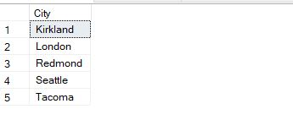

**Task 12.** Show first, last names and dates of birth of the employees who celebrate their birthdays this month.

SELECT LastName, FirstName, BirthDate

FROM Employees

WHERE DATEPART (m, BirthDate) = 09



**Task 13.** Show first and last names of the employees who used to serve orders shipped to Madrid.

SELECT LastName, FirstName

FROM Employees

WHERE EmployeeID IN ( SELECT EmployeeID FROM Orders WHERE ShipCity = 'Madrid')

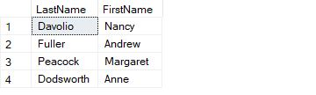

**Task 14.** Show first and last names of the employees as well as the count of orders each of them have received during the year 1997 (use left join).

SELECT LastName, FirstName, COUNT(Employees.EmployeeID) As AmountOrders

FROM Employees LEFT JOIN Orders

ON Employees.EmployeeID = Orders.EmployeeID

WHERE YEAR(OrderDate) = 1997

GROUP BY LastName, FirstName

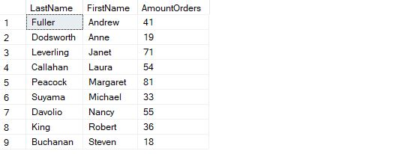

**Task 15.** Show first and last names of the employees as well as the count of orders each of them have received during the year 1997 (use a subquery).

SELECT LastName, FirstName, COUNT(Employees.EmployeeID) As AmountOrders

FROM Employees LEFT JOIN Orders

ON Employees.EmployeeID = Orders.EmployeeID

WHERE OrderDate IN (SELECT OrderDate FROM Orders WHERE YEAR(OrderDate)=1997)

GROUP BY LastName, FirstName

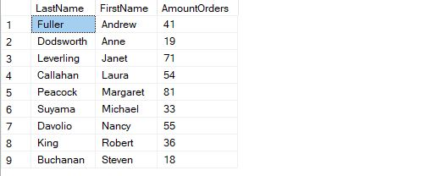

**Task 16.** Show first and last names of the employees as well as the count of their orders shipped after required date during the year 1997 (use left join).

SELECT LastName, FirstName, COUNT(Employees.EmployeeID) As AmountOrders

FROM Employees LEFT JOIN Orders

ON Employees.EmployeeID = Orders.EmployeeID

WHERE ShippedDate > RequiredDate AND YEAR(OrderDate) = 1997

GROUP BY LastName, FirstName

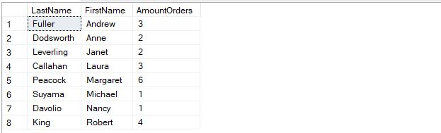

**Task 17.** Show the count of orders made by each customer from France.

SELECT ContactName, COUNT(Customers.CustomerID) As AmountOrders, Country

FROM Customers LEFT JOIN Orders

ON Customers.CustomerID = Orders.CustomerID

WHERE Country = 'France'

GROUP BY ContactName, Country

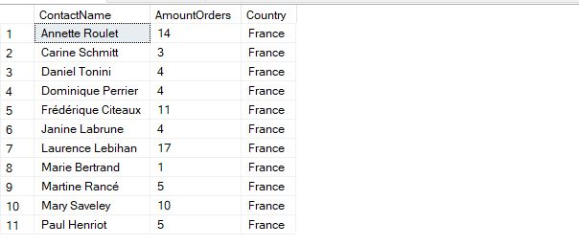

**Task 18.** Show the list of french customers’ names who have made more than one order (use grouping).

SELECT ContactName

FROM Customers LEFT JOIN Orders

ON Customers.CustomerID = Orders.CustomerID

WHERE Country = 'France'

GROUP BY ContactName

HAVING COUNT(Customers.CustomerID) > 1

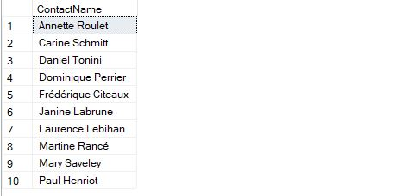

**Task 19.** Show the list of french customers’ names who have made more than one order (use a subquery).

SELECT ContactName

FROM Customers

WHERE Country = 'France' AND (SELECT COUNT(OrderID) FROM Orders WHERE Customers.CustomerID = Orders.CustomerID) > 1

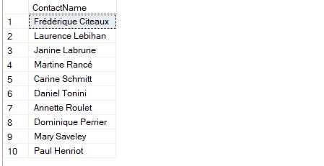

**Task 20.** Show the list of customers’ names who used to order the ‘Tofu’ product (use a subquery).

SELECT ContactName

FROM Customers

WHERE CustomerID IN ( SELECT CustomerID FROM Orders, [Order Details], Products WHERE Orders.OrderId = [Order Details].OrderId AND [Order Details].ProductID = Products.ProductID AND ProductName = 'Tofu')

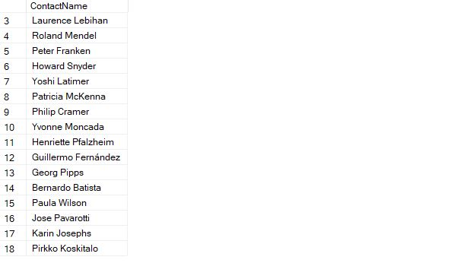

**Task 21. \***Show the list of customers’ names who used to order the ‘Tofu’ product, along with the total amount of the product they have ordered and with the total sum for ordered product calculated.

SELECT ContactName, COUNT(Customers.CustomerID) AS AmountTofu, SUM(Products.UnitPrice) AS Suma

FROM Customers, Orders, [Order Details], Products

WHERE Customers.CustomerID = Orders.CustomerID AND Orders.OrderId = [Order Details].OrderId

AND [Order Details].ProductID = Products.ProductID AND ProductName = 'Tofu'

GROUP BY ContactName

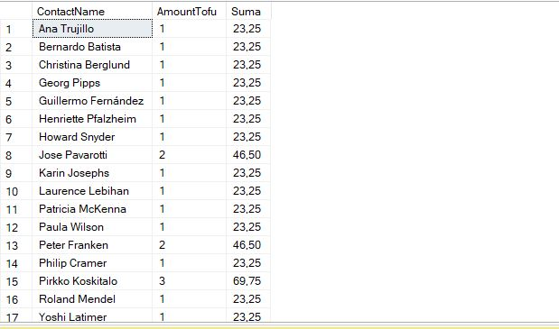

**Task 22.** *Show the list of french customers’ names who used to order non-french products (use left join).

**Task 23.** *Show the list of french customers’ names who used to order non-french products (use a subquery).

SELECT Customers.ContactName

FROM Customers

WHERE Customers.Country = 'France' AND Customers.CustomerID IN (SELECT Customers.CustomerID FROM Orders, Customers, [Order Details], Products, Suppliers

WHERE Customers.CustomerID = Orders.CustomerID AND Orders.OrderID = [Order Details].OrderID AND [Order Details].ProductID = Products.ProductID AND Suppliers.SupplierID = Products.SupplierID AND Suppliers.Country NOT LIKE 'France')

GROUP BY ContactName

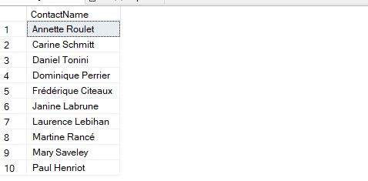

**Task 24.** *Show the list of french customers’ names who used to order french products.

SELECT Customers.ContactName

FROM Customers

WHERE Customers.Country = 'France' AND Customers.CustomerID IN (SELECT Customers.CustomerID FROM Orders, Customers, [Order Details], Products, Suppliers

WHERE Customers.CustomerID = Orders.CustomerID AND Orders.OrderID = [Order Details].OrderID AND [Order Details].ProductID = Products.ProductID AND Suppliers.SupplierID = Products.SupplierID AND Suppliers.Country = 'France')

GROUP BY ContactName

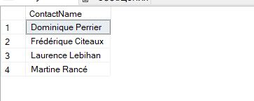

**Task 25.** *Show the total ordering sum calculated for each country of customer.

SELECT ShipCountry, SUM(Products.UnitPrice) AS Suma

FROM Orders, Products, [Order Details]

WHERE [Order Details].OrderID = Orders.OrderID AND [Order Details].ProductID = Products.ProductID

GROUP BY ShipCountry

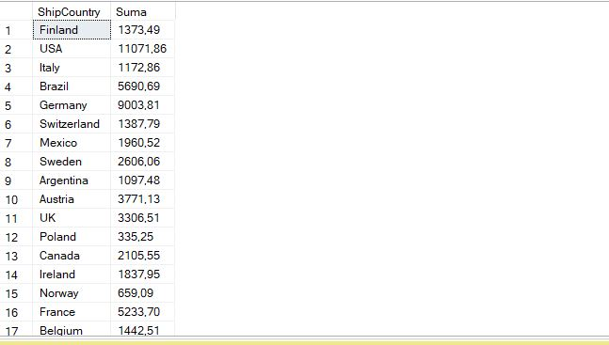

**Task 27.** *Show the list of product categories along with total ordering sums calculated for the orders made for the products of each category, during the year 1997.

SELECT CategoryName, SUM(Products.UnitPrice) As TotalSum

FROM Categories, Products, [Order Details], Orders

WHERE Products.CategoryID = Categories.CategoryID AND [Order Details].ProductID = Products.ProductID AND YEAR(Orders.OrderDate) = 1997 AND Orders.OrderId = [Order Details].OrderID

GROUP BY CategoryName

