-- find all books which price is higher than 50 and category is Computer

SELECT b.title, b.price

FROM Book b

WHERE price > 50 AND category = 'Computer';

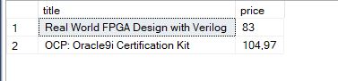

-- Show all info about customer with id = 9

SELECT *

FROM Customer

WHERE id = 9;

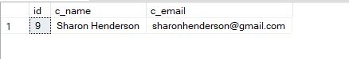

-- find the titles and id for all books with less than 15 copies in stock

SELECT title, id

FROM Book

WHERE quantity < 15;

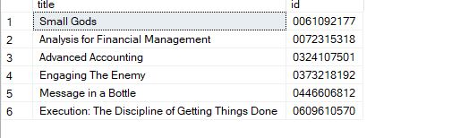

-- calculate all the books category 'Horror'

SELECT COUNT(*) As amount

FROM Book

WHERE Category= 'Horror';

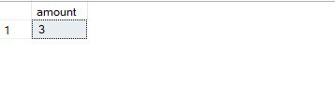

-- Show title and category of the cheapest book

SELECT title, category

FROM Book

WHERE price = (SELECT MIN(price) FROM Book);

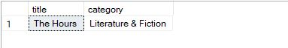

--Show titles and categories of 5 the most expensive books

SELECT title, category

FROM Book

WHERE price IN (SELECT TOP (5) price FROM Book GROUP BY price)

ORDER BY title;

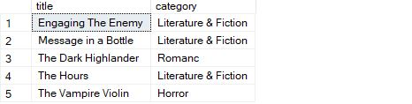

--Show list of all book categories

SELECT DISTINCT category

FROM Book

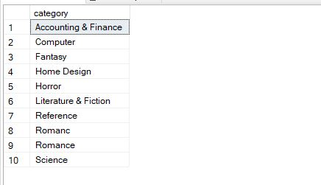

--Show list of all books which were published in 1997

SELECT title

FROM Book

WHERE prod_year IN ( SELECT prod_year FROM Book WHERE prod_year = 1997)

ORDER BY title;

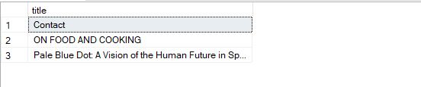

-- Show all books titles whic quantity is > 70

SELECT title

FROM Book

WHERE quantity IN ( SELECT quantity FROM Book WHERE quantity > 70)

ORDER BY title;

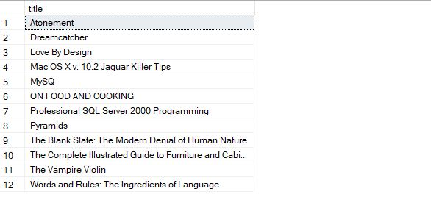

--SHow all customers which name star with J

SELECT c_name

FROM Customer

WHERE c_name LIKE 'J%'

ORDER BY c_name;

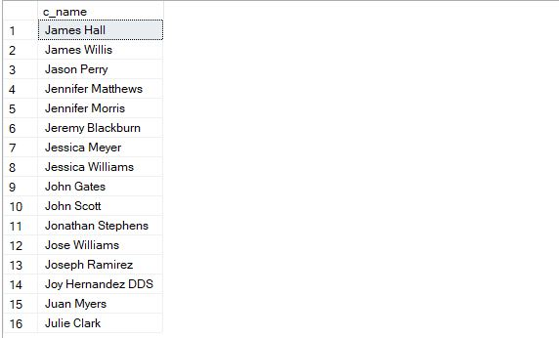

-- Show information about books which price is between 10 and 15

SELECT *

FROM Book

WHERE price BETWEEN 10 AND 15;

