***GIT Basics homework II***

***Part 1 (do 'GIT Basics homework' first)***

1. Do all your experiments in folder “task2 – git pracrice II”.

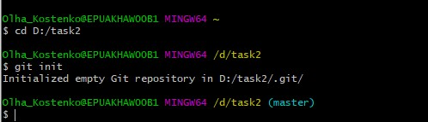

2. Checkout on develop.

3. Create new branch “first”.

4. Create another new branch “second”.

5. Do one (or more) commits to develop (Add to repository some files, change them).

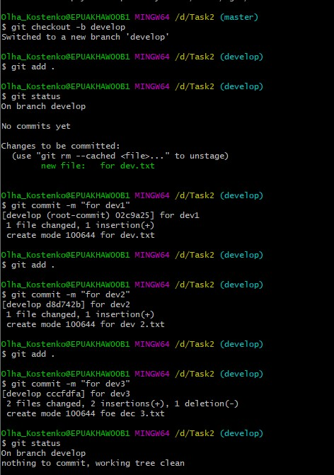

6. Checkout on the first branch and do several commits (about 5).

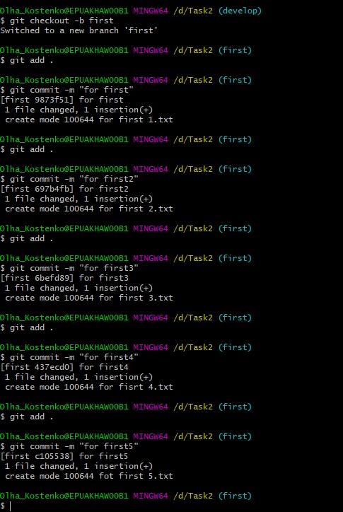

7. Checkout on the second branch and do several commits (about 3). Make sure that you have at least one commit, which changes more than one file.

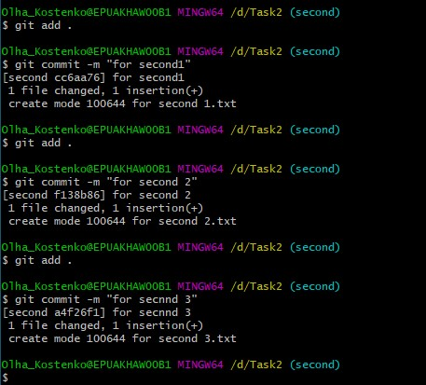

8. Do interactive rebasing. Your commits from the second branch should appear on the top of develop branch. During interactive rebasing:

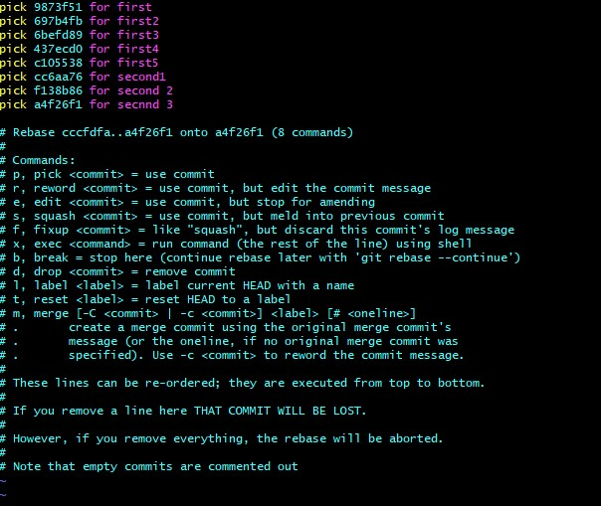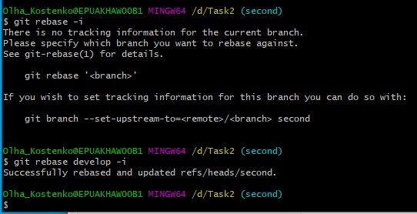

9. Divide one of your commits (so you should have two commits instead of one);

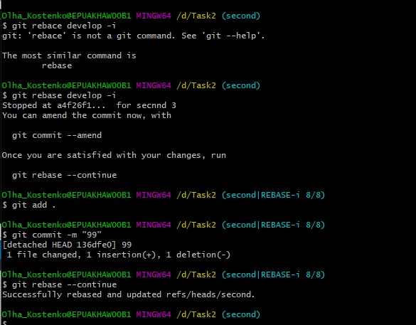

(Последн. изм. файл меняем pick меняем на edit в новом окне , выходим ескейп --:qw , добавляем изменения в последний файл. )

10. Change content of other commit and change commit message for it.

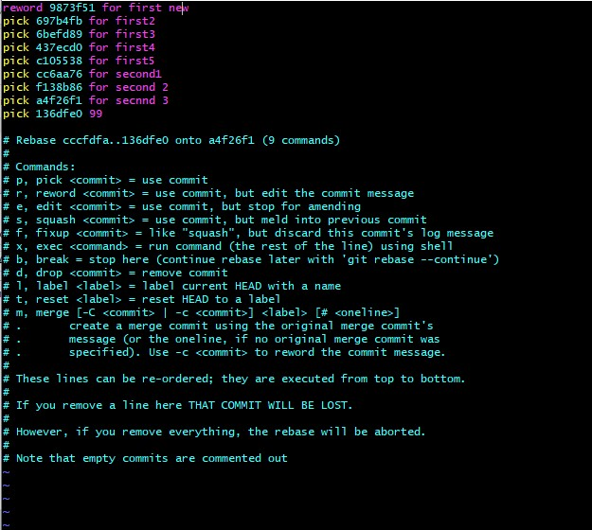

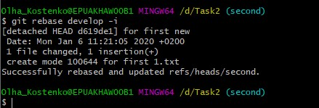

11. Checkout to the first branch.

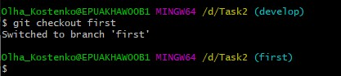

12. Do interactive rebasing. Your commits from the first branch should appear on the top of develop branch. During interactive rebasing:

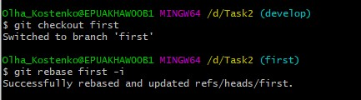

13. Squash three commits into one;

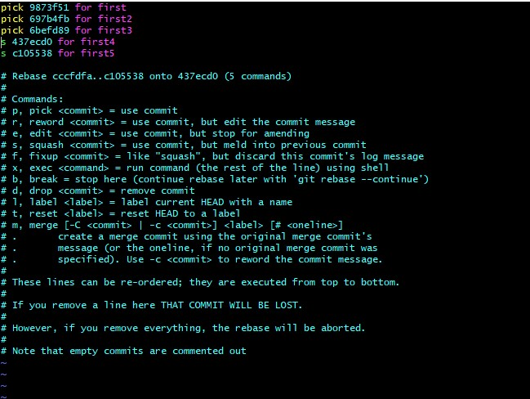

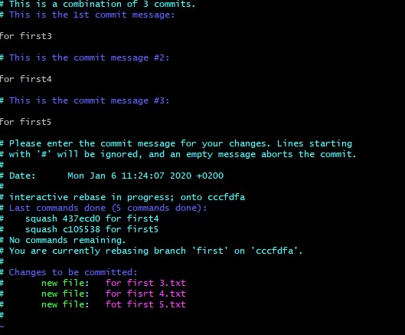

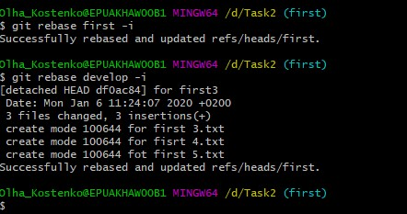

14. Drop one commit.

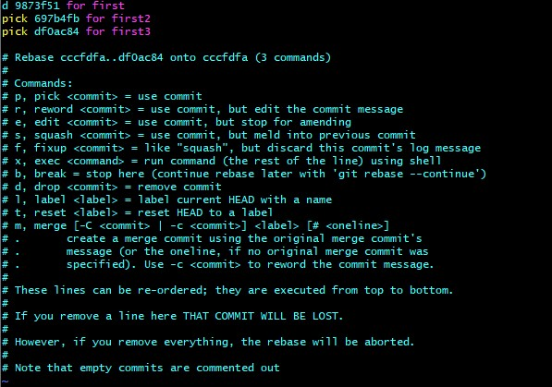

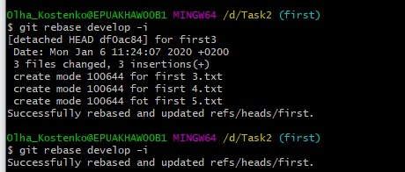

15. Merge the develop branch into master branch.

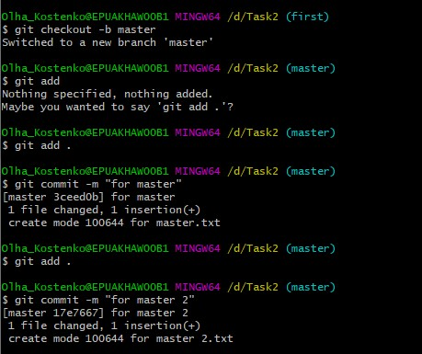

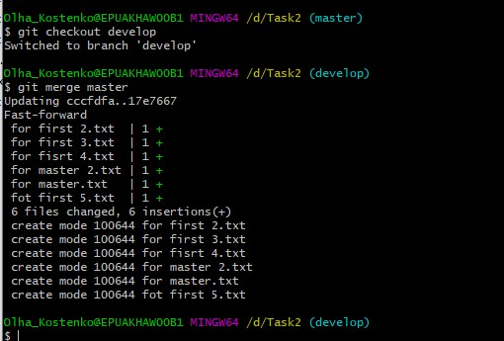

**Execute command “git reflog” and save it content somewhere (not in repository) with filename “*GIT_Basics_homework*.txt”.**

