1. Write the following SQL commands (Do not use MySQL):

a. Extract phone number and address of Muzik user.

b. Get all users whose name ends with A

c. Extract data about users who have an order amount of more than UAH 2,000.

d. Count the number of orders in the table

e. Calculate the total amount of orders made.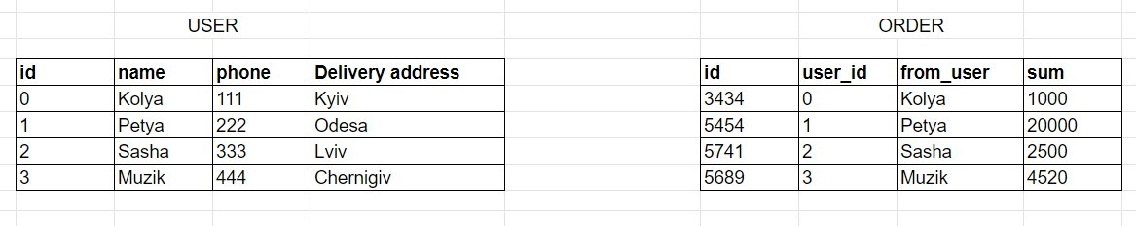

1. SELECT phone, Delivery address FROM user WHERE name=‘Muzik’ ;
2. SELECT * FROM user WHERE name LIKE ‘%A’ ;
3. SELECT * FROM order WHERE sum >=2000 ;
4. SELECT COUNT(*) FROM order ;
5. SELECT SUM(sum) AS total_orders_sum FROM order ;