Your Name: Daniel Davieau

Exercise 1: Simple Substitution Cipher (30)

1. Include the cipher.cy code (10 points)

phrase = input("Enter the sentence to encrypt ")

shift = int(input("Enter a shift value "))

for i in enumerate(phrase):

asciiCode = ord(i[1])

encodedLetter = asciiCode+shift

letterCode = chr(encodedLetter)

print("The encoded phrase is "+ str(letterCode))

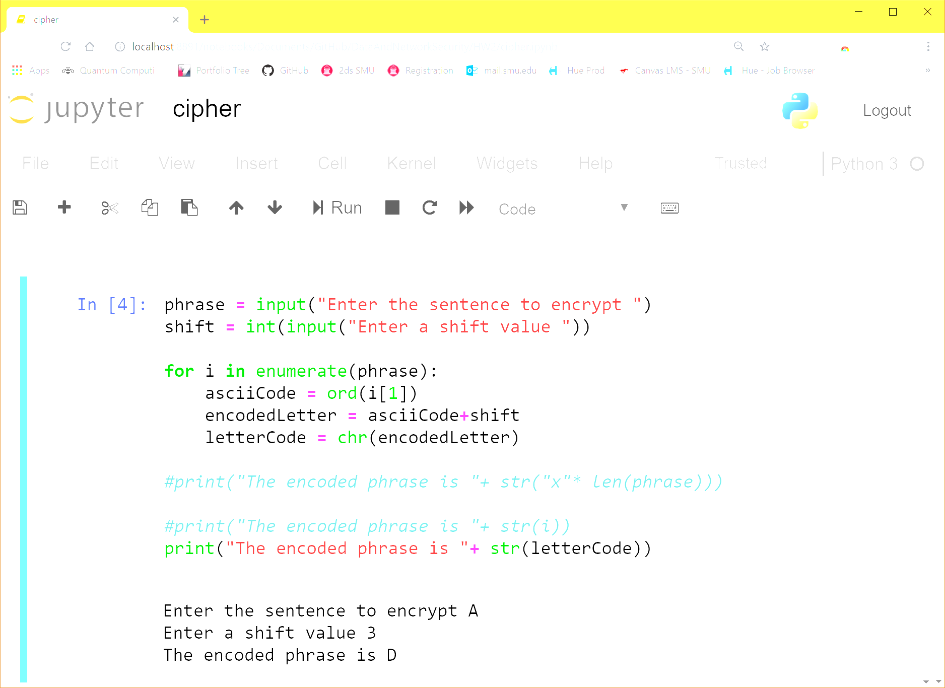

1. Include screen shoot for your answer for part 1-2 (10 points)

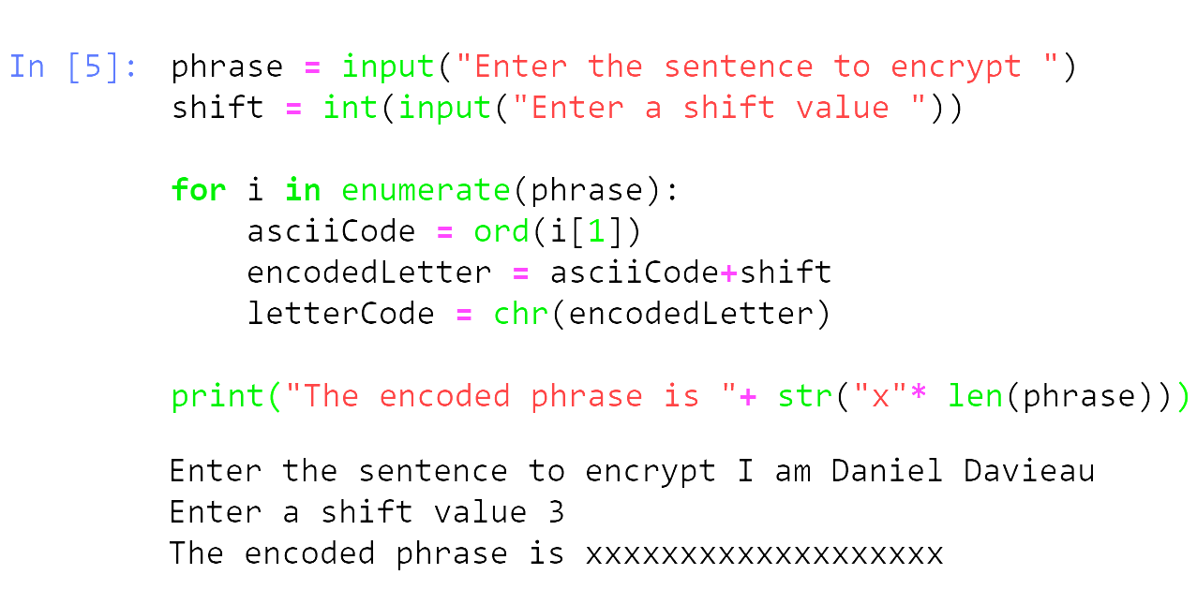

1. Include screen shoot for your answer for part 1-3 (10 Points)

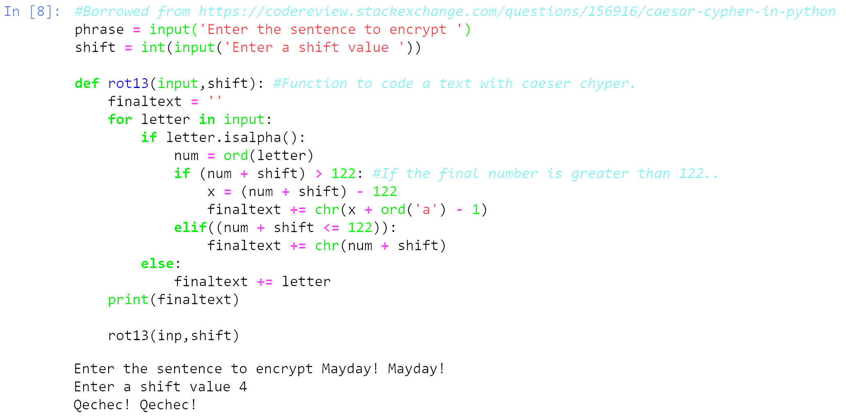

Exercise 2: Breaking a Simple Substitution Cipher-3 (30)

1. Include the program code (20 points)

#Borrowed from team-mate Alex Salamah

MAX_KEY_SIZE=26

def getMode():

while True:

print('Do you wish to encrypt or decrypt a message?')

mode = input().lower()

if mode in 'encrypt e decrypt d'.split():

return mode

else:

print('Enter either "encrypt" or "e" or "decrypt" or "d".')

def getMessage():

print('Enter your message:')

message = input()

return message

def getKey():

key = 0

while True:

print('Enter the key number (1-%s)' % (MAX_KEY_SIZE))

key = int(input())

if (key >= 1 and key <= MAX_KEY_SIZE):

return key

def getTranslatedMessage(mode, message, key):

translated = ''

symbol = 0

num=0

for symbol in message:

if symbol.isalpha():

num = ord(symbol)

num += key

if symbol.isupper():

if num > ord('Z'):

num -= 26

elif num < ord('A'):

num += 26

elif symbol.islower():

if num > ord('z'):

num -= 26

elif num < ord('a'):

num += 26

translated += chr(num)

elif symbol.isnumeric():

num = int(symbol)

num += int(key)

num = num%6

#print(num)

translated += str(num)

else:

translated += symbol

return translated

mode = getMode()

message = getMessage()

key = getKey()

if mode[0] == 'd':

key = -key

decodedmsg= getTranslatedMessage(mode, message, key)

if decodedmsg.isnumeric():

print ('Your translated number is:' + (decodedmsg))

else:

print('Your translated text is:' + str(decodedmsg))

#Borrowed from team-mate Alex Salamah

1. Include a screen capture of the program in action and the posted cipher text and its corresponding plaintext and key as retrieved by your program for each of the posted cipher texts (10 points)

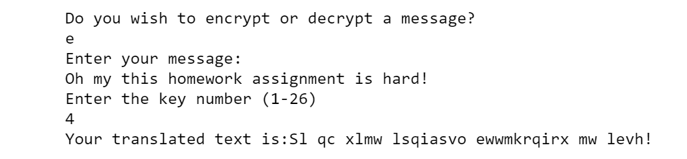

***Faster than brute force: In the post below from the wall we can assume that lone single letter is probably the letter “I”. The letter I position is letter is 7 positions prior to p so the shift value it probably 7.*** 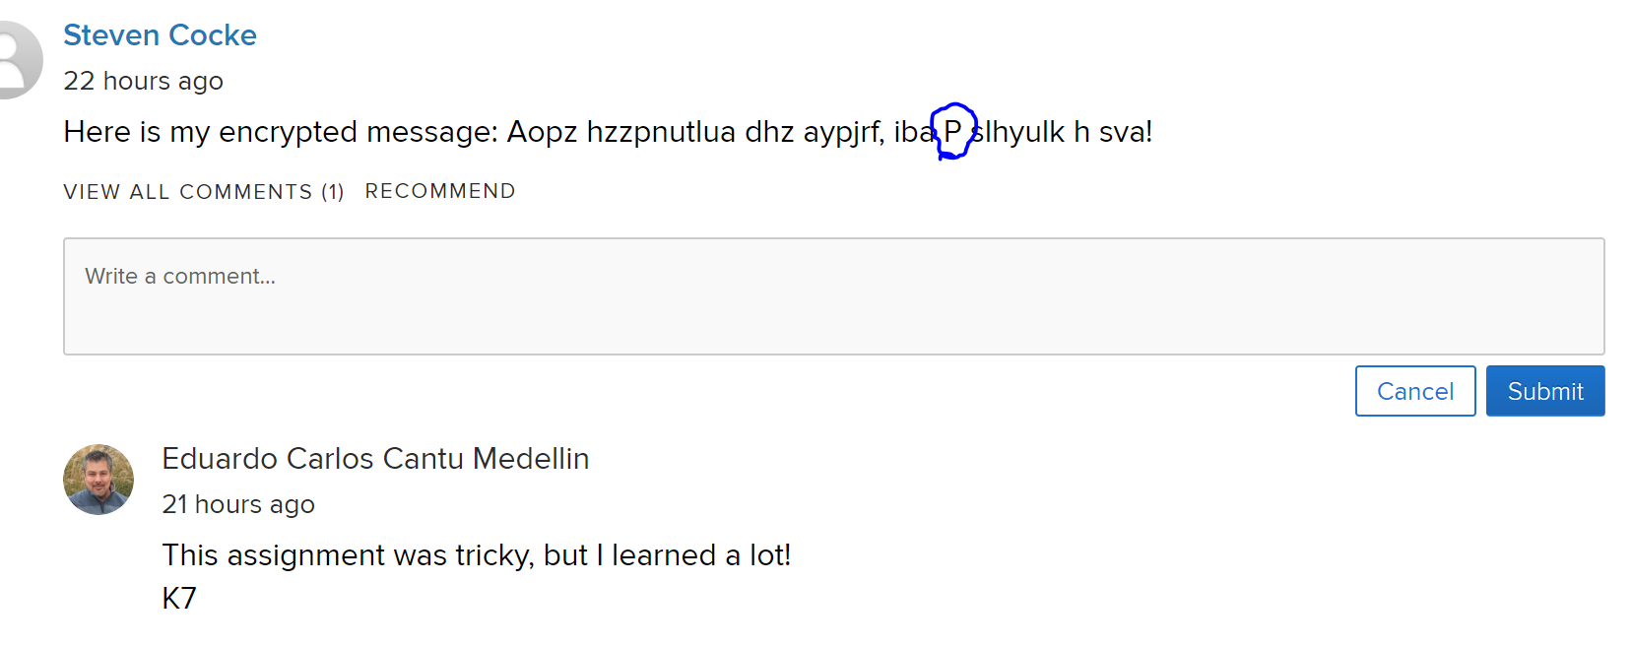

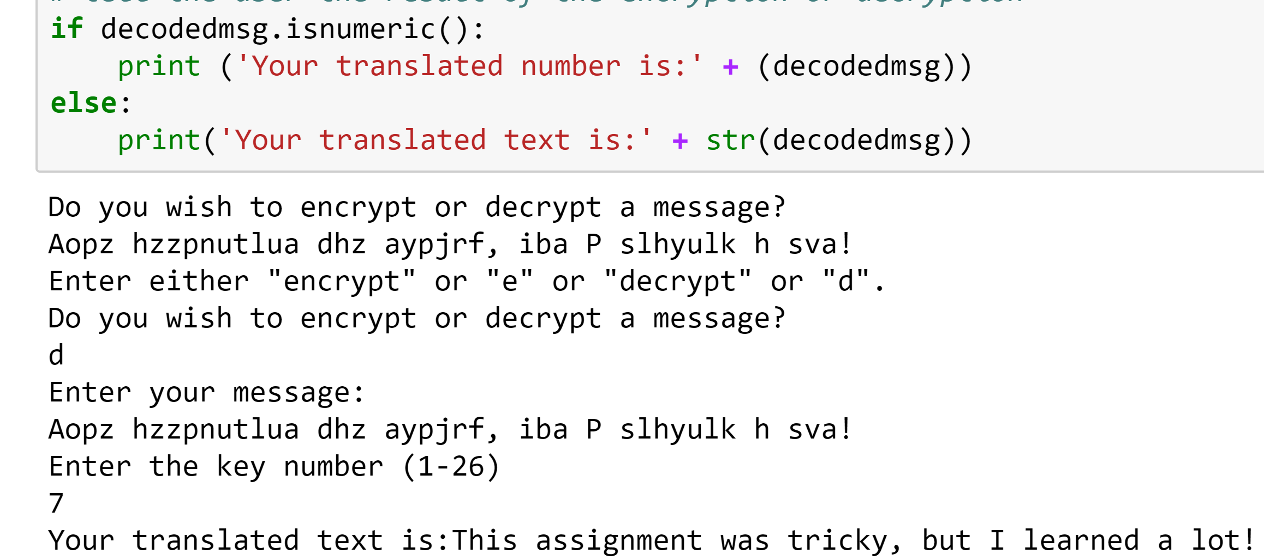

Exercise 3: AES (40 points)

1. Include the program code (10 points)
2. Include a screen capture of the program in action, the original jpg and each of the encrypted versions of the jpg. (30 Points)

***I am not equipped to complete this assignment in a reasonable amount of time.***