IGNOU

Overview:
IGNOU which stands for Indira Gandhi National Open University, is a national centre for open and distance learning. Located in the capital city of the country that is Delhi. It is found to serve Indian population by means of distance and open education by providing quality higher education opportunities to all segments of the society.
The main mission of this university is to democratize education in India and beyond. The aim is to provide inclusive and equitable access to higher education across the nation and through its overseas learner support centres.

Programs & Study Centres:
Ranked as number one in the category of open university , IGNOU offers a number of programs, it offers about 228 certificate, diploma, degree and doctoral programmes. This programs are online, distance or goal oriented. Such services are available even to international students.
There are a number of study centres in India where the IGNOU operates. In Goa too there are centres. Dhempe College of Arts & Science has an IGNOU Study Centre located within the college premises. It is the North Goa Study Centre(0802) in Goa. And the same programs as mentioned in the IGNOU curriculum are been undertaken. The study centres provide resources, mentorship and other amenities, to the students enrolled in IGNOU programmes.

Accessing the IGNOU services:
A student has to register online and then they can access the services. Image given below shows the different services available;
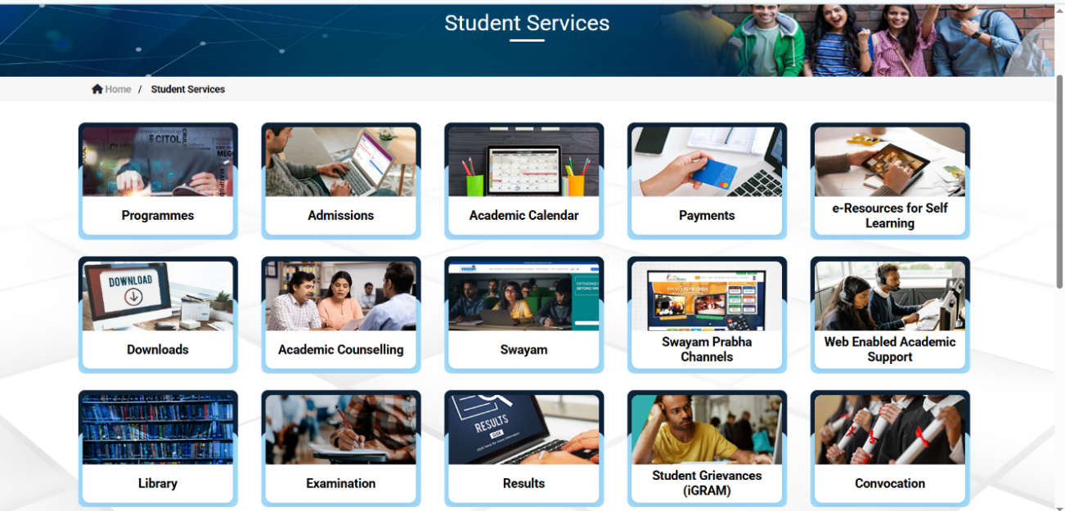

How the IGNOU system works?
As said above it operates as a distance learning university, offering various undergraduate, post graduate ,diploma and certificate programmes across a variety of subjects.
The students are assessed in the following way; It combines assignments and end of semester exams, with the assignments contributing to the final grade, often thirty percent. A student needs to score a minimum of forty percent in each subject to pass, and this includes both assignments and theory exams.
Assignments are assigned and students need to prepare and submit by the required deadline, failing to which will lead to loss of the opportunity to answer the term exam as well as carry a backlog of submitting an assignment in the next session.
Rubrics are as follows ; thirty percent of weightage is given for assignments and remaining seventy percent is contributed for term exam.

Benefits:
The presence of IGNOU centre has a number of advantages they are as follows;
- Provides access to higher education for all segments of the society.
- Offers high quality, innovative, need based programmes at different levels.
- Provides programmes in all parts of the country at affordable costs.
- It promotes, coordinates and regulates the standards of education through open and distance learning.
- Provides professional development and training to all sectors of the economy.
- Programs are available to student from diverse backgrounds and locations.

Why choose IGNOU ?
Where it comes to balancing work, family and education that can be tough ,more people begin to look for flexible and accessible learning options. In that regard distance education is a great solution that is provided by IGNOU. It helps students learn, gain knowledge and build a career without changing their daily routines.
And the same is true in the case of the programs coordinated by the Dhempe College Of Arts and Science that hosts IGNOU.

Summary:
If we summarize;
- IGNOU is the ‘only’ open university in the country. It fosters distance learning at the students convenience and provides degrees/diploma’s/certificates that are recognized by the Association of Indian Universities.
- A number of study centres of IGNOU are present all over India, in Goa too the north centre is present at Dhempe College of Arts and Science. And a number of programs are presented.
- For those who are caught up in the busy lives, distance learning is the best ,which can be availed through IGNOU’s different programs.

References:
https://www.ignou.ac.in ; Accessed on 12 May 2025
https://education.vikaspedia.in/viewcontent/education/resource-links/scientific-and-educational-institutions/indira-gandhi-national-open-university?lgn=en ; Accessed on 12 May 2025
Done By:
Saisha Prabhu
Olivia Fernandes

