A chromogenic medium for the enumeration of Escherichia coli and total coliforms in 100 mL water samples: validation of a novel MPN-based method according to ISO 9308-2
Anicet R. Blanch^{1*}, Ariadna Jorba¹, Julia Martín-Díaz¹, Miriam Pascual-Benito¹, Raquel Casas-Mangas¹, Helga Núñez-Chapela^{1,2}, Javier Méndez¹, Daniel Asensio²
¹ Department of Genetics, Microbiology and Statistics, Faculty of Biology, Universitat de Barcelona, Diagonal 643, 08028 Barcelona, Spain
² Reactivos para Diagnóstico S.L., Sentmenat, Spain

* Corresponding author: ablanch@ub.edu

ABSTRACT
Microbiological monitoring of water quality relies mainly on the detection and quantification of Escherichia coli, as required by international and European regulatory frameworks, including the EU Directives on drinking water quality, water reuse, and bathing water management. Among the methods commonly applied for E. coli enumeration, ISO 9308-2 describes a Most Probable Number approach based on the detection of β-D-glucuronidase activity using the fluorogenic substrate 4-methylumbelliferyl-β-D-glucuronide. However, fluorescence detection requires ultraviolet illumination at 365 nm, implying additional equipment requirements and potential occupational exposure concerns. Here, the ENUMERA®Coli100 method for E. coli and Total Coliforms in 100 mL is presented as a novel complete chromogenic alternative to ISO 9308-2. The method incorporates a chromogenic glucuronic acid derivative that produces a visible green colour reaction under ambient light, eliminating the need for UV irradiation. The dehydrated medium is integrated into a sealed bottle cap through a “twist-and-release” mechanism that minimizes handling steps and reduces contamination risks during sample preparation. Performance was evaluated against ISO 9308-2 using 120 water samples representing five matrices: drinking water, surface water, wastewater, reclaimed water, and seawater. Both methods yielded statistically equivalent results for E. coli and Total Coliforms across all matrices. ENUMERA®-Coli100 demonstrated 100% sensitivity, high specificity and selectivity comparable to ISO 9308-2, excellent linearity, low limits of detection and quantification, and satisfactory accuracy. Validation was performed following ISO 16140-2 and ISO 13843 criteria. ENUMERA®-Coli100 constitutes a robust, reliable, and operationally practical alternative for the enumeration of E. coli and total coliforms in water samples, simplifying result interpretation, improving laboratory safety, streamlining workflow, and eliminating UV detection equipment.
Keywords: Escherichia coli; total coliforms; water quality; MPN method; chromogenic medium; ISO 9308-2; microbial indicators; water safety

1. Introduction
Faecal contamination of water remains one of the major global threats to public health and is responsible for millions of cases of waterborne disease each year (UN-Water, 2021). Among the microbiological indicators used to assess this risk, Escherichia coli has long been regarded as the reference faecal indicator bacterium owing to its specific association with faecal contamination from warm-blooded animals and its suitability for routine culture-based detection (Baudišová, 1997; Dufour et al., 1981). As a member of the coliform group, defined by the ability to ferment lactose and express β-galactosidase activity, E. coli can be differentiated from other coliform bacteria by its constitutive production of β-D-glucuronidase, an enzymatic activity that is largely specific to this species within the Enterobacteriaceae (Blanch et al., 2007; Feng and Hartman, 1982). This biochemical distinction underpins modern fluorogenic and chromogenic methods for the detection and enumeration of E. coli in water.
The principal international standard methods currently available for the detection and enumeration of E. coli in water include ISO 9308-1 (International Organization for Standardization, 2014), based on membrane filtration for waters with low background flora; ISO 9308-2, based on a Most Probable Number (MPN) format using multi-well trays and applicable to a wide variety of water types, including turbid and heavily loaded samples (International Organization for Standardization, 2012); and ISO 9308-3, based on a miniaturised liquid-medium format intended for surface and waste waters, especially those containing high levels of suspended matter, but not for drinking water (International Organization for Standardization, 1999). Among these standards, ISO 9308-2 has become one of the most widely adopted methods for the routine assessment of microbiological water quality. This method specifies a selective medium containing two defined substrates: ortho-nitrophenyl-β-D-galactopyranoside (ONPG), hydrolysed by the β-galactosidase of coliform bacteria to produce a yellow colour, and 4-methylumbelliferyl-β-D-glucuronide (MUG), hydrolysed by the β-glucuronidase of E. coli to release fluorescent 4-methylumbelliferone, detectable under UV illumination at 365 nm. At the same time, the composition of the medium is described in relatively broad and non-specific terms, thereby allowing substantial variation in formulation. Within the European regulatory framework, the EU Drinking Water Directive on the quality of water intended for human consumption (2020/2184), the EU on minimum requirements for water reuse (2020/741) and, the EU Directive concerning the management of bathing water quality (2006/7/EC) and their national transpositions require the use of standardised methods for enumeration of Escherichia coli such as ISO 9308-1 and ISO 9308-3. While the method ISO 9308-2 is not explicitly required by the principal EU water legislation, it is nevertheless widely recognized and implemented across European laboratories as a harmonized ISO standard for the microbiological assessment of drinking water, reclaimed water, and other regulated water matrices. Consequently, this reference method or other validated equivalent methods for routine surveillance are applied by laboratories. In this regard, the current wording of ISO 9308-2 has been regarded by some authors as being closely aligned with the characteristics of certain defined-substrate commercial systems, while nevertheless allowing the validation of alternative equivalent methods within the applicable regulatory framework (Boubetra et al., 2011).
A wide range of media and test formats has been developed for the detection and enumeration of E. coli, many of them relying on fluorogenic substrates for the detection of β-glucuronidase activity (Olstadt et al., 2007). Although these systems are analytically robust, their dependence on UV illumination for result interpretation introduces additional equipment requirements, maintenance needs, and practical constraints in routine laboratory use. By contrast, chromogenic substrates based on indoxyl derivatives, such as 5-bromo-4-chloro-3-indolyl-β-D-glucuronide (X-Gluc), generate a visible blue-green precipitate under ambient light following hydrolysis by β-glucuronidase, thus offering an attractive alternative to fluorogenic detection (Blackburn et al., 2023; Fricker et al., 1997; Manafi, 2000; Olstadt et al., 2007). This principle has already been applied successfully in both solid media and liquid MPN formats. In particular, the AquaCHROM ECC method demonstrated that a non-agar-based chromogenic medium can provide detection and enumeration of coliforms and E. coli in 100 mL water samples without UV-based reading, thereby representing an important precedent in the development of practical chromogenic alternatives for routine water analysis (Blackburn et al., 2023). However, there remains scope for formats that combine chromogenic detection with greater operational simplicity, closed-system handling, and direct compatibility with the ISO 9308-2 analytical workflow.
Another important aspect to consider in procedures based on the Most Probable Number (MPN) approach is the intrinsically statistical nature of the method. Unlike direct counting techniques, the MPN method estimates the concentration of microorganisms in a sample from the distribution of positive and negative growth responses obtained after incubation in multiple analytical compartments (wells) of defined volumes. The final concentration is calculated by comparing the observed pattern of positive wells with standardized probability tables or mathematical algorithms. Consequently, the estimated MPN value is strongly dependent on the nominal volume assigned to each analytical well. Even small differences in well volumes may lead to variations in the calculated MPN, despite identical patterns of positive and negative wells. This effect becomes particularly relevant at high microbial concentrations, where a large proportion of wells are positive and the statistical calculation becomes increasingly sensitive to minor variations in compartment volume. Under these conditions, relatively small differences in the assumed analytical volumes may produce noticeable differences in the estimated MPN values, even when the observed growth distribution remains unchanged (McBride, 2003).
Building on previous experience in rapid viral indicator detection (Pascual-Benito et al., 2024), the ENUMERA®-Coli100 method for E. coli and Total Coliforms in 100 mL was developed as a chromogenic liquid MPN method aligned with the workflow described in ISO 9308-2. The method incorporates a novel liquid culture medium (Aquacoli), in which β-galactosidase activity generates a yellow colour indicative of total coliforms, while β-glucuronidase activity produces a visible green colour specific for E. coli under ambient light conditions, thereby eliminating the need for UV-based result interpretation. The system also integrates a closed reagent-in-cap device that enables aseptic resuspension of the dehydrated medium directly inside the sample bottle, simplifying handling procedures and minimizing sample manipulation. Quantification is performed using a proprietary 95-well ENUMERA® tray (Pascual-Benito et al., 2024), designed to provide a broad analytical working range for 100 mL samples. The tray geometry and corresponding MPN table were specifically designed together to ensure internal consistency between the physical configuration and the statistical estimation model used for enumeration. The aim of the present study was to validate the equivalence of ENUMERA®-Coli100 method as an alternative procedure to the ISO 9308-2 reference method by evaluating its sensitivity, selectivity, specificity, accuracy, linearity, and limits of detection and quantification across five ecologically and analytically distinct water matrices. Method performance was assessed in accordance with the principles and requirements established in ISO 16140-2 (International Organization for Standardization, 2016) and ISO 13843 (International Organization for Standardization, 2017).

2. Materials and Methods

2.1. Water matrices and sample preparation
Five water matrices were included in the study: drinking water, surface water, reclaimed water, wastewater, and seawater. Drinking water consisted of bottled mineral water purchased from a local retailer to avoid interference from residual chlorine. Surface water was collected from the lower course of the Llobregat River (Catalonia, Spain). Reclaimed water and wastewater were collected after tertiary and secondary treatment, respectively, from a municipal wastewater treatment plant serving approximately two million inhabitant-equivalents in the Barcelona Metropolitan Area. Seawater was collected from two beaches located in the same metropolitan area. River water, reclaimed water, and wastewater samples were collected in sterile 1 L polyethylene containers, transported under refrigeration, and analysed within 24 h of collection.
A total of 120 water samples were analysed, corresponding to 24 samples for each water matrix. Matrices with naturally occurring coliform bacteria were diluted with sterile water from the same source, whereas matrices without detectable coliforms were spiked with secondary-treated wastewater. For each experimental unit, 500 mL of sample were prepared, homogenised by magnetic stirring for 10 min, and divided into four 100 mL aliquots. Two aliquots were analysed using the reference method (ISO 9308-2), and the remaining two were analysed using the ENUMERA®-Coli100 kit. Seawater samples were diluted 1:10 in sterile distilled water prior to analysis, in accordance with ISO 9308-2, to minimise the inhibitory effect of salinity on bacterial growth.

2.2. Reference method: ISO 9308-2
Escherichia coli and coliform bacteria were enumerated using the Colilert-18/Quanti-Tray system (IDEXX Laboratories, Westbrook, ME, USA), following the most probable number (MPN) procedure described in ISO 9308-2:2012. The assay is based on the presence of o-nitrophenyl-β-D-galactopyranoside (ONPG), used to detect coliform bacteria, and 4-methylumbelliferyl-β-D-glucuronide (MUG), used to detect E. coli. Briefly, 100 mL of sample were mixed with the reconstituted medium and distributed into a 97-well Quanti-Tray consisting of one overflow well, 48 large wells, and 48 small wells, comprising one overflow well with a maximum volume of 2.08 mL, 48 large wells with a maximum volume of 1.88 mL, and 48 small wells with a maximum volume of 0.160 mL (McBride, 2003). Following incubation at 36 ± 2 °C for 18 ± 2 h, yellow wells were scored as positive for coliform bacteria, and wells exhibiting fluorescence under UV light (365 nm) were scored as positive for E. coli. Final results were expressed as MPN values according to the standard interpretation table provided by the manufacturer.

2.3. Alternative method: ENUMERA®-Coli100 method
The ENUMERA®-Coli100 method, designed for the enumeration of E. coli and total coliforms in 100 mL water samples, consists of two components: (i) a 125 mL testing bottle fitted with a proprietary integrated cap (“reagent-in-cap”) containing the dehydrated chromogenic medium Aquacoli sealed in a blister within the cap threads; (ii) a 95-well ENUMERA® tray (Pascual-Benito et al., 2024) composed of one overflow well, 46 large wells, and 48 small wells. The chromogenic medium is based on the components described in the ISO 9308-2 and contains ONPG for the detection of β-galactosidase activity, used to indicate total coliforms by a yellow colour change, and a chromogenic glucuronic acid derivative (indoxyl-β-D-glucuronide family substrate) for the detection of β-glucuronidase activity, used to indicate E. coli by a green colour change.
Briefly, the water sample was transferred into the testing bottle, and the cap was twisted to release the dehydrated medium directly into the sample without opening the bottle. After gentle mixing for 1 min, the reaction mixture was dispensed into the ENUMERA® tray, thermosealed, and incubated at 36 ± 2 °C for 18 ± 2 h. Results were read under ambient white light. Wells exhibiting a yellow or green colour reaction were recorded as positive for total coliforms, whereas wells exhibiting a green colour reaction were additionally recorded as positive for E. coli.
In tray-based MPN systems, the estimated concentration is derived from the observed combination of positive and negative wells across defined inoculated volumes; therefore, the physical geometry of the tray is directly embedded in the statistical model used for enumeration. In the development of the ENUMERA® tray, particular attention was therefore paid to ensuring traceability between tray design and MPN estimation. The tray comprises one overflow well collecting 5.51 mL, 46 large wells of 1.86 mL each, and 48 small wells of 0.186 mL each, providing a total nominal sample volume of 100 mL. The corresponding MPN table was specifically derived for this configuration using the methodology previously described (Hurley and Roscoe, 1983), following the principles of ISO 9308-2 and incorporating the nominal well volumes defined for this tray geometry. This approach provides a transparent and reproducible basis for interpreting enumeration results and ensures consistency between the physical tray configuration and the statistical framework applied (see Supplementary Material for the complete MPN table).

2.4. Comparison of the main components of both MPN methods
The two MPN methods mainly differ in the composition of the chromogenic or fluorogenic culture media and in the characteristics of the MPN trays, including well number, well volume, tray geometry, and sealing membrane materials. To comparatively evaluate the influence of these components on analytical performance, a cross-assessment of the media and tray formats was performed.
Ten surface water samples were analysed using different combinations of media and tray systems. The Aquacoli chromogenic medium from the ENUMERA®-Coli100 method was applied both in the proprietary ENUMERA® tray and in the Quanti-Tray® system, while the Colilert-18 fluorogenic medium was similarly evaluated in both tray formats. The obtained enumeration results were compared with those generated using the original configurations of each commercial kit.

2.5. Selectivity and specificity testing
Selectivity (inclusivity) was evaluated using 20 coliform and E. coli strains (Table 1), whereas specificity (exclusivity) was assessed using 10 non-coliform strains (Table 2). Pure cultures were grown overnight in Tryptic Soy Broth (TSB, Condalab, Spain) and tested with both the ENUMERA®-Coli100 method and the Colilert-18/Quanti-Tray system (ISO 9308-2) under the same conditions described above. Results were recorded as positive (+) or negative (−) for total coliform and E. coli detection.

2.6. Statistical analysis

Method validation was undertaken within the general framework of ISO 16140-2 for the evaluation of alternative microbiological methods against a reference method. For quantitative methods, this framework emphasises the assessment of relative trueness, bias, and agreement between the alternative and reference procedures. Relative trueness was therefore evaluated using the Bland-Altman approach described in ISO 16140-2, while additional regression-based analyses were used as complementary tools for method comparison.

Statistical analyses were performed using R (version 4.5.3). All titres were calculated using the MPN package (version 0.4.0; Ferguson & Ihrie, 2024), with a 95% confidence level and the Jarvis confidence interval method (Jarvis et al., 2010). Relative trueness (bias) between methods was evaluated using the valytics package (version 0.4.1) (Grassi, 2026). Method comparison was assessed by Deming and Passing-Bablok regression analyses using the mcr package (version 1.3.3.1) (Potapov et al., 2024).

The linear regression relating the reference method to the alternative method was evaluated in terms of linearity, functional form, and heteroscedasticity using the Harvey-Collier test, the Ramsey RESET test, and the Harrison-McCabe test, respectively, as implemented in the lmtest package. Additionally, the limit of detection (LOD) and limit of quantification (LOQ) were determined following ISO 16140-2 and ISO 13843.

3. Results

3.1. Water matrices

Following the processing of the 120 samples, 117 were successfully quantified for E. coli, whereas the number of samples quantified for total coliforms was reduced to 102. In the case of E. coli, two drinking water samples were excluded owing to insufficient spiking, while one wastewater sample was discarded because its concentration exceeded the quantifiable range of the MPN method, resulting in positive readings in all tubes. For total coliforms, eight drinking water samples and ten wastewater samples were excluded for the same reason, namely concentrations above the quantifiable range. In addition, three surface water samples were omitted from the final analysis due to detected lack of homogeneity, as their values fell outside the expected range.
For statistical purposes, the matrices were classified into four groups according to their expected E. coli and total coliform levels. Drinking water samples (DW) were considered separately, as they reflected low levels of both indicators. Surface water (SW) and reclaimed water (RW) were combined into a single group corresponding to intermediate levels, whereas diluted wastewater samples (WW) were assigned to a third group characterised by high levels. Marine water samples (MW) were treated as a distinct category because their salinity required prior dilution. DW and MW samples were spiked with a reference material of environmental origin, whereas SW, RW and WW samples were naturally contaminated (Figure 1).

3.2. Sensitivity
All samples positive by the reference method (ISO 9308-2) were also scored as positive by the ENUMERA®-Coli100 method (Table 1 and 2). Accordingly, the sensitivity of the alternative method was 100% for both E. coli and total coliforms across all water matrices included in the study.

3.3. Selectivity (inclusivity) and specificity (exclusivity)
Selectivity testing was performed using 20 coliform strains, including 13 E. coli strains and seven strains belonging to other coliform genera (Table 1). The ENUMERA®-Coli100 method correctly identified all coliform strains in full agreement with ISO 9308-2. All E. coli strains, including clinically relevant serotypes such as O25:H4, were correctly detected as positive for both total coliforms and E. coli. The only exception was E. coli DH5α, a laboratory strain lacking β-galactosidase activity, which was therefore negative for total coliform detection but positive for E. coli in both methods. Likewise, non-E. coli coliforms such as Citrobacter freundii, Enterobacter cloacae, Klebsiella pneumoniae, and Kluyvera ascorbata were correctly scored as coliform-positive and E. coli-negative by both methods.
Specificity testing was carried out using 10 non-coliform strains (Table 2). No false-positive results were observed for Salmonella enteritidis, Aeromonas sp., Pseudomonas aeruginosa, Enterococcus faecalis, or Staphylococcus aureus. In contrast, Shigella dysenteriae, Shigella flexneri, and Shigella sonnei tested positive for both total coliform and E. coli markers in the ENUMERA®-Coli100 method as well as in ISO 9308-2. Overall, the selectivity and specificity profiles of the ENUMERA®-Coli100 method were equivalent to those of the reference method.

3.4. Precision
Precision of the ENUMERA®-Coli100 method was expressed as the standard deviation of reproducibility (SR) and the coefficient of variation (CV) for each matrix and defined group (Table 3). For E. coli, SR ranged from 0.060 to 0.143. For total coliforms, SR ranged from 0.067 to 0.195 log10. The corresponding CV values ranged from 12.98 % to 28.12 % for E. coli and from 14.28 % to 36.20 % for total coliforms. All values were within the generally accepted performance limits of 0.2 log10 for SR and 37 % for CV. These results indicate that the precision of the ENUMERA®-Coli100 method was satisfactory in all water matrices and comparable to that of the reference method (Figure 2).

3.5. Overall performance of the method
The productivity ratio (P_{R}) was defined as (ENUMERA (MPN/100 mL)/REFERENCE (MPN/100 mL)). For each type of matrix, uncertainty around the median ratio was estimated by bootstrap using bias-corrected and accelerated (BCa) 95 % confidence intervals.
To assess whether the P_{R} differed significantly from 1, a two-sided one-sample Wilcoxon signed-rank test was performed. The resulting p-values were adjusted for multiple comparisons using the Holm procedure. For E. coli, a statistically significant deviation from 1 after Holm correction was observed only for MW (adjusted p ≤ 0.05), whereas no statistically significant differences were detected for the remaining matrices and groups. A similar pattern was observed for total coliforms: all matrices yielded adjusted p-values > 0.05, with the exception of the intermediate-level group (SW + RW). From a practical standpoint, the MPN method in this format consists of a tray comprising three different types of wells, whose number and volume are known, which are filled with the sample and a specific culture medium. To verify that neither the medium nor the tray exerted an effect on the P_{R}, a paired experiment was conducted in which ten MPN counts of E. coli and total coliforms were performed using diluted wastewater under the four possible tray-medium combinations. The combinations tested were: the reference method with the reference tray (R.R), the reference method with the ENUMERA® Tray (R.E), the ENUMERA®-Coli100 method with the ENUMERA® Tray (E.E), and the ENUMERA®-Coli100 method with the reference tray (E.R). This yielded four types of P_{R} ratios: R.R/R.R, R.E/R.R, E.E/R.R and E.R/R.R.
Using a BCa approach and applying the Holm procedure for p-value adjustment, all p-values obtained for the P_{R} of both E. coli and total coliforms were > 0.05, indicating the absence of statistically significant differences in all cases.

3.6. Relative trueness
Relative trueness was evaluated by Bland-Altman analysis with all combined matrices. The Bland-Altman analysis (log₁₀ (x + 1) scale) demonstrated a good overall agreement between the ISO 9308-2 reference method and the ENUMERA®-Coli100 assay for both E. coli and total coliforms across all water matrices.
For E. coli (n = 114), a small negative bias was observed (-0.066 log₁₀ units; 95 % CI: -0.092 to -0.041), indicating a slight tendency of the ENUMERA® method to underestimate concentrations relative to the reference method. The limits of agreement ranged from -0.335 to 0.202 log₁₀ units, with most observations distributed evenly around the mean difference and no evident systematic trend across the concentration range.
Similarly, for total coliforms (n = 99), the ENUMERA® method showed a modest negative bias (-0.083 log₁₀ units; 95% CI: -0.118 to -0.048), with limits of agreement between -0.426 and 0.261 log₁₀ units. The dispersion of differences was slightly wider than that observed for E. coli, reflecting greater variability.
In both cases, the Shapiro-Wilk for normality test indicated deviations from normality (p-values ≤ 0.05), suggesting that the distribution of differences may not be strictly Gaussian. Nevertheless, visual inspection of the plots (Figure 3) did not reveal marked heteroscedasticity or proportional bias, supporting the overall comparability of the methods within the observed range.

3.7. Linearity and heteroscedasticity assessment
For both E. coli and total coliforms, the diagnostic tests support the adequacy of the linear model, with no evidence of model misspecification, non-linearity, or heteroscedasticity. The Ramsey’s regression equation specification error test (p-values > 0.05) indicate that the linear functional form is appropriate. Linearity is further confirmed by the Harvey-Collier tests (p-values > 0.05), while the Harrison-McCabe tests (p-value = 0.867 and p-value = 0.792, respectively) show no significant heteroscedasticity, moreover, these large p-values supports the assumption that the variance of the residuals remains constant across the fitted values.
Overall, these results demonstrate that the assumptions underlying the linear models are satisfactorily met, supporting their suitability for both microbial indicators.

3.8. Deming and Passing-Bablok regression analysis
Passing-Bablok and Deming regressions are widely used in method-comparison studies (Linnet, 1993). Across water matrices and defined groups, both approaches yielded slopes close to unity and intercepts close to zero for E. coli and total coliforms (Figure 4), indicating good overall agreement between the ENUMERA®-Coli100 method and the ISO 9308-2 reference method (Table 4).
For most individual matrices, slopes and intercepts were consistent with method comparability. Some exceptions were noted: negative intercepts for total coliforms in DW and for E. coli in WW using Deming regression, and wider confidence intervals in MW, reflecting greater variability in this matrix. The intermediate and global datasets showed the same general pattern of agreement, with narrower confidence intervals after aggregation. However, the global dataset revealed small but statistically detectable systematic deviations, with negative intercepts and slopes slightly above 1 for both microbial groups and both regression approaches.
These minor constant and proportional biases are unlikely to compromise overall method comparability. They may partly reflect inherent differences between the two MPN-based approaches in translating positive/negative response patterns into concentration estimates, as well as analytical variability and sample-size effects: matrices with fewer or more variable observations tend to show wider confidence intervals, while aggregation increases statistical precision and may render minor biases detectable. The possible contribution of MPN design characteristics to these differences is considered in more detail in the following section.

3.9. Effect of MPN Configuration on MPN Estimates
The reference method uses a well configuration comprising three different well types: one overflow well with a maximum volume of 2.08 mL, 48 large wells with a maximum volume of 1.88 mL, and 48 small wells with a maximum volume of 0.160 mL (McBride, 2003). However, the MPN tables are constructed by treating the overflow well as a large well. If the MPN tables are generated using the central estimates for cases in which the overflow well is treated as a 1.88 mL well rather than as a 2.08 mL well, the differences between the resulting MPN values increase to approximately 5 % of the measured value.
The agreement between the two MPN modelling approaches was assessed using Bland-Altman analysis (Figure 5) . When the overflow well was negative, the differences between the 3-well and 2-well configurations showed a clear concentration-dependent pattern. In particular, at higher mean MPN values, the 3-well model produced lower estimates than the 2-well model, with differences reaching approximately -0.02 log10 units. This suggests that treating a negative overflow well as an independent 2.08 mL well has a greater effect on the estimated MPN than treating it as an additional 1.88 mL large well.
By contrast, when the overflow well was positive, the differences between the two modelling approaches were extremely small, remaining close to zero across the analytical range. Although a structured pattern was visible, the magnitude of the differences has a negligible practical impact.
This asymmetry is consistent with the greater inferential weight of a negative result in a larger-volume well, which provides stronger evidence against high microbial concentrations than a negative result in a smaller-volume well. Overall, these results indicate that the effect of the overflow well structure is mainly driven by negative overflow outcomes, particularly at higher MPN levels.

3.10. Limits of detection and quantification
The limits of detection (LOD) and quantification (LOQ) of the ENUMERA®-Coli100 method were determined for both E. coli and total coliforms in each water matrix (Table 5). For E. coli, LOD values ranged from 1.4 MPN/100 mL in surface water to 2.1 MPN/100 mL in seawater, whereas LOQ values ranged from 3.1 to 9.2 MPN/100 mL. For total coliforms, LOD values ranged from 1.2 to 1.9 MPN/100 mL and LOQ values from 3.0 to 7.0 MPN/100 mL. These limits were comparable to those obtained with the ISO 9308-2 reference method and confirmed the suitability of the ENUMERA®-Coli100 method for the detection and quantification of low concentrations of E. coli and total coliforms in the matrices studied. The slightly higher LOQ observed in seawater is consistent with the 1:10 dilution step applied prior to analysis.

3.11. Comparative Performance of Aquacoli and Colilert-18 Across Different Tray-Based MPN Formats
The comparative evaluation of the different media and tray combinations showed that Escherichia coli enumeration was highly comparable between both culture media regardless of the MPN tray format employed. However, slightly higher E. coli counts were consistently observed when analyses were performed using the ENUMERA® tray compared with the Quanti-Tray® system, independently of the culture medium used.
This trend may be associated with differences in the physical properties of the sealing membranes used in both tray systems. The membrane material of the ENUMERA® tray appears to present greater air permeability, potentially facilitating improved bacterial recovery and growth, particularly for environmentally stressed E. coli cells present in water samples. This hypothesis is further supported by the observation that the Colilert-18 medium also yielded slightly higher enumerations when used in the ENUMERA® tray than in the Quanti-Tray® format.
The comparative performance of the Aquacoli chromogenic medium in different tray-based MPN configurations showed that the enumeration of E. coli (green wells) and total coliforms (green plus yellow wells) obtained using the Aquacoli medium in Quanti-Tray® was comparable to that achieved using the proprietary ENUMERA® tray, indicating that the analytical performance of the medium is not restricted to a single tray geometry (Figure 6). In addition, the chromogenic formulation of the Aquacoli medium enabled direct visual interpretation of results under ambient light conditions, avoiding the need for UV lamp detection required in fluorogenic approaches.

4. Discussion
This study provides an internal validation and method-comparison assessment of the ENUMERA®-Coli100 method as an alternative MPN method for the simultaneous enumeration of Escherichia coli and total coliforms in 100 mL water samples.
The relevance of the method lies not only in its analytical equivalence to ISO 9308-2, but also in the way in which that equivalence is achieved. The reference standard is based on an MPN approach in liquid medium, coupled to differential substrate reactions and interpretation through MPN tables. In the present study, the ENUMERA®-Coli100 method followed the same analytical principle while using a distinct tray configuration and a different substrate format, thereby showing that ISO 9308-2-compatible enumeration can be implemented through alternative, independently validated designs.
It is important to note that the performance of Aquacoli medium is not confined to the ENUMERA®-Coli100 tray but is applicable to other contexts as well. As demonstrated by the productivity ratio analysis, the overall comparability of the alternative and reference methods was further substantiated. Of particular significance was the paired tray-medium experiment, which evaluated the four possible combinations of reference and ENUMERA®-Coli100 media and trays. The experiment demonstrated that, following Holm's correction for multiple comparisons, no statistically significant differences were observed. This finding suggests that neither the chromogenic medium nor the ENUMERA® tray exhibited a systematic impact on productivity under the experimental conditions assessed. This suggests that the performance of the chromogenic medium is largely independent of the specific tray format used for partitioning, provided that the MPN principle is preserved. In practical terms, this broadens the applicability of the medium and may facilitate its integration into different tray-based workflows used in routine water analysis.
A particularly relevant aspect of the new method is the replacement of fluorogenic detection of E. coli with a visible chromogenic reaction. Detection of E. coli through β-D-glucuronidase activity is well established, and both fluorogenic and chromogenic glucuronide substrates have been widely used for this purpose (Feng and Hartman, 1982; Manafi, 2000). In classical MUG-based systems, hydrolysis generates a fluorescent product that requires UV illumination for reading, whereas chromogenic glucuronide substrates yield a directly visible coloured reaction product (Feng and Hartman, 1982; Manafi, 2000). In practical terms, this allows interpretation under ambient light and simplifies the analytical workflow without changing the biochemical target of detection. The medium was formulated within the compositional framework described in ISO 9308-2, while replacing fluorogenic β-D-glucuronidase detection with a chromogenic substrate system.
The selectivity and specificity results were fully consistent with that biochemical basis. All environmental and clinical E. coli strains included in the study were correctly detected by both methods, with the expected exception of E. coli DH5α, a laboratory strain lacking β-galactosidase activity and therefore negative for total coliform detection. Importantly, the same behaviour was observed with ISO 9308-2, indicating that this finding reflects the strain phenotype rather than a limitation of the alternative method. Likewise, the positive results obtained for Shigella spp. are biologically coherent, since Shigella is phylogenetically embedded within E. coli and may therefore share the same enzymatic detection profile (Lan and Reeves, 2002). The complete agreement observed between both methods in these cases reinforces the interpretative consistency of the ENUMERA®-Coli100 method.
Quantitative agreement between methods was supported by complementary statistical analyses. Bland-Altman analysis showed a small negative bias for both E. coli and total coliforms, indicating a slight tendency of ENUMERA®-Coli100 method to provide lower estimates than the reference method. However, the magnitude of this bias was low and remained compatible with practical method comparability. This small systematic difference may partly be explained by the intrinsic characteristics of MPN-based enumeration. Unlike direct colony counts, MPN estimates are model-derived values calculated from the pattern of positive and negative wells across defined inoculated volumes. Previous work by McBride (2003) showed that relatively small variations in the nominal volumes assigned to tray wells can produce measurable differences in the resulting MPN estimates, particularly for specific combinations of positive and negative wells. Although such differences may appear minor from an engineering perspective, they underline the importance of maintaining consistency between the physical characteristics of the tray and the MPN table used for result interpretation. Consequently, the physical configuration of the tray, including the number and volume of wells, forms an integral part of the analytical system. Even small differences in well volume or tray geometry can modify the likelihood structure used to estimate microbial concentration and may therefore lead to slight differences in the resulting MPN values. This was illustrated in the comparison of MPN estimates obtained with the reference method when the overflow well was either treated as an independent well or incorporated into the group of large wells. These considerations reinforce the importance of maintaining consistency between the physical characteristics of the tray and the statistical model used for MPN calculation.
Taken together, these complementary analyses of precision, linearity, and method-comparison regression converge in indicating that the small deviations observed — including the slightly higher variability noted for total coliforms in seawater and the minor biases detected only in the aggregated global dataset — reflect matrix-related variability and the increased statistical power of the combined analysis rather than any systematic shortcoming of the ENUMERA®-Coli100 method, reinforcing its overall analytical comparability with ISO 9308-2.
Seawater deserves specific comment because this matrix required a 1:10 dilution prior to analysis to reduce salinity-related inhibition. As expected, this resulted in a somewhat higher LOQ than in the other matrices. However, this effect is inherent to the matrix rather than specific to the ENUMERA®-Coli100 method, since the same practical constraint applies when saline samples are analysed by the reference MPN approach. The seawater results should therefore be interpreted as matrix-driven and not as indicative of reduced analytical suitability of the method.
Beyond analytical performance, the new method offers practical features that may be relevant in routine use. The visible-light readout simplifies interpretation by avoiding the need for UV illumination, and the integrated reagent-in-cap design reduces open handling steps during sample preparation. These features are expected to reduce opportunities for accidental contamination and to facilitate workflow in laboratories processing large numbers of samples. Since the present work was designed as an analytical validation and method-comparison study rather than as a dedicated usability study, these operational advantages should nevertheless be considered technically plausible rather than formally quantified outcomes. The performance observed in this study suggests that the analytical behaviour of the new method is primarily driven by compliance with the functional requirements of the ISO 9308-2 framework rather than by any specific proprietary medium formulation. The chromogenic substrate system therefore represents the principal distinguishing feature of the method while remaining compatible with the general compositional principles described in the standard.
Beyond the individual analytical findings discussed above, it is the combination of three features that makes the ENUMERA®-Coli100 method genuinely disruptive relative to the current state of the art: it replaces UV-dependent fluorogenic detection with a chromogenic readout that can be interpreted under ordinary visible light, it confines sample handling within a sealed, reagent-in-cap system that minimises manipulation and contamination risk, and it maintains full internal consistency between the physical tray design and the MPN estimation model used to interpret it. Combined, these features mark a shift towards a simpler, safer and more robust approach to the routine enumeration of E. coli and total coliforms, while remaining fully aligned with the analytical principles set out in ISO 9308-2.

This work constitutes a formal method validation providing method-comparison evidence generated under controlled experimental conditions, following the framework established by ISO 16140-2 for the validation of alternative proprietary methods against a reference method. The successful completion of this validation process represents a prerequisite for broader adoption of the ENUMERA®-Coli100 method, since national and international regulations governing the microbiological quality assessment of water generally require that alternative methods demonstrate both reproducibility and transferability before they can be implemented in routine analyses. Accordingly, the data presented here provide the necessary basis for independent laboratories and water quality operators to proceed with the in-house verification of the method, as required prior to its integration into their routine analytical workflows.

5. Conclusions

The ENUMERA®-Coli100 method is a validated alternative to ISO 9308-2 for the simultaneous MPN-based enumeration of E. coli and total coliforms in 100 mL water samples. In this study, the method showed full analytical comparability with the reference procedure across drinking water, surface water, reclaimed water, wastewater, and seawater. Sensitivity was 100%, selectivity and specificity were fully consistent with those of the reference method, and quantitative performance in terms of relative trueness, precision, linearity, LOD, and LOQ was satisfactory throughout the study.
The method also introduces two practical innovations of relevance for routine application: first, a chromogenic substrate for E. coli detection that enables direct visual reading under ambient light; and second, an integrated reagent-delivery cap that allows resuspension of the dehydrated medium without opening the sample bottle. These features simplify the analytical procedure while preserving the fundamental MPN principles underlying ISO 9308-2 and maintaining consistency between tray configuration and statistical interpretation.
The chromogenic medium was also found to be compatible with alternative tray-based MPN formats, indicating that its applicability is not limited to a single proprietary tray design.
Overall, the results show that ISO 9308-2-compatible enumeration of E. coli and total coliforms can be achieved through an alternative format that does not rely on UV-dependent fluorescence and remains analytically equivalent to the reference method. The ENUMERA®-Coli100 method therefore represents a robust and promising option for routine microbial water quality monitoring. Further interlaboratory validation would be the appropriate next step to confirm reproducibility under broader implementation conditions.

Funding
This work was supported by research project FBG 312185, managed through the Fundació Bosch i Gimpera of the University of Barcelona.

Declaration of competing interests
There are no competing interests in relation to this work.

References
Armon, R., Araujo, R., Kott, Y., Lucena, F., Jofre, J., 1997. Bacteriophages of enteric bacteria in drinking water, comparison of their distribution in two countries. Journal of Applied Microbiology 83, 627–633. https://doi.org/10.1046/j.1365-2672.1997.00278.x
Baudišová, D., 1997. Evaluation of Escherichia coli as the main indicator of faecal pollution. Water Science and Technology 35, 333–336. https://doi.org/10.2166/wst.1997.0755
Blackburn, J., Deterding, A., Thompson, W., Benzinger, M.J., Bastin, B., Evrard, J., Wentrup, C., Michon, C., Cruz Ramos, H., 2023. Validation of the AquaCHROMTM ECC for the Detection and Enumeration of Coliforms and Escherichia coli in Water Samples: AOAC Performance Tested MethodSM 072202. Journal of AOAC International 106, 678–689. https://doi.org/10.1093/jaoacint/qsac120
Blanch, A., Galofré, B., Lucena, F., Terradillos, A., Vilanova, X., Ribas, F., 2007. Characterization of bacterial coliform occurrences in different zones of a drinking water distribution system. JOURNAL OF APPLIED MICROBIOLOGY 102, 711–721. https://doi.org/10.1111/j.1365-2672.2006.03141.x
Bonjoch, X., Blanch, A., 2009. Resistance of Faecal Coliforms and Enterococci Populations in Sludge and Biosolids to Different Hygienisation Treatments. MICROBIAL ECOLOGY 57, 478–483. https://doi.org/10.1007/s00248-008-9430-7
Boubetra, A., Nestour, F.L., Allaert, C., Feinberg, M., 2011. Validation of alternative methods for the analysis of drinking water and their application to Escherichia coli. Applied and Environmental Microbiology 77, 3360–3367. https://doi.org/10.1128/AEM.00020-11
Brown-Jaque, M., Calero-Cáceres, W., Espinal, P., Rodríguez-Navarro, J., Miró, E., González-López, J.J., Cornejo, T., Hurtado, J.C., Navarro, F., Muniesa, M., 2018. Antibiotic resistance genes in phage particles isolated from human faeces and induced from clinical bacterial isolates. International Journal of Antimicrobial Agents 51, 434–442. https://doi.org/10.1016/j.ijantimicag.2017.11.014
Brown-Jaque, M., Muniesa, M., Navarro, F., 2016. Bacteriophages in clinical samples can interfere with microbiological diagnostic tools. Scientific Reports 6, 33000. https://doi.org/10.1038/srep33000
Colomer-Lluch, M., Jofre, J., Muniesa, M., 2014. Quinolone resistance genes (qnrA and qnrS) in bacteriophage particles from wastewater samples and the effect of inducing agents on packaged antibiotic resistance genes. Journal of Antimicrobial Chemotherapy 69, 1265–1274. https://doi.org/10.1093/jac/dkt528
Colomer-Lluch, M., Mora, A., López, C., Mamani, R., Dahbi, G., Marzoa, J., Herrera, A., Viso, S., Blanco, J.E., Blanco, M., Alonso, M.P., Jofre, J., Muniesa, M., Blanco, J., 2013. Detection of quinolone-resistant Escherichia coli isolates belonging to clonal groups O25b:H4-B2-ST131 and O25b:H4-D-ST69 in raw sewage and river water in Barcelona, Spain. Journal of Antimicrobial Chemotherapy 68, 758–765. https://doi.org/10.1093/jac/dks477
Dufour, A.P., Strickland, E.R., Cabelli, V.J., 1981. Membrane filter method for enumerating Escherichia coli. Applied and Environmental Microbiology 41, 1152–1158. https://doi.org/10.1128/aem.41.5.1152-1158.1981
Feng, P.C.S., Hartman, P.A., 1982. Fluorogenic assays for immediate confirmation of Escherichia coli. Applied and Environmental Microbiology 43, 1320–1329.
Fricker, E.J., Iliffe, M., Fricker, C.R., 1997. Using IDEXX Colilert and Quantitray for the simultaneous detection and enumeration of total coliforms and E. coli. Journal of the American Water Works Association 89, 131–136.
Grassi, M., 2026. valytics: Statistical methods for analytical method comparison and validation (manual). https://doi.org/10.32614/CRAN.package.valytics
Hanahan, D., 1983. Studies on transformation of Escherichia coli with plasmids. Journal of Molecular Biology 166, 557–580. https://doi.org/10.1016/S0022-2836(83)80284-8
Hurley, M.A., Roscoe, M.E., 1983. Automated statistical analysis of microbial enumeration by dilution series. Journal of Applied Bacteriology 55, 159–164.
Imamovic, L., Martínez-Castillo, A., Benavides, C., Muniesa, M., 2015. BaeSR, involved in envelope stress response, protects against lysogenic conversion by Shiga toxin 2-encoding phages. Infection and Immunity 83, 1451–1457. https://doi.org/10.1128/IAI.02916-14
Imamovic, L., Muniesa, M., 2011. Quantification and evaluation of infectivity of shiga toxin-encoding bacteriophages in beef and salad. Applied and Environmental Microbiology 77, 3536–3540. https://doi.org/10.1128/AEM.02703-10
International Organization for Standardization, 2017. ISO 13843:2017. Water quality — Requirements for establishing performance characteristics of quantitative microbiological methods. International Organization for Standardization, Geneva, Switzerland.
International Organization for Standardization, 2016. ISO 16140-2:2016. Microbiology of the food chain — Method validation — Part 2: Protocol for the validation of alternative (proprietary) methods against a reference method. International Organization for Standardization, Geneva, Switzerland.
International Organization for Standardization, 2014. ISO 9308-1:2014. Water quality — Detection and enumeration of Escherichia coli and coliform bacteria — Part 1: Membrane filtration method for waters with low bacterial background flora. International Organization for Standardization, Geneva, Switzerland.
International Organization for Standardization, 2012. ISO 9308-2:2012. Water quality — Enumeration of Escherichia coli and coliform bacteria — Part 2: Most probable number method. International Organization for Standardization, Geneva, Switzerland.
International Organization for Standardization, 1999. ISO 9308-3:1999. Water quality — Detection and enumeration of Escherichia coli and coliform bacteria — Part 3: Miniaturized method (Most Probable Number) by inoculation in liquid medium. International Organization for Standardization, Geneva, Switzerland.
Jarvis, B., Wilrich, C., Wilrich, P.T., 2010. Reconsideration of the derivation of Most Probable Numbers, their standard deviations, confidence bounds and rarity values. Journal of Applied Microbiology 109, 1660–1667. https://doi.org/10.1111/j.1365-2672.2010.04792.x
Jofre, J., Lucena, F., Mooijman, K.A., Pierzo, V., Araujo, R., Bahar, M., Demarquilly, C., Havelaar, A., 2000. Bacteriophages in bathing waters: A feasibility study on the development of a method based on bacteriophages for the determination of microbiological quality of bathing waters., bcr Information. European Commission, Directorate General XII, Luxemburg. https://doi.org/http://hdl.handle.net/2445/170910
Lan, R., Reeves, P.R., 2002. Escherichia coli in disguise: molecular origins of Shigella. Microbes and Infection 4, 1125–1132. https://doi.org/10.1016/S1286-4579(02)01637-4
Linnet, K., 1993. Evaluation of regression procedures for methods comparison studies. Clin Chem 39, 424–432.
Manafi, M., 2000. New developments in chromogenic and fluorogenic culture media. INTERNATIONAL JOURNAL OF FOOD MICROBIOLOGY 60, 205–218. https://doi.org/10.1016/S0168-1605(00)00312-3
Marti, E., Jofre, J., Balcazar, J.L., 2013. Prevalence of Antibiotic Resistance Genes and Bacterial Community Composition in a River Influenced by a Wastewater Treatment Plant. PLoS ONE 8, e78906. https://doi.org/10.1371/journal.pone.0078906
McBride, G.B., 2003. Preparing exact Most Probable Number (MPN) tables using occupancy theory, and accompanying measures of uncertainty (No. Technical Report 121). NIWA.
Muniesa, M., Serra-Moreno, R., Jofre, J., 2004. Free Shiga toxin bacteriophages isolated from sewage showed diversity although the stx genes appeared conserved. Environmental Microbiology 6, 716–725. https://doi.org/10.1111/j.1462-2920.2004.00604.x
Olstadt, J., Schauer, J.J., Standridge, J., Kluender, S., 2007. A comparison of ten USEPA approved total coliform/E. coli tests. Journal of Water and Health 5, 267–282.
Pascual-Benito, M., Méndez, J., Ramos-Barbero, M.D., Jorba-Plassa, A., Martín-Díaz, J., Blanch, A.R., 2024. Efficient quantification of somatic coliphages in water: Development and validation of the Enumera®Rapid kit. Science of the Total Environment 957, 177500. https://doi.org/10.1016/j.scitotenv.2024.177500
Potapov, S., Model, F., Schuetzenmeister, A., Manuilova, E., Dufey, F., Raymaekers, J., 2024. mcr: Method comparison regression (manual). https://doi.org/10.32614/CRAN.package.mcr
R, L., Pr, R., n.d. Escherichia coli in disguise: molecular origins of Shigella. PubMed.
Ubeda, C., Maiques, E., Knecht, E., Lasa, I., Novick, R.P., Penadés, J.R., 2005. Antibiotic-induced SOS response promotes horizontal dissemination of pathogenicity island-encoded virulence factors in staphylococci. Molecular Microbiology 56, 836–844. https://doi.org/10.1111/j.1365-2958.2005.04584.x
UN-Water, 2021. Summary Progress Update 2021 – SDG 6 – water and sanitation for all. UN-Water, Geneva, Switzerland.

Table 1. Selectivity (inclusivity) of the ENUMERA®-Coli100 method and ISO 9308-2 reference method, evaluated using 20 coliform strains, including Escherichia coli and non-E. coli coliform species. Results are expressed as positive (+) or negative (−) for total coliform detection (β-galactosidase activity) and E. coli detection (β-D-glucuronidase activity). ATCC: American Type Culture Collection. CECT: Colección Española de Cultivos Tipo. MARS: Research group MARS (Microbiologia de l'Aigua Relacionada amb la Salut), University of Barcelona. WDCM: World Data Centre for Microorganisms.
 | ENUMERA®-Coli100 |  | Reference method
Strain | Total Coliforms | E. coli | Total Coliforms | E. coli | SOURCE
Citrobacter freundii | + | - | + | - | (Bonjoch and Blanch, 2009)
Enterobacter cloacae
CTT 10006 | + | - | + | - | (Bonjoch and Blanch, 2009)
qnrS | + | - | + | - | (Colomer-Lluch et al., 2014)
PBE | + | - | + | - | MARS
Escherichia coli
BL21 (BL21 ∆BaeSR pCDF-1 ∆cas) | + | + | + | + | (Imamovic et al., 2015)
BL21 (BL21 ∆BaeSR pGEM-BaeSR) | + | + | + | + | (Imamovic et al., 2015)
BL21 (BL21 s pCDF-1 ∆cas) | + | + | + | + | (Imamovic et al., 2015)
C600 (CECT 106) | + | + | + | + | CECT
C600 (Lisogen stx:saa) | + | + | + | + | (Imamovic and Muniesa, 2011)
CECT 434 | + | + | + | + | CECT (WDCM 00090)
CECT 515 | + | + | + | + | CECT (WDCM 00013)
CN13 | + | + | + | + | (Armon et al., 1997)
DH5α | - | + | - | + | (Hanahan, 1983)
O25:H4 FV7593 | + | + | + | + | (Colomer-Lluch et al., 2013)
O25:H4 FV7595 | + | + | + | + | (Colomer-Lluch et al., 2013)
O25:H4 FV9569 | + | + | + | + | (Colomer-Lluch et al., 2013)
WG5 | + | + | + | + | (Jofre et al., 2000)
Klebsiella spp.
Kleb. aerogenes CECT 684 | + | - | + | - | CECT (WDCM 00175)
Kleb. pneumoniae oxa48+ | + | - | + | - | (Brown-Jaque et al., 2018)
Kluyvera ascorbata CECT 891 | + | - | + | - | CECT

Table 2. Specificity (exclusivity) of the ENUMERA®-Coli100 and ISO 9308-2 reference method evaluated using 10 non-coliform strains. Results are expressed as positive (+) or negative (−) for total coliform detection (β-galactosidase activity) and E. coli detection (β-D-glucuronidase activity).

 | ENUMERA®-Coli100 |  | Reference method
Strain | Total Coliforms | E. coli | Total Coliforms | E. coli | SOURCE
Aeromonas sp. qnrS2 P1D3 | - | - | - | - | (Marti et al., 2013)
Enterococcus faecalis ATCC 29212 | - | - | - | - | ATCC
Pseudomonas aeruginosa
CECT 108 | - | - | - | - | CECT (WDCM 00025)
CECT 110 | - | - | - | - | CECT (WDCM 00024)
Pseud. aeruginosa strain | - | - | - | - | (Brown-Jaque et al., 2016)
Salmonella enteritidis r.314 | - | - | - | - | MARS
Shigella spp.
Shigella dysenteriae 500-H | + | + | + | + | (Muniesa et al., 2004)
Shigella flexneri 805-F | + | + | + | + | (Muniesa et al., 2004)
Shigella sonnei 635-F | + | + | + | + | (Muniesa et al., 2004)
Staphylococcus aureus RN27 | - | - | - | - | (Ubeda et al., 2005)

Table 3. Standard deviation of reproducibility (SR, log10 MPN/100 mL) and coefficient of variation (CV, %) of the ENUMERA®-Coli100 method for E. coli and total coliforms in the different water matrices analysed. Bold values correspond to the overall estimates obtained when all matrices were considered together.

Matrix | E. coli |  | Total coliforms
 | SR (log₁₀) | CV (%) | SR (log₁₀) | CV (%)
Drinking water | 0.14 | 27.92 | 0.19 | 21.83
Sea water | 0.14 | 28.12 | 0.09 | 36.20
Reclaimed water | 0.08 | 17.97 | 0.06 | 14.28
Surface water | 0.06 | 12.98 | 0.15 | 29.38
Wastewater | 0.07 | 15.14 | 0.15 | 29.16
Reclaimed + Surface | 0.07 | 15.48 | 0.10 | 21.83
All matrices | 0.10 | 21.87 | 0.13 | 26.96

Table 4. Deming and Passing-Bablok parameters describing the relationship between the ENUMERA®-Coli100 method and ISO 9308-2 reference method for E. coli and total coliforms in each water matrix and for all matrices combined. The table shows slope, intercept and their 95% confidence intervals.
 |  | E. coli |  | Total coliforms
Matrix | Method | Intercept (95% CI) | Slope (95% CI) | Intercept (95% CI) | Slope (95% CI)
DW | Deming | -0.123 (-0.424, 0.085) | 1.016 (0.900, 1.153) | -0.123 (-0.413, -0.091) | 1.016 (0.904, 1.155)
 | Passing-Bablok | -0.127 (-0.419, 0.156) | 1.019 (0.877, 1.169) | -0.127 (-0.414, -0.131) | 1.019 (0.879, 1.165)
MW | Deming | -0.287 (-0.748, 0.062) | 1.083 (0.920, 1.285) | -0.287 (-0.732, 0.055) | 1.083 (0.927, 1.279)
 | Passing-Bablok | -0.366 (-0.902, 0.044) | 1.123 (0.924, 1.374) | -0.366 (-0.872, 0.193) | 1.123 (0.924, 1.350)
RW | Deming | -0.093 (-0.264, 0.097) | 1.014 (0.929, 1.087) | -0.093 (-0.259, 0.088) | 1.014 (0.938, 1.091)
 | Passing-Bablok | -0.119 (-0.271, 0.087) | 1.028 (0.936, 1.112) | -0.119 (-0.298, 0.096) | 1.028 (0.932, 1.103)
SW | Deming | -0.060 (-0.163, 0.061) | 1.021 (0.963, 1.070) | -0.060 (-0.155, 0.056) | 1.021 (0.959, 1.070)
 | Passing-Bablok | -0.089 (-0.213, 0.075) | 1.031 (0.972, 1.093) | -0.089 (-0.217, 0.066) | 1.031 (0.972, 1.099)
WW | Deming | -0.170 (-0.366, -0.001) | 1.057 (0.992, 1.139) | -0.170 (-0.378, 0.005) | 1.057 (0.989, 1.141)
 | Passing-Bablok | -0.160 (-0.405, 0.007) | 1.059 (0.985, 1.153) | -0.160 (-0.388, 0.004) | 1.058 (0.986, 1.150)
Intermediate | Deming | -0.064 (-0.166, 0.047) | 1.012 (0.960, 1.057) | -0.064 (-0.163, 0.051) | 1.012 (0.960, 1.057)
 | Passing-Bablok | -0.095 (-0.181, 0.021) | 1.027 (0.975, 1.062) | -0.095 (-0.182, -0.023) | 1.027 (0.978, 1.065)
Global | Deming | -0.173 (-0.312, -0.062) | 1.050 (1.003, 1.105) | -0.173(-0.301, -0.056) | 1.050 (1.003, 1.104)
 | Passing-Bablok | -0.165 (-0.272, -0.069) | 1.054 (1.012, 1.097) | -0.165 (-0.281, -0.070) | 1.054 (1.012, 1.099)

Table 5. Limits of detection (LOD) and limits of quantification (LOQ) of the ENUMERA®-Coli100 method for E. coli and total coliforms in the water matrices analysed, expressed as MPN/100 mL. Values were calculated according to ISO 16140-2 and ISO 13843.

Matrix | E. coli  (MPN/100 mL) |  | Total Coliforms (MPN/100 mL)
 | LOD | LOQ | LOD | LOQ
Drinking water | 1.6 | 4.4 | 1.8 | 6.4
Sea water | 2.1 | 9.2 | 1.8 | 6.2
Reclaimed water | 1.9 | 7.1 | 1.2 | 3.7
Surface water | 1.4 | 3.1 | 1.9 | 7.0
Wastewater | 1.7 | 4.6 | 1.4 | 3.0

Figure 1. Comparison of results obtained using the ISO 9308-2 (reference) method and ENUMERA®-Coli100 method for the determination of E. coli and total coliforms. Results are expressed as log₁₀ MPN/100 mL. DW, MW, RW, SW and WW refer to drinking water, marine water, reclaimed water, surface water and wastewater matrices, respectively.

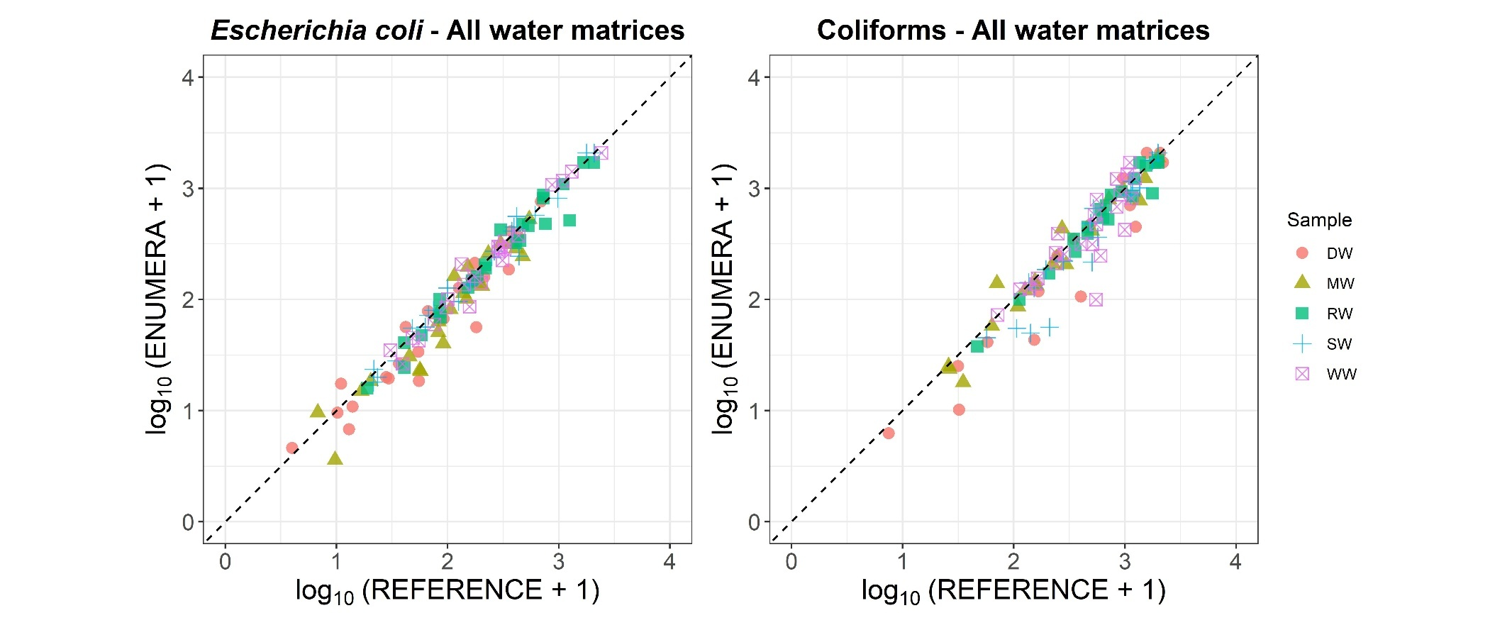

Figure 2. Precision profiles of the ENUMERA®-Coli100 method and ISO 9308-2 (Reference) for E. coli and total coliforms, expressed as standard deviation of reproducibility (SR). The relative differences between duplicate analyses are shown as a function of analyte concentration. DW: drinking water; RW: reclaimed water (RW); MW: seawater; SW: surface water; and WW: wastewater.

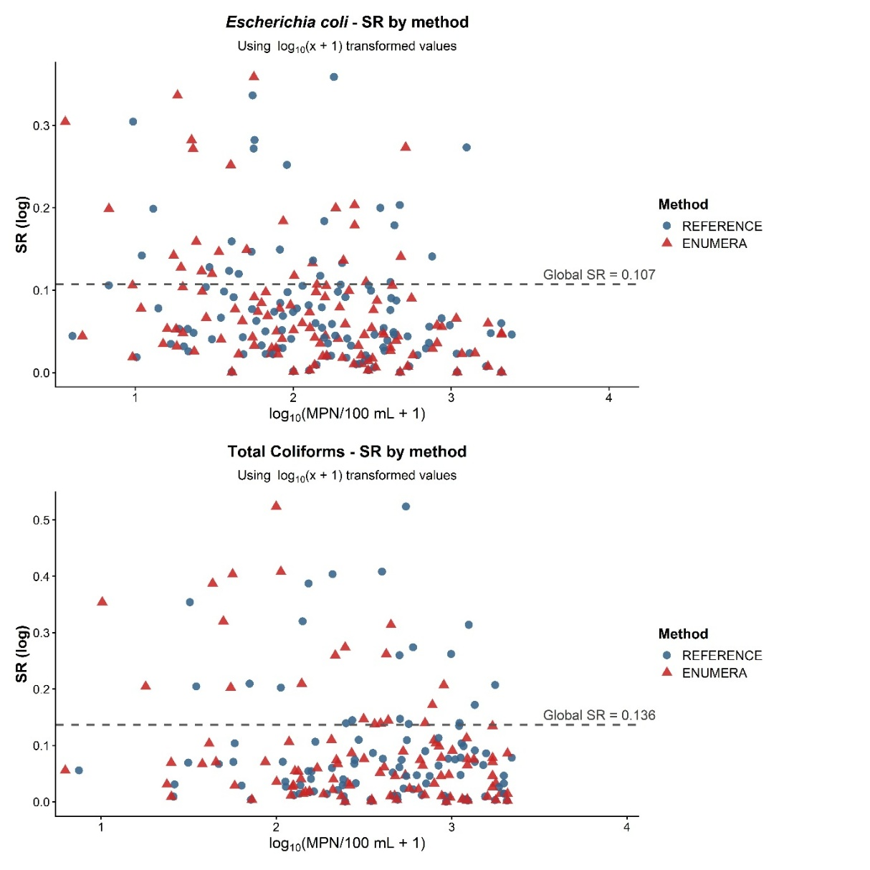

Figure 3. Bland-Altman plots showing agreement between the ENUMERA®-Coli100 method and ISO 9308-2 (Reference) for E. coli and total coliforms in all water matrices. Differences between paired results are plotted against the corresponding mean values. The solid central line indicates the bias, and the upper and lower lines indicate the 95% limits of agreement. Water matrices are identified as drinking water (DW), reclaimed water (RW), seawater (MW), surface water (SW), and wastewater (WW).

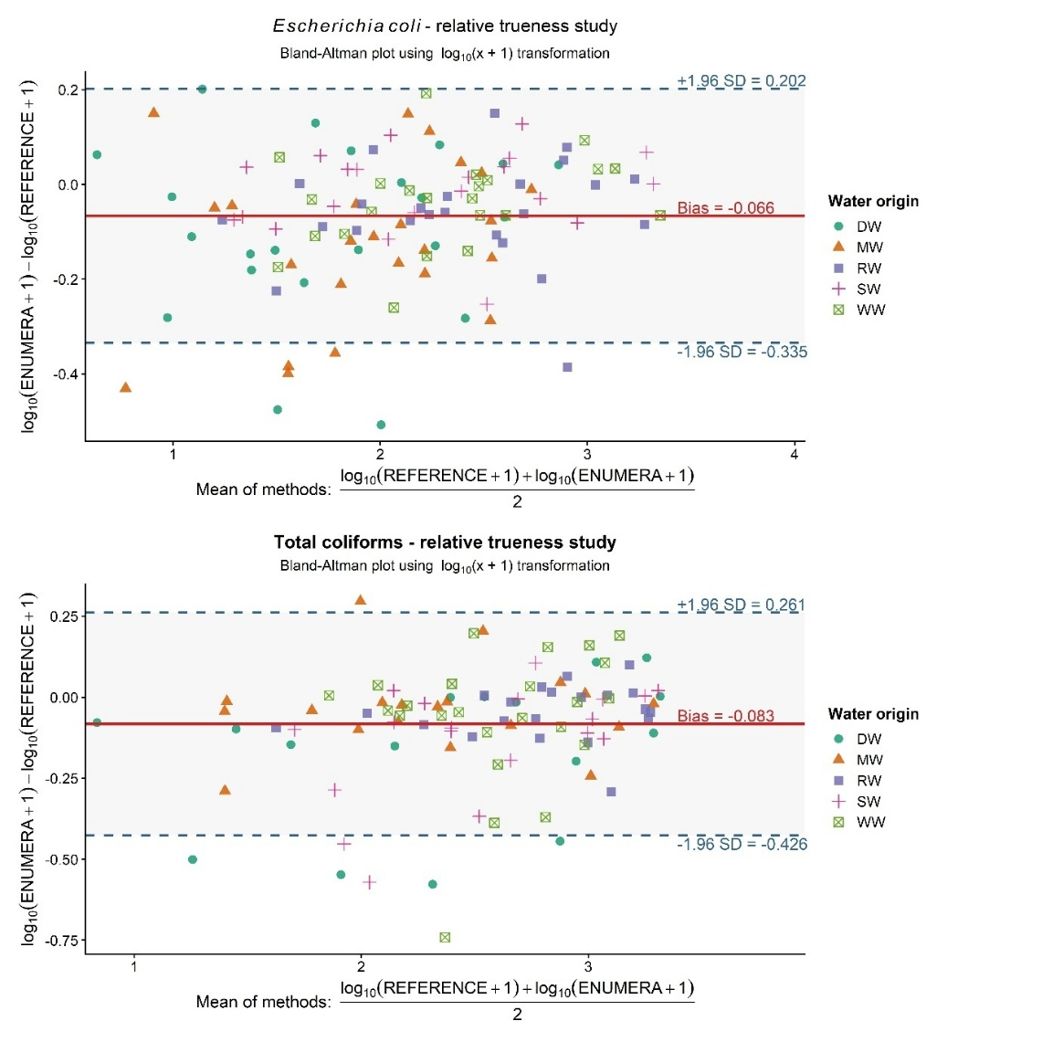
Figure 4. Passing-Bablok regression plots comparing the ENUMERA® Coli1100 method with the ISO 9308-2 reference method for E. coli and total coliforms across all water matrices, using log10(1 + MPN/100 mL)-transformed values. Regression parameters and Pearson’s r are shown in each plot.

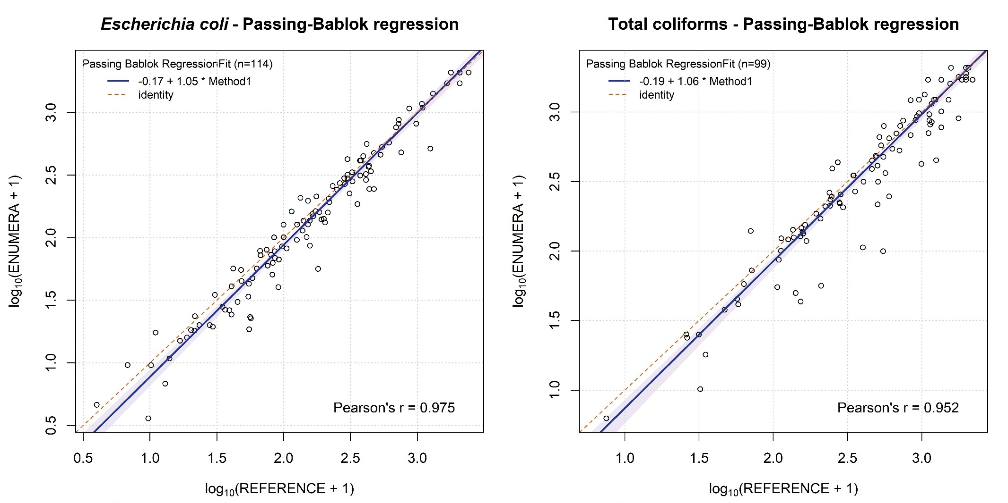

Figure 5. Effect of overflow well status on MPN estimates using log₁₀ (1 + MPN/100 mL): Bland-Altman comparison of 2-well and 3-well configurations.
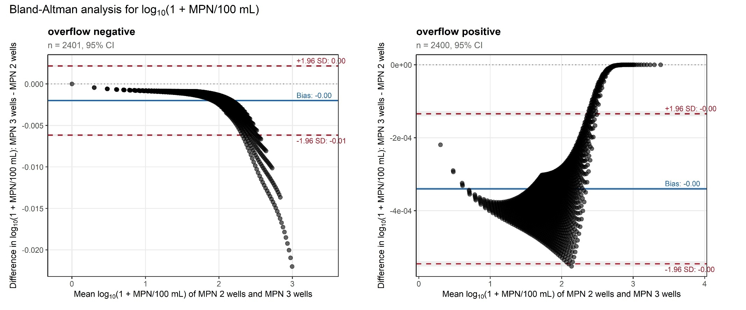

Figure 6. Comparative performance of the Aquacoli chromogenic medium in different tray-based MPN formats. Enumeration of E. coli (green) and total coliforms (green + yellow) in Quanti-Tray® was comparable to that obtained with the proprietary ENUMERA® Tray, indicating that the medium performance is not restricted to a single tray geometry.

