**Name:** Ejike-Nweze, Olisaeloka Michael

**Topic:** Process Documentation – Creating New Employee Emails in cPanel.

**Objective:** This document aims to provide a step-by-step guide for creating new employee email accounts using cPanel.

**Audience:** The intended audience for this process documentation are the technical department, the human resources department, and management.

**Prerequisite:** Access to cPanel account with appropriate privileges.

**Step 1:** Log in to your cPanel account.

1. Open your preferred web browser.
2. Enter the cPanel access URL provided by your hosting provider (e.g., https://yourdomain.com/cpanel). Replace ‘domain’ with your domain name.
3. Login using your cPanel username and password.

**Step 2:** Navigate to email accounts.

1. Once logged in, locate the “Email” section in your dashboard.
2. Click on “Email Accounts”.

**Step 3:** Create a new email account.

1. On the "Email Accounts" page, locate the "Create" button.
2. Fill in the required details for the new email account:
3. Enter the desired email address (e.g., company.employee@companydomain.com).
4. Set a secure password for the email account or send a login link to an alternate email address for password setup.
5. Specify the mailbox storage space (optional).
6. Click on the "Create" button to finalize.

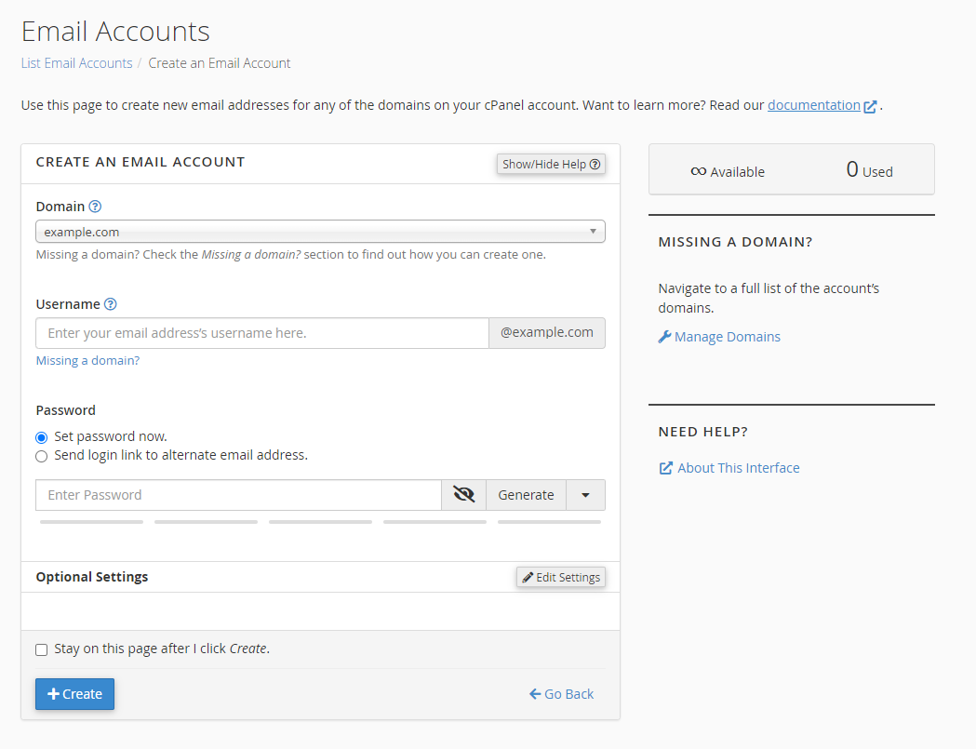

**Step 4:** Test the email.

1. Send a test email to the newly registered email address to confirm it receives emails successfully.
2. Send a test email from the newly registered email to confirm it sends emails successfully.