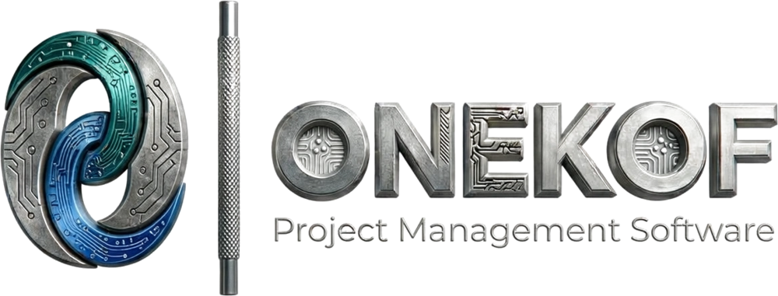
Onekof Support Guide
Getting Started & Navigation
Feature Documentation for the Technical Assistance Team
Version 1.0 · July 25, 2026
Prepared by: Oli Tamrat, CTO — DAPS Analytics PLC

1. What is Onekof?
Onekof is a project management platform built by DAPS Analytics PLC for Ethiopian government institutions, NGOs, enterprises, and schools. One account gives a user access to one or more workspaces (organizations); inside a workspace, work is organized into projects, issues, sprints, goals, budgets, teams, and documents. The platform speaks five languages — English, Amharic, Afaan Oromo, Tigrinya, and Somali — and adapts its features to the type of organization using it.
This guide covers the first-day experience: creating an account, joining or creating a workspace, choosing the organization type, switching languages, and finding your way around.

2. Who Can Do What
Action | Required role
Sign up, create a personal workspace | Anyone
Invite members, accept members into the org | Org Owner or Admin
Apply an organization preset / customize sections | Org Owner or Admin (others can open the page but saving is refused)
Change org branding, currency, terminology | Org Owner or Admin
Use the platform, switch language and theme | Any member
See Budget, Members, Reports, Settings in the sidebar | Any member except Guests — Guests never see these

3. Key Terms
- Workspace (organization) — the top-level container for everything: members, projects, budgets, settings. A user can belong to several and switch between them from the top bar.
- Organization preset — a one-click configuration for a type of institution: Ministry / Government, NGO / Non-Profit, Business / Startup, or Education. It decides which sections appear and which features are on.
- Section — a major sidebar area (Teams, Budget, Goals, Automations, Documents, Docs…). Owners/Admins can switch sections on or off per organization.
- Terminology scheme — Agile ("Sprint") or Formal ("Work Cycle") vocabulary, chosen per organization. Every screen and report follows it.
- Command palette — the universal search box (Ctrl+K / Cmd+K): searches issues, projects, members, teams, goals, and docs, and jumps anywhere.
- Project scope — picking one project in the sidebar filters every dashboard page to that project; a green scope card shows the filter is on.

4. Step-by-Step Guides

4.1 Create an account
- Go to the sign-up page. Enter your name, email, and a password — at least 8 characters with an uppercase letter, a lowercase letter, and a number.
- Check your email and open the verification link (valid for 24 hours).
- Sign in. Google, Microsoft, GitHub, and LinkedIn sign-in buttons may also be available depending on the deployment; email + password always works.

4.2 First-time onboarding
- Pick the kind of work you do (or Skip for now) — this only tunes suggestions, nothing is locked.
- Create your workspace: name, web address (auto-suggested), and team size. You land on the Dashboard.
- If you were invited to an existing organization, you will not get a personal workspace — verify your email, accept the invitation, and you join the inviter’s workspace directly.

4.3 Apply the organization type (Owner/Admin)
- Go to Settings → Customization (direct address: /dashboard/settings/customization).
- Under Quick Start Presets, choose Ministry / Government, NGO / Non-Profit, Business / Startup, or Education. The sections and features adjust immediately in the preview.
- Fine-tune individual section toggles and budget features if needed, then press Save Changes. The dashboard reloads with the new layout.

4.4 Switch language
- On a computer: click the globe icon in the top bar and pick English, አማርኛ (Amharic), Afaan Oromoo, ትግርኛ (Tigrinya), or Af Soomaali.
- On a phone: open the ⋮ menu in the top bar → Language.
- The choice is remembered per browser/device. Amharic and Tigrinya switch the interface to an Ethiopic font automatically.

4.5 Find your way around
- Sidebar: Home, Projects (with Issues, Calendar, Timeline, Goals, Reports underneath), Teams, Budget, and the Knowledge group (AI Documents, Automation, Wiki, Docs). Which sections appear depends on the organization’s preset and settings.
- Top bar: workspace switcher, search (opens the command palette), + Create button (Issue, Project, Wiki page, Team, Invite member), language, notifications bell, light/dark theme, and your avatar menu.
- Press Ctrl+K (Cmd+K on Mac) anywhere to search and jump. On phones, the sidebar is behind the ☰ button and the top-bar tools are behind ⋮.

4.6 Focus on one project
- In the sidebar under Projects, pick a specific project. All dashboard pages now show only that project’s data, and a green scope card appears.
- To go back to everything, press the X on the scope card or choose View all projects.

5. Rules the System Enforces (and Why)
These are deliberate protections, not bugs.
- Email must be verified before full use. The verification link expires after 24 hours — re-request it if missed. This keeps accounts tied to real institutional mailboxes.
- Passwords have a minimum strength. 8+ characters with upper, lower, and a number. Weak passwords are refused at sign-up and reset.
- Repeated failed logins lock the account temporarily. The message says how many minutes remain. This blocks password-guessing; it resolves by itself — no support action needed.
- Customization saves are Owner/Admin only. Anyone can look at the Customization page, but saving as a regular member is refused with "Admin access required". Layout decisions belong to org administrators.
- Guests see a reduced sidebar. Budget, Members, Reports, Settings, and Automation are hidden from Guest accounts by design — not a display error.
- Presets are starting points, not locks. Applying Ministry, NGO, Business, or Education just sets the toggles; an Owner/Admin can change any individual toggle afterwards.

6. Troubleshooting & FAQ
Question / symptom | Answer
"Automations / AI Assistant is missing." | Only the Business/Startup preset enables Automations and the AI Assistant. Ministry, NGO, and Education presets switch them off deliberately. An Owner/Admin can enable them under Settings → Customization.
"The Budget (or Teams) section disappeared." | An Owner/Admin turned that section off in Settings → Customization, or the account is a Guest (Guests never see Budget, Members, Reports, Settings, Automation).
"The app switched back to English on my other computer." | Language is remembered per browser/device, not per account. Pick it again on each device; clearing browser data also resets it.
"I can’t save on the Customization page." | Saving requires the org Owner or Admin role. Also, the Save button stays disabled until something is actually changed.
"I signed up but the verification link doesn’t work." | Links expire after 24 hours. Request a new one from the sign-in page.
"I’m locked out after wrong passwords." | A temporary security lock — the message states the minutes remaining. Wait it out or use Forgot password.
"I was invited but ended up in an empty workspace of my own." | Accept the invitation from the email after verifying — invited users join the inviter’s organization; a personal workspace is only created when there is no pending invitation.
"Onboarding never asked whether we are a Ministry or NGO." | Correct — onboarding creates a neutral workspace. The organization type is applied afterwards by an Owner/Admin at Settings → Customization (/dashboard/settings/customization).
"Google/Microsoft sign-in does nothing." | Social sign-in providers must be configured on the specific deployment. Email + password always works.
"Why does this org say Work Cycle instead of Sprint?" | The organization uses the Formal terminology scheme. Same feature, formal vocabulary — common for government-facing organizations.

7. Why This Design — the Benefits

For users
- One account, many workspaces — a consultant or ministry liaison switches organizations from the top bar without separate logins.
- The interface speaks the user’s language, including Ge’ez-script languages with proper fonts, on every page from sign-in onwards.

For administrators
- Presets configure a whole institution in one click — a ministry gets procurement and transparency, an NGO gets grants and donations, a school gets a simplified layout.
- Sections users don’t need simply don’t appear — less training, fewer wrong turns.

For leadership
- Security by default: verified emails, strong passwords, login-lockout protection, optional two-factor authentication (Settings → Security), and role-gated administration.
- The same platform serves every organization type in the country — one support team, one training program, four institutional flavors.

8. Under the Hood (Senior Support Reference)
- Authentication is NextAuth with JWT sessions; sign-out invalidates the session server-side. OAuth providers (Google, Microsoft, GitHub, LinkedIn) activate only when configured on the deployment.
- Sign-up is rate-limited and failed logins trigger a timed account lock — both return messages that state the remaining wait.
- A user with zero organizations is force-redirected to onboarding; a user with an organization who opens onboarding is bounced back to the dashboard.
- Section visibility is resolved per organization from enabledSections + feature flags; if settings fail to load, the sidebar fails open (shows everything) rather than hiding work.
- Language preference is stored client-side (onekof-locale). The organization also has its own language/terminology settings used for generated reports.
- Preset definitions live in code (organization-presets.ts) — support can state exactly what each preset turns on or off.

9. Where Everything Lives
I want to… | Go to
Sign in / sign up / reset password | /auth/signin · /auth/signup · Forgot password link
Switch workspace (organization) | Top bar → workspace name dropdown
Search everything / jump anywhere | Ctrl+K (Cmd+K) or the top-bar search box
Create issue, project, wiki page, team, or invite | Top bar → + Create
Change language / theme | Top bar → globe icon / theme toggle (phone: ⋮ menu)
Apply org type preset, toggle sections | Settings → Customization (/dashboard/settings/customization) — Owner/Admin
Security: password, two-factor | Dashboard → Settings → Security
Notifications | Top-bar bell (phone: /dashboard/notifications)

Questions not covered here: support@onekof.com

