## **Project “UNITY-RPG” GDD**

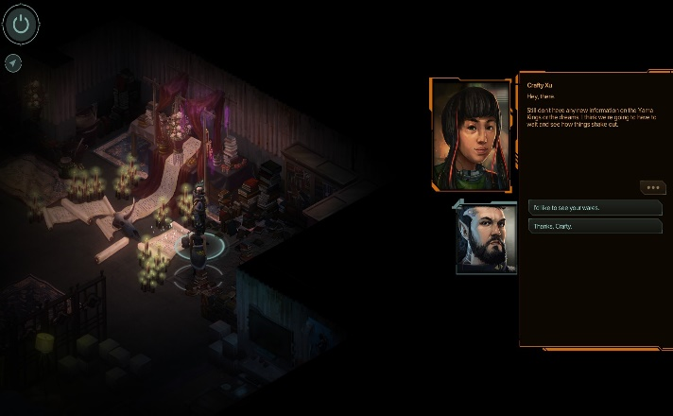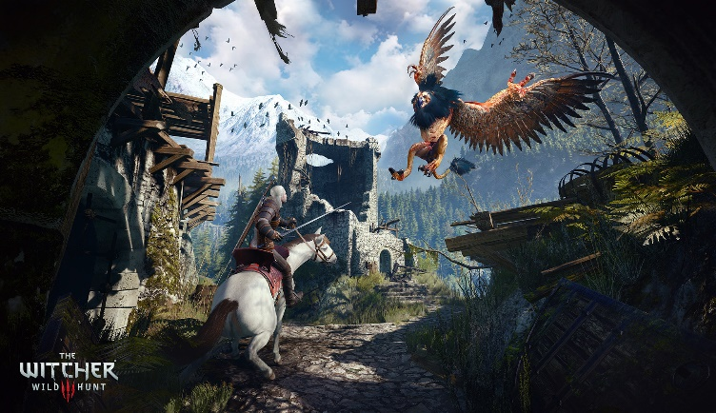Story-driven action-rpg

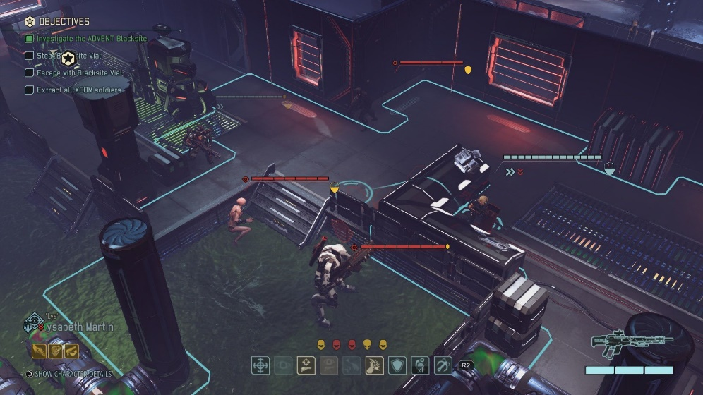

**Genre:** RPG, 3rd person camera RPG.  
**Target Audience:** T for Teen.

**Controls:** Keyboard and mouse

**Thematic Setting:** Medieval fantasy – swords, hunters, castles

**Tech Stack:** Unity 5+, Blender, Photoshop

**Platform(s):** Steam, Web, Mobile

**Game Summary:** Unity-RPG (development title) is a Diablo style RPG with the richness of the story design of the Witcher 3 game. As a man inflicted with a curse, you venture the world of Artia looking for answers about your condition and a way to cure it. All the while facing the woes of a land where helping someone can be as punishing as it can be rewarding. People remembers your choice, thread carefully.

**Core Player Experience:** Master your destiny, Dark Humour, Meaningful decisions.

**Central Theme:** Overcoming oneself to become a Hero. Unraveling the Mystery.

**Design Pillar:** Putting the player in gray areas where he must make a choice and deal with the consequences, always aspiring to the best outcome (be it for him, the ones involve, or neither).

**Anticipated Remarkability:** Deep and rich lore.

**Anticipated Steam Early Access Launch date:** N/A

**Feature Development Priorities:**

* Real-time combat
* RPG progression (levels, abilities, spells, upgrades).
* Story Arcs
* Branching Dialogue system
* Character customization
* Inventory, loot, usable items

**Comparative Products:** The Witcher 3 (story arcs, monsters hunting), Diablo (gameplay), Shadowrun