**COURSEWORK SUBMISSION FORM**

|  |  |  |  |
| --- | --- | --- | --- |
| **STUDENT USE** | | **STAFF USE** | |
| Module Name | Web Technologies | First Marker’s  (acts as signature) |  |
| Module Code | 4BUIS011C | Second Marker’s  (acts as signature) |  |
| Lecturer Name | Olga Yugay | Agreed Mark |  |
| UoW Student IDs |  | **For Registrar’s office use only (hard copy submission)** | |
| WIUT Student IDs | 00007458 |
| Deadline date | 21.11.2019 |
| Assignment Type | 🗌Group🗸Individual |

**SUBMISSION INSTRUCTIONS**

**COURSEWORKS *must* be submitted in *both* HARD COPY (to the Registrar’s Office) *and* ELECTRONIC unless instructed otherwise.**

For hardcopy submission instructions refer to: <http://intranet.wiut.uz/Shared%20Documents/Forms/AllItems.aspx> - Coursework hard copy submission instructions.doc

For online submission instructions refer to: <http://intranet.wiut.uz/Shared%20Documents/Forms/AllItems.aspx> - Coursework online submission instructions.doc

|  |
| --- |
| **MARKERS FEEDBACK (Continued on the next page)** |
|  |

Content

**1. Brief information about the website 3**

**2. Functions and Features 3**

**2.1 Hosting and used libraries 3**

**2.2 Home Page 3**

**2.3 Contact page 4**

**2.4 Start page 4**

**3. Conclusion 4**

**Appendices 5**



# **Brief information about the website**

The QuizLand (**olimjonov.github.io**) - is a platform of quizzes where everyone can check their knowledge. The idea was inspired by websites like quizly.co and playbuzz.com. Questions for the quiz were collected from different areas. That is why, the target audience can be anyone who knows English. Moreover, due to, online quiz websites can be used for educational purposes, it can reach high visitors for the QuizLand. The name and the logo of the website does not represent actual company or service, they were made by the student of WIUT. The name QuizLand is easy to remember and very simple, however, the meaning of it is – “the land of Quizzes”. The mission of the website is to create quizzes for all type of people, starting from kids to pensioners.

# Functions and Features

* 1. **Hosting and used libraries**

As a hosting I used “Github.com” platform, because it is free and accessible for many country in the world. Bootstrap 4 and JQuery libraries were used for CSS and JavaScript to create a website responsive and attractive. Most of the buttons created with the help of Bootstrap library and customized in the file named stylesheet.css. JQuery library were used in order to create a pre-loader.

* 1. **Home Page**

Home page of the website includes header, footer and 3 more sections. In order to create a header with 2 types of responsive navigation I used “Bootstrap 4” library and made some changes in my custom css file which is called stylesheet.css. For the devices up to 992 pixels of the width size, there will be button for the navigation bar and from 992px size, it will be adapted for the desktop devices. To make the website attractive there is a background video with dark overlay (Appendix A). Navigation bar of the website can direct the user to the “Home Page”, “About” section, which is in the “Home Page”, “Contact” page and “Start” page. The first and the last sections of the websites there is a “Start” button, which makes users easy to find the “quiz” part of the website.

* 1. **Contact page**

The contact page is also contains header, footer and a section (Appendix B). In this page, users can contact the developer, know the address of the company and go to the pages of social network. Moreover, “mailto:” function is used in order to send an e-mail to the developer’s e-mail address.

* 1. **Start page**

The main part of the website – “Start” page includes header with navigation bar, footer with developer’s info and 2 sections with quiz application (Appendix C). The first section of the “Start” page contains the information about the quiz application. The second section contains the quiz application, which is created mainly with JavaScript. Buttons of the quiz application is customized in the CSS file – stylesheet.css. There are 5 questions in the application. If the user clicks wrong answer it will be covered with red color and if the user clicks correct answer it will be covered with green color (Appendix D). Every time when the user reload the page, questions will be sorted randomly.

# Conclusion

Overall, QuizLand is a website for all category of internet users and can be developed for the high amount of audience. Visual effects with the usage of JavaScript and CSS make the website interesting and attractive.

# Appendices

Appendix A

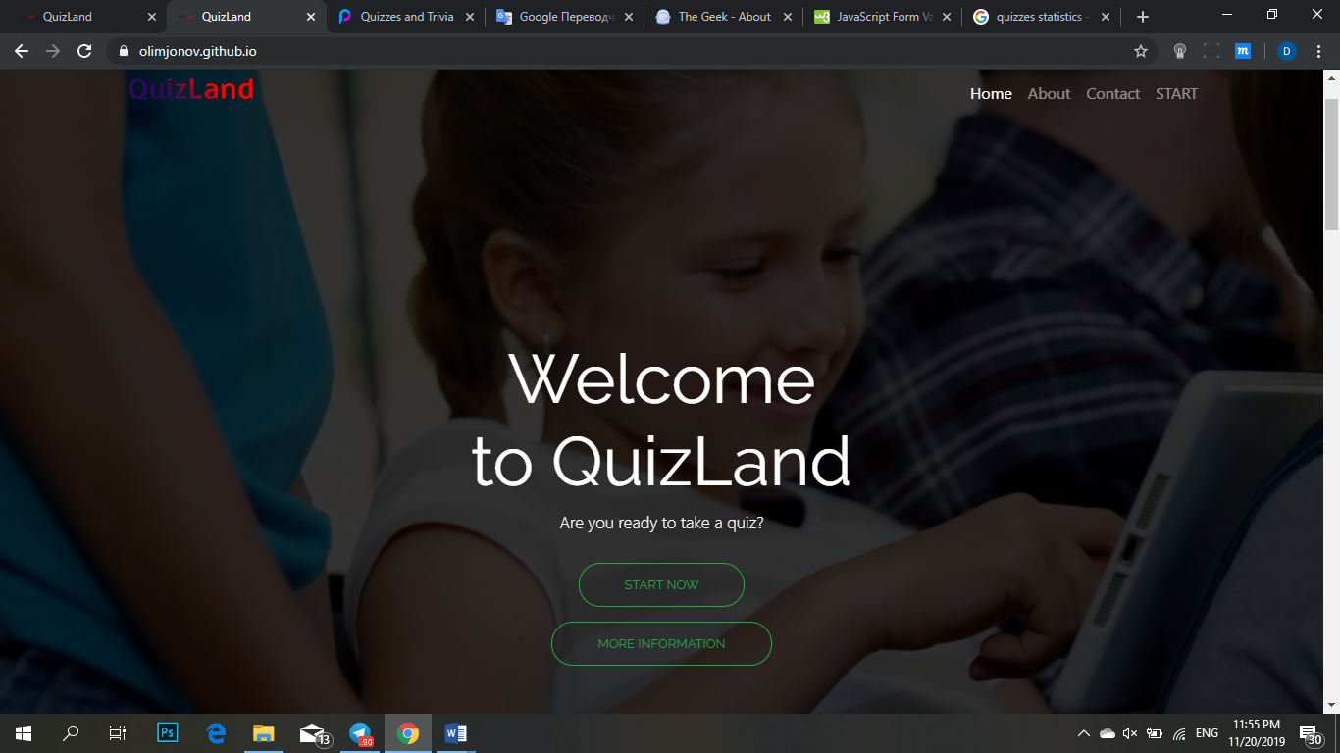

Appendix B

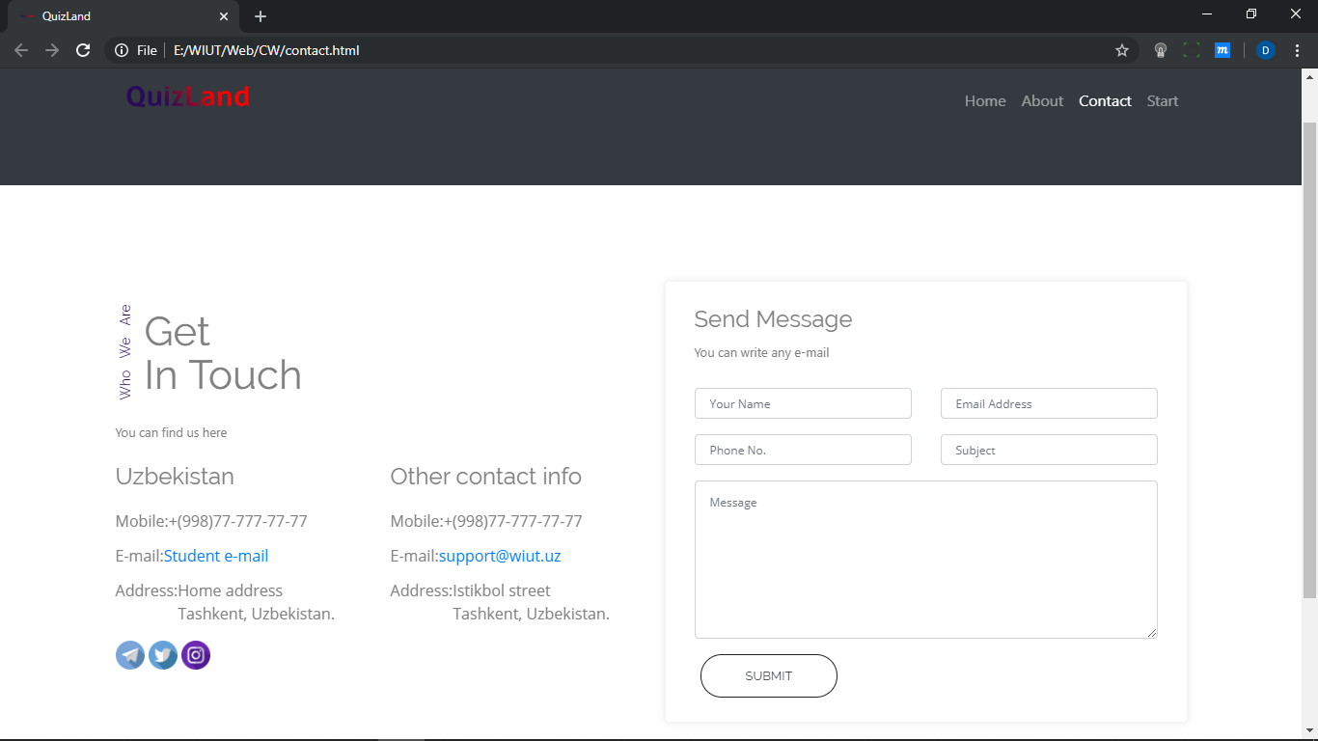

Appendix C

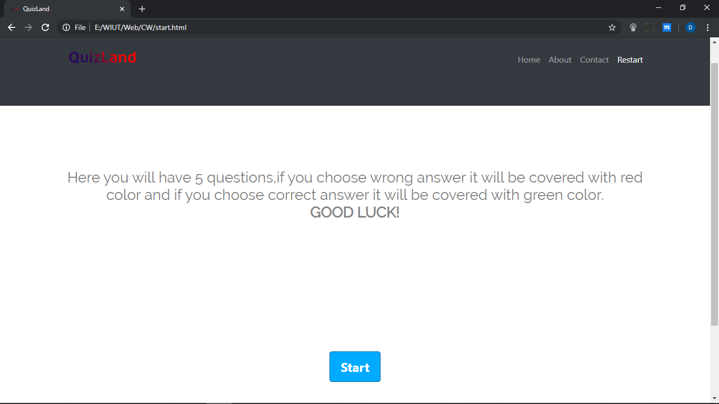

Appendix D

