Measuring the Freezing Process Impact on 10x sc-RNA-seq Experiment

Simon Cai

# Introduction

10x Genomics has been one of the most popular single-cell RNA-seq platforms. Numerous findings have been made from the large-scale datasets generated by the platform, which supports the RNA-seq for hundreds of thousands of single cells. However, the official protocol provided by 10x only allows using fresh cells, which poses a great limitation on the technology. In this project, we focus on finding the difference between Fresh and Frozen (or THA for thawed) samples, under 4 different conditions (2 different cell lines X 2 differential stages). Figure 1 below describes the experiment design.

Figure 1 10x Experiment Layout. The red and blue arrows highlight the comparisons in the scope of Fresh vs Frozen study. This experiment is also used for other analyses which are indicated by other arrows.

# Results

As this is a shortened snapshot for demonstration, only one pair (D1-FA2) of comparisons is included in the result section.

## Correlation plots

We first plotted all the genes with the total number of UMI counts and calculated the Pearson correlation and $R^{2}$ between the fresh and frozen pairs. We saw at the global level the correlation was only slightly lower than the correlation between inter-chip replicates.

C

B

A

Figure 2 Correlation plots.  
A. the correlation plot from official 10x technical report for technical replicates between chips.  
B. correlation between Fresh and Frozen (THA) for D1 and FA2 cell line.  
C. correlation between Fresh and Frozen (THA) for D4 and FA2 cell line.

## Differentially expressed genes (DEGs)

We then zoomed into the actual DEGs to analyse if there was any impact on any specific set of genes or pathways. We filtered to only include cells that have total UMI counts higher than 4,000 and less than 40,000, which consists of ~80% of all the cells. We also performed DEG analysis for both all genes and highly expressed genes (> 500 UMI total counts).

B

A

D

C

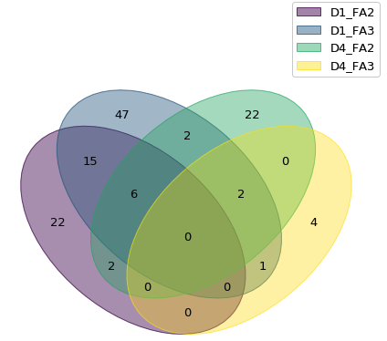

Figure 3 Differentially Expressed Genes.  
A. All DEGs selected at FDR < 0.001 for D1-FA2  
B. DEGs for highly expressed genes FDR < 0.001 D1-FA2  
C. Venn diagram for DEGs with fold change > 2 or < -2  
D. Venn diagram for DEGs (highly expressed genes) with fold change > 2 or < -2

## Pathway analysis

For the DEGs included in Fig 3A (but for all pairs), we selected ones that appeared in at least three comparative pairs for pathway analysis. As shown in Figure 4, the top ones are all related to mitochondria and energy acquisition, which is exactly expected.

Figure 4 Top five affected pathways.

## Clustering analysis

Clustering analysis in one of the main analytical methods in single-cell analysis, which aims to identify various cell populations in the sample.

In this section we investigate the difference between FRESH and FROZEN via a standard clustering workflow. No obvious difference was seen between fresh and frozen.

Figure 5 Clustering results from standard Seurat workflow.

# Methods

|  |  |
| --- | --- |
| Tool | Usage |
| CellRanger | Alignment and pre-processing for the raw sequencing data |
| Scanpy | Dataset processing |
| NBID | DEG computation |
| IPA | Pathway analysis |
| Seurat | Dataset integration and clustering |
| Seaborn, ggplot | Visualisation |

# Conclusion (preliminary)

Based on the current results from DEG, pathway and clustering analysis, we have shown that frozen samples can be used without major impact on 10x experiments. However, if the research question is specifically about mitochondrial pathways, especially for oxidative phosphorylation and sirtuin signalling pathways, we suggest not using the frozen samples, as consistent difference and impact on those pathways have been observed from the frozen condition.