**Coversheet**

**The Coversheet has to contain the following:**

* **Heading “Electrical System Form FSAE-E 2016”**
* **University and Team Name**
* **Car number**
* **Main Team Contact for ESF related questions**

Feel free to add team logo, car picture, and the like.

**Requirements (delete this section after you have read and understood it):**

Read the document “How to pass ESF&FMEA” which is available at <http://www.formulastudent.de/uploads/media/FSE2011_How_to_pass_ESF_FMEA_01.pdf>

Maximum number of pages for the complete ESF is 100 pages!

Links to video or audio data are prohibited.

If you did not fill out the tables or if you changed the format of the ESF Template, you will fail by default.

Every single part/heading of the ESF Template must be filled with content. If the respective part is not relevant for your concept, describe shortly why not.

The table of contents must be hyperlinked.

The generated PDF must contain hyperlinked bookmarks (an example can be found in the FSAE Electric 2016 rules for example).

Use internal reference links. For example when describing wiring and mentioning a figure in the text then link it to the figure.

Do not just copy all of your datasheets in the appendix, e.g. we do not need to know what you have to do to program your motor controller; we do not need the whole user manuals of microcontrollers to review your ESF, etc. Similarly, do not just paste only a link to the entire data sheet. We should not need an internet connection to obtain the information necessary to review your ESF.

Single pages/figures/tables extracted from the complete datasheet showing the important parameters, figures, etc. are usually sufficient, but the source/link to the complete datasheet has to be provided. If the datasheet describes more than one type, clearly mark in the datasheet to which type you are referring / which type you plan to use.

Datasheets should only be used as a reference. Please cover the important data in your text by using tables, figures, etc.

If you refer to parts of a data sheet, then you need to provide an internal document links from the text to the respective datasheet and another internal document link back from the datasheet to the text section.  
For example a link in the motor controller section “The datasheet can be found here (clickable)” and a link above the motor controller datasheet in the appendix “The section covering the motor controller can be found here (clickable)”.

If you are unsure with respect to feedback of the reviewer, do not hesitate to write an e-mail and ask.

Parts of the ESF which are changed because of reviewer’s feedback have to be marked in red.

Following these guidelines will guarantee a swift review process.

Table of Contents

Table of Contents iii

I List of Figures vii

II List of Tables viii

III List of Abbreviations ix

1 System Overview 2

2 Electrical Systems 3

2.1 Shutdown Circuit 3

2.1.1 Description/concept 3

2.1.2 Wiring / additional circuitry 3

2.1.3 Position in car 4

2.2 IMD 4

2.2.1 Description (type, operation parameters) 4

2.2.2 Wiring/cables/connectors/ 5

2.2.3 Position in car 5

2.3 Inertia Switch 5

2.3.1 Description (type, operation parameters) 5

2.3.2 Wiring/cables/connectors/ 5

2.3.3 Position in car 5

2.4 Brake Plausibility Device 5

2.4.1 Description/additional circuitry 5

2.4.2 Wiring 6

2.4.3 Position in car/mechanical fastening/mechanical connection 6

2.5 Reset / Latching for IMD and BMS 6

2.5.1 Description/circuitry 6

2.5.2 Wiring/cables/connectors 6

2.5.3 Position in car 6

2.6 Shutdown System Interlocks 7

2.6.1 Description/circuitry 7

2.6.2 Wiring/cables/connectors 7

2.6.3 Position in car 7

2.7 Tractive system active light 7

2.7.1 Description/circuitry 7

2.7.2 Wiring/cables/connectors 8

2.7.3 Position in car 8

2.8 Measurement points 8

2.8.1 Description 8

2.8.2 Wiring, connectors, cables 8

2.8.3 Position in car 8

2.9 Pre-Charge circuitry 8

2.9.1 Description 8

2.9.2 Wiring, cables, current calculations, connectors 8

2.9.3 Position in car 9

2.10 Discharge circuitry 9

2.10.1 Description 9

2.10.2 Wiring, cables, current calculations, connectors 9

2.10.3 Position in car 10

2.11 HV Disconnect (HVD) 10

2.11.1 Description 10

2.11.2 Wiring, cables, current calculations, connectors 10

2.11.3 Position in car 10

2.12 Ready-To-Drive-Sound (RTDS) 11

2.12.1 Description 11

2.12.2 Wiring, cables, current calculations, connectors 11

2.12.3 Position in car 11

3 Accumulator 12

3.1 Accumulator pack 1 12

3.1.1 Overview/description/parameters 12

3.1.2 Cell description 12

3.1.3 Cell configuration 13

3.1.4 Cell temperature monitoring 13

3.1.5 Battery management system 13

3.1.6 Accumulator indicator 14

3.1.7 Wiring, cables, current calculations, connectors 14

3.1.8 Accumulator insulation relays 14

3.1.9 Fusing 15

3.1.10 Charging 16

3.1.11 Mechanical Configuration/materials 17

3.1.12 Position in car 17

3.2 Accumulator pack 2 17

4 Energy meter mounting 18

4.1 Description 18

4.2 Wiring, cables, current calculations, connectors 18

4.3 Position in car 18

5 Motor controller 19

5.1 Motor controller 1 19

5.1.1 Description, type, operation parameters 19

5.1.2 Wiring, cables, current calculations, connectors 19

5.1.3 Position in car 20

5.2 Motor controller 2 20

6 Motors 21

6.1 Motor 1 21

6.1.1 Description, type, operating parameters 21

6.1.2 Wiring, cables, current calculations, connectors 21

6.1.3 Position in car 22

6.2 Motor 2 22

7 Torque encoder 23

7.1 Description/additional circuitry 23

7.2 Torque Encoder Plausibility Check 23

7.3 Wiring 23

7.4 Position in car/mechanical fastening/mechanical connection 23

8 Additional LV-parts interfering with the tractive system 24

8.1 LV part 1 24

8.1.1 Description 24

8.1.2 Wiring, cables, 24

8.1.3 Position in car 24

8.2 LV part 2 24

9 Overall Grounding Concept 25

9.1 Description of the Grounding Concept 25

9.2 Grounding Measurements 25

10 Firewall(s) 26

10.1 Firewall 1 26

10.1.1 Description/materials 26

10.1.2 Position in car 26

10.2 Firewall 2 26

11 Appendix 27

# 

# List of Figures

Has to be hyperlinked!

# List of Tables

Table 1.1 General parameters 2

Table 2.1 List of switches in the shutdown circuit 3

Table 2.2 Wiring – Shutdown circuit 4

Table 2.3 Parameters of the IMD 4

Table 2.4 Parameters of the Inertia Switch 5

Table 7.1 Torque encoder data 6

Table 2.6 Parameters of the TSAL 7

Table 2.7 General data of the pre-charge resistor 9

Table 2.8 General data of the pre-charge relay 9

Table 2.9 General data of the discharge circuit 10

Table 3.1 Main accumulator parameters 12

Table 3.2 Main cell specification 13

Table 3.5 Wire data of company A, 0.205 mm² 14

Table 3.3 Basic AIR data 15

Table 3.4 Basic fuse data 15

Table 3.5 Fuse Protection Table 16

Table 3.6 General charger data 17

Table 5.1 General motor controller data 19

Table 5.2 Wire data of company A, 0.205 mm² 20

Table 6.1 General motor data 21

Table 7.1 Torque encoder data 23

Has to be hyperlinked!

# List of Abbreviations

# 

# System Overview

* Short description of the system’s concept
* Rough Schematic (blocks) showing all parts affected with the electrical systems and function of the tractive-system
* No detailed wiring
* Additionally fill out the following table, replacing the values with your specifications:

|  |  |
| --- | --- |
| Maximum Tractive-system voltage: | 100VDC |
| Nominal Tractive-system voltage: | 90DC |
| Control-system voltage: | 12VDC |
| Accumulator configuration: | 2s2p in 12s |
| Total Accumulator capacity: | 67.5Ah |
| Motor type: | Brushless DC Motor |
| Number of motors: | Total: 2 |
| Maximum combined motor power in kW |  |

Table 1.0 General parameters

# 

# Electrical Systems

## Shutdown Circuit

### Description/concept

Describe your concept of the shutdown circuit, the master switches, shut down buttons, brake over travel switch, etc.

Additionally fill out the following table replacing the values with your specification and append additional switches from your setup:

|  |  |
| --- | --- |
| Part | Function |
| Main Switch (TSMS) | Normally open |
| Brake over travel switch (BOTS) | Normally closed |
| Shutdown buttons (SDB) (Left, right cockpit) | Normally closed |
| Insulation Monitoring Device (IMD) | Normally open |
| Battery Management System (BMS) x4 | Normally open |
| Inertia Switch | Normally closed |
| Interlocks | Closed when circuits are connected |
| Brake System Plausibility Device | Normally closed |

Table 2.0 List of switches in the shutdown circuit

### Wiring / additional circuitry

Describe wiring and additional circuitry, show extra schematics for example if additional transistors etc. are used, also describe the function of additional circuitry and make good use of figures.

Additionally fill out and add information to the following table:

|  |  |
| --- | --- |
| Total Number of AIRs: | 2 |
| Current per AIR: | 0.5A |
| Additional parts consumption within the shutdown circuit: | 2A |
| Total current: | 7A |
| Cross sectional area of the wiring used: | 0.205 mm² |

Table 2.0 Wiring – Shutdown circuit

### Position in car

Provide CAD-renderings showing the relevant parts. Mark the parts in the renderings, if necessary.

## IMD

### Description (type, operation parameters)

Describe the IMD used and use a table for the common operation parameters, like supply voltage, set point, etc. Also describe how the IMD indicator light is wired, etc.

The IMD used will be a Bender A-ISOMETER IR155-3203, as recommended by FSAE in EV 5.5.2. The output is normally low and only high if it does not detect a ground fault. The output is then used in a 3PDT relay to power both the indicator light and closes the switch in the shutdown circuit.

Additionally fill out the following table replacing the values with your specification:

|  |  |
| --- | --- |
| Supply voltage range: | 10..36VDC |
| Supply voltage | DC 12V/24V |
| Environmental temperature range: | -40..105°C |
| Selftest interval: | Every 5 minutes |
| High voltage range: | DC 0..1000V |
| Set response value: | 100kΩ (500Ω/Volt) |
| Max. operation current: | 150mA |
| Approximate time to shut down at 50% of the response value: | 27s Depends per model |

Table 2.0 Parameters of the IMD

### Wiring/cables/connectors/

Describe wiring, show schematics, describe connectors and cables used and show useful data regarding the wiring including wire gauge/temp/voltage rating and fuses protecting the wiring.

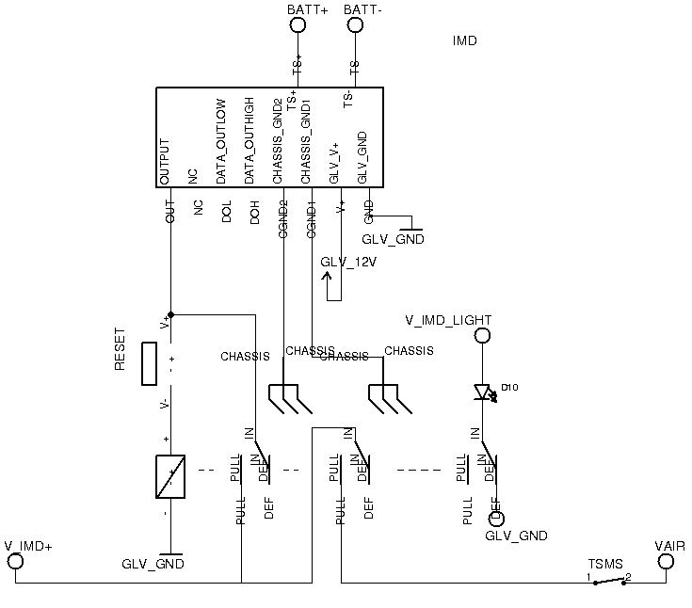

The wiring gauge going to and from the IMD is

### Position in car

Provide CAD-renderings showing the relevant parts. Mark the parts in the rendering, if necessary.

## Inertia Switch

### Description (type, operation parameters)

Describe the Inertia Switch used and use a table for the common operation parameters, like supply voltage, temperature, etc.

Additionally fill out the following table replacing the values with your specification:

|  |  |
| --- | --- |
| Inertia Switch type: | Sensata 6-11g |
| Supply voltage range: | 10..36VDC |
| Supply voltage: | 12VDC |
| Environmental temperature range: | -40..105°C |
| Max. operation current: | 10A |
| Trigger characteristics: | 6g for 50ms / 11g for 15ms |

Table 2.0 Parameters of the Inertia Switch

### Wiring/cables/connectors/

Describe wiring, show schematics, describe connectors and cables used and show useful data regarding the wiring.

The Inertia switch will be wired to be normally closed and open in the case that there is a crash. The switch will be wired according to the figure. The normally closed switch will close the shutdown circuit.

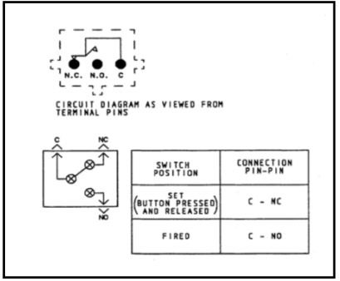

### Position in car

Provide CAD-renderings showing the relevant parts. Mark the parts in the rendering, if necessary.

## Brake Plausibility Device

## Description/additional circuitry

Describe how your electronic hardware brake plausibility system works (this is in addition to your ECU controlled brake plausibility software), provide tables with main operation parameters, and describe additional circuitry used to check or for an implausibility. Describe how the system reacts if an implausibility or error is detected.

|  |  |
| --- | --- |
| Brake sensor used: | ABC Sensor |
| Torque encoder used: | potentiometer |
| Supply voltages: | 5V |
| Maximum supply currents: | 20mA |
| Operating temperature: | -20..180 °C |
| Output used to control AIRs: | Open a relay |

Table 2.0 Torque encoder data

## Wiring

Describe the wiring, show schematics including the circuit board, show data regarding the cables and connectors used. If not detailed in section 2.1, be sure to show how the device open the shutdown circuit.

A Hall effect current sensor, wired before the current splits to the motor controllers, will send a proportional signal to a comparator. If the current is above 50 Amps, the output will be positive, and a positive signal will be sent to the AND gate. If the brakes are actuated, a positive signal will come from the brake pressure switch, causing the AND gate to return positive. This will go to two 555 timers, causing a time delay of .5 seconds. Should the signal be maintained over this time period, current will flow through the normally-closed relay, opening it and shutting down the current to the AIRs.

## Position in car/mechanical fastening/mechanical connection

Provide CAD-renderings showing all relevant parts and discuss the mechanical connection of the sensors to the pedal assembly. Mark the parts in the rendering, if necessary.

## Reset / Latching for IMD and BMS

### Description/circuitry

Describe the concept and circuitry of the latching/reset system for a tripped IMD or BMS. Describe the method for resetting the IMD and BMS.

BMS reset process: The AMS detects a fault. It shuts down the shutdown circuit, and latches into that state. When the switch on the IMD is pressed, the IMD passes a "Reset" CAN message to the AMS boards. At that point, if the accumulators are within parameters, the AMS reactivates the shutdown circuit.

### Wiring/cables/connectors

Describe wiring, show schematics, describe connectors and cables used and show useful data regarding the wiring. If not detailed in section 2.1, be sure to show how the device opens the shutdown circuit.

### Position in car

Provide CAD-renderings showing the relevant parts. Mark the parts in the rendering, if necessary.

## Shutdown System Interlocks

### Description/circuitry

Describe the concept and circuitry of the Shutdown System Interlocks.

Interlocks check if connectors and enclosures are closed, and if not, they break the shutdown circuit.

*Note: Interlocks are circuits used to open the shutdown circuit if a connector is disconnected or enclosure is opened. This is not the entire shutdown circuit.*

### Wiring/cables/connectors

Describe wiring, show schematics, describe connectors and cables used and show useful data regarding the wiring.

### Position in car

Provide CAD-renderings showing the relevant parts. Mark the parts in the rendering, if necessary.

## Tractive system active light

### Description/circuitry

Describe the tractive system active light and additional circuitry.

Additionally fill out the table:

|  |  |
| --- | --- |
| Supply voltage: | 12VDC |
| Max. operational current: | 250mA |
| Lamp type | LED strip |
| Power consumption: | 3 W |
| Brightness | 100 Lumen |
| Frequency: | 1.5Hz |
| Size (length x height x width): | 1cmx1.5cmx15cm |

Table 2.0 Parameters of the TSAL

### Wiring/cables/connectors

Describe wiring, show schematics, describe connectors and cables used and show useful data regarding the wiring. Include gauge, voltage and temperature rating of wiring used and any fuses or other overcurrent protection used.

### Position in car

Provide CAD-renderings showing the relevant parts. Mark the parts in the rendering, if necessary.

## Measurement points

### Description

Describe the housing used and how it can be accessed, etc. Describe how the measurement points protected/covered when not in use and how the electrical connections on the back of the measurement points are protected when the measurement points are being used.

Non-conductive, well-marked housing that can be opened without tools. It will be protected from people touching it by shrouded banana jack connectors.

### Wiring, connectors, cables

Describe wiring, show schematics, and describe connectors and cables used and show useful data regarding the wiring. Include details on the protection resistor including resistance, voltage and power rating.

Connections (all shrouded by 4 mm banana jacks): TS+ (TS system power), TS- (TS system ground), GND (GLV gnd)

HV TSMP connections will be secured with a current limiting resistor, 5 kOhms, according to the table in EV4.4.6. There will not be a fuse.

### Position in car

Provide CAD-renderings showing the relevant parts. Mark the parts in the rendering, if necessary.

The TSMP will be well-marked and on the back right side of the car. It will not require body panel removal for access.

## Pre-Charge circuitry

### Description

Describe your concept of the pre-charge circuitry.

### Wiring, cables, current calculations, connectors

Describe wiring, show schematics, describe connectors and cables used and show useful data regarding the wiring.

* Give a plot “Percentage of Maximum Voltage” vs. time
* Give a plot Current vs. time
* For each plot, give the basic formula describing the plots

Additionally fill out the tables:

|  |  |
| --- | --- |
| Resistor Type: | ABC Resistor |
| Resistance: | 680Ω |
| Continuous power rating: | 60W |
| Overload power rating: | 200W for 30 sec |
| Voltage rating: | 1500V |
| Cross-sectional area of the wire used: | 0.205 mm² |

Table 2.0 General data of the pre-charge resistor

|  |  |
| --- | --- |
| Relay Type: | DEF Relay |
| Contact arrangment: | SPDT, SPST, SPCO, SPTT, DPST, …. |
| Continuous DC current: | 25A |
| Voltage rating | 2000VDC |
| Cross-sectional area of the wire used: | 0.205 mm² |

Table 2.0 General data of the pre-charge relay

### Position in car

Provide CAD-renderings showing all relevant parts. Mark the parts in the rendering, if necessary.

## Discharge circuitry

### Description

Describe your concept of the discharge circuitry.

### Wiring, cables, current calculations, connectors

Describe wiring, show schematics, describe connectors and cables used and show useful data regarding the wiring.

* Give a plot “Voltage” vs. time
* Give the formula describing this behavior
* Give a plot “Discharge current” vs. time
* Give the formula describing your plot

Additionally fill out the table:

|  |  |
| --- | --- |
| Resistor Type: | ABC Resistor |
| Resistance: | 680Ω |
| Continuous power rating: | 350W |
| Overload power rating: | 600W for 20 sec |
| Voltage rating: | 1500V |
| Maximum expected current: | 0.7A |
| Average current: | 0.3A |
| Cross-sectional area of the wire used: | 0.205 mm² |

Table 2.0 General data of the discharge circuit

### Position in car

Provide CAD-renderings showing all relevant parts. Mark the parts in the rendering, if necessary.

## HV Disconnect (HVD)

### Description

Describe your concept of the HVD and how it can be operated.

Delivering superior shielding and current density, the ImperiumTM Connector System safely operates in extreme shock and vibration conditions found in the hybrid-electric and electrical commercial vehicle markets

### Wiring, cables, current calculations, connectors

Describe wiring, show schematics, describe connectors and cables and show useful data regarding the wiring. Include information on the working voltage and current rating of the HVD.

### Position in car

Provide CAD-renderings showing all relevant parts. Mark the parts in the rendering, if necessary.

1000V and 250.0A per contact

## Ready-To-Drive-Sound (RTDS)

### Description

Describe your concept of the RTDS, how is the sound produced, what are the parameters for activating the RTDS, etc.

The Ready to Drive sound includes a buzzer, (Mallory Sonalert Products Inc. SC648AJR, datasheet attached at the end), a CAN node and a relay. The buzzer automatically makes a noise when given power, with the loudness proportional to the voltage. The last step in the startup up sequence will notify the CAN system it is time for the ready to drive sound and then the corresponding node on the buzzer will close a relay for between the ready to drive sound's voltage source (The TS voltage after a 2.6 kOhm resistor (5 Watts) in order to limit the voltage to 48V and limit the current to 20 mA) and the buzzer, and then opening the (normally open) relay after 2 seconds. Buzzer datasheet located in appendix.

### Wiring, cables, current calculations, connectors

**Describe wiring, show schematics, describe connectors and cables and show useful data regarding the wiring.**

-Ask byron if this node will be shared with another functional

-This'll go right outside

.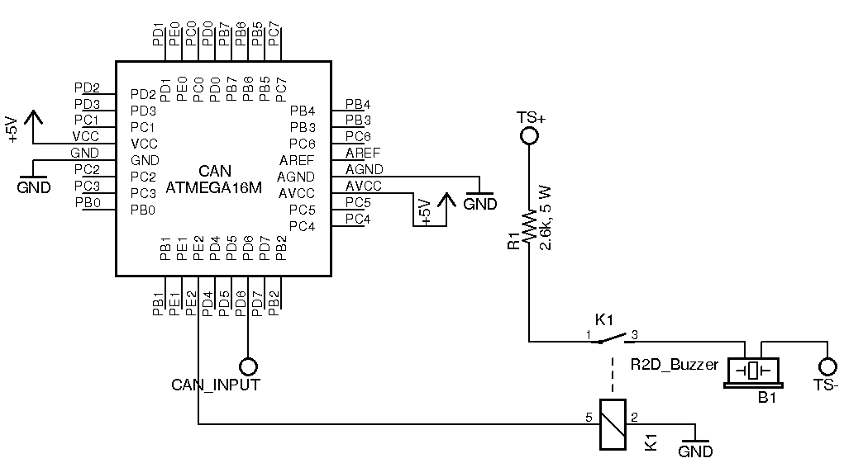

# Accumulator

## Accumulator pack 1

### Overview/description/parameters

Describe concept of accumulator pack, provide table with main parameters like number of cells, cell stacks separated by maintenance plugs, cell configuration, resulting voltages->minimum, maximum, nominal, currents, capacity etc.

The accumulator includes 12 Nissan Leaf battery modules in series. Each module includes 4 cells, in a 2S 2P configuration as shown in the figure. Each module has a shutdown separator in the middle of each string of cells in parallel (at points MIDPWR1 and MIDPWR2 in the figure). Each cell in the module has a nominal voltage of 3.75V, resulting in 7.5V per module and 90V in the final 12-series configuration.

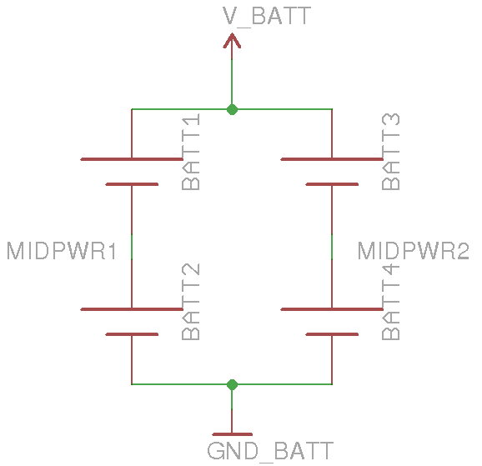

Fill out the following table:

|  |  |
| --- | --- |
| Maximum Voltage: | 100VDC |
| Nominal Voltage: | 90VDC |
| Minimum Voltage: | 60VDC |
| Maximum output current: | 405A for 10s |
| Maximum nominal current: | 250A |
| Maximum charging current: | 50A |
| Total numbers of cells: | 48 |
| Cell configuration: | 12 2s2p in series |
| Total Capacity: |  |
| Number of cell stacks < 120VDC |  |

Table 3.0 Main accumulator parameters

### Cell description

Describe the cell type used and the chemistry, provide table with main parameters.

Fill out the following table:

|  |  |
| --- | --- |
| Cell Manufacturer and Type | Automotive Energy Supply Corporation, modle E5 |
| Cell nominal capacity: | 5.4 Ah |
| Maximum Voltage: | 4.2 V |
| Nominal Voltage: | 3.7V |
| Minimum Voltage: | 2.5V |
| Maximum output current: | 20C for 10s |
| Maximum nominal output current: | 15C |
| Maximum charging current: | 5C |
| Maximum Cell Temperature (discharging) | 60°C |
| Maximum Cell Temperature (charging) | 50°C |
| Cell chemistry: | Lithium-ion – Laminate type  Cathode/Anode Material: LiMn2O4 with LiNiO2/Graphite |

Table 3.0 Main cell specification

### Cell configuration

Describe cell configuration, cell interconnect, show schematics of electrical configuration and CAD of connection techniques, cover additional parts like internal cell fuses etc.

-Need a pic of the module busbar connections

-Need a pic of cell connections

-Reference to figure above in the overall description

### Cell temperature monitoring

Describe how the temperature of the cells is monitored, where the temperature sensors are placed, how many cells are monitored, etc. Show schematics, cover additional parts, etc.

### Battery management system

Describe the BMS used including at least the following:

* Sense wiring protection (fusing / fusible link wire used)
* What upper and lower voltage does the BMS react at and how does it react?
* What cell temperature does the BMS react at and how does it react?
* Show tables of operation parameters
* Describe how many cells are sensed by each BMS board, the configuration of the cells, the configuration of the boards and how any comms wiring between boards is protected
* Describe how the BMS is able to open the AIRs if any error is detected
* Describe where galvanic isolation occurs between TS and GLV system connections.

The AMS shunts 3 A when the cell gets above 4.0 V. The AMS opens a relay in line with the shutdown circuit if any cell gets below 2.5 V. The AMS opens a relay in line with the shutdown circuit if any cell gets above 60 C. Each AMS board monitors 6 cells. There are 4 AMS boards. Each AMS board is coupled to a cell-top board, which includes 3 thermistors, which will be mounted directly in the stack up of the module terminals. CAN communication from the board is isolated via a TI ISO1050DUBR (isolated CAN tranceiver), with board cutouts to maintain proper clearance and creepage. On each cell-top board, there are 7 surface mount 3 A fuses. (Lowest voltage reference, and top voltage of each of 6 cells.) They are all Bel C1Q 3 A fuses. The relays which allow the BMS to control the shutdown circuit provide isolation between the BMS and the GLV system, as well as the isolated CAN transceivers.

### Accumulator indicator

Describe the indicator, show wiring, provide tables with operation, PCB design, etc.

J2 connects the accumulator indicator, D14, to a DC-DC converter run off of the tractive system voltage. R13 is a 220 Ohm resistor to limit current. The DC-DC converter supplies 12V. If we assume a forward voltage drop of the LED to be about 2V, then the LED current will be 10V/ 220 Ohm = 45mA. 22 gauge wire will be used to connect the PCB to the DC-DC converter.

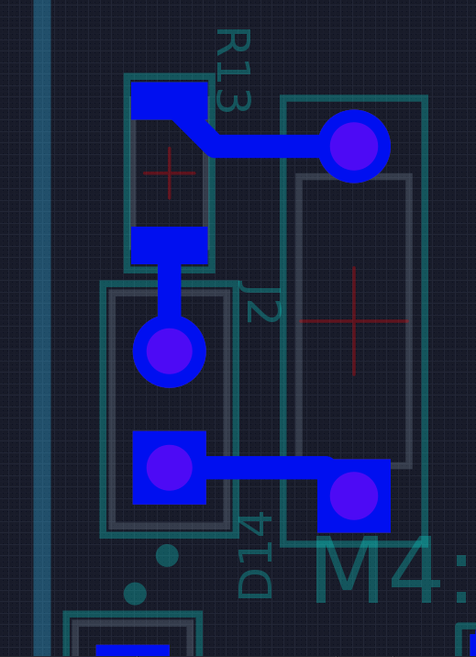

### Wiring, cables, current calculations, connectors

Describe the internal wiring, show schematics, provide calculations for currents and voltages and show data regarding the cables and connectors used.

* Discuss maximum expected current, DC and AC how long will this be provided?
* Compare the maximum values to nominal currents
* Give a table for each kind of wire in your tractive-system:
* Describe your maintenance plugs, provide pictures
* Use tables like the one shown below:

|  |  |
| --- | --- |
| Wire type | Company A, |
| Continuous current rating: | 150A |
| Cross-sectional area | 0.205 mm² |
| Maximum operating voltage: | 800VDC |
| Temperature rating: | 150 °C |
| Wire connects the following components: | Cell and BMS |

Table 3.0 Wire data of company A, 0.205 mm²

### Accumulator insulation relays

Describe the AIRs used and their main operation parameters, use tables, etc.

Additionally fill out the following table:

|  |  |
| --- | --- |
| Relay Type: | Relay |
| Contact arragment: | SPST-NO-DM |
| Continous DC current rating: | 500A |
| Overload DC current rating: | 200A for 10sec |
| Maximum operation voltage: | 900VDC |
| Nominal coil voltage: | 12VDC |
| Normal Load switching: | See figures |
| Maximum Load switching | See figures |

Table 3.0 Basic AIR data

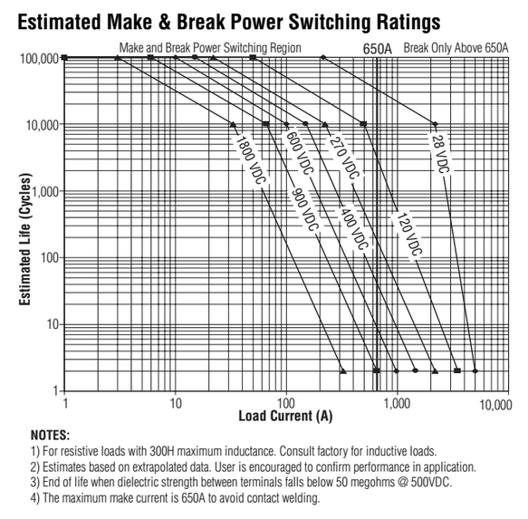

### Fusing

Describe the fuses used and their main operation parameters, use tables, etc.

Additionally fill out the following table for each fuse type used:

|  |  |
| --- | --- |
| Fuse manufacturer and type: | Littelfuse, FLNR Fuse |
| Continous current rating: | 175A |
| Maximum operating voltage | 125VDC |
| Type of fuse: | Time delay |
| I2t rating: | 1500A2s at 450VDC |
| Interrupt Current (maximum current at which the fuse can interrupt the current) | 20kA |

Table 3.0 Basic fuse data

Create a table with components and wires protected by the fuse(s) and the according continuous current rating, below is an example table with some potential entries. Complete this table with information for your design and add/remove additional locations as applicable. Ensure that the rating of all of the components is greater than the rating of the fuse such that none of the other components become the fuse.

|  |  |  |  |  |
| --- | --- | --- | --- | --- |
| Location | Wire Size | Wire Ampacity | Fuse type | Fuse rating |
| Cells to AIRs | 2 AWG | 190 | FLNR Fuse | 175 |
| AIR to Motor controller | 2 AWG | 190 |  |  |
| TS to Light DC-DC converter | 22 AWG | 7 | AGX Fuse | 1.5 |
| Accumulator output connector | 2 AWG | 190 |  |  |
| Cells to BMS | PCB trace | Trace ampacity: 7.6 A (open air) | CIQ Fuse | 3A |
| TS to GLV DC-DC converter | 18 | 14 | AGX Fuse | 10 |
| TS+ to IMD L+ input | 22 | 7 | AGX Fuse | .125 |
| Module stack to module stack (within accumulator) |  |  |  |  |
| GLV 12V to Brake Plausibility 555 Timer | 22 | 7 | AGX Fuse | .125 A |
| GLV 12V to AIR Economizer 555 Timer | 22 | 7 | AGX Fuse | .125 A |
| GLV 12V to 5V regulator (CAN system) | 22 | 7 | AGX Fuse | .150 A |
| Keyswitch, in parallel with TS voltage | 18 | 14 | AGX Fuse | 7A |

Table 3.0 Fuse Protection Table

### Charging

Describe how the accumulator will be charged. How will the charger be connected? How will the accumulator be supervised during charging? Show schematics, CAD-Renderings, etc., if needed

Additionally fill out the table:

|  |  |
| --- | --- |
| Charger Type: | Delta Q Technologies |
| Maximum charging power: |  |
| Maximum charging voltage: |  |
| Maximum charging current: |  |
| Interface with accumulator | CAN-Bus |
| Input voltage: |  |
| Input current: |  |

Table 3.0 General charger data

### Mechanical Configuration/materials

Describe the concept of the container, show how the cells are mounted, use CAD-Renderings, show data regarding materials used, etc.

### Position in car

Provide CAD-renderings showing the relevant parts. Mark the parts in the rendering, if necessary. Ensure that the required mechanical structure to protect the accumulator and other electrical components is clearly identified.

## Accumulator pack 2

…

If identical parts are used, just refer to the corresponding sections, don’t copy and paste.

# 

# Energy meter mounting

## Description

Describe where the energy meter is mounted and how, etc.

## Wiring, cables, current calculations, connectors

Describe the wiring, show schematics, provide calculations for currents and voltages, and show data regarding the cables and connectors used.

## Position in car

Provide CAD-renderings showing all relevant parts. Mark the parts in the rendering, if necessary.

# 

# Motor controller

## Motor controller 1

### Description, type, operation parameters

Describe important functions; provide table with main parameters like resulting voltages->minimum, maximum, nominal, currents etc.

Fill out the following table:

|  |  |
| --- | --- |
| Motor controller type: | ABC Controller |
| Maximum continous power: | 60kW |
| Maximum peak power: | 75kW for 10s |
| Maximum Input voltage: | 600VDC |
| Output voltage: | 250VAC |
| Maximum continuous output current: | 100A |
| Maximum peak current: | 200A for 5s |
| Control method: | PWM, analog signal... |
| Cooling method: | Air, water, oil... |
| Auxiliary supply voltage: | 24VDC |

Table 5.0 General motor controller data

### Wiring, cables, current calculations, connectors

Describe the wiring, show schematics, provide calculations for currents and voltages and show data regarding the cables and connectors used.

Additionally fill out table:

|  |  |
| --- | --- |
| Wire type: | Company A, 0.205 mm² |
| Current rating: | 150A |
| Maximum operating voltage: | 800V |
| Temperature rating: | 150 °C |

Table 5.0 Wire data of company A, 0.205 mm²

### Position in car

Provide CAD-renderings showing the relevant parts. Mark the parts in the rendering, if necessary.

## Motor controller 2

…

If identical parts are used, just refer to the corresponding sections, don’t copy and paste.

.

# 

# Motors

## Motor 1

### Description, type, operating parameters

Describe the motor used, provide table with main parameters like resulting voltages->minimum, maximum, nominal, currents, resulting motor power, use figures to show important characteristics.

Additionally fill out table:

|  |  |
| --- | --- |
| Motor Manufacturer and Type: | Zero Motorcycles, Model Number: 30-0534 |
| Motor principle | DC Brushless |
| Maximum continuous power: | 4.36 kW |
| Peak power: | 44 kW for WHAT seconds |
| Input voltage: | 104 V |
| Nominal current: | 250A |
| Peak current: | 420A |
| Maximum torque: |  |
| Nominal torque: |  |
| Cooling method: | Air |

Table 6.0 General motor data

* Give a plot of power vs. Rpm including a line for nominal and maximum power
* give a plot of torque vs. rpm including a line for nominal and maximum torque

### Wiring, cables, current calculations, connectors

Describe the wiring, show schematics, provide calculations for currents and voltages and show data regarding the cables and connectors used.

### Position in car

Provide CAD-renderings showing all relevant parts. Mark the parts in the rendering, if necessary and clearly identify the structure used to protect all relevant parts.

## Motor 2

…

If identical parts are used, just refer to the corresponding sections, don’t copy and paste.

# 

# Torque encoder

## Description/additional circuitry

Describe the type of the torque encoder(s) used, provide tables with main operation parameters, and describe additional circuitry used to check or manipulate the signal going to the motor controller. Describe how the system reacts if an implausibility or error (e.g. short circuit or open circuit or equivalent) is detected.

The encoder will consist of two rotary potentiometers mounted on the torque pedal. Each output from the potentiometers will go to a CAN node on an atmega16M. The CAN node will compare the two outputs and send a message to the CAN node on the motor controller with the throttle requested. The node will only do this if the sensors are within 10% of each other. If one sensor reads as either the maximum or minimum value while the other does not, the CAN node will not send the motor controller throttle information. If a short circuit with either potentiometer would occur, the input of the atmega 16M would stop working, and the node would go silent and there would be no throttle input to the motor controller. The CAN system would then display which node is no longer sending messages, and the team would be able to detect the error. Similarly, the CAN node would tell the system if both of its potentiometer inputs are zero (open circuit).

|  |  |
| --- | --- |
| Torque encoder manufacturer and type: | ABC Encoder |
| Torque encoder principle: | potentiometer |
| Supply voltage: | 5V |
| Maximum supply current: | 20mA |
| Operating temperature: | -20..180 °C |
| Used output: | 0-5V |

Table 7.0 Torque encoder data

## Torque Encoder Plausibility Check

Describe additional circuitry used to check or manipulate the signal going to the motor controller. Describe how failures (eg. Implausibility, short circuit or open circuit or equivalent) are detected and how the system reacts if an implausibility or errors is detected.

Two potentiometers, which will be RP0922 rotary potentiometers from Active Sensors, are mounted on the torque pedal. Using 22 gauge wire, current will be carried through these potentiometers and to CAN nodes. The voltages will then be compared to be certain potentiometers agree on pedal travel. There will also be a pressure switch on the brakes, wired to a CAN node with the 22 gauge. If the pressure switch indicates actuation of the brake and the potentiometers measure more than 25% pedal travel, the power to the motors will be completely shut down until the torque pedal indicates less than 5% pedal travel.

## Wiring

Describe the wiring, show schematics, show data regarding the cables and connectors used.

## Position in car/mechanical fastening/mechanical connection

Provide CAD-renderings showing all relevant parts and discuss the mechanical connection of the sensors to the pedal assembly. Mark the parts in the rendering, if necessary.

# Additional LV-parts interfering with the tractive system

## LV part 1

Describe those parts here which interfere or influence the tractive system, for example a controlling unit that measures wheel speeds and steering angle and calculates a target torque for each motor or a DC/DC-Converter providing power for the LV-system from the HV-system, etc.

### Description

Describe the parts used and their circuitry, and provide main operation parameters, use tables or figures, etc.

### Wiring, cables,

Describe the wiring, show schematics, etc.

### Position in car

Provide CAD-renderings showing the relevant parts. Mark the parts in the rendering, if necessary.

## LV part 2

…

# Overall Grounding Concept

## Description of the Grounding Concept

Describe how you intend to achieve the resistances between components at the required levels as defined in EV4.3.

## Grounding Measurements

Describe which measurements you will take to ensure that EV4.3 is achieved

No carbon fiber will be used, all around the car.

# 

# Firewall(s)

## Firewall 1

### Description/materials

Describe the concept, layer structure and the materials used for the firewall. Show how the low resistance Control System ground connection is achieved.

The Firewall is constructed of two layers. The layer facing the tractive system is 1.5 mm Aluminum sheet metal. The second layer facing the cockpit is 1/8 in. Flame-Retardant Multipurpose Garolite (G-10/FR4). We have only 1 firewall that shields the driver from the accumulator since we do not have an engine or other components that pose a fire hazard.

### Position in car

Provide CAD-renderings showing all relevant parts. Mark the parts in the rendering, if necessary.

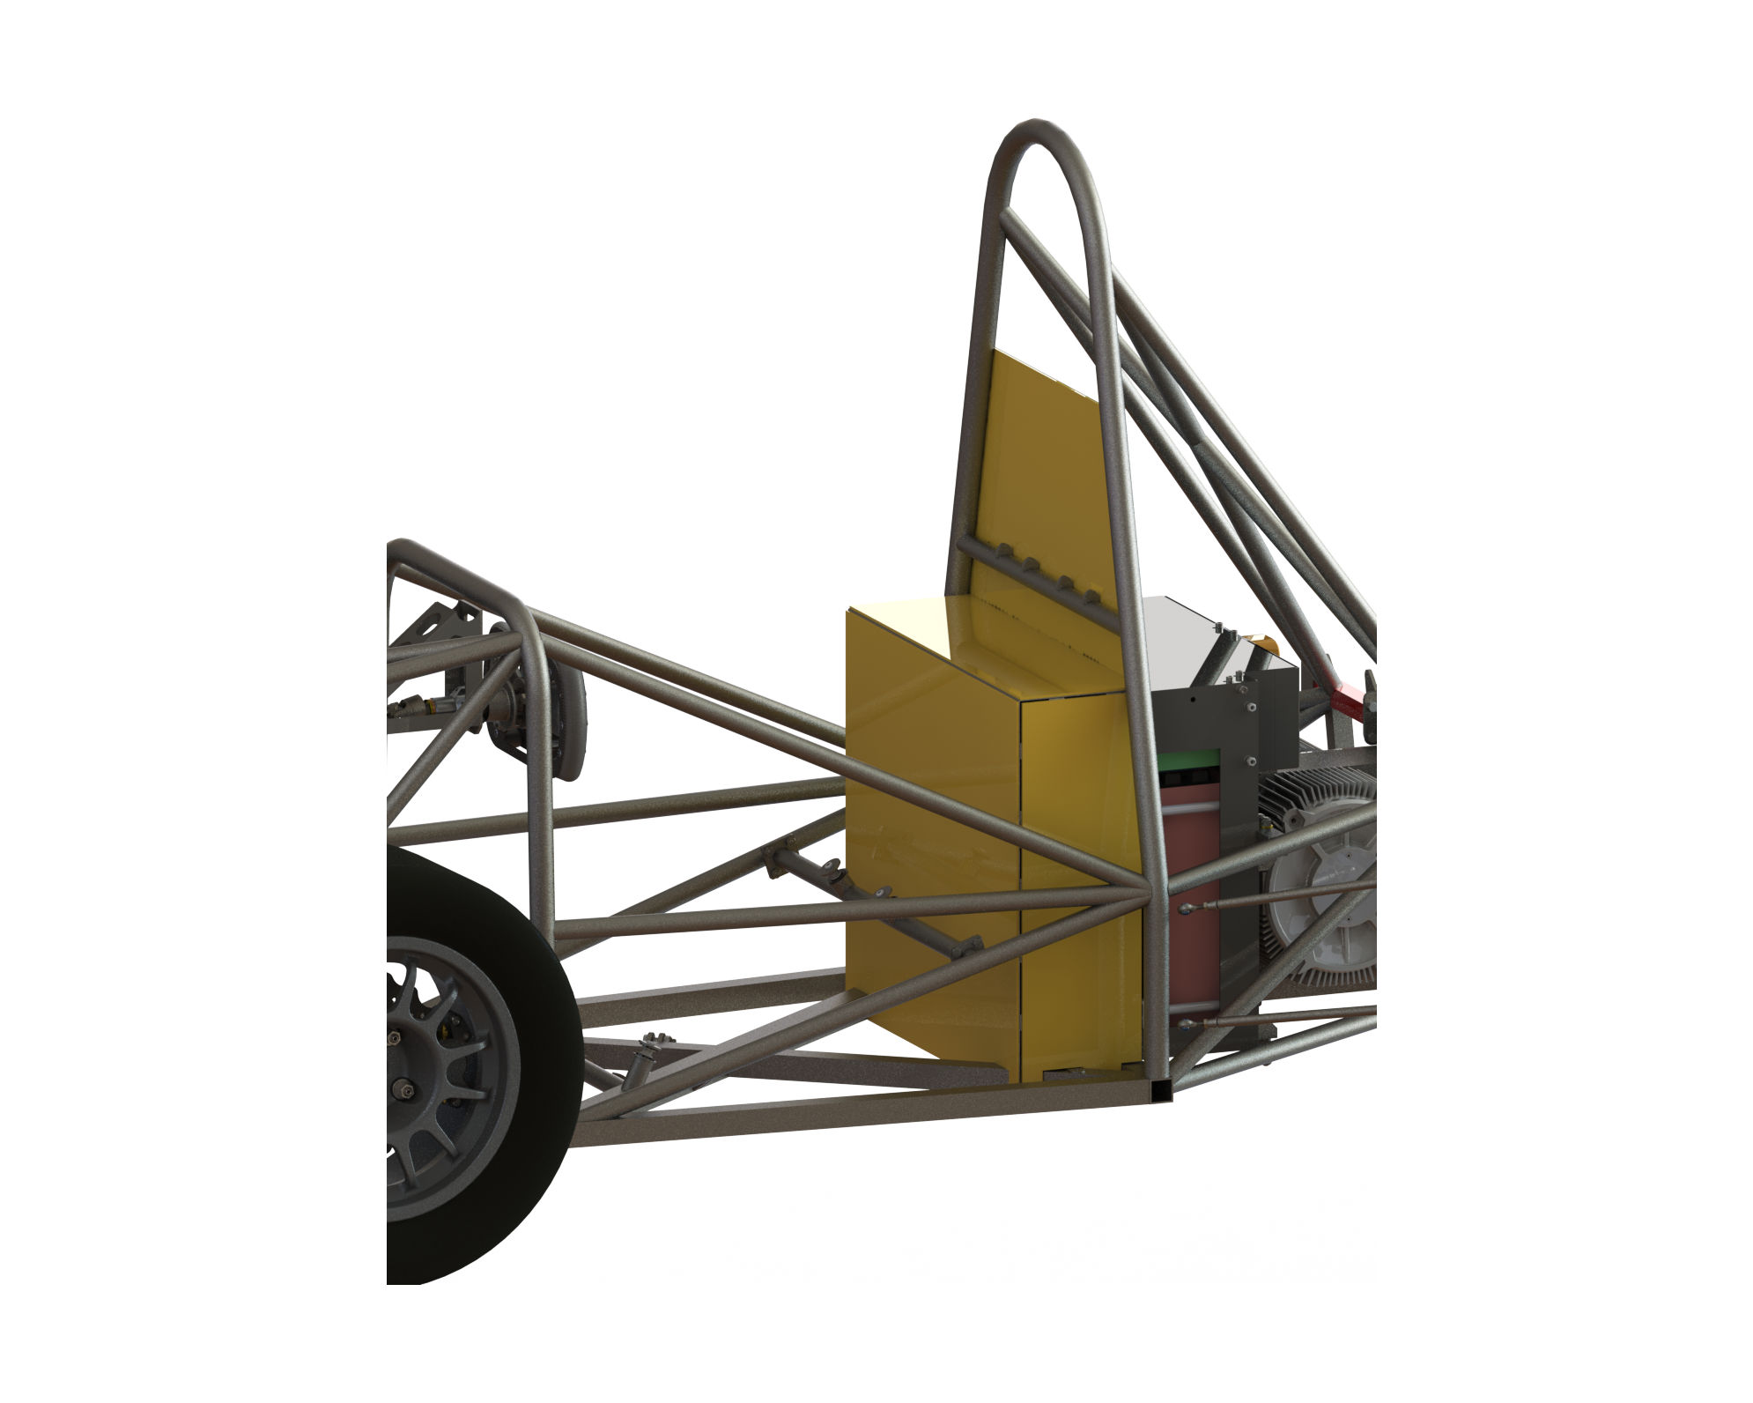

## Firewall 2

# 

# Appendix

**Numbering according to chapter 1 to 10**

A datasheet for motor controller one for example has to have the numbering 11.10.5

Example appendix entry:

11.2.2 – Bender IR155-3203 IMD ratings

Referred from 10.1.1.

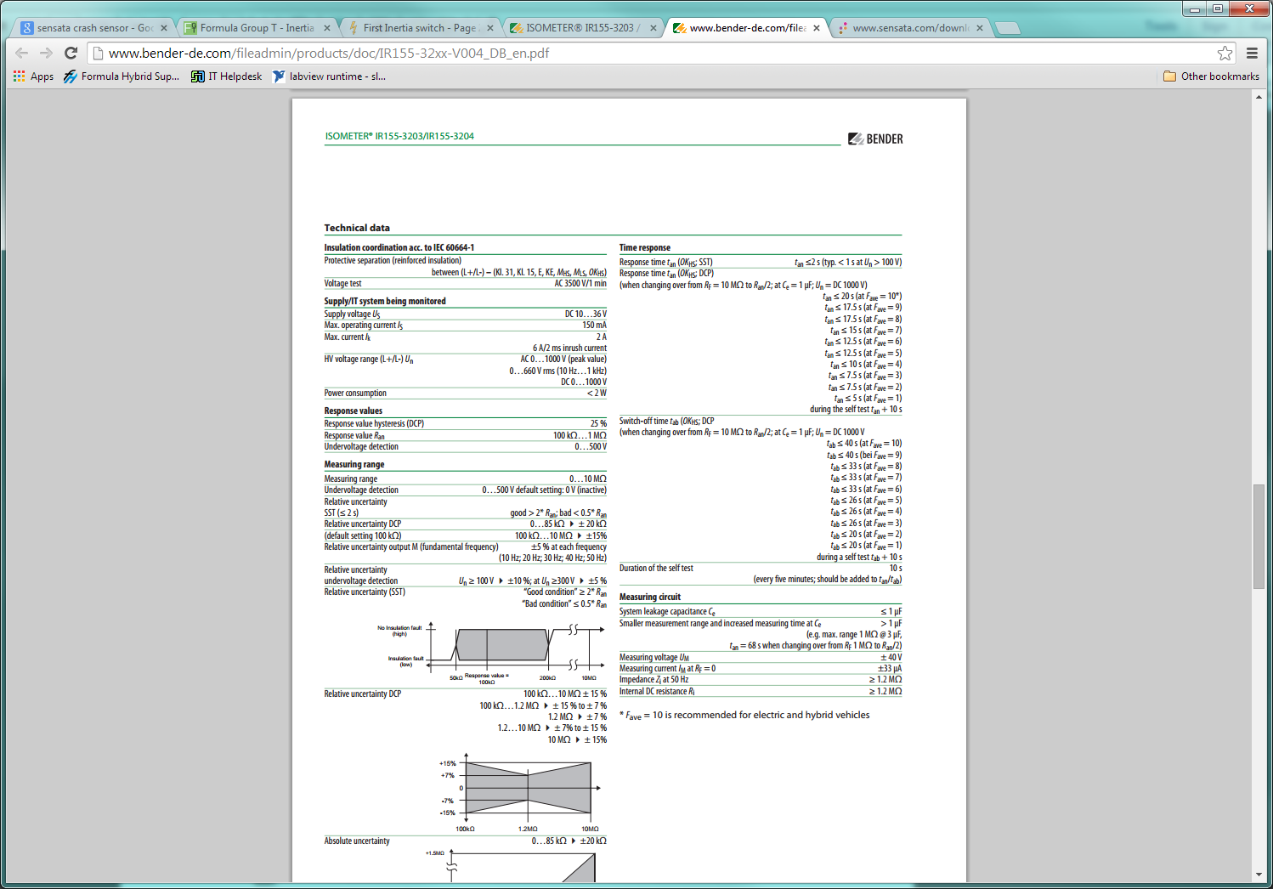

Complete data sheet located at: <http://www.bender-de.com/fileadmin/products/doc/IR155-32xx-V004_DB_en.pdf>