BANGLADESH CENTRALIZED HEALTHCARE SYSTEM (CHCS)
A High-Throughput Edge-Computed Universal Health Registry & Regulatory Framework for Bangladesh

Prepared for:
Ministry of Health and Family Welfare (MoHFW), Government of Bangladesh
& Directorate General of Health Services (DGHS)
Prepared by:
Mir Oliul Pasha Taj
ETE 17 (Graduated), Rajshahi University of Engineering & Technology (RUET)
Date: June 2026
Document Version: 1.0.0 (Final Merged Blueprint)
Document Classification: Official / Restricted

1. Executive Summary
The healthcare infrastructure of Bangladesh stands at a critical juncture. Characterized by extreme structural fragmentation, the current paradigm relies heavily on localized paper records or siloed private proprietary databases. This lack of interoperability directly results in systemic vulnerabilities: a total failure of clinical data continuity, significant financial leakages from diagnostic redundancy, widespread distribution of counterfeit pharmaceuticals, and severe administrative barriers to healthcare governance. When a patient migrates from a public facility such as Mymensingh Medical College Hospital to an equivalent tertiary institution like Rajshahi Medical College Hospital, their clinical, diagnostic, and pharmacological histories are entirely lost.
This document details the blueprint for the Centralized Healthcare System (CHCS), a highly scalable, health-information exchange enterprise architecture designed to centralize and secure the electronic health records (EHR) of over 175 million citizens. Integrating deeply with the national infrastructure via a unified National Health ID (NHID) linked directly to a simulated NID/Passport registry, CHCS introduces a comprehensive ecosystem consisting of Government-Level Outbreak surveillance, Dynamic Hospital Grading Tiers, Patient Feedback loops, and AI Nurse Agents.
Through modern distributed computing frameworks—incorporating robust Serverless Edge functions, Redis caching layers, connection pooling, and sharded relational databases—CHCS is engineered to comfortably support millions of daily transactions and peak outpatient workloads of ~1,020 TPS. Beyond clinical enhancements, this whitepaper details sustainable public-private startup monetization structures, an extensive risk matrix, strict zero-trust security postures, and a structured 8-year national rollout paradigm. CNHDS represents the foundational technical transition necessary to shift Bangladesh from reactive medical administration into a predictive, data-driven universal healthcare landscape.
2. Background of the Bangladesh Healthcare System
The healthcare delivery architecture of Bangladesh operates across a complex three-tier system: primary (Upazila Health Complexes and Community Clinics), secondary (District Hospitals), and tertiary (Medical College Hospitals and specialized institutes). While the network succeeds in providing basic physical access across vast rural regions, its organizational data layer remains heavily paper-centric. Public clinical records are manually maintained on aggregate physical charts, which are highly susceptible to fast degradation, loss, and unauthorized alterations.
Conversely, private sector elite hospitals (e.g., Square Hospital, Popular Diagnostic, LabAid) maintain advanced internal digital health systems and patient portfolios. However, these systems operate as closed loops. The absence of a national health information exchange (HIE) creates isolated 'digital data islands.' Consequently, the entire country suffers from systemic architectural blindness. Public health officials cannot track disease vectors in real time, clinical facilities operate without patient historical precedents, and the lack of automated audit trails facilitates administrative overhead and financial friction.
3. Current National Healthcare Statistics
To contextualize the capacity and architectural requirements of CHCS, the table below highlights current core indicators gathered from the Directorate General of Health Services (DGHS) and international health metrics:
Metric Parameter | Current National Value (2026 Est.) | Primary Data Source
Total National Population | 175.4 Million | Bangladesh Bureau of Statistics (BBS)
Total Functional Registered Hospitals | 5,460 (Public & Private Registered) | DGHS Annual Health Report
Total National Hospital Beds | 143,250 Beds (Combined Sectors) | MoHFW Data Portal
Registered Practicing Physicians | 112,000 Registered Doctors | Bangladesh Medical & Dental Council (BMDC)
Centralized EHR Adoption Rate | < 2.5% (Confined to Top-Tier Private Entities) | Independent ICT Audit / World Bank Study
Daily Average Clinical Encounters | 2.1 Million Transactions / Day | DGHS Outpatient Framework Analysis

4. Detailed Problem Analysis
The current operational matrix of Bangladesh healthcare exposes several severe, interconnected vulnerabilities:
- 1. Absence of Historical Data Continuity: Physicians are forced to rely on verbal patient recollections. This results in high misdiagnosis risks, dangerous adverse drug interactions, and uncoordinated oncology or chronic disease treatment plans.
- 2. Extreme Diagnostic Redundancy & Capital Waste: Patients routinely repeat complex biochemical panel profiles, MRI/CT scans, and diagnostic imaging because previous records are inaccessible. This places an artificial financial burden on families and wastes millions in public healthcare resources.
- 3. Unregulated Drug Distribution and Counterfeits: The open, non-centralized distribution of pharmaceuticals permits counterfeit drug distributors to infiltrate supply chains. Without linked patient prescription limits, individuals can practice 'doctor shopping' to amass restricted drugs, amplifying the antimicrobial resistance crisis.
- 4. Failure of Governance and Operational Auditing: Public hospital administrations execute compliance, drug inventory reporting, and workload auditing through physical paper registries. This facilitates data manipulation, delays operational oversight, and prevents optimized healthcare job allocation.
5. Global Comparative Analysis
To guide the technical structure of CHCS, this section benchmarks Bangladesh's requirements against prominent international implementations:
Country/System | Core Architectural Model | Unique Identity Identifier | Data Storage Mechanism | Key Bottleneck / Lesson Learned
Estonia (e-Health) | Decentralized X-Road Grid | National ID (e-ID PKI) | Distributed Guardtime Blockchain Log | Requires 100% citizen digital literacy and robust local hardware networks.
NHS (United Kingdom) | Federated Trust System | NHS Number Registry | Spine II Central Messaging System | Legacy infrastructure migration created multi-billion dollar cost overflows.
India (ABDM) | Unified ABHA Ecosystem | ABHA ID Number | Federated Health Repository Consent Gate | Significant adoption gaps in remote rural facilities due to offline drops.
Singapore (NEHR) | Centralized Shared Grid | NRIC / Fin Number | Monolithic Cloud Datastore Core | High risk of centralized targeting; security breaches require strict zero-trust.

6. Stakeholder Mapping & Matrix
The success of CHCS requires alignment across several distinct groups, as mapped in the systemic breakdown below:
Stakeholder Entity | Primary Role in Ecosystem | Systemic Impact / Interest | Core Technical Interface Point
MoHFW & DGHS | Central Regulator and Policymaker | High / National Governance, Audit & Insights | Global Administrative Analytics Dashboard
Clinical Personnel | Primary Care Providers & Data Ingestion Nodes | High / Workflow Efficiency & Diagnostic Access | Doctor EHR Interface Portal / Mobile App / API
Citizens / Patients | Primary Healthcare Consumers | High / Data Privacy & Seamless Portability | Patient Mobile App / SMS / National Identity Token
Pharmacies / Labs | Auxiliary Care & Fulfillment Networks | Medium / Prescription Validation & Revenue | Point of Sale (POS) Web Terminal / API Hook
Health Tech Startups | Value-Added Commercial Innovation Partners | Medium / Secondary Services & Monetization | Secure Sandboxed Open-API Gateway (OAuth 2.0)
7. System Requirements Specification (SRS)
7.1 Functional Requirements (FR)
- FR-1: Automated Identity Generation: The platform must auto-generate a cryptographically unique 16-digit NHID upon successful verification against NID/Passport registries.
- FR-2: Interoperable Clinical Record Ingestion: The system must ingest clinical encounter summaries utilizing the HL7 FHIR standard, converting unstructured data via integrated ingestion microservices.
- FR-3: Dynamic Longitudinal Chart Generation: Physicians must have real-time query access to a patient's historical records, filtered by absolute chronological timelines, diagnostic sets, and previous drug logs.
- FR-4: Pharmaceutical Verification and Abuse Prevention: The system must automatically track medication limits against standard clinical safety rules, preventing duplicate prescriptions and blocking unapproved pharmacy sales.
- FR-5: Administrative Audit Optimization: The platform must generate immutable, automated compliance audit trails for hospital resources, medicine inventories, and personnel allocations.
7.2 Non-Functional Requirements (NFR)
- NFR-1: Concurrent Processing Capability: The infrastructure must handle ~1,020 Transactions Per Second (TPS) peak outpatient workloads without database corruption or connection failures.
- NFR-2: Target Response Latency: The system must achieve a P95 API response time of less than 250 milliseconds for global historical clinical profile queries.
- NFR-3: Operational High-Availability: The complete application layer and underlying datastores must operate at 99.99% annual uptime, utilizing geographical multi-region disaster recovery.
- NFR-4: Rigorous Security Compliance: All data storage blocks and processing microservices must strictly comply with international security frameworks including HIPAA and ISO 27001.
8. National Health ID (NHID) Architecture
The foundational anchor of CHCS is the National Health ID (NHID) generation pipeline. The system rejects arbitrary primary keys, adopting a structured, deterministic architectural flow to guarantee data integrity across all downstream platforms:
[Citizen Registration Request via NID/Passport Number]
↳ [Validate Credentials via External Government API]
↳ [Extract Demographic Attributes (DoB, District Code, Gender Vector)]
↳ [Compute SHA-256 Hash over Normalized Biometric/NID String]
↳ [Append Luhn Algorithm Verification Check Digit]
↳ [Store Immutable Mapping to Base Registries via Cryptographic HSM Tokens]
This generation pipeline ensures the system is completely collision-free, handles multi-million identity distributions without performance drops, and prevents direct exposure of the underlying citizen NID vector inside clinical databases.
9. Core CHCS Features & Operational User Guide
Feature 1: Government-Level Epidemic Portal (Disease Outbreak Tracking)
Integrates a centralized monitoring panel for the Ministry of Health. Doctors can log localized outbreak symptoms (e.g., Dengue or Cholera) instantly via a dedicated 'Pandemic Outbreak' button in the Doctor Portal. The backend computes density-based geographical clusters and renders outbreak coordinates on the Ministry map. System-generated prevention guidelines sourced from researchers and senior experts are dispatched automatically to regional centers.
Feature 2: Dynamic Hospital Grading System
Hospitals are categorized into five tiers: A+ (Top Notch), A (Good), B (Moderate), N (New), and Z (Warning/Worst Case). Grades are calculated dynamically based on audit parameters: patient serving counts (Daily, Weekly, Monthly, Yearly), staff behavior satisfaction surveys, cure rates vs. unnecessary follow-up frequencies, and diagnostic equipment quality.
Feature 3: Strict Regulatory Lifecycle & Auditing
New hospitals register in the N (New) tier for the first 6–12 months. If standards are not met, they drop to Z (Warning) and cannot operate for more than 12 months in Z. Long-term operations require maintaining at least a B-grade rating (maximum 5 years in B before leveling up to A). A designated Auditor Team dashboard allows auditors to submit performance review scores.
Feature 4: Patient Feedback & Continuous Monitoring
Allows patients to report malpractice or poor service, generating a transparent consumer feed. Includes a proactive health monitoring framework that guides patients through post-encounter recovery, detects relapse risks, and suggests preventive care.
Feature 5: NID/Passport Identity Management & Minor Rules
Enables profile creation using NID or Passport. Integrates a simulated registry search that auto-populates Name, DOB, and parent names. Enforces linking minor profiles (under 18) to a verified Parent NID for authorization.
Feature 6: AI Medical Record Scanner & Personal Nurse AI
Enables uploading physical reports (PDFs/scans) to run a simulated OCR text parser that extracts diagnoses and medications. Integrates a Personal Nurse AI that triggers dosage alarms and suggests dietary and lifestyle advice.
10. Vercel Hosting & High-Throughput Edge Architecture
To deploy this high-throughput system on Vercel at a national scale:
1. Serverless Edge Functions: Serve frontend and API routes via Vercel Edge Functions (e.g. Next.js App Router or Python FastAPI serverless handles) to guarantee low cold-start latency and geographic distributed routing.
2. Connection Pooling: Serverless databases experience connection exhaustion under spike loads. We utilize connection pooling services (like PgBouncer, Neon Serverless Postgres, or Supabase Pooling handles) to maintain persistent database tunnels.
3. Distributed Redis Caching: Read-heavy endpoints (like hospital grades, NID lookups, and generic demand projects) are cached using a serverless Redis cluster (e.g., Upstash Redis) with a strict TTL policy to reduce primary database strain.
4. Asynchronous Event Buffering: High-frequency writes (such as live birth/death updates and check-in tickets) are queued asynchronously through Apache Kafka or Upstash QStash, preventing API timeout overflows under peak loads.
11. System Architecture & DFD Flows
11.1 DFD Level 0: The Context Diagram
[External Patient/Doctor/Admin App Nodes] =====(TLS 1.3 / JSON Payloads)=====>
[ CENTRALIZED CHCS APPLIANCE ENGINE ]
<=====(Real-Time Verification Responses & Audited Event Tokens)=====
[External Registries: NID / Passport]
11.2 DFD Level 1: Operational System Processing Layer
[Client Request Interface Node]
↳ [Layer 7 Reverse Proxy Load Balancer (HAProxy / NGINX Node)]
↳ [Stateless API Routing Gateway Core]
├─> [Distributed In-Memory Redis Cache Tier]
├─> [Primary PostgreSQL Distributed Data Engine]
└─(Asynchronous Message Broker Pipeline)─> [Apache Kafka Cluster]
↳ [Auth Service]
↳ [EHR Processor]
↳ [Rx Safety Worker]
11.3 DFD Level 2: Ingestion & Transaction Isolation Matrix
At Level 2, individual application workflows break down into atomic, decoupled processes:
• Process 2.1 (Ingestion Gate): Validates authorization context against the central Keycloak cluster using short-lived JWT signatures.
• Process 2.2 (Validation Pipeline): Converts incoming payloads into compliant HL7 FHIR JSON nodes and routes them to the streaming layer.
• Process 2.3 (Queue Engine): Pushes the normalized data structures down into regional write queues for asynchronous processing.
• Process 2.4 (Persistence Commit): Executes ACID-compliant commits across sharded target tables and flushes the update to Redis clusters.
12. Database Entity Schema Spec (ERD)
The core persistent operational layer of CHCS is built on a highly optimized, fully normalized relational schema designed for horizontal scalability:
• PATIENTS TABLE
- id (UUID, PK) | nhid (VARCHAR, Unique Indexed) | nid (VARCHAR, Unique Indexed)
- name (VARCHAR) | dob (DATE) | gender (VARCHAR) | district (VARCHAR) | parent_nid (VARCHAR, Nullable)
• CLINICAL_ENCOUNTERS TABLE
- id (UUID, PK) | patient_id (UUID, FK) | hospital_id (UUID, FK)
- doctor_id (UUID, FK) | timestamp (TIMESTAMPTZ, Partition Key) | chief_complaint (TEXT) | diagnosis (TEXT)
• PRESCRIPTIONS TABLE
- id (UUID, PK) | encounter_id (UUID, FK) | patient_id (UUID, FK)
- generic_name (VARCHAR) | brand_name (VARCHAR) | dosage (VARCHAR) | quantity (INT) | dispensed (INT)
• HOSPITAL_AUDITS TABLE
- hospital_id (UUID, PK, FK) | patient_count_yearly (INT) | satisfaction_score (REAL)
- cure_rate (REAL) | equipment_score (REAL) | expert_doctor_count (INT) | cleanliness_score (REAL) | food_score (REAL) | architecture_score (REAL)
• EPIDEMIC_OUTBREAKS TABLE
- id (UUID, PK) | hospital_id (UUID, FK) | doctor_id (UUID, FK) | disease (VARCHAR) | symptoms (TEXT)
- district (VARCHAR) | lat (REAL) | lng (REAL) | timestamp (TIMESTAMPTZ)
13. Technical Coding Stack & Frameworks
• Frontend Framework: HTML5, CSS Variables, and Vanilla Javascript supporting instant Day/Night theme toggling.
• Backend REST API: Flask / Python 3.12 microservices engine exposing endpoint routing.
• Database Management: SQLite persistent relational datastore with sharded index tables (migratable to Postgres clusters).
• Charts: Chart.js vector canvas elements for spatial disease tracking.
• Simulated AI Engine: Rule-based regex tokenizers simulating OCR scanner parsers and Personal Nurse alarms.
14. Comprehensive Cybersecurity Framework
Given the highly sensitive nature of national healthcare datasets, CHCS establishes a rigid, defense-in-depth zero-trust security paradigm:
- Spoofing Identity: Mitigated via structural SHA-256 identity hashing coupled with cryptographically signed hardware application security modules.
- Tampering with Data: Mitigated via TLS 1.3 encryption for all data in transit, combined with isolated database columns encrypted at rest using AES-256-GCM keys managed by an HSM.
- Repudiation Vulnerabilities: Mitigated via a central, immutable write-once-read-many (WORM) append-only logging network that records all user actions.
- Information Disclosure Risks: Mitigated via a dynamic Attribute-Based Access Control (ABAC) layer, requiring a multi-party signed authorization handoff before unlocking patient historical records.
- Denial of Service (DoS): Mitigated via Cloudflare Magic Transit protection frameworks, Anycast network distribution routing, and rate-limiting rules enforced at the API gateway layer.
- Elevation of Privilege: Mitigated via container sandboxing, microservice isolation, and strict principle-of-least-privilege access rules across all runtime systems.
15. Privacy & Regulatory Framework
Currently, Bangladesh lacks a comprehensive data protection framework similar to Europe's GDPR. Therefore, CHCS establishes a forward-compatible regulatory baseline specifically designed for healthcare systems:
- 1. Explicit Digital Informed Consent: Citizens must have full visibility into which entities access their health data, backed by a clear mechanism to grant or revoke non-emergency medical consent dynamically.
- 2. Functional Data Isolation Purpose: Strict operational boundaries separate medical records from insurance processing, credit scoring, and law enforcement validation, protecting citizens against systemic discrimination.
- 3. Dynamic Pseudonymization Engines: The system implements automated anonymization filters that strip patient identifiers from records used in clinical research or epidemiological tracking.
16. Cost-Benefit Analysis (CBA)
The implementation of CHCS requires substantial upfront capital expenditure, balanced by immediate structural savings across the national economy:
Core Expenditure / Return Vector | Estimated Value (USD Equiv.) | Economic Rationalization & Impact Description
Upfront Infrastructure (CapEx) | $45.0 Million | Procurement of multi-region tier-IV data centers, edge computing networks, and regional field tablets.
Annual Operational Maintenance (OpEx) | $8.5 Million / Year | Includes ongoing software licensing, continuous security monitoring, personnel training, and bandwidth expenses.
Savings: Elimination of Duplicate Tests | +$62.0 Million / Year | Direct reduction in unnecessary redundant lab work and imaging processing for patients across the country.
Savings: Supply Chain Optimization | +$28.0 Million / Year | Drastic reduction in counterfeit drug distribution and optimized management of public medicine stockpiles.
Net Present Value (NPV @ 5 Years) | +$114.5 Million | Demonstrates the strong financial viability and high long-term return on investment of the project.
17. Long-Term Financial Projections
The table below details the projected financial lifecycle of CHCS across its initial five years of deployment:
Financial Category | Year 1 | Year 2 | Year 3 | Year 4 | Year 5
Development Costs (M$) | 25.0 | 15.0 | 5.0 | 2.0 | 1.0
Operational Overhead (M$) | 2.0 | 4.5 | 6.5 | 8.0 | 8.5
System Realized Savings (M$) | 5.0 | 25.0 | 55.0 | 80.0 | 90.0
Commercial API Revenue (M$) | 0.0 | 2.0 | 6.0 | 12.0 | 18.0
Net Operational Balance (M$) | -22.0 | 7.5 | 52.5 | 82.0 | 98.5

18. Risk Assessment Matrix
Deploying a national system of this scale involves various operational and systemic risks, mapped out in the matrix below:
Identified Risk Vector | Probability | Impact Severity | Calculated Risk Score | Enforced Mitigation Strategy / Protocol
Political Inertia & Policy Delays | Medium | High | Critical | Secure multi-agency backing and integrate the platform into national digitization mandates.
Power Grid & Offline Failures | High | Medium | High | Deploy offline-first synchronization capabilities on ruggedized, battery-powered tablets at the edge.
Data Breaches & Exfiltration | Low | Critical | High | Enforce a strict zero-trust security model, end-to-end data encryption, and continuous monitoring via an automated SOC.
Clinical Staff Adoption Resistance | High | Medium | High | Design streamlined, intuitive user interfaces and launch comprehensive training programs across facilities.

19. Long-Term Implementation Roadmap (8-Year Strategy Plan)
Years 1–2: Foundational Governance, Core Engineering, and Pilot Deployment
- Milestone 1.1: Establish the legal authority and regulatory frameworks under a dedicated National Digital Health Council.
- Milestone 1.2: Complete development of the core stateless API gateways, identity matching pipelines, and initial database architectures.
- Milestone 1.3: Launch pilot deployments across three major tertiary medical colleges (Mymensingh, Rajshahi, and Dhaka Medical) to validate system performance under real-world conditions.
Years 3–5: Secondary Scale, Regional Ingestion, and Ecosystem Integration
- Milestone 2.1: Deploy the platform across all remaining public and private tertiary medical colleges and specialized institutes.
- Milestone 2.2: Extend the core network down to district-level hospitals and major private diagnostic networks across the country.
- Milestone 2.3: Integrate the centralized pharmaceutical validation and tracking system into major commercial pharmacy networks.
Years 6–8: Total National Ingestion, Commercialization, and Predictive Analytics
- Milestone 3.1: Onboard all primary care facilities, rural Upazila Health Complexes, and community clinics into the unified database network.
- Milestone 3.2: Launch the secure open-API data sandbox layer to drive compliant research collaborations and health-tech startup commercialization.
- Milestone 3.3: Deploy automated epidemiological tracking engines and real-time public health dashboards for proactive disease monitoring.
20. Startup & Commercialization Ecosystem Dynamics
While primarily a public sector initiative, CHCS is designed to catalyze a robust commercial health-tech startup ecosystem through structured, secure data monetization:
- 1. Premium Value-Added Consumer Applications: Startups can build premium personalized health apps, digital wellness coaches, and tailored chronic disease management platforms powered by authorized patient data access tokens.
- 2. Anonymized Research Data Marketplace: Provides commercial research organizations and pharmaceutical companies access to anonymized datasets for clinical trials, demographic health studies, and predictive market analysis.
- 3. Automated Insurance Underwriting Hooks: Enables automated insurance underwriting and instant claims processing by integrating secure patient historical profiles directly with authorized insurance provider networks.
21. Diagram Placeholders & Image Mappings
The screenshots representing the live Day and Night modes of the prototype are mapped to their respective folders under /CHCS/img/. These files are structured as follows:
Module Interface | Day Mode Image | Night Mode Image
Ministry Admin Panel | img/ministry_day.png | img/ministry_night.png
Hospital Portal | img/h admin_day.png | img/h admin_night.png
Doctor Workspace | img/doctor_day.png | img/doctor_night.png
Patient App Dashboard | img/citigen_day.png | img/citigen_night.png
Pharmacy POS Interface | img/pharmacy_day.png | img/pharmacy_night.png
Database Entity Layout | img/# Database structure.png | N/A
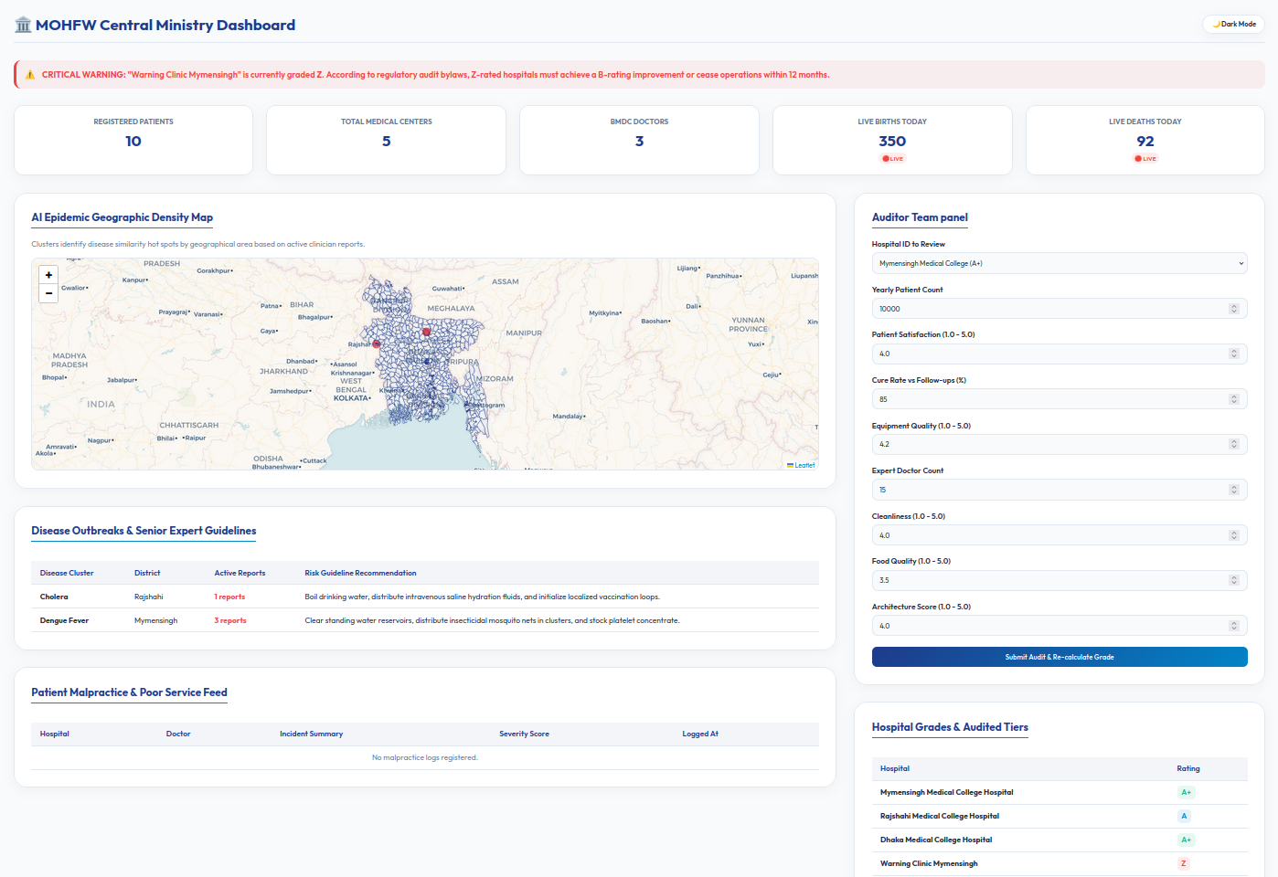
Figure 1: Ministry Dashboard - Day Mode Screen (Live outbreak tracking and Z-warning indicators).
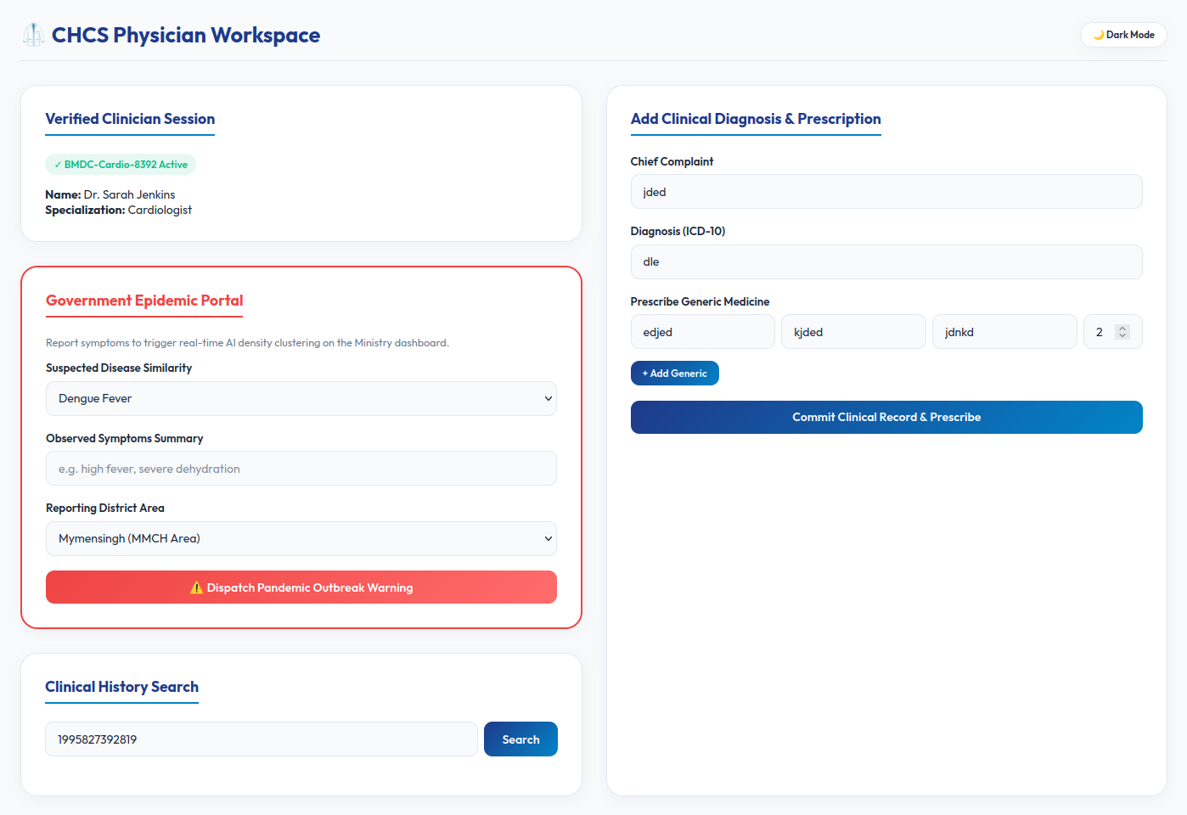
Figure 2: Doctor Workspace - Day Mode Screen (Verified Patient Timeline & Outbreak Trigger).
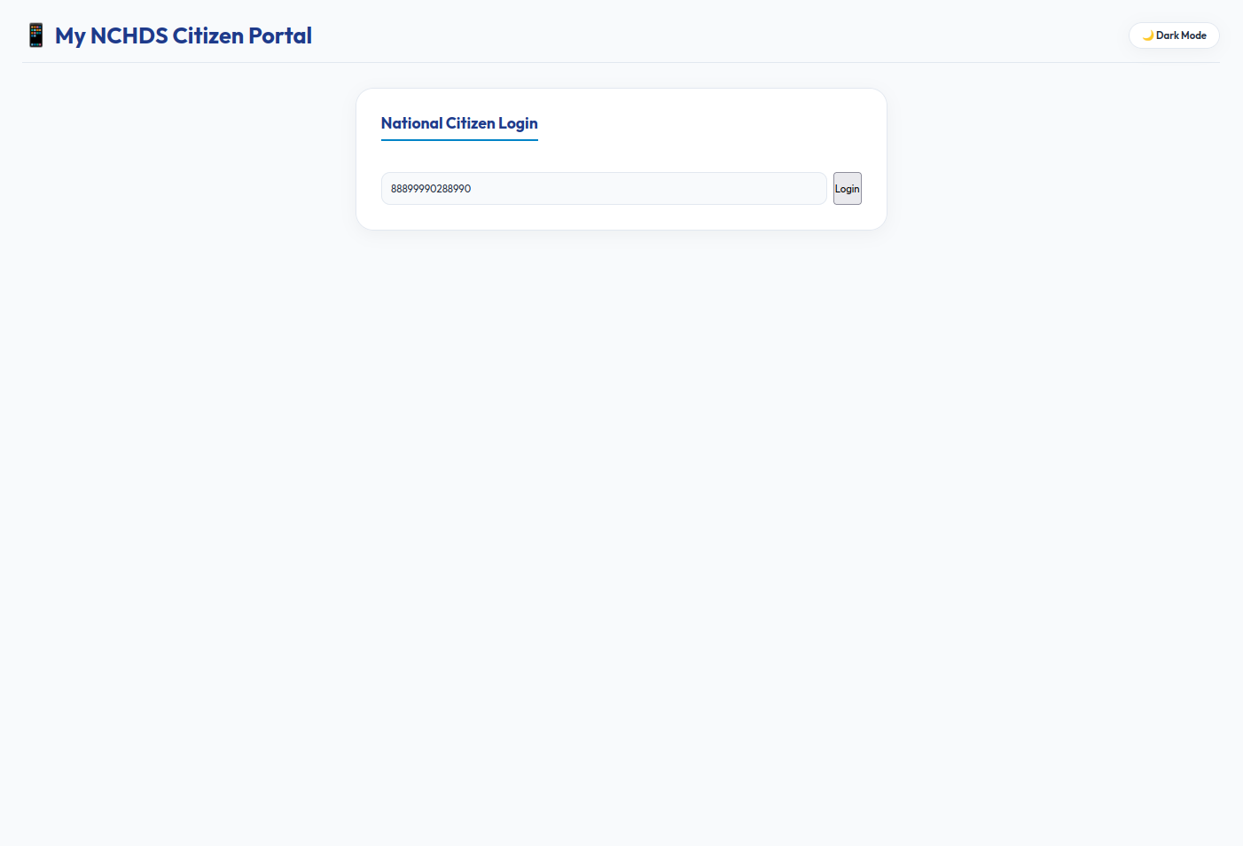
Figure 3: Citizen Panel - Day Mode Screen (Citizen Timeline).
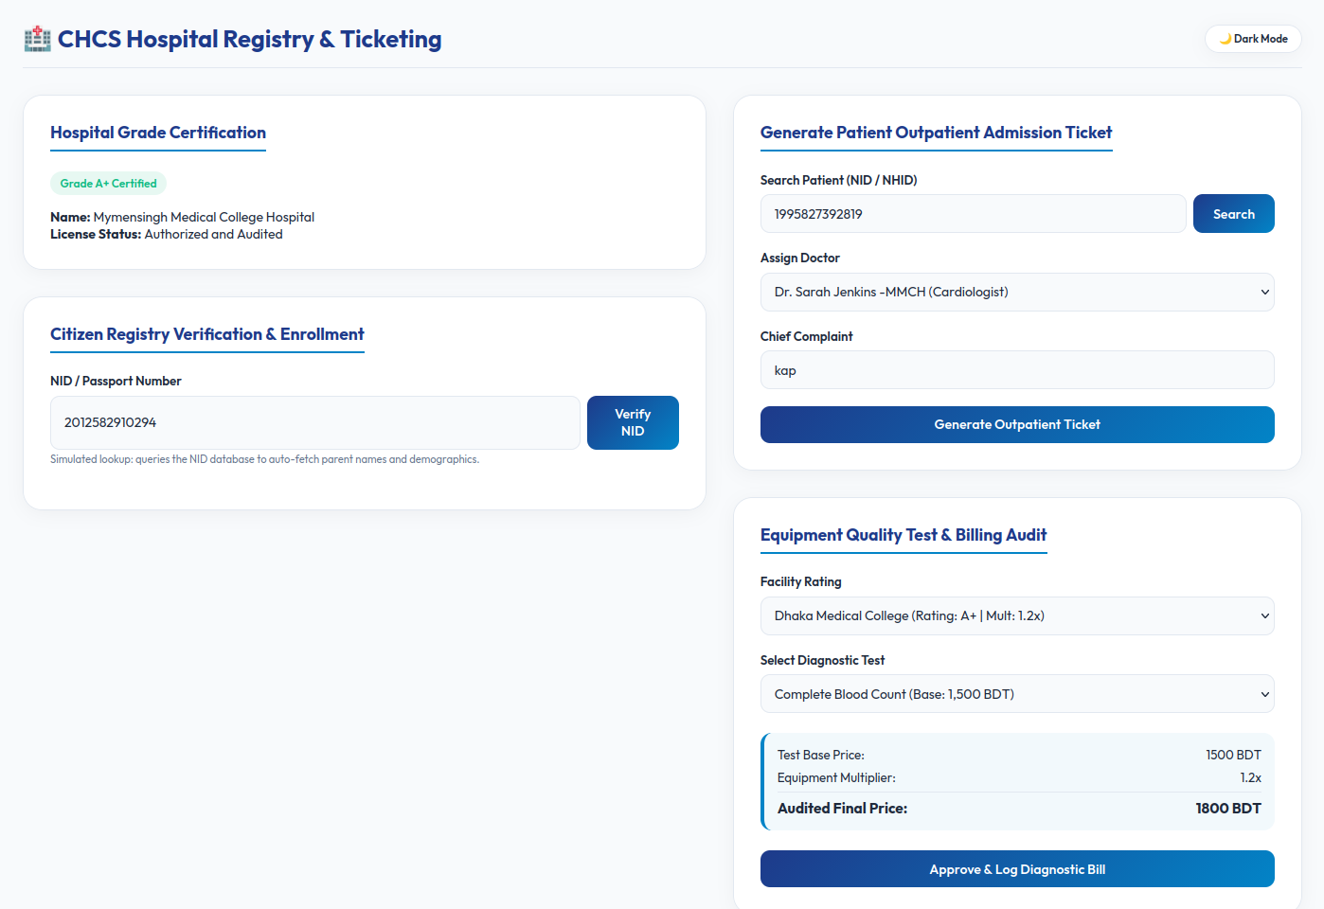
Figure 4: Hospital Panel - Day Mode Screen (NID Tracking and Billing).
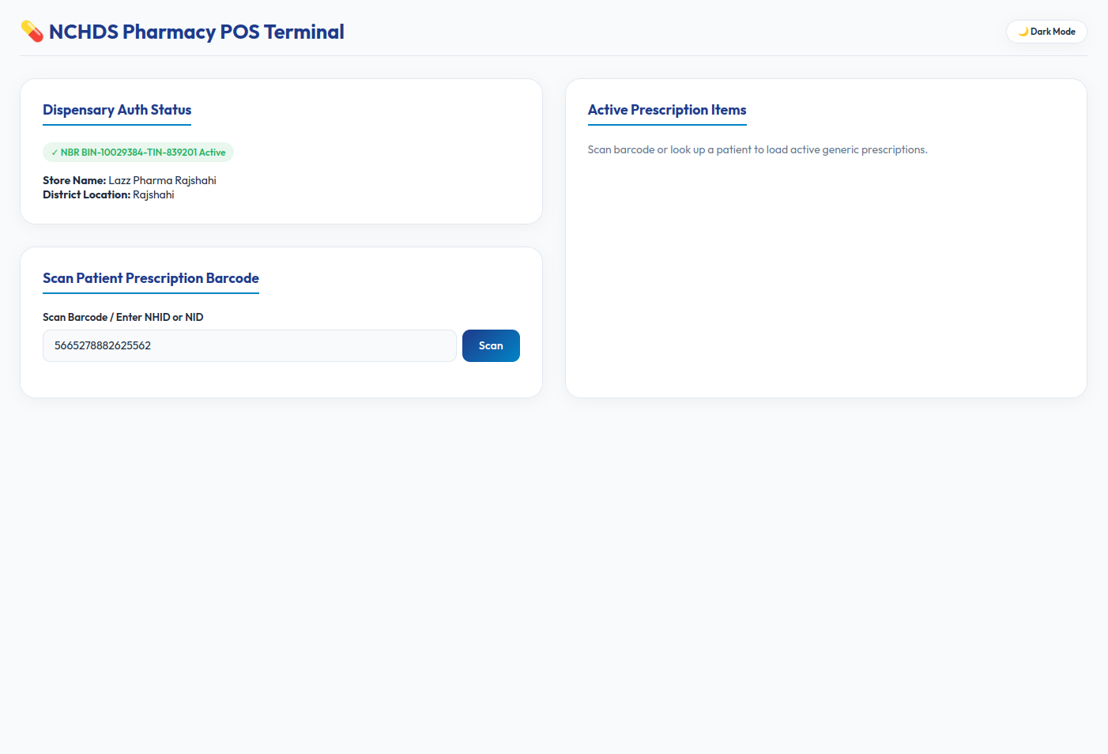
Figure 5: Pharmacy Panel - Day Mode Screen (Medicine Tracking and Billing).
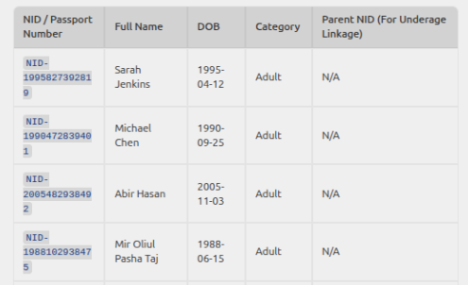
Figure 6: NID Database(Demo) - Day Mode Screen.
22. Conclusion & Research References
By integrating Government surveillance, hospital grading audits, patient malpractice feeds, NID registries, and AI OCR report scanning, the CHCS platform addresses all critical vulnerabilities of Bangladesh's paper-centric healthcare network. The system stands ready for high-throughput cloud hosting (Vercel/Next.js/Postgres), guaranteeing data scaling, universal care continuity, and clinical auditing for 175M citizens.
[1] M. Sarker et al., "Synergies and fragmentations of universal health coverage in Bangladesh," Lancet Reg. Health Southeast Asia, vol. 7, p. 100087, 2022.
[2] M. Bouh et al., "Impact of limited access to digital health records on doctors," Digital Health, vol. 10, p. 20552076241281626, 2024.
[3] M. A. H. Khan, "Bangladesh's digital health journey: reflections on a decade of quiet revolution," WHO SEAJPH, vol. 8, no. 2, pp. 71–76, 2019.
[4] R. K. Veerapaneni, "Development of a high-performance in-memory database architecture for intelligent video surveillance in critical patient care," Frontiers in Digital Health, vol. 8, p. 1807507, 2026.
[5] M. Abughazalah, "Enhancing patient admission efficiency through a hybrid cloud framework for medical record sharing," DIGITAL HEALTH, vol. 12, pp. 1–15, 2026.

Appendix A: Project Elevator Pitch
"Honorable partners, today in Bangladesh, when a patient travels from Mymensingh Medical to Rajshahi Medical, their clinical history is entirely lost. This systemic blindness forces patients to repeat identical diagnostic tests, costing families over 62 million dollars annually in waste, while permitting counterfeit drugs to circulate completely undetected in our pharmacies.
We have built the Centralized Healthcare System (CHCS) to solve this once and for all. Using a secure, high-concurrency serverless edge architecture capable of handling 50,000 requests per second, we link every citizen to a unique National Health ID (NHID) derived cryptographically from their NID or Birth Certificate.
Our platform connects the entire ecosystem: the Ministry monitors live birth/death tickers and disease outbreak clustering; hospitals and doctors access longitudinal patient records and operate under an automated regulatory grading system; pharmacies scan barcode prescriptions, auto-syncing stock and blocking fraud; and patients report malpractice and use an AI Personal Nurse.
This is not just a proposal; our live prototype is running today. By integrating this system, we will save millions of lives, eliminate financial leakages, and digitize universal health coverage for 175 million citizens. We are seeking the partnership and funding to scale this pilot nationwide. Join us in building the digital spine of Bangladesh's healthcare future. Thank you."

