1. **Overview** of the analysis: Explain the purpose of this analysis.

To make a review in how the Neural Networks models works. Analyzing it with the help of the challenge.

1. **Results**: Using bulleted lists and images to support your answers, address the following questions:

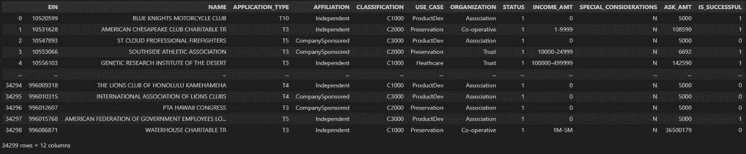Database

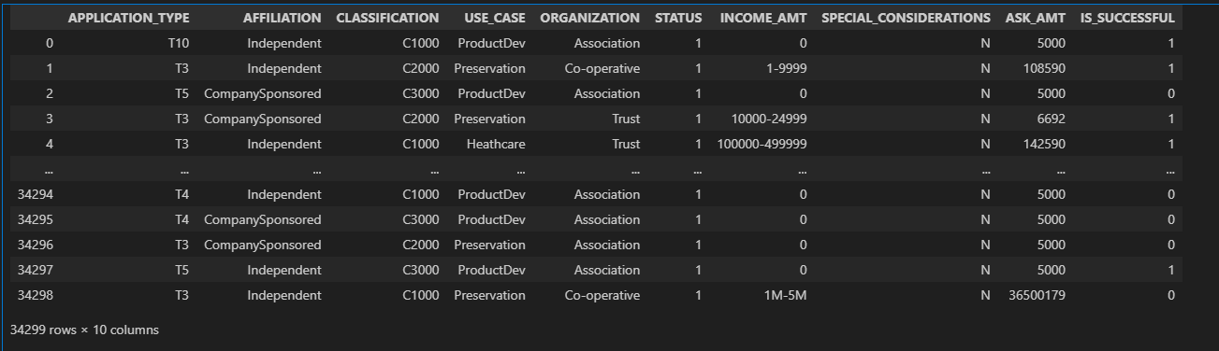Database after erasing columns ‘EIN’, ‘NAME’

The value counts before and after grouping if the count where significant lower.

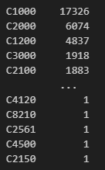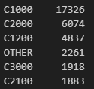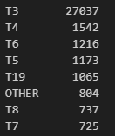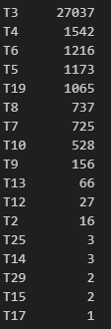‘APPLICATION_TYPE’ column. ‘CLASSIFICATION’ column (Not concidering values of 1).

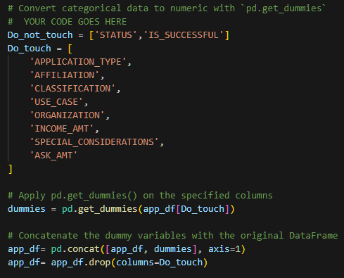Using command to be able to use the information in specific columns, transforming it to 0 and 1s.

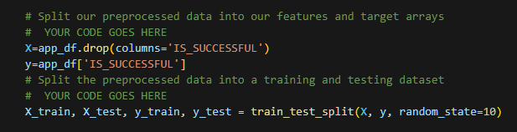Creating the variables to train and to test.

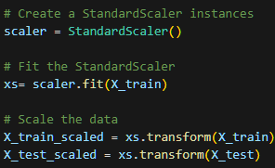Transforming information to be more able to handel

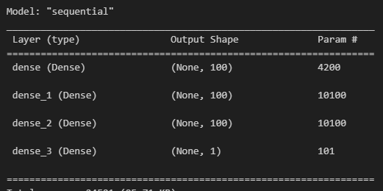The structure of the model ‘Keras’ after creating hidden layers with their specific units and activation.

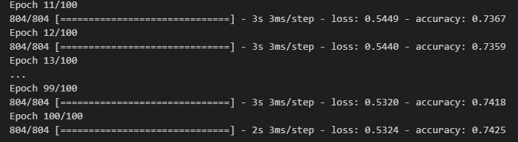Training the model.

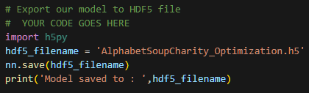Saving information into a HDF5 file.

* Data Preprocessing
  + What variable(s) are the target(s) for your model?

Target = ‘IS_SUCCESSFUL’ column.

* + What variable(s) are the features for your model?

`APPLICATION_TYPE`, `AFFILIATION CLASSIFICATION`, `USE_CASE`, `ORGANIZATION`, `STATUS`, `INCOME_AMT`, `SPECIAL_CONSIDERATIONS`, `ASK_AMT` columns.

* + What variable(s) should be removed from the input data because they are neither targets nor features?

‘EIN’ and ‘Name’

* Compiling, Training, and Evaluating the Model
  + How many neurons, layers, and activation functions did you select for your neural network model, and why?

3 hidden layers with ‘relu’ activation, ‘100’ neurons and 1 output layer with ‘sigmoid’ activation, after multiple tries fin than aggregating more hidden layer it drops o keeps in the same result.

* + Were you able to achieve the target model performance?

No, max I could obtain were 74.25.

* + What steps did you take in your attempts to increase model performance?

Changing the activation model, the neurons, the epoch and hidden layers.

1. **Summary**: Summarize the overall results of the deep learning model. Include a recommendation for how a different model could solve this classification problem, and then explain your recommendation.

This challenge was design to help us to understand the process we might do using neural networks for machine learning supervised. The data we had in the biggening had some columns that was not useful for machine learning, and some other columns contain values that where not able to handle due to they were strings, we have also some values that where so little that was going to affect the functionality of the process disbalancing it. We must be effective between the information that we were going to train the model and to evaluate the model. And at the end create the model to be train, test and evaluate. And all this information were storage in a HDF5 file.