**Project Proposal for Web Services**

“Bonjour-Santé clone”

**Team:** Dang Huynh Minh (#1670214), Anastassia Tarassova (#1277712) and Trang Trieu (#6341464)

**Project description:**

The project is a web-based platform designed as a clone of the Bonjour Santé appointment scheduling system. It will consist of two main components: a server-side REST API and a client-side user interface.

The server will manage *user authentication, medical appointment scheduling, and retaining documents*. The client-side interface will allow users to easily search for available appointments, view healthcare providers, and manage bookings. The platform aims to streamline appointment scheduling by providing real-time availability, reminders, and secure user data management. Users will have access to their appointment history and can easily cancel or reschedule appointments.

The backend will be developed for authentication, authorization, and secure connection to ensure fast response times and reliability. This project will leverage modern web technologies to deliver a seamless user experience. The system will be designed with a focus on security, ensuring privacy and protection of sensitive medical information.

**Technologies used:**

* MySQL DB in MS Cloud (see Azure instructions video day 07)
* Visual Studio Code as IDE
* Coolors.com for color palette
* Figma for front-end mock-up
* GitHub Desktop
* Trello for Kanban

**Additional libraries:**

* Nodemon
* Node Npm
* NPMLog
* Node express
* Sequelize
* JQuery
* Bootstrap

**Special features:**

* Real understanding of user stories (patients)
* Medical history for each patient: allergies, associated healthcare providers, etc.
* CRU(D) of patient documentation (prescriptions, imagery, lab results)
* ((Search by medical specialty))
* ((Cloud storage: Azure BLOB as bucket of files))

**OPTIONAL features:**

1. ((Email push notifications for appointment reminders))
2. Real understanding of user stories (doctors)
3. EXTRA: ((Location-based search (70km radius)))

**Challenging items:**

See ((items)) above

**List of URLs:**

/main

/login

/register

/search

/profile

/appointments

/appointments/documents

**Design of the database:**

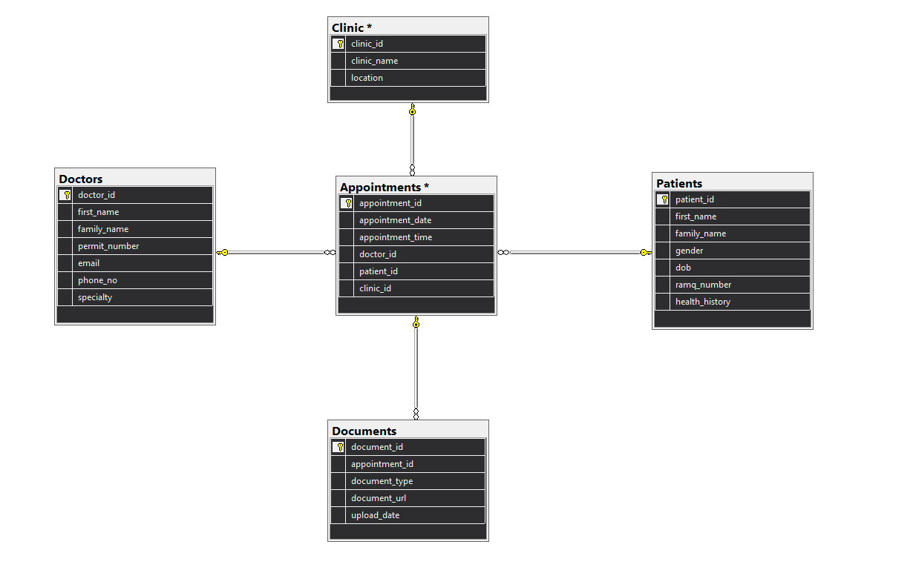

**Use case diagram:**

**Screenshots (selected):**

MAIN HOME PAGE

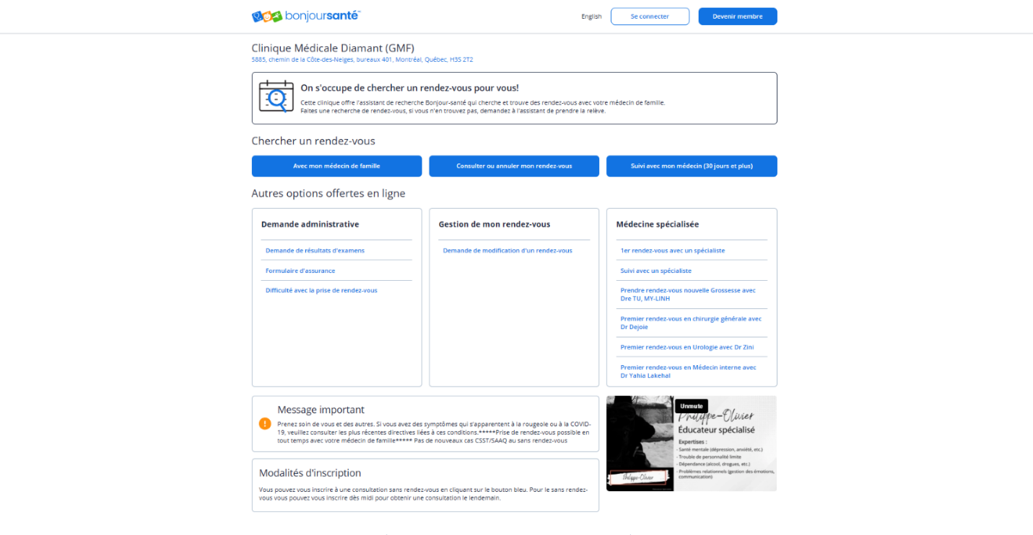

CREATE APPOINTMENT (1)

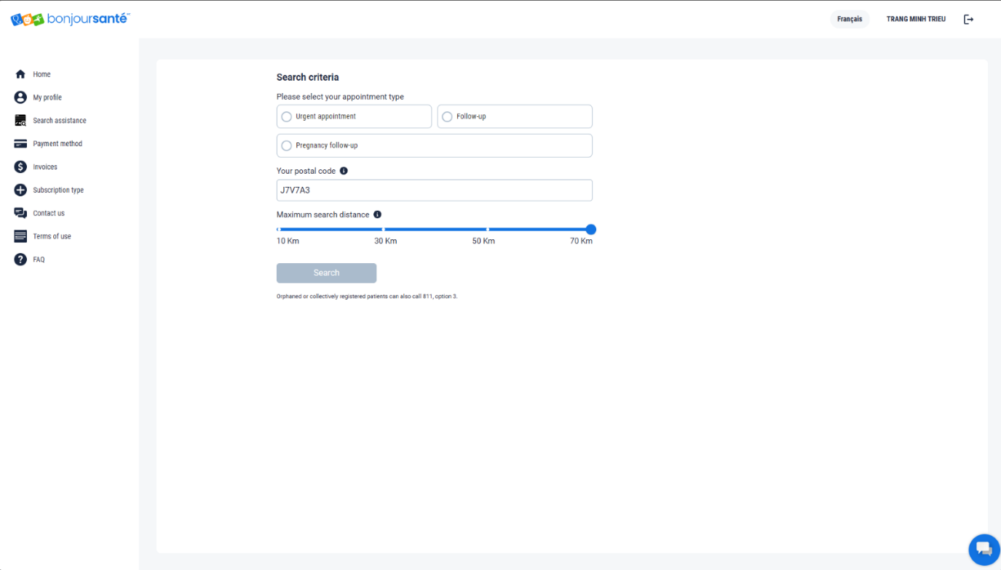

CREATE APPOINTMENT (2)

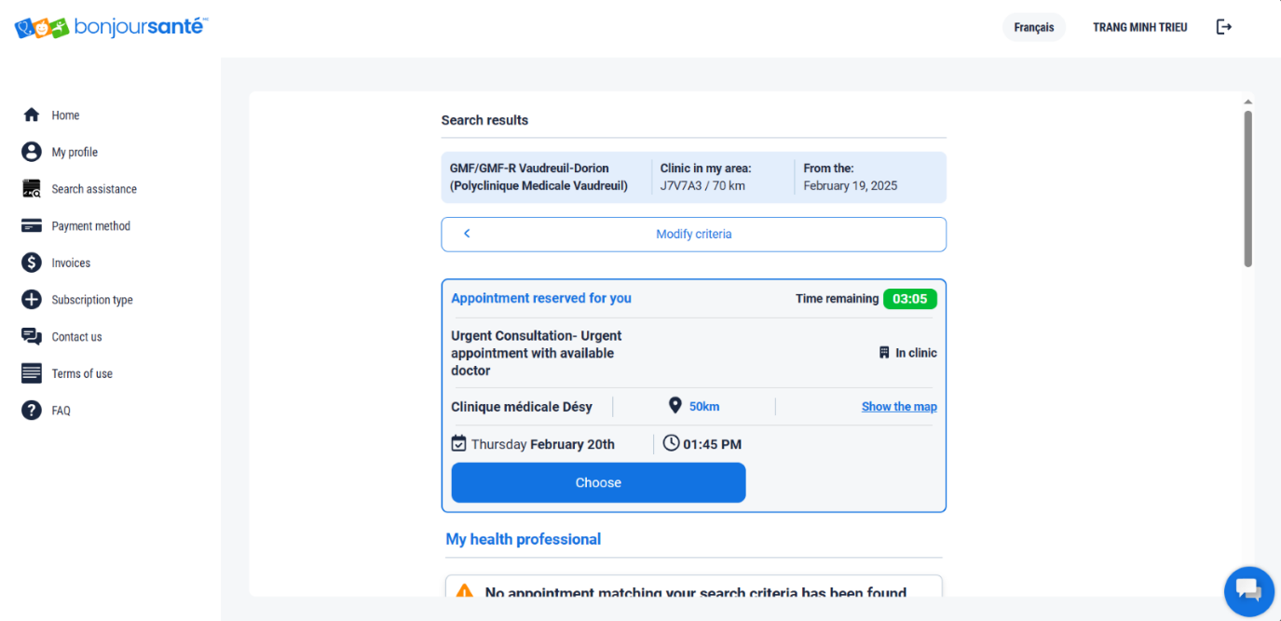

UPDATE APPOINTMENT

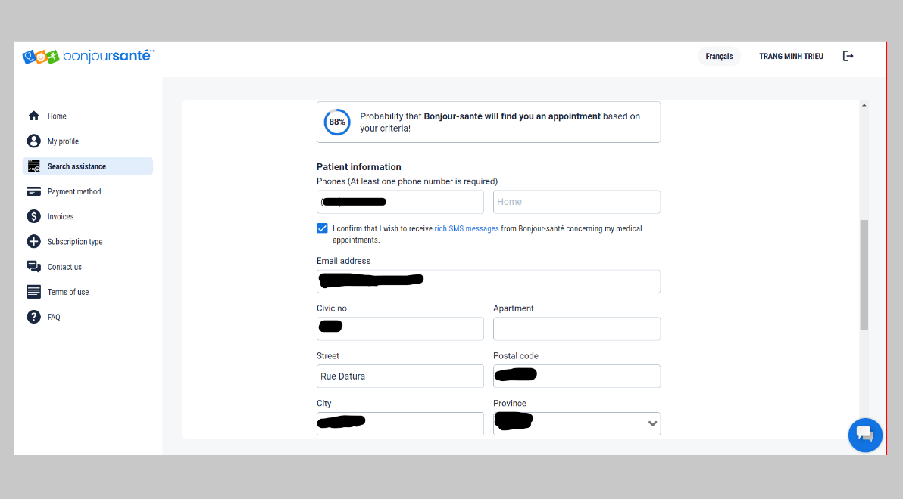

DELETE APPOINTMENT

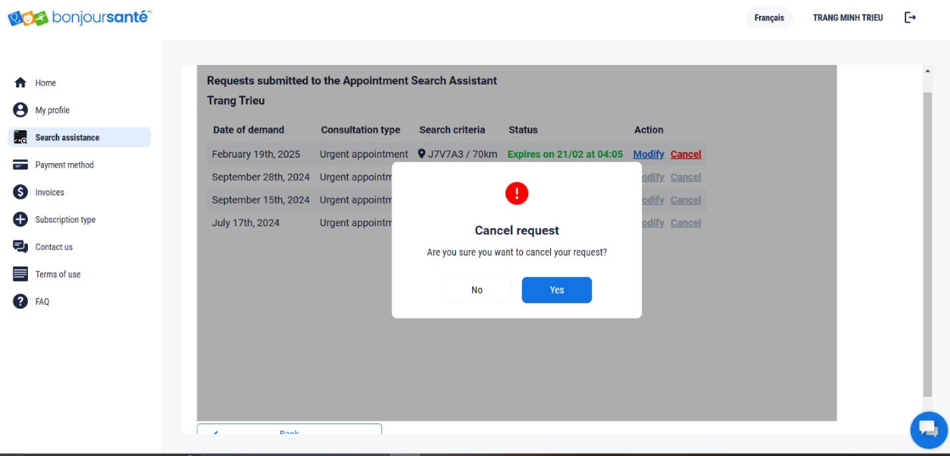

**Questions discussed with Dr. Prokopski:**

* *If provided appropriate resources and individual consultations, can we learn cloud hosting for this project?* 
  + To be discussed on Monday if project progresses as planned.

* *Any suggestions on improving DB design?* 
  + Watch appropriate tutorials/course materials for use of Azure Data Studio.
* *Any suggestions for improving user experience*
  + KISS (Keep It Simple, Silly).
* *Are there any recommended methods for securing the API, especially with sensitive medical data?* 
  + Patient could have a 2-factor authentication, but this is not a concern for this level of project complexity.
  + Use https for encryption.