My program is structured in a specific way. First it asks for your income, then your budget. Then you input your expenses, the price of them, the category they are in and then the date this occurred. Then it looks at the values of the things in the “expenses” list and adds them up, then saves it to give you later when its called. Then it asks if you want to add any to a savings pot. This isn’t required of me to include but I wanted to add it in for more depth. After the savings, my code then features two functions to both view expenses and filter them. Then finally, I use the “main” function at the end to call everything forward and basically initialise the whole code and run through it section by section. My “main” function at the end sets up an important menu for the user to navigate exactly what they want to do. Throughout my code, I have used helpers to remove the unneeded spaces and to remove the possibility of crashing when the user uses odd capital letters.

Please find below the testing evidence in the form of screenshots:
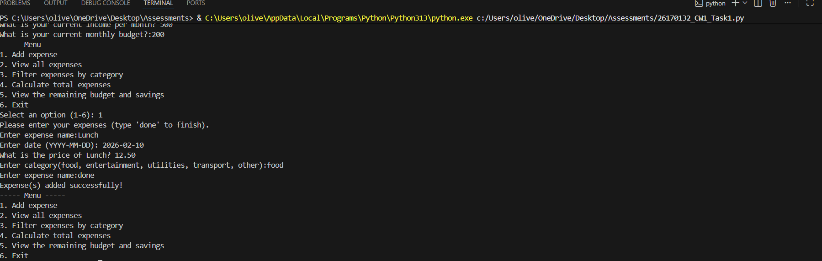
In this test, I have used the menu to add an expense, add in the name of it, the date, the price and the category. I have then exited the menu as I don’t need to add another expense. This is the normal case.

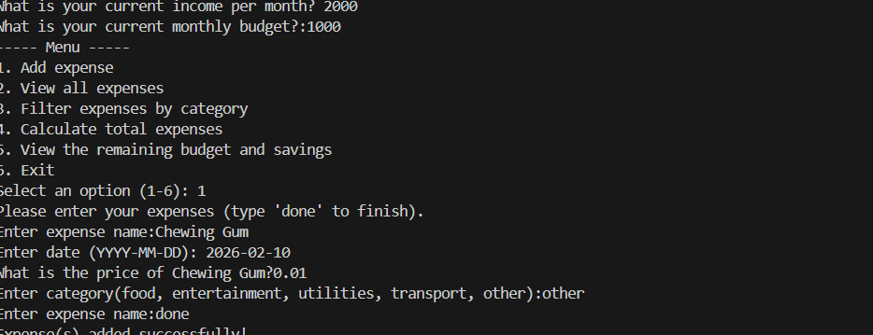
This is the edge case. Here I have done the same as the previous test, but used an odd price. Like expected, this is still accepted by the code.
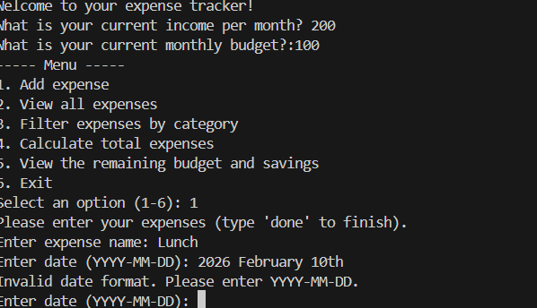
This is the invalid input case. Here, I have input the date into the wrong format by using letters. As expected, the code prompted me again until its right.

