NLP lecture06 – Neural networks

********************************************************************************

*Próba pisania po polsku*

1. Czym jest deep learning

- Deep learnig – scieć z modułów które są trenowane (np gradient base optimalisation)
- Każdy moduł liczy coś innego np median/average – simple computational unit:
  - posiada input
    - inhibit – jeżeli są wartości ujemne
    - exite – wartości dodatnie
  - posiada output
  - jezeli znamy/przypuszczamy output który mamy otrzymać z modułu to input musi się zmienić – zależność różniczkowa – differentiable objects
    - w praktyce nie ma to znaczenia
********************************************************************************

1. Overview

1.1 Applications of neural networks:
- computer vision
- text and speech
- control → AI for games, self driving cars

1.2 Scaling
- Hardware is getting faster but for specific operations – not every
  - matrix multiplications are mostly used in neural networks → GPUs used for this
- Data
  - some computation scale good or bad with data. “Data hungry models”
- Modularity
  - Connection of small computational units are building a network and this network is trained with gradient-base optimization

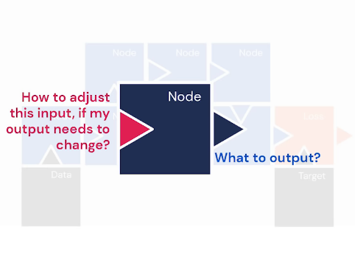

- differentiable objects –> if you change the output, the node has to change the input respectively

2. Neural networks
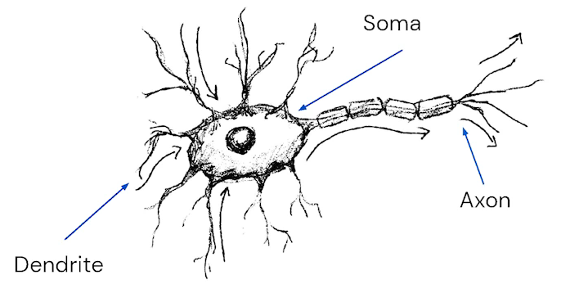
Moduł na neuronu:
    - soma zbiera dane = weighted sum of inputs
    - dendryty – input od innych neuronów
    - axon – output dla wielu neuronów
      - ciekawostka Hodgin Huxley model
    - Celem AI/Deep learningu jest obserwacja jakiegoś systemu biologicznego a nie repredukcja wszystkich dynamik tego systemu
    - stateless model – taki prosty model zawsze daje nam taki sam output – u nornalnej komórki
    - NEURON = UNITS

- Sieci neuronowe to nic innego jak zbiór liniowych regresji które są połączone ze sobą. Neurony– czyli jednolistki liczące te regresje są ze sobą w jakiś sposob połaczone.

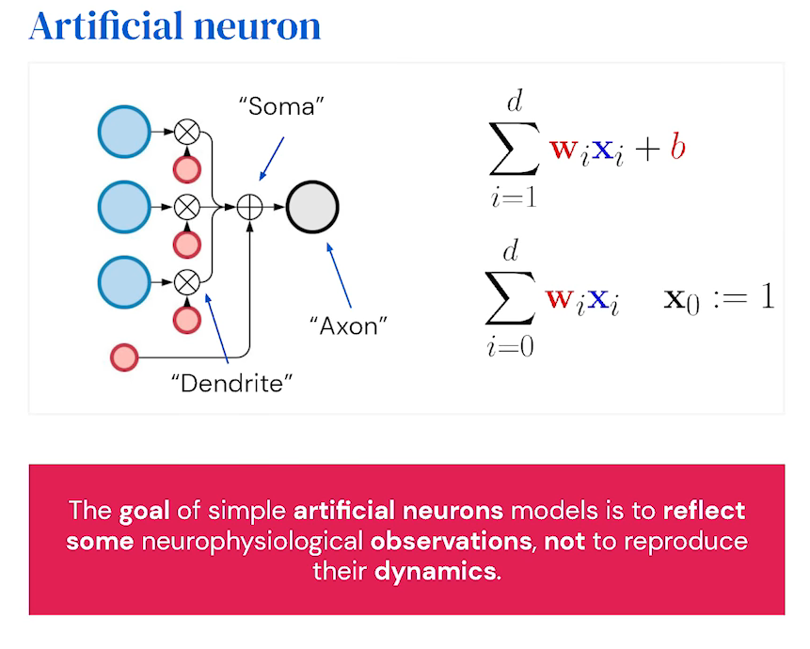
Red – parameters, blue – inputs

- Weighed avergae defines an affine projection of your data – mostly in 2D

2.2 Liear layer

- make layers of those neurons
- computaion is scaled down to a normal affine transformation --> can be efficiently vectorised (inputs and outputs)
- Mutliplication of 2 matrices O(n^2) but with tensors or vectors you can go down – GPUs compute very fast those matrices
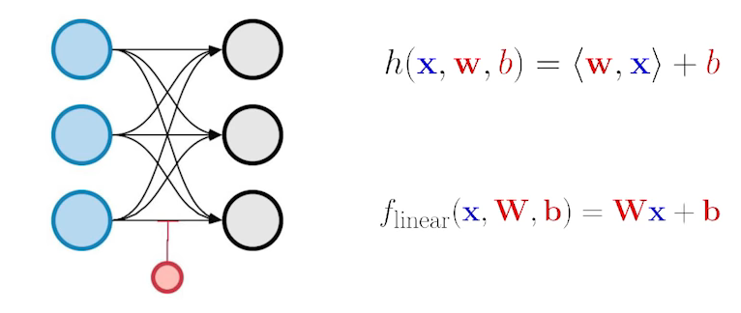
- One node computes a linear regression BUT Neural Network make MANY linear regressions

3, Single Layer neural networks

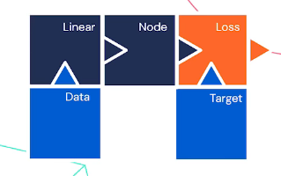

Aktivation function – non linearity – sigmoid activation function:
- Object to induce more complex models – for example summing up linear regressions --> so it iduce non-linear behavior
- Produces probability estimates
- Simple derivaties –-> differentiable
- Saturation --> Those activation function apply that your estimation is in a good range – for example 0-1 (0%-100%). Adjusting weights near to the saturation is challenging

Los function
- binary classification (dog vs non dog --> 1 vs 0)
- encdoing of negation --> probability of correct or non correct classification
- Cross entropy loss --> negative log likelihood --> classification meassure if we done it ok or not
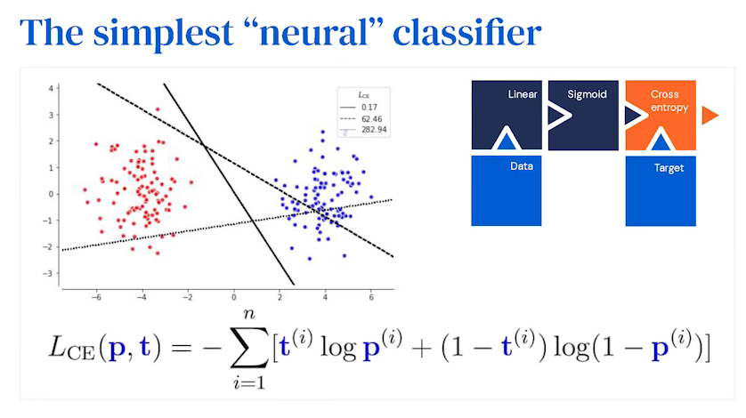
Logistic classfier -> Loss is additive in respect to samples. So if loss is high we got an an incorect classfier. But it scales good with big datasets

- IF WE GOT MORE THAN 2 CLASSES --> SOFTMAX -> final classification -> smoothing maximum. It is a multi dimentional generasation of Sigmoid. IT IS STILL A LINEAR MODE and it is used in Reinforcement Learning

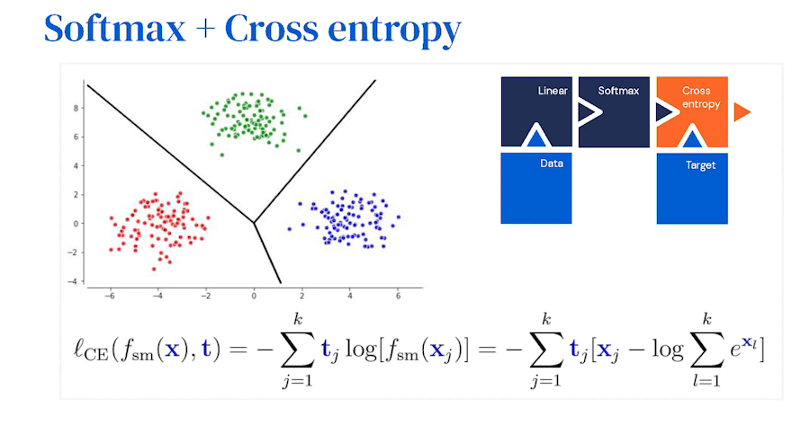
Usecases
- classifier for handwritten digits -> 92% - the data dont have to be 2D – multidimentiona data scales very well
- in NLP -> MaxEnt (Maximum Entropy Classifier)
- not for games AI – like AplhaGo

3.1 Two layer neural networks with one hidden layer

But why? Becouse we cant seperate the data that for expample blue points are in the same group witb pink points with only one line-> we have to use another line
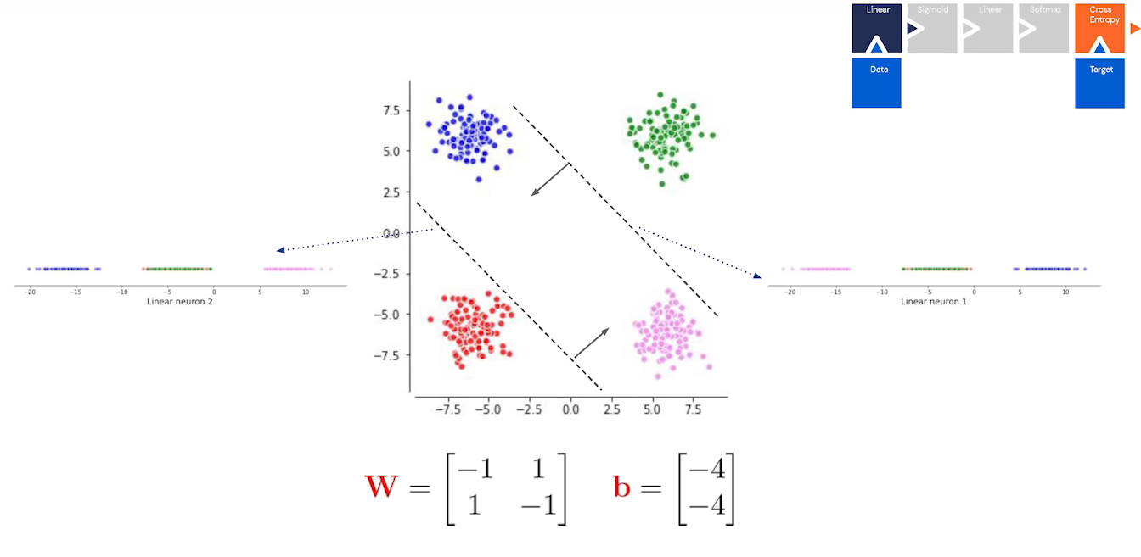

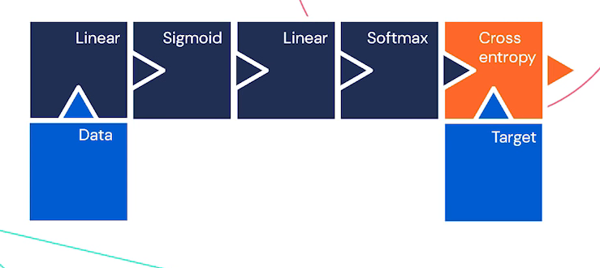
Squaching into 2D projection – rotate and squaching points

Hiden layers provides non-linear input space transformation so that final linear layer can classify
1-hidden layer network vs XOR:
- with 2 hidden neurons we solve XOR
- Hidden layers allows us to bent and twist input spaces
- linear models are used on top of those layers to do the classification in 2D space

https://playground.tensorflow.org/

Universal Approximation Theorem – tego nie kumam za chuja -> there is not constructive way to find/adjust parameter weights.

4. Deep neural networks – example of pictures
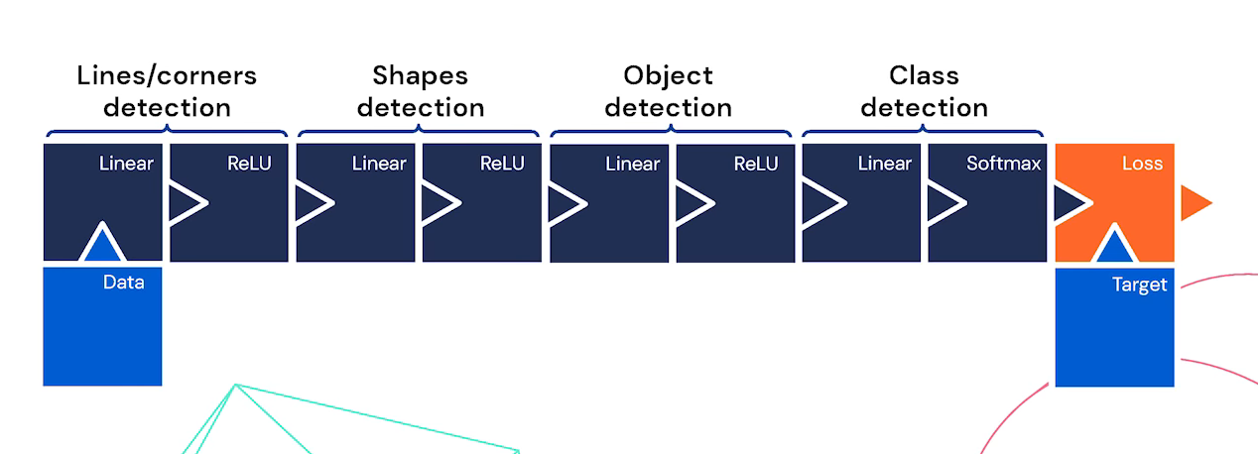

- RELU – Rectified Linear Unit -> activation function -> pice-wise linear or not linear -> to się przekłada że możemy daną funkcje bardzo dokładnie przestawić jako całkę wielu małych funkcji

- Debbuging singal in neural net = dead neuron

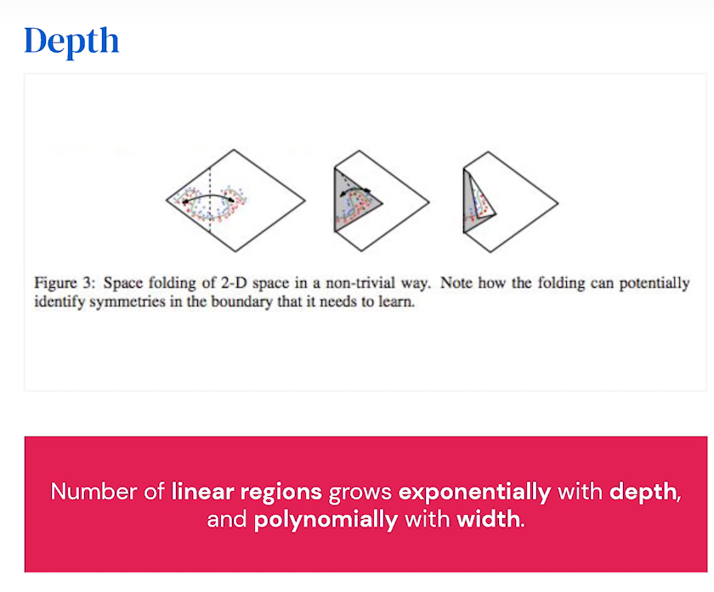
FOR COMPUTATION ITS BETTER TO GO DEEPER THAN WIDE

5. Learning

- Gradients + Jacobian matrix
- Gradient descent recap -> minimal loss -> local optimum
- Adam – stop gradient

backpropagation: API – forward/backward pass for adjusting inputs --> difrentiable rule

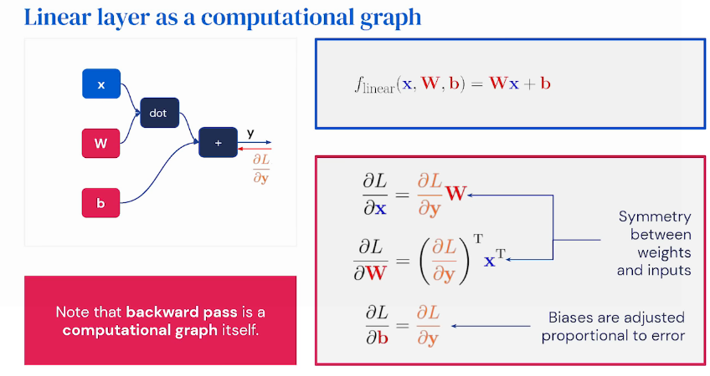

Layers

- Maxpool layers --> Node takes only the maximum gradient input --> selection of maximum
- Conditional execution --> which layer /branch to choose based on probabilty distribution

Overfitting and regularisation
- complexity of model is connected to training risk
- More data -> training risk go down
- Neural Networks dont overfiit becouse there are to many parameters – so models do not saturate

Guide to NN

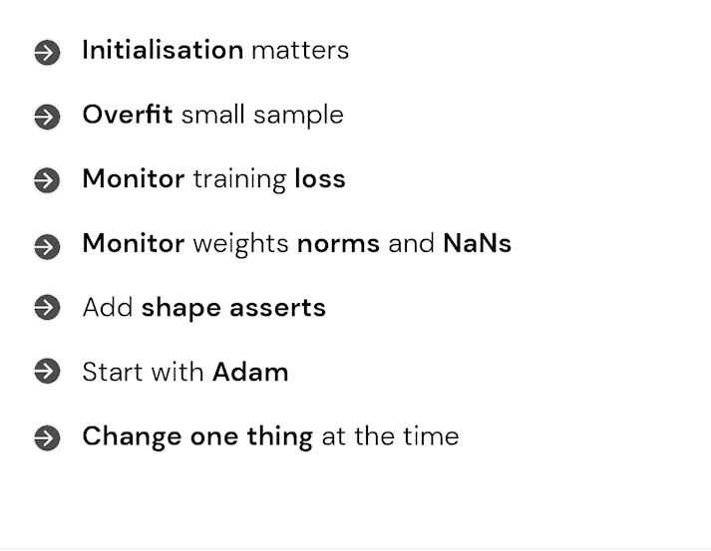

What MLPs cannot do?

- Multiplication of numbers --> hudge errors

