**analyzeStandings.R**

**SECTION I. COMPUTE AND PLOT PCT OF SUBMITTED LINEUPS THAT CASHED**

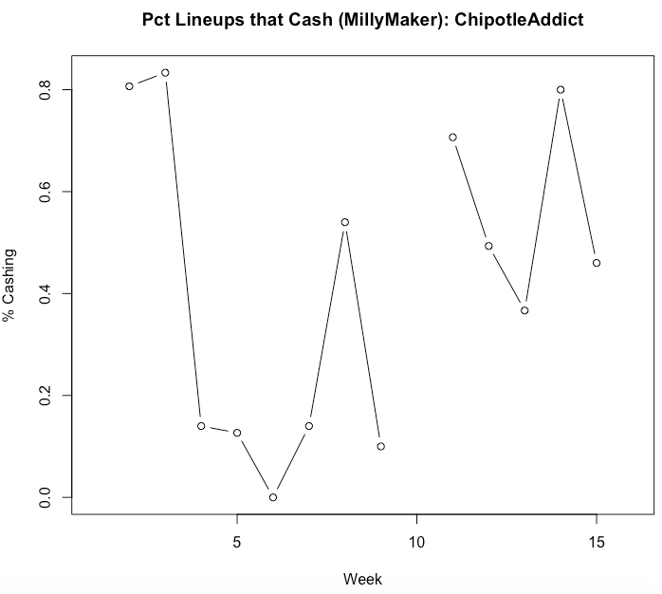

**SECTION II. COMPUTE AND PLOT PCT OF SUBMITTED LINEUPS > SOME PERCENTILE**

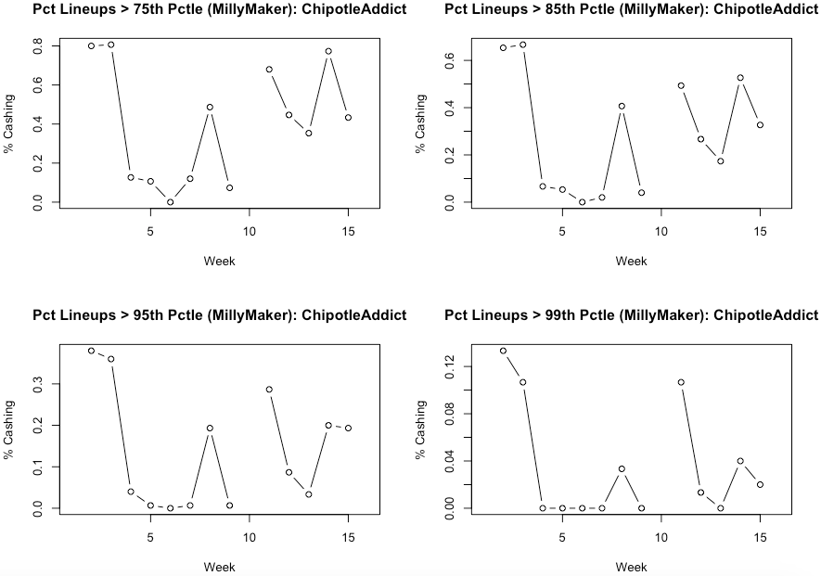

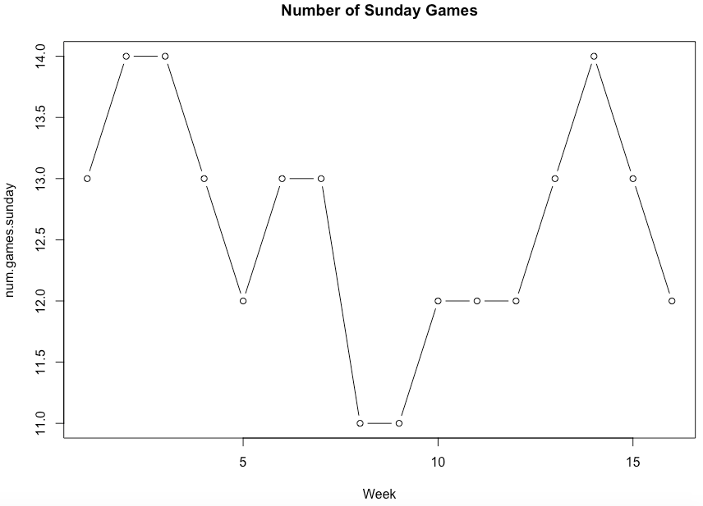

**SECTION III. EXAMINE NUMBER OF UNIQUE PLAYERS (OVERALL AND BY POSITION)**

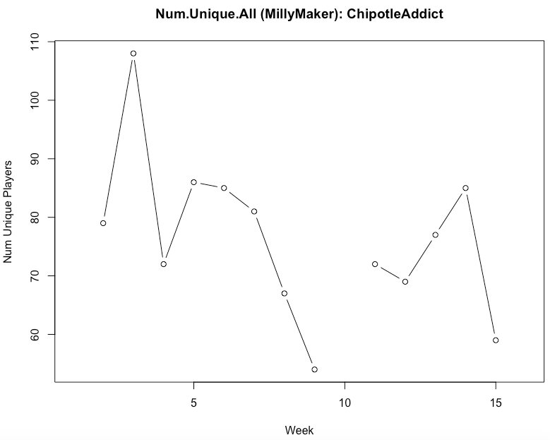

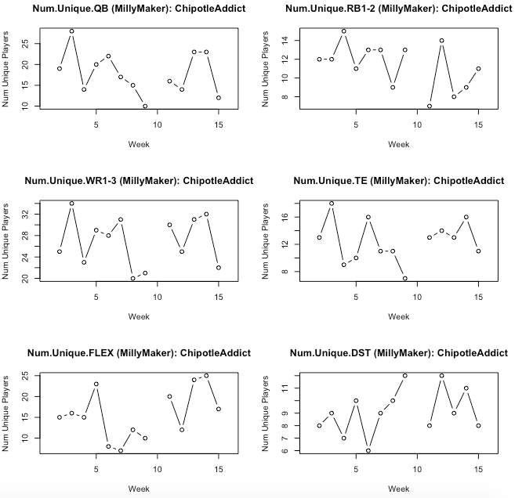



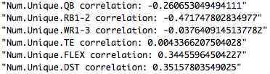

**SECTION V. EXAMINE POSITION EXPOSURES**



