Français
Flag Act
R.S.O. 1990, Chapter F.20
Consolidation Period: From December 31, 1990 to the e-Laws currency date.
No amendments.
Preamble
Whereas it is deemed expedient to adopt a flag of historical significance as the provincial flag of the Province of Ontario;
And whereas it is desirable that such flag have the design and colouring of the Canadian Red Ensign except that the badge in the fly be the shield of the armorial bearings of the Province of Ontario granted by Royal Warrant in 1868;
Therefore, Her Majesty, by and with the advice and consent of the Legislative Assembly of the Province of Ontario, enacts as follows:
Provincial flag
1. The flag described and illustrated in the Schedule to this Act is the provincial flag of the Province of Ontario. R.S.O. 1990, c. F.20, s. 1.
SCHEDULE
1. Description:
A flag of the shade of red specified in the next following paragraph and of the proportions two by length and one by width with the Union Jack occupying the upper quarter next the staff and with the shield of the armorial bearings of the Province of Ontario centred in the half farthest from the staff.
British Admiralty Colour Code No. T1144 for nylon worsted bunting and No. T818A for other bunting.
2. Illustration:
Insert graphics\statutes\F20001ab.tif
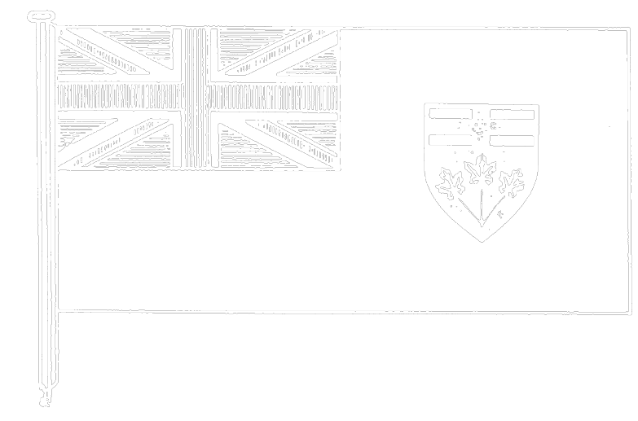
R.S.O. 1990, c. F.20, Sched.
______________

Français

Back to top

