Word Style

Oliver

October 20, 2021

Table of Contents

Title 1 1

R Markdown 1

H3 1

Including Plots 2

# Title 1

## R Markdown

### H3

#### H4

This is an R Markdown document. Markdown is a simple formatting syntax for authoring HTML, PDF, and MS Word documents. For more details on using R Markdown see <http://rmarkdown.rstudio.com>.

When you click the **Knit** button a document will be generated that includes both content as well as the output of any embedded R code chunks within the document. You can embed an R code chunk like this[1]:

summary(cars)

## speed dist   
## Min. : 4.0 Min. : 2.00   
## 1st Qu.:12.0 1st Qu.: 26.00   
## Median :15.0 Median : 36.00   
## Mean :15.4 Mean : 42.98   
## 3rd Qu.:19.0 3rd Qu.: 56.00   
## Max. :25.0 Max. :120.00

## Including Plots

You can also embed plots, for example:

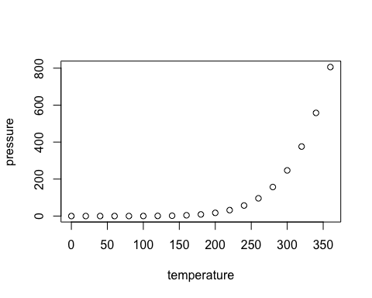

Note that the echo = FALSE parameter was added to the code chunk to prevent printing of the R code that generated the plot.

1. point 1;
2. Point 2;
3. Point 3.

1. Hi this is footnote.