BossBros

# Controls

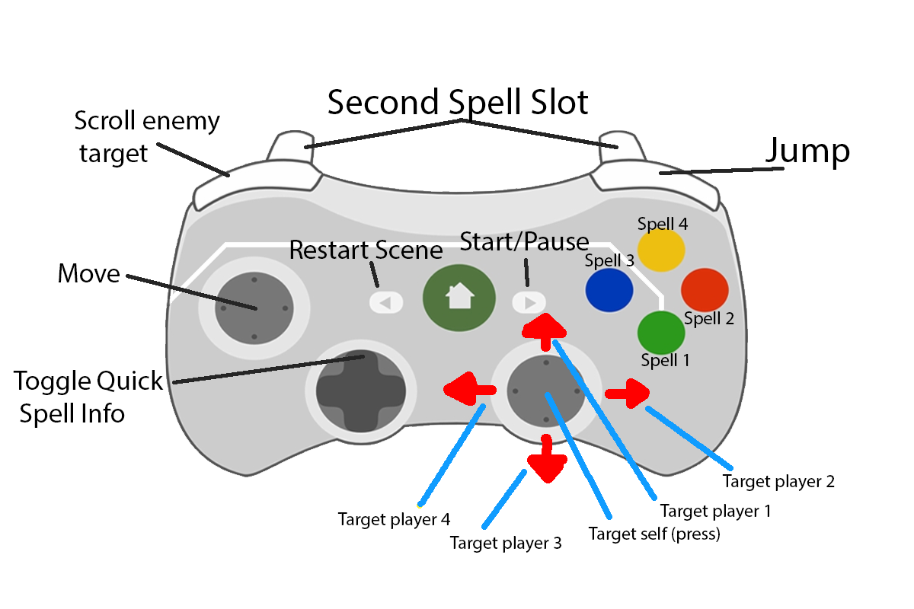

## Keyboard

Spells: 1, 2, 3 ,4  
Second Spell Slot: Shift

TargetPlayers: F1, F2, F3, F4  
TargetSelf: G  
Scroll EnemyTarget: Tab

Jump: Space  
Move: WASD

Toggle Quick Spell Info: I

Start/Pause: Escape  
Restart: R

# Overall game idea

Play as four players in a couch co-op environment, together battling against different bosses. Each level has its own unique boss fight, without the need of clearing trash packs in between.

The characters can choose between different classes, mixing them up how they want. (Currently locked to one each to test out different skills).

No rewards for killing bosses, apart from being able to claim victory. No need for gear to progress on other bosses, just an increasing difficulty in skill on the bosses for now.

This game is basically a copy of wow dungeons, but it is couch co-op and no unnecessary trash packs and that boring stuff. So, mix of wow and Furi.

## Game flow

The game starts with a screen to start. Next there is level selection, much like overcooked does, driving a van to different locations. When a level has been selected, there is a character selection screen, allowing the selection of classes and colour. When all characters are selected, the players enter the level.

At each level the players battle against the boss. The players can at any time reset the level, starting it over from scratch. In the level, the players can always opt back to character select where they can switch classes or go back to level select.

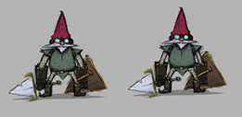

# Stats

### Speed Multiplier

Increases or decreases the speed of which the character moves with.

### Attack Speed

Increases or decreases the speed of the melee attacks or cast time of spells

### Damage Increase

Increases or decreases the damage dealt by the next spells or melee attack

### Damage Mitigator

Increase or decreases the damage taken by the next spell or attack

### Auto Attack Range

The distance of the melee attacks

### Auto Attack damage

The damage dealt by the melee attacks

### Threat

The boss/enemies have a threat meter, each spell generates threat to the enemies. Spells have a threat modifier which increases the threat gained.

### Resource

Each character has a resource bar, that regenerates at different speed. Resource is used to cast spells.

# Characters

## Brute

The brute is a drunk character, whose aim is to tank the damage dealt by the boss. Since the class is drunk, they don’t feel as much pain.

## Loremaster

The Loremaster is a character who is knowledgeable about the ways of medicine. Alternatively change to witchdoctor or something that makes more sense! Is the healer. Has a lot of resource, but it regenerates at a very slow speed.

## Wizard

The wizard is basically Gandalf. Deals damage from a distance with spells, but also has one spell to increase next melee attack.

## Mercenary

The mercenary is a melee class that deals damage in close quarter combat. Is also able to resuscitate if someone dies.

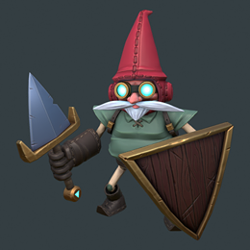

# Brute

### Rude

Rude is the spell where the brute says something horrible which instantly hurts the feelings of the boss, forcing the boss to attack the brute for a few seconds.

### Default Attack

The brute uses its default attack to deal damage and generate threat on the boss. A melee spell used in close quarter combat.

### Bum Jump

The brute jumps on his bum, creating a small AOE attack due to a shockwave?

### Raise Shield

The brute raises his shield, reducing the incoming damage taken for a few seconds.

### Leap

The brute leaps to the current target.

### Shield Wall

The brute creates a “barrier” with his shield in front of him, causing all incoming projectiles from that direction to be destroyed.

### Spell 7 is empty

Reserved slot for cool ability

### Spell 8 is empty

Reserved slot for cool ability

# Loremaster

### Big Heal

The Loremaster casts a healing spell that heals for a lot on the friendly target.

### HOT

The Loremaster places an instant cast HOT on the friendly target, regenerating their health over time.

### Shield

The Loremaster places an instant shield on the target, causing them to absorb a certain amount of damage for a few seconds,

### Sacrifice

The Loremaster casts a quick spell that gives a part of his health to the friendly target.

### Tug

The Loremaster pulls the friendly target to himself. Instant cast.

### Meditate

The Loremaster sits down for a few seconds, unable to do any other actions while regenerating resources/mana.

### Spell 7 is empty

Reserved slot for cool ability

### Spell 8 is empty

Reserved slot for cool ability

# Wizard

### Default spell

The wizard casts a default spell that flies and damages the enemy.

### Burst damage

The wizards casts an instant spell on the enemy, dealing damage.

### Thunder Strike

The Loremaster places a barrier on the target, causing them to absorb a certain amount of damage for a few seconds,

### DOT

The wizards casts a dot on the enemy, causing them to take damage over time.

### Confuse

The wizard says a riddle that confuses the enemy, dealing small damage and interrupting the enemies current spell cast. Instant cast.

### Barrier

The wizard stands still and raises a barrier over himself and in a small area. Any friend standing within the barrier gains a buff to reduce damage taken while inside it.

### God Power (or something cool)

Calls upon the power of the higher beings, gaining a buff to increase damage dealt and reduces the time it takes to cast spell.

### Spell 8 is empty

Reserved slot for cool ability

# Mercenary

### Jab

The mercenary jabs his weapon into the chest of the enemy, causing them to take damage.

### Organ Punch

Punches a vital organ in the enemy, causing them to take a lot of damage.

### Spin

An AOE attack that causes damage to all surrounding enemies.

### Teleport

The mercenary teleports forward.

### DOT

The mercenary does something that causes the target to bleed damage over time.

### Rush (Maybe remove since already has teleport)

The mercenary increases his movement speed for a few seconds.

### Furious

Becomes angry. That means that the mercenary will attack faster and harder.

### Resuscitate

The mercenary begins resuscitating the dead player, reviving them back to live.



# Bosses

The bosses will have a set of spells that will be shown when selecting levels.

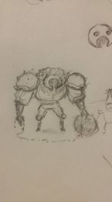Each boss is hopefully unique and exciting, STRETCHING out our imagination of fun bosses.