Java Fundamentals Trailblazer Assignment

You have been given a text file that contains comma separated details for cars.

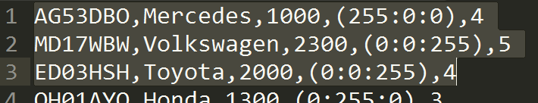

The following information is contained in each line of the text file

**Registration Number**

**Make**

**Engine Size**

**Colour**

**Number of Doors**

It is your job to read this data and produce an output on the console that looks as follows :

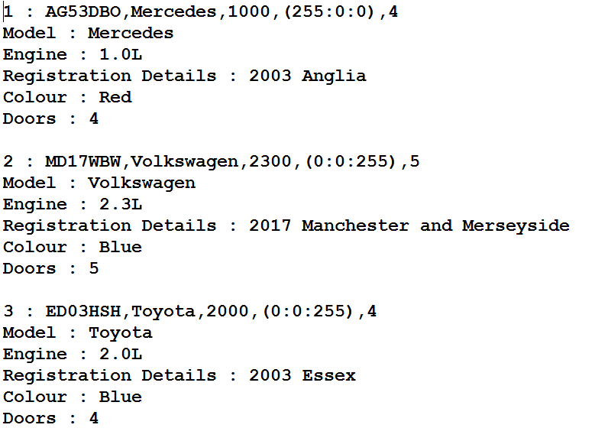

Create a class or as many classes as you see fit to implement this functionality.

The following files are to be used

Car.data (raw car information)

Location.data (location details)

The following information you may find useful

1. The Registration plate can be used to work out the year and location (see the details further on in this document to work out the algorithm to use)
2. The colour information is held as a colon separated group of byte integers each one representing a colour in the format of Red : Green : Blue (This can be used to work out the colour)
3. Some examples of classes and methods you might find useful are as follows, details and examples of their use can be found in the Java Fundamentals Training Material!

String class

substring()

split()

arrays

ArrayList class

HashList class

Arrays class

String.format()

FileReader

Color class

rgb()

UK Registration Plate Details

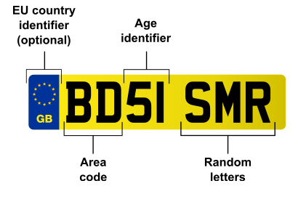

|  |  |  |  |
| --- | --- | --- | --- |
| **A** | [**A**nglia](https://en.wikipedia.org/wiki/East_Anglia) | [Peterborough](https://en.wikipedia.org/wiki/Peterborough) | A B C D E F G H J K L M N |
| [Norwich](https://en.wikipedia.org/wiki/Norwich) | O P R S T U |
| [Ipswich](https://en.wikipedia.org/wiki/Ipswich) | V W X Y |
| **B** | [**B**irmingham](https://en.wikipedia.org/wiki/Birmingham) | Birmingham | A–Y |
| **C** | [**C**ymru](https://en.wikipedia.org/wiki/Wales) ([Wales](https://en.wikipedia.org/wiki/Wales)) | [Cardiff](https://en.wikipedia.org/wiki/Cardiff) | A B C D E F G H J K L M N O |
| [Swansea](https://en.wikipedia.org/wiki/Swansea) | P R S T U V |
| [Bangor](https://en.wikipedia.org/wiki/Bangor,_Gwynedd) | W X Y |
| **D** | [**D**eeside](https://en.wikipedia.org/wiki/Deeside) | [Chester](https://en.wikipedia.org/wiki/Chester) | A B C D E F G H J K |
| [Shrewsbury](https://en.wikipedia.org/wiki/Shrewsbury) | L M N O P R S T U V W X Y |
| **E** | [**E**ssex](https://en.wikipedia.org/wiki/Essex) | [Chelmsford](https://en.wikipedia.org/wiki/Chelmsford) | A–Y |
| **F** | [**F**orest](https://en.wikipedia.org/wiki/Sherwood_Forest) and [**F**ens](https://en.wikipedia.org/wiki/The_Fens) | [Nottingham](https://en.wikipedia.org/wiki/Nottingham) | A B C D E F G H J K L M N P |
| [Lincoln](https://en.wikipedia.org/wiki/Lincoln,_England) | R S T V W X Y |
| **G** | [**G**arden of England](https://en.wikipedia.org/wiki/Kent) | [Maidstone](https://en.wikipedia.org/wiki/Maidstone) | A B C D E F G H J K L M N O |
| [Brighton](https://en.wikipedia.org/wiki/Brighton) | P R S T U V W X Y |
| **H** | [**H**ampshire](https://en.wikipedia.org/wiki/Hampshire) and [Dorset](https://en.wikipedia.org/wiki/Dorset) | [Bournemouth](https://en.wikipedia.org/wiki/Bournemouth) | A B C D E F G H J |
| [Portsmouth](https://en.wikipedia.org/wiki/Portsmouth) | K L M N O P R S T U V X Y |
| [Isle of Wight](https://en.wikipedia.org/wiki/Isle_of_Wight) (issued in Portsmouth) | W |
| **K** | No official mnemonic[[b]](https://en.wikipedia.org/wiki/Vehicle_registration_plates_of_the_United_Kingdom#endnote_Kb) | [Borehamwood](https://en.wikipedia.org/wiki/Borehamwood) (formerly [Luton](https://en.wikipedia.org/wiki/Luton))[[c]](https://en.wikipedia.org/wiki/Vehicle_registration_plates_of_the_United_Kingdom#endnote_Kc) | A B C D E F G H J K L |
| [Northampton](https://en.wikipedia.org/wiki/Northampton) | M N O P R S T U V W X Y |
| **L** | [**L**ondon](https://en.wikipedia.org/wiki/London) | [Wimbledon](https://en.wikipedia.org/wiki/Wimbledon,_London) | A B C D E F G H J |
| [Borehamwood](https://en.wikipedia.org/wiki/Borehamwood) (formerly [Stanmore](https://en.wikipedia.org/wiki/Stanmore)) | K L M N O P R S T |
| [Sidcup](https://en.wikipedia.org/wiki/Sidcup) | U V W X Y |
| **M** | [**M**anchester](https://en.wikipedia.org/wiki/Manchester) and [**M**erseyside](https://en.wikipedia.org/wiki/Merseyside) | Manchester | A–Y |
| Note: MN reserved for [Isle of Man](https://en.wikipedia.org/wiki/Isle_of_Man) |
| **N** | [**N**orth](https://en.wikipedia.org/wiki/Northern_England) | [Newcastle](https://en.wikipedia.org/wiki/Newcastle_upon_Tyne) | A B C D E G H J K L M N O (NF is not issued) |
| [Stockton](https://en.wikipedia.org/wiki/Stockton-on-Tees) | P R S T U V W X Y |
| **O** | [**O**xford](https://en.wikipedia.org/wiki/Oxford) | Oxford | A–Y |
| **P** | [**P**reston](https://en.wikipedia.org/wiki/Preston,_Lancashire) | [Preston](https://en.wikipedia.org/wiki/Preston,_Lancashire) | A B C D E F G H J K L M N O P R S T |
| [Carlisle](https://en.wikipedia.org/wiki/Carlisle,_Cumbria) | U V W X Y |
| **R** | [**R**eading](https://en.wikipedia.org/wiki/Reading,_Berkshire) | Reading | A–Y |
| **S** | [**S**cotland](https://en.wikipedia.org/wiki/Scotland)[[a]](https://en.wikipedia.org/wiki/Vehicle_registration_plates_of_the_United_Kingdom#endnote_scotlanda) | [Glasgow](https://en.wikipedia.org/wiki/Glasgow) | A B C D E F G H J |
| [Edinburgh](https://en.wikipedia.org/wiki/Edinburgh) | K L M N O |
| [Dundee](https://en.wikipedia.org/wiki/Dundee) | P R S T |
| [Aberdeen](https://en.wikipedia.org/wiki/Aberdeen) | U V W |
| [Inverness](https://en.wikipedia.org/wiki/Inverness) | X Y |
| **V** | [Se**v**ern **V**alley](https://en.wikipedia.org/wiki/Severn_Valley_(England)) | [Worcester](https://en.wikipedia.org/wiki/Worcester) | A–Y |
| **W** | [**W**est of England](https://en.wikipedia.org/wiki/West_of_England) | [Exeter](https://en.wikipedia.org/wiki/Exeter) | A B C D E F G H J |
| [Truro](https://en.wikipedia.org/wiki/Truro) | K L |
| [Bristol](https://en.wikipedia.org/wiki/Bristol) | M N O P R S T U V W X Y |
| **Y** | [**Y**orkshire](https://en.wikipedia.org/wiki/Yorkshire) | [Leeds](https://en.wikipedia.org/wiki/Leeds)[[d]](https://en.wikipedia.org/wiki/Vehicle_registration_plates_of_the_United_Kingdom#endnote_YLd1) | A B C D E F G H J K |
| [Sheffield](https://en.wikipedia.org/wiki/Sheffield)[[d]](https://en.wikipedia.org/wiki/Vehicle_registration_plates_of_the_United_Kingdom#endnote_YLd2)[[e]](https://en.wikipedia.org/wiki/Vehicle_registration_plates_of_the_United_Kingdom#endnote_YVe1) | L M N O P R S T U |
| [Beverley](https://en.wikipedia.org/wiki/Beverley)[[e]](https://en.wikipedia.org/wiki/Vehicle_registration_plates_of_the_United_Kingdom#endnote_YVe2) | V W X Y |

**Age identifiers**

|  |  |  |  |  |  |  |  |  |  |  |  |  |  |  |  |  |  |  |  |  |  |  |  |  |  |  |  |  |  |  |  |  |  |  |  |  |  |  |  |  |  |  |  |  |  |  |  |  |  |  |  |  |  |  |  |  |  |  |  |  |  |  |  |  |  |  |  |  |  |  |  |  |  |  |  |  |  |  |  |  |  |  |  |  |  |  |  |  |  |  |  |  |  |  |  |  |  |  |  |  |  |  |  |  |  |  |  |  |  |  |  |  |  |  |  |  |  |  |  |  |  |  |  |  |  |  |  |  |  |  |  |  |  |  |  |  |  |  |  |  |  |  |  |  |  |  |  |  |  |  |  |  |  |  |  |  |  |
| --- | --- | --- | --- | --- | --- | --- | --- | --- | --- | --- | --- | --- | --- | --- | --- | --- | --- | --- | --- | --- | --- | --- | --- | --- | --- | --- | --- | --- | --- | --- | --- | --- | --- | --- | --- | --- | --- | --- | --- | --- | --- | --- | --- | --- | --- | --- | --- | --- | --- | --- | --- | --- | --- | --- | --- | --- | --- | --- | --- | --- | --- | --- | --- | --- | --- | --- | --- | --- | --- | --- | --- | --- | --- | --- | --- | --- | --- | --- | --- | --- | --- | --- | --- | --- | --- | --- | --- | --- | --- | --- | --- | --- | --- | --- | --- | --- | --- | --- | --- | --- | --- | --- | --- | --- | --- | --- | --- | --- | --- | --- | --- | --- | --- | --- | --- | --- | --- | --- | --- | --- | --- | --- | --- | --- | --- | --- | --- | --- | --- | --- | --- | --- | --- | --- | --- | --- | --- | --- | --- | --- | --- | --- | --- | --- | --- | --- | --- | --- | --- | --- | --- | --- | --- | --- | --- | --- | --- |
| |  |  |  | | --- | --- | --- | | **Year** | **1 March – 31 August** | **1 September – 28/29 February** | | **2001/02** | -- | 51 | | **2002/03** | 02 | 52 | | **2003/04** | 03 | 53 | | **2004/05** | 04 | 54 | | **2005/06** | 05 | 55 | | **2006/07** | 06 | 56 | | **2007/08** | 07 | 57 | | **2008/09** | 08 | 58 | | **2009/10** | 09 | 59 | | **2010/11** | 10 | 60 | | **2011/12** | 11 | 61 | | **2012/13** | 12 | 62 | | **2013/14** | 13 | 63 | | **2014/15** | 14 | 64 | | **2015/16** | 15 | 65 | | **2016/17** | 16 | 66 | | ***2017/18*** | 17 | *67* | | ***2018/19*** | *18* | *68* | | ***2019/20*** | *19* | *69* | | ***2020/21*** | *20* | *70* | | ***2021/22*** | *21* | *71* | | ***2022/23*** | *22* | *72* | | ***2023/24*** | *23* | *73* | | ***2024/25*** | *24* | *74* | | ***2025/26*** | *25* | *75* | | |  |  |  | | --- | --- | --- | | **Year** | **1 March – 31 August** | **1 September – 28/29 February** | | ***2026/27*** | *26* | *76* | | ***2027/28*** | *27* | *77* | | ***2028/29*** | *28* | *78* | | ***2029/30*** | *29* | *79* | | ***2030/31*** | *30* | *80* | | ***2031/32*** | *31* | *81* | | ***2032/33*** | *32* | *82* | | ***2033/34*** | *33* | *83* | | ***2034/35*** | *34* | *84* | | ***2035/36*** | *35* | *85* | | ***2036/37*** | *36* | *86* | | ***2037/38*** | *37* | *87* | | ***2038/39*** | *38* | *88* | | ***2039/40*** | *39* | *89* | | ***2040/41*** | *40* | *90* | | ***2041/42*** | *41* | *91* | | ***2042/43*** | *42* | *92* | | ***2043/44*** | *43* | *93* | | ***2044/45*** | *44* | *94* | | ***2045/46*** | *45* | *95* | | ***2046/47*** | *46* | *96* | | ***2047/48*** | *47* | *97* | | ***2048/49*** | *48* | *98* | | ***2049/50*** | *49* | *99* | | ***2050/51*** | *50* | *00* | |

Suggested enhancements when complete

1. Using the file LocationAdvanced.data read in the contents and cache the data in your program (you will have to decide the best way to hold the information!) and use it to display not only the year of registration and area but the district within an area

Eg. LN17

Registration Details : 2017 London, Borehamwood

1. Write a program to “randomly” generate Car data based on your own criteria ie. Makes, Engine Sizes etc. Make sure the data makes sense and the registration plates are genuine. The Java Class **Random** may be useful here!
2. Having displayed all the details ask the user to choose the sort order of the output then based on their selection sort the data

Eg. By year, by Area, By Model etc.

1. A further enhancement would be to allow multiple sorts i.e. by year then by model