**Term Deposit Marketing Campaign**

**Executive Summary**

Bank A’s marketing campaign, conducted primarily through phone calls, sought to increase subscriptions to its term deposits. Overall, customer demographics, financial standing, and the quality of campaign interactions strongly influence subscription rates.

Analysis of the dataset revealed the following key insights:

|  |  |
| --- | --- |
|  |  |
| *Figure 1 – Data Insights* | *Figure 2 – Machine Learning Insights* |

* Subscriber Composition: Only 11.52% of customers subscribed, showing strong untapped potential.
* Demographics: Subscriptions are concentrated in the 30–40 age group, who also hold higher average yearly balances. Clients under 30 show low subscription rates.
* Occupational Profile: Managers, technicians, and blue-collar workers are the main subscriber groups, suggesting campaign tailoring to specific work environments.
* Campaign Effectiveness: Longer calls reduce the need for follow-ups, highlighting the importance of quality over quantity in customer engagement.
* Clustering Insights: K-means clustering identified promising customer segments, particularly blue-collar and technician workers with secondary education and clients aged 38–43.
* Predictive Analytics: Decision trees and regression models showed that call duration, prior campaign outcomes, and occupation are the strongest predictors of subscription likelihood.
* Prescriptive Analytics: Monte Carlo simulation suggests that optimizing parameters such as call duration, campaign frequency, and personalized incentives can maximize expected subscriptions.

**Introduction**

Bank A conducted a phone-based marketing campaign to promote its term deposit products. The dataset contains:

* Demographics: age, marital status, employment status, etc.
* Bank-related data: client financial and account information.
* Campaign interaction details: call duration, number of calls per client.
* Outcome: whether the client subscribed to the term deposit.

This dataset enables analysis of client characteristics, campaign effectiveness, and factors influencing subscription decisions.

**Situation**

The marketing campaign mainly via phone call to boost term deposit subscriptions but resulted into varied outcomes.

**Complication**

Success rate of the existing phone call approach is uncertain. Various investment options such as cryptocurrency, stock market, annuity plan, etc make the bank to exercise more campaign to attract the customers to consider term deposit.

**Business Problem**

What customer characteristics / segments contribute to a higher likelihood of subscribing to term deposits?

Variables include demographic (age, marital status, and occupation) can be analysed to provide insights into the customer’s profile, bank information (bank balance, housing loans, and personal loans) to assess its financial standing, campaign information (duration of calls, number of calls, and previous campaign outcomes) to assess the effectiveness of the marketing campaign

Assumptions include that the customer demographic and financial standing remain unchanged, even though different life stages may involve varying financial commitments. The external market environment is expected to remain stable, with no significant revisions to US Treasury yields or interest rates during the forecast period, and no major financial crises, economic downturns, or disruptive technological advancements, such as emerging digital banking, social media marketing campaigns, or new competitors.

**Tabular Summary of dataset:**

|  |  |  |  |
| --- | --- | --- | --- |
| **Data Field** | **Data Type** | **Description** | **Explanation** |
| age | Ratio | Measure between current year and year of born | A meaningful zero point for the scale |
| job | Nominal | Occupation | Classified according to its individual labels (entrepreneur, admin., management, blue-collar, technician, self-employed, services, housemaid, retired, student, unemployed, unknown) and no implied order |
| marital | Nominal | Marital Status | Classified according to its individual labels (Divorced, married, single) and no implied order |
| education | Ordinal | Education Level | Order to the education ranking in a sequence - Primary, secondary, tertiary, unknown |
| default | Nominal | Default payment in customer track record | Classified according to its individual labels or Flag type (Yes or No) |
| balance | Ratio | Average yearly balance | A meaningful zero point for the scale |
| housing | Nominal | Any housing loan in customer accounts | Classified according to its individual labels or Flag type (Yes or No) |
| personal | Nominal | Any personal loan in customer accounts | Classified according to its individual labels or Flag type (Yes or No) |
| contact | Nominal | Channel of contact communication | Classified according to its individual labels (cellular, telephone, unknown) and no implied order |
| duration | Ratio | Duration (seconds) of last contact | A meaningful zero point for the scale |
| campaign | Ratio | No. of contacts in current campaign | A meaningful zero point for the scale |
| previous | Ratio | No. of contacts prior to current campaign | A meaningful zero point for the scale |
| poutcome | Nominal | Result from the former marketing activities | Classified according to its individual labels (failure, success, other, unknown) |
| deposit | Nominal | Whether the customer opted for the term deposit. | Classified according to its individual labels or Flag type (Yes or No) |

Figure 3 - Data Dictionary

**Summary of measures:**

|  |  |  |  |  |  |  |  |  |  |  |
| --- | --- | --- | --- | --- | --- | --- | --- | --- | --- | --- |
| Field | Measurement | Number of records | Unique / Number of Category | Min | Max | Mean | Std. Dev | Median | Mode | Skewness |
| age | Ratio | 4,521 | 67 | 19 | 87 | 41.17 | 10.57 | 39 | 34 | 0.7 |
| job | Nominal | 4,521 | 12 | NA | NA | NA | NA | NA | management | NA |
| marital | Nominal | 4,521 | 3 | NA | NA | NA | NA | NA | married | NA |
| education | Ordinal | 4,521 | 4 | NA | NA | NA | NA | NA | secondary | NA |
| default | Nominal | 4,521 | 2 | NA | NA | NA | NA | NA | no | NA |
| balance | Ratio | 4,521 | 2,353 | -3,313 | 71,188 | 1,422.65 | 3,009.63 | 444 | 0 | 6.59 |
| housing | Nominal | 4,521 | 2 | NA | NA | NA | NA | NA | yes | NA |
| personal | Nominal | 4,521 | 2 | NA | NA | NA | NA | NA | no | NA |
| contact | Nominal | 4,521 | 3 | NA | NA | NA | NA | NA | cellular | NA |
| duration | Ratio | 4,521 | 875 | 4 | 3,025 | 263.96 | 259.85 | 185 | 123 | 2.77 |
| campaign | Ratio | 4,521 | 32 | 1 | 50 | 2.79 | 3.10 | 2 | 1 | 4.74 |
| previous | Ratio | 4,521 | 24 | 0 | 25 | 0.54 | 1.69 | 0 | 0 | 5.87 |
| poutcome | Nominal | 4,521 | 4 | NA | NA | NA | NA | NA | unknown | NA |
| deposit | Nominal | 4,521 | 2 | NA | NA | NA | NA | NA | no | NA |

*Figure 4 - Summary of Data Measures*

**Dashboard Visualisation via PowerBI**

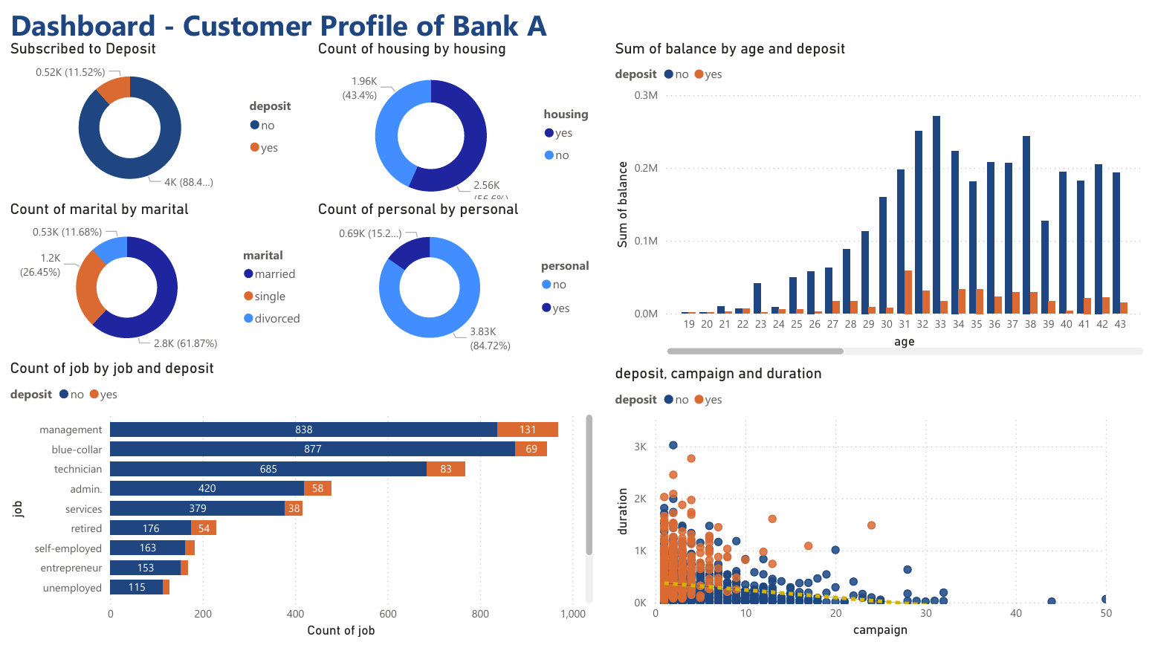

*Figure 5 - Dashboard*

**Explaination of how the components of the dashboard collectively address the Term Deposit Marketing Campaign**

**Pie chart showing composition of deposit subscribers vs. non-subscribers.**

Display proportions of deposit subscribers vs. non-subscribers.

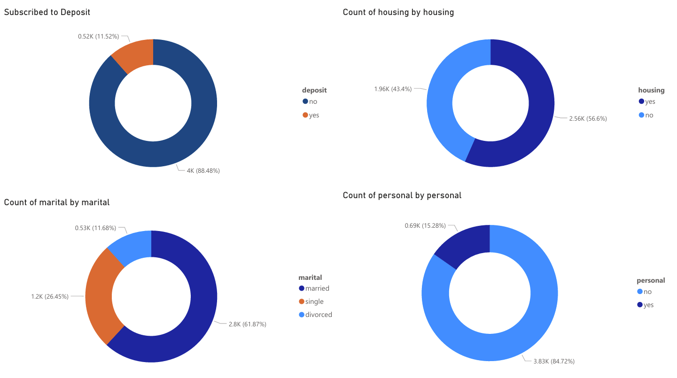

*Figure 6 - Pie chart of deposit subscribers vs. non-subscribers.*

Only 11.52% of existing customers are subscribed to term deposits, indicating significant potential for Bank A to encourage non-subscribers to place term deposit.

**Histogram of distribution of age group and comparison of average yearly balance**

A histogram is used to visualize the age distribution among clients, identifying age groups with higher or lower subscription rates, suggesting potential strategies for different age group. The bar chart also shows average yearly balance balances which are available for term deposit among age group.

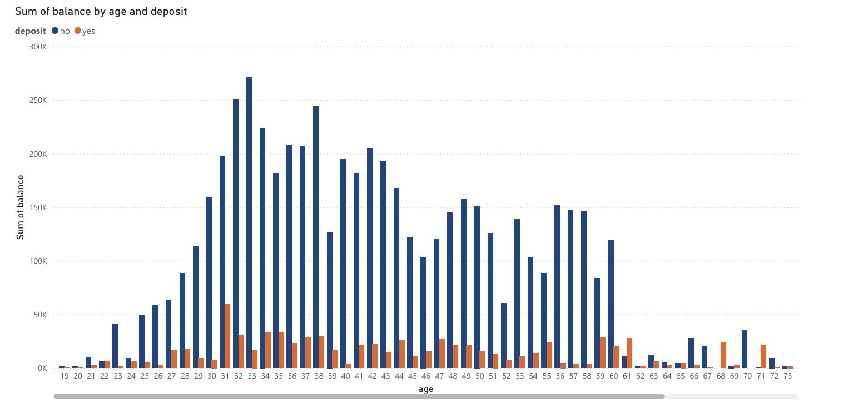

*Figure 7 - Histogram of age distribution by average yearly balance*

A positively skewed distribution suggests that the data is concentrated on one side of the scale (Taylor, 2024). The skewness indicates a small number of subscribers under 30, while the age group between early 30s and early 40s holds higher average yearly balance. Bank A can develop marketing strategies to target this age group for term deposit subscriptions.

**Stacked bar chart for job composition**

A stacked bar chart is used to show job composition

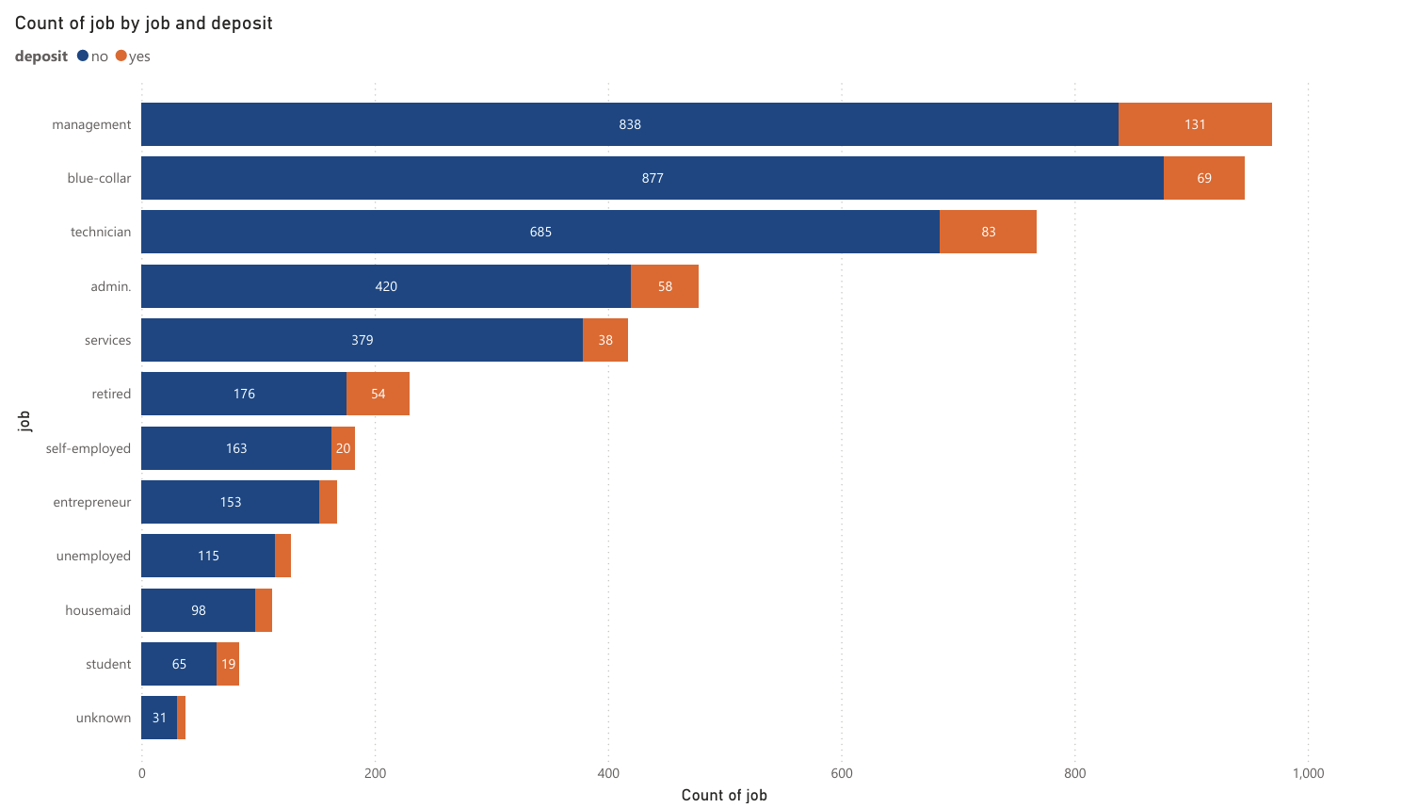

*Figure 8 - Stacked bar chart for job composition*

The primary deposit subscribers hold management positions, followed by technicians and blue-collar workers. Therefore, relevant marketing campaigns, such as roadshows, can be organized at operational sites and offices to target technicians and blue-collar workers, and managers respectively.

**Bubble chart showing relationship among last contact duration, number of contacts performed during current campaign and deposit subscriber vs non-subscriber**

A bubble chart is used to visualize the relationship among three dimensions last contact duration, total contacts made during this campaign and deposit subscriber vs non-subscriber, whereas a scatter chart displays only two value axes. (Pedamkar, 2023). It also uses to assess the effectiveness of the marketing campaign.

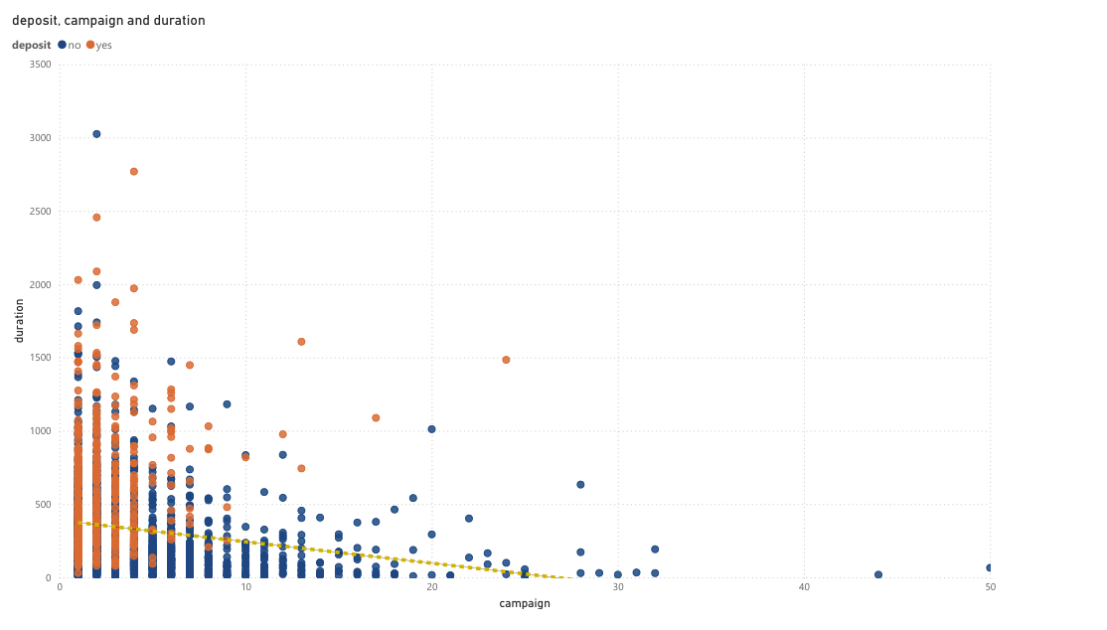

*Figure 9 - Bubble chart showing three dimensions relationship among duration, current campaign and deposit subscriber vs non-subscriber*

A negative correlation between the last contact duration and number of contacts performed during current campaign, suggesting that longer conversations lead to fewer follow-ups. It may reflect a strategic shift in approach, where quality interactions are prioritized over quantity, leading to more in-depth discussions rather than multiple brief contacts. The effectiveness of campaign is not necessary to have long duration of call.

**Business analytics solution via Machine Learning**

**Clustering (Unsupervised Machine Learning)**

Clustering groups customers into segments based on similar characteristics, facilitating targeted marketing efforts. K-means clustering can categorize clients into distinct groups based on demographic (age, marital status, and occupation), financial status (bank balance, housing loans, and personal loans) and responses to campaign (duration of calls, number of calls, and previous campaign outcomes). The dataset is filtered for "Deposit" = "Yes" to identify customers who subscribed to the term deposit. Load the data into the machine, specifying the input variables and the value of "K," or the number of clusters. The machine will compute K centroids, and each data point will be assigned to its nearest centroid.

|  |  |
| --- | --- |
|  |  |
| *Figure 10 - Cluster by customer* | *Figure 11 - Cluster Comparison* |

The bank can refine the marketing strategies, focusing on group of customers from blue-collar, technician with secondary school education and also customers in age group between 38 years old and 43 years old.

**Predictive Analytics (Supervised Machine Learning)**

The bank can apply a predictive modelling namely, regression, neural networks and decision trees to estimate probabilities of customer subscribing to a term deposit as a target outcome (“deposit”) based on criteria of customers’ social demographic status (age, marital status, and occupation), financial status (bank balance, housing loans, and personal loans) and responses to campaign (duration of calls, number of calls, and previous campaign outcomes) as the input variables. The target output is the Deposit" = "Yes". (Banu, 2023)

The classification algorithm is trained on historical data and its performance is validated via cross-validation method. The anticipated outcome will be displayed in a decision tree, where each observation is allocated to a leaf node with a binary result: "Yes" for subscribe and "No" for not subscribe. The splitting criteria include demographic status, financial status and responses to campaign. The predictive model’s accuracy can measure using metrics such as Mean Square Error, F1-score ,accuracy, precision and recall (Koh, 2005)

|  |
| --- |
|  |
| *Figure 12 - Classification and Regression Trees (CART) for Deposit* |

Inputs higher in the decision tree i.e. duration of last contact, outcome of the previous marketing campaign (e.g., success, failure, unknown), job are considered more influential for predicting the target customers subscribing deposit.

Prescriptive analytics

Prescriptive analytics e.g. Monte Carlo Simulation can be used to create numerous simulated scenarios by randomly varying input parameters (e.g., call duration, campaign frequency, offer incentives). For each scenario, assess the predicted probability of subscription and calculate the expected number of conversions. Monte Carlo Simulation allows the bank to provide personalized messaging at scale and increase the chance of yielding the highest expected number of subscribing the term deposit.

**Recommendations & Next Steps**

1. Targeted Campaigns:
   * Focus on the 30–43 age group with higher balances.
   * Tailor marketing approaches for managers, technicians, and blue-collar workers, including workplace campaigns and financial education sessions.
2. Improve Call Strategy:
   * Train agents to prioritize longer, more meaningful conversations instead of multiple short follow-ups.
   * Use predictive analytics to identify high-potential customers before outreach.
3. Segmented Incentives:
   * Offer customized deposit plans for specific clusters (e.g., incentives for blue-collar workers with stable employment but lower balances).
4. Leverage Predictive Models:
   * Implement decision tree models in CRM systems to provide real-time guidance to agents on customer subscription likelihood.
5. Run Prescriptive Simulations:
   * Use Monte Carlo simulations to test variations in campaign strategy (e.g., incentives, call frequency).
   * Prioritize campaigns predicted to deliver the highest conversion rates.
6. Monitor & Refine:
   * Track KPIs such as conversion rate, cost per acquisition, and campaign ROI.
   * Continuously retrain models with new customer and campaign data.

**Reference**

Banu, S. (2023, Nov 20). BANK MARKETING-Term Deposit Prediction Model. *Medium.* Retrieved from https://medium.com/@mail4sameera/bank-marketing-term-deposit-prediction-modelexploratory-data-analysis-a10df946b190

businesswire (2023, Dec 12). *MANTL Announces Growth Marketing Solution that Helps Financial Institutions Grow Deposits Quickly Without Offering Market-leading Rates*. businesswire. <https://www.businesswire.com/news/home/20231212786350/en/MANTL-Announces-Growth-Marketing-Solution-that-Helps-Financial-Institutions-Grow-Deposits-Quickly-Without-Offering-Market-leading-Rates>

Few, S. (2015). *Signal: Understanding What Matters in a World of Noise*. Analytics Press. <http://books.google.ie/books?id=U78drgEACAAJ&dq=Signal:+Understanding+What+Matters+in+a+World+of+Noise&hl=&cd=1&source=gbs_api>

Koh, H. C. (2005). *Data mining applications for small and medium enterprises*. Nanyang Technological University.

Pedamkar, P. (2023, March 24). Power BI Bubble Chart. *EDUCBA.* Retrieved from https://www.educba.com/power-bi-bubble-chart/

Powell, S. G., & Baker, K. R. (2016). *Business analytics: The art of modeling with spreadsheets (5th ed.)*. Wiley.

Taylor, S. (2024, April 26). Positively Skewed Distribution. *CFI Education Inc.* Retrieved from https://corporatefinanceinstitute.com/resources/data-science/positively-skewed-distribution/

Yau, N. (2013). *Data Points*. John Wiley & Sons. <http://books.google.ie/books?id=uD6g_xbJ3sgC&printsec=frontcover&dq=Data+Points:+Visualization+That+Means+Something&hl=&cd=1&source=gbs_api>