Oliver Amparo

4/29/2021

Container

Installing docker on ubuntu server. Because most linux distributions already have a docker repository the only thing you would want to do is run this command “sudo apt-get install docker”.

To install docker on a Centos server you would want to run “sudo yum install docker” on the terminal.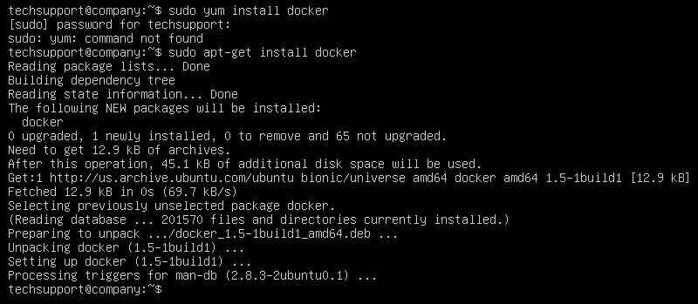

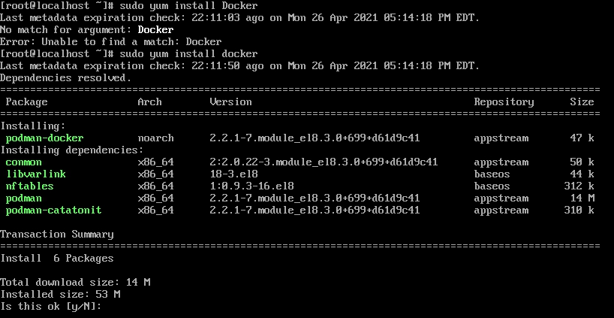

To make sure docker is running correctly I run this command “docker run hello-world” and it will say if it is running correctly.

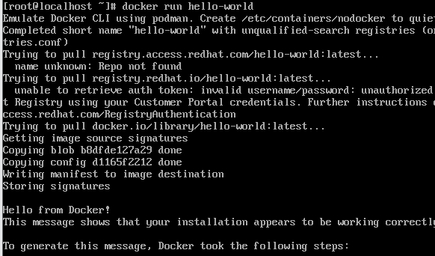

To install kubernetes you would want to make a repository because there is no public repository available. To do this you would have to copy and paste everything below. Also there is a screenshot of what it should look like in the terminal. In all this you are giving a name to that repository and an id to make sure you which is the repository. The link to the thing you would want to make the repository. And if you want to enable it.

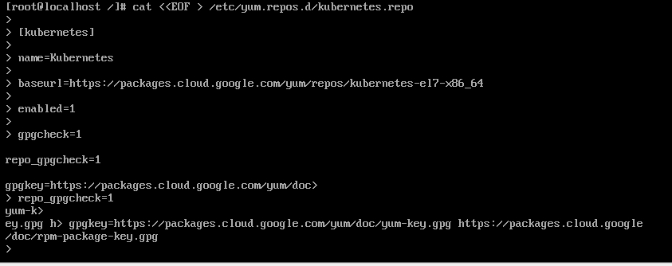

cat <<EOF > /etc/yum.repos.d/kubernetes.repo

[kubernetes]

name=Kubernetes

baseurl=https://packages.cloud.google.com/yum/repos/kubernetes-el7-x86_64

enabled=1

gpgcheck=1

repo_gpgcheck=1

gpgkey=https://packages.cloud.google.com/yum/doc/yum-key.gpg https://packages.cloud.google.com/yum/doc/rpm-package-key.gpg

EOF

After making the repository you would want to install kubelet kubeadm kubetcly which is needed to be able to use kubernetes.

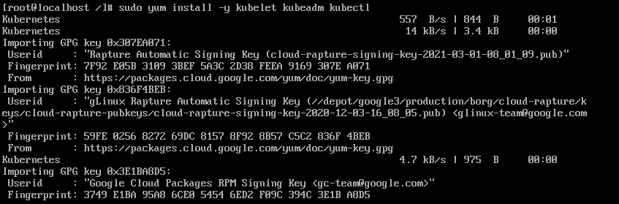

Now to install kubernetes in ubuntu. What you would want to do is run this command “sudo apt-get-repository “deb http://apt.kubernetes.io/ kubernetes-xenial main”. The last part in quotes is basically telling the system where to find the data. I had to rerun the command because I wasn't able to screenshot it.

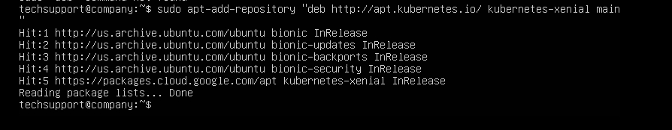

Now to install the tools needed to use kubernetes. You would need to run this command “sudo apt-get install -y kubelet kubeadm kubectl”. This will install 3 package. The y option is basically answering the following question when you are going to install something. As you can see it has already been installed.

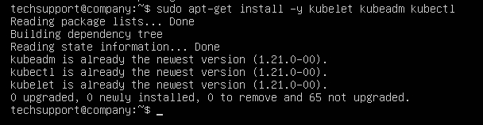

A small paragraph describing how the Minikube tutorial went, what gave you trouble (if anything) and how you fixed it.

When I was doing the minikube tutorial everything went well. Nothing really gave me trouble except for creating a development because it was more of a syntax issue. I didn't know how to format it other then that everything went well.

Sources:

I didn't know how to create a new repository from scratch so I used these sources to guide me.

<https://www.percona.com/blog/2020/01/02/how-to-create-your-own-repositories-for-packages/>

<https://phoenixnap.com/kb/how-to-install-kubernetes-on-centos>

<https://www.youtube.com/watch?v=h4IawuI-EWk&ab_channel=MiAleev>

<https://kubernetes.io/docs/tutorials/hello-minikube/>