Oliver Amparo

3/28/2021

1. First I redirected port 80 traffic to 8080



This is a script to add or drop an ip address meaning that if I run that command it will ask me for the address and then it asks if you want to allow access to the ip or drop it.

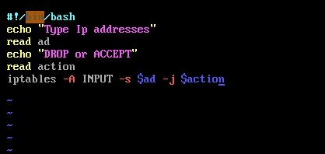

This script is just to accept a port. Below is the result when I run this script.

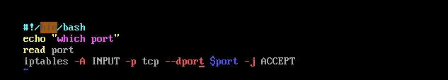

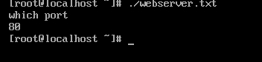

This is how I backed up the iptables. So all things I accepted and dropped are below.

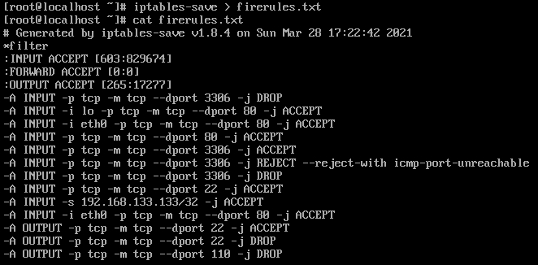

I am not really going to be using ping so I just disabled it. Ping is dangerous so it is better to have it off.



I disabled port 3306 because I am not going to be dealing with databases so there isn't really a point in having 3306 enabled.





I am going to be transferring files from my host operating system. So I enabled input and output



To deal with smtp and pop3. I disable the most that is used for them. They are port 110 and port 25

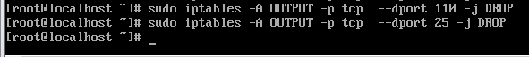

This is the whole iptables list.

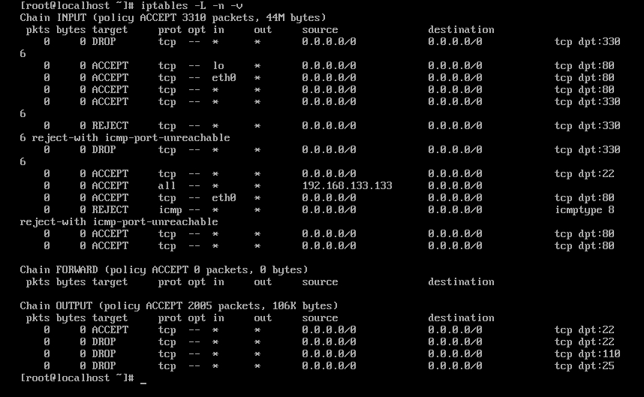

sources

<https://www.cyberciti.biz/tips/linux-iptables-examples.html>

<https://opensource.com/article/18/9/linux-iptables-firewalld>