Oliver Amparo

Below are pictures of me installing the different programs.

To install lolcat I installed ruby which is a package that already includes lolcat. To do this I typed sudo yum install ruby.

After I had already installed it you can see how I listed whatever is in the directory colorfully.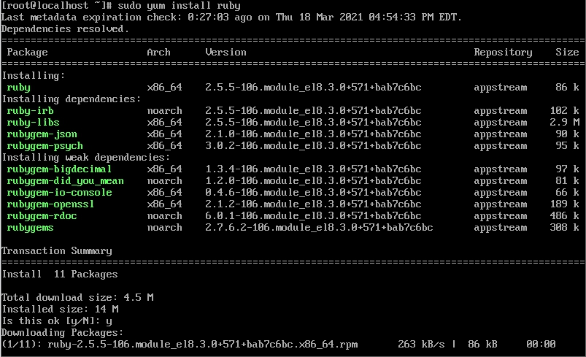

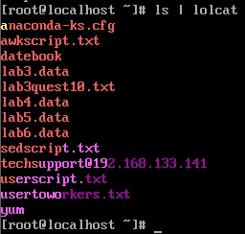

Next I installed cowsay. The command I used was sudo yum install cowsay. Below is a screenshot of me installing it and using it.

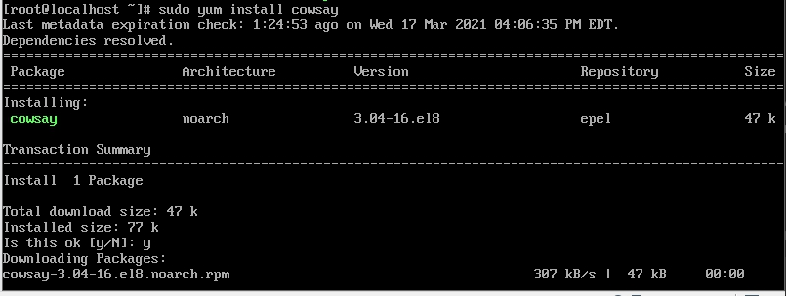

Using Cowsay and using lolcat at the same time: The command I used is cowsay “words” | lolcat.

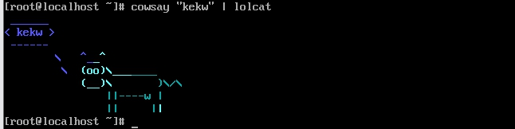

Next I installed emucs. The command I use to install it is sudo yum install emucs.

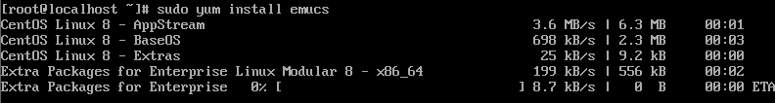

After that I installed tmux. The command I used to install it was sudo yum install tmux. Below is a screenshot.

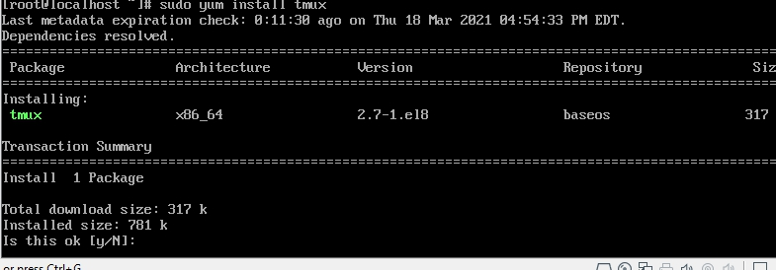

Finally to install fail2ban on centos. The way I installed it is I typed sudo yum install fail2ban. Here is a screenshot.

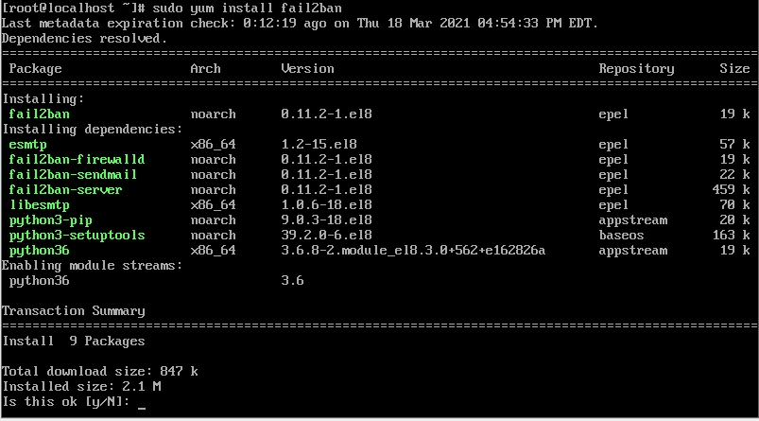

Here is fail2ban active.

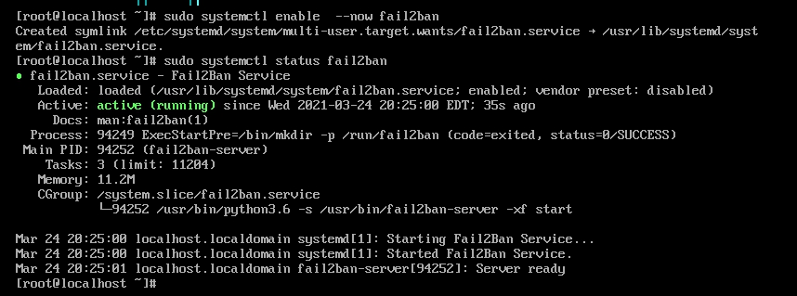

Now I will show you how to install each of these in a ubuntu server

To install emucs on a ubuntu you need to type sudo apt install emucs. Below is a screenshot.

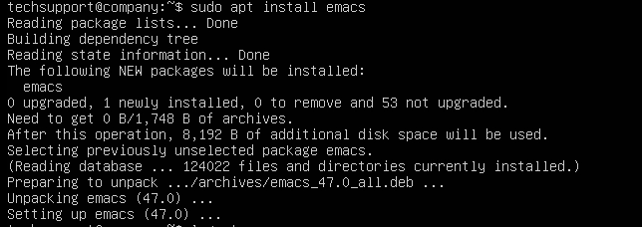

Here is how to instal tmux on ubuntu. You need to type sudo apt install tmux and it will automatically install

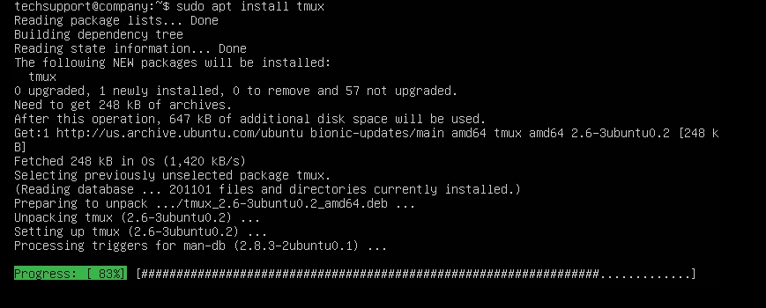

Now to install fail2ban on ubuntu. What I did was I runned this command sudo apt install fail2ban. And below are also some of the settings.

