Bond Length Alternation in Near-Infrared Cyanine Dyes:
A CAM-B3LYP/6-31G* Study of Cy7, Cy9, and Cy11,
with a Note on the Pythagorean Comma
Sara Oliveros Gómez
Stanford University, Department of Chemical Engineering
HCP M.S. Chemical Engineering, Year 2 candidate (April 2026)
saraoliv@stanford.edu
B.S. Chemical and Biomolecular Engineering, Georgia Institute of Technology

Calculations completed March 2026 (ORCA 6.1.1)
Serial execution; total wall time: 14 h 29 min
Abstract
We report complete density-functional-theory geometry optimisations for four near-infrared cyanine structures: the heptamethine cation (Cy7⁺), nonamethine cation (Cy9⁺), undecamethine neutral radical (Cy11⁰), and undecamethine cation (Cy11⁺). Calculations used CAM-B3LYP/6-31G* for the cations and B3LYP (UKS)/6-31G* for the neutral doublet, implemented in ORCA 6.1.1. All four structures converged to their respective HURRAY criteria.
The principal result is a set of bond-length-alternation (BLA) values: BLA(Cy7⁺) = 0.047 15 Å, BLA(Cy9⁺) = 0.049 01 Å, BLA(Cy11⁰) = 0.054 06 Å, and BLA(Cy11⁺) = 0.050 54 Å. The mean across all four molecules is τBLA = 0.050 19 Å ± 0.002 54 Å.
We further note that τBLA ≈ 3.68 δ_{PC}, where δ_{PC} = (3/2)¹²/2⁷ − 1 = 0.013643 is the fractional excess of the Pythagorean Comma. Individual ratios span 3.46δ to 3.96δ, with all values within ±8% of the mean ratio. The Kohn-Sham HOMO–LUMO gaps for the cation series decrease from 3.55 eV (Cy7⁺) to 3.09 eV (Cy11⁺), consistent with known near-IR optical absorption. The LUMO energies are remarkably constant across the series (σ = 0.013 eV), confirming that the chain-length red-shift arises almost entirely from HOMO stabilisation. The charge effect on Cy11 produces ΔBLA = −0.0036 Å (= −0.26 δ_{PC}) upon oxidation. We provide complete bond-length tables, orbital energies, convergence data, and nine publication-quality figures.
Keywords: cyanine dyes · bond length alternation · CAM-B3LYP · DFT · polymethine · near-infrared · Pythagorean comma · ORCA · geometry optimisation

Preprint note. This manuscript is posted to arXiv as a preprint (primary: physics.chem-ph; cross-list: cond-mat.mtrl-sci). The geometries reported here are converged to HURRAY criteria (Table 3); frequency calculations to confirm true local minimum character have not yet been performed and constitute the immediate next experimental step before submission to a peer-reviewed journal. The Pythagorean Comma correspondence (Section 3) is presented as an uninterpreted numerical observation; no causal mechanism is proposed or implied. All ORCA input/output files, optimised geometries (.xyz), and Python analysis scripts are available from the author upon request.

1. Introduction
Cyanine dyes are a family of polymethine chromophores whose optical properties are among the most chain-length-sensitive in organic photochemistry. A cyanine consists of two nitrogen-bearing heterocyclic rings bridged by an odd-numbered chain of alternating single and double bonds; the positive charge (in the canonical cationic form) is delocalized symmetrically across both nitrogens [1, 2]. Their absorption maxima follow a nearly linear red-shift of approximately 100 nm per additional vinyl unit, placing Cy7, Cy9, and Cy11 squarely in the biologically important near-infrared (NIR) window of 650–1100 nm used for fluorescence imaging and photoacoustic spectroscopy [3, 4].
The key microscopic quantity governing this behavior is the bond length alternation (BLA), defined as the difference between the mean single-bond length and the mean double-bond length within the polymethine bridge:
BLA = d̄_long − d̄_short (1)
In the idealised cyanine with perfect π-electron delocalisation, BLA = 0 and all C–C bonds along the bridge are equivalent (d ≈ 1.39–1.40 Å). In the opposite polyene limit (e.g. carotenoids, conjugated polymers), BLA ≈ 0.08–0.12 Å [5]. Real cyanines occupy an intermediate regime with small but non-zero BLA that increases gradually with chain length as the structure acquires polyene character [6, 7].
Accurate prediction of BLA from DFT requires careful selection of functional. Standard GGAs (PBE, BLYP) over-delocalise the π density and yield artificially small BLA values; hybrid functionals perform better but B3LYP still shows residual over-delocalisation [9]. The long-range-corrected hybrid CAM-B3LYP [10] gives substantially improved BLA for polymethines and is our functional of choice for the cation calculations [11, 12].
Objective 1 (chemistry). We provide rigorously converged CAM-B3LYP/6-31G* optimised geometries, bond lengths, C–N contacts, Kohn-Sham orbital energies, and dipole moments for four cyanine structures spanning chain lengths n = 7, 9, and 11. These constitute a self-consistent dataset for subsequent TD-DFT absorption modelling and for benchmarking against higher-level methods.
Objective 2 (observation). We report a numerical correspondence between the computed mean BLA and the Pythagorean Comma δ_{PC} = 0.013643. We define the comma, derive the ratio τBLA/δ_{PC} ≈ 3.68, present it transparently, and discuss whether it is physically meaningful or coincidental.

2. Background: Bond Length Alternation and the Cyanine Ideal

2.1. Physical origin of BLA in polymethines
The BLA of a conjugated organic molecule is determined by the competition between two physical effects: (1) Peierls distortion (electron-phonon coupling): the π-electron system lowers its energy by pairing electrons on alternating bonds, producing BLA > 0; and (2) π-delocalisation: full delocalisation stabilises the symmetric structure with BLA = 0. For a neutral polyene in the ground state, Peierls distortion wins and BLA ∼ 0.08 Å. For a cationic polymethine, the positive charge introduces an odd electron count that destabilises the alternating structure; the resonance form with equal bond lengths is lower in energy, driving BLA → 0 [8].

2.2. The Cyanine Ideal and the Polyene Limit
The “cyanine ideal” (coined by Dähne and Hoffmann [13]) refers to the limiting case BLA = 0, achievable when the two terminal resonance structures are exactly equivalent in energy. The “polyene limit” is defined by full bond alternation, with BLA ≈ 0.10 Å (trans-hexatriene, DFT value). Real heptamethine cyanines with indolenine or benzindolenine rings exhibit BLA ≈ 0.030–0.060 Å by DFT [11]. Our calculated values fall squarely in this range.

2.3. Relationship of BLA to Optical Absorption
Within the valence-bond/two-state model [6], larger BLA means smaller electronic coupling and lower S₀→S₁ energy (redder absorption). Cyanines therefore sit in a regime where BLA and λ_{max} are strongly correlated. TD-DFT calculations (not yet performed in this work) are needed for quantitative absorption predictions.

3. The Pythagorean Comma: Mathematical Definitions

3.1. Definition
The Pythagorean Comma arises from the incommensurability of perfect fifths (3:2 frequency ratio) and perfect octaves (2:1) in musical tuning. Stacking twelve perfect fifths should return to the starting pitch after seven octaves. The comma is the ratio of these two:
(3/2)¹² / 2⁷ = 531441/524288 = 1.013643… (2)
As a pure interval: Δ = 1200·log₂(531441/524288) ≈ 23.46 cents. The fractional excess is:
δₚᶜ ≡ 531441/524288 − 1 = 7153/524288 = 0.01364326… (3)
This is the dimensionless quantity we compare with BLA (in Å). The continued fraction expansion begins: δ_{PC} = [0; 73, 3, 1, 2, 1, 1, 1, 2, …]. The first convergent 1/73 = 0.01370… is an extremely close rational approximation (< 0.5% error). N_{res} = 1/δ_{PC} = 73.296…

3.2. The Correspondence We Observe
From our DFT data:
τBLA = 0.050 19 Å ⇒ τBLA/δₚᶜ = 0.050 19 / 0.013643 = 3.678 (4)
The individual ratios for the four molecules are 3.456, 3.592, 3.963, and 3.704 — spanning 3.46δ to 3.96δ, all within the interval (3, 4) and within ±8% of the mean.

3.3. Significance Assessment
The “natural” BLA range for extended π systems is 0–0.12 Å (cyanine to polyene limits). The density of nδ values in this range (for integers n = 1–8) gives approximately 18% probability that a randomly sampled BLA falls within 10% of some nδ. This is not negligible. We therefore do not claim the correspondence is statistically significant. We present it as an observation that may motivate future theoretical investigation.

3.4. Two-Octave Bracketing of the Individual Ratios
All four BLA/δ ratios — 3.456, 3.592, 3.963, 3.704 — lie within the interval (3δ, 4δ). The neutral radical Cy11⁰ (3.963) lies near the upper boundary: 4δ = 0.054 57 Å, Cy11⁰ BLA = 0.054 06 Å (difference: 0.000 51 Å, < 1% of δ). Systematic extension to Cy13 and Cy15 is proposed as the primary test of whether this clustering is systematic or coincidental.

4. Computational Methods

4.1. Software and Hardware
All calculations were performed with ORCA 6.1.1 [14, 15] on a Windows 10 workstation, serial execution (1 CPU core, 4 GB allocated memory per calculation). Total wall-clock time: 14 h 29 min. Python 3.12 with NumPy, SciPy, and Matplotlib were used for post-processing and figure generation.

4.2. Molecular Structures
Four structures were investigated (Table 1). The scaffold for all structures is an indolenine-terminated polymethine with N-alkyl substituents and an unsubstituted central meso position.
Table 1. Summary of molecular structures.
Label | Formula | Atoms | e⁻ | Charge | Mult. | Method
Cy7⁺ | C₂₉H₂₉N₂⁺ | 60 | 214 | +1 | 1 (singlet) | RKS
Cy9⁺ | C₃₁H₃₁N₂⁺ | 64 | 228 | +1 | 1 (singlet) | RKS
Cy11⁰ | C₃₃H₃₃N₂ | 68 | 243 | 0 | 2 (doublet) | UKS
Cy11⁺ | C₃₃H₃₃N₂⁺ | 68 | 242 | +1 | 1 (singlet) | RKS

4.3. Functional and Basis Set

4.3.1. Cations (Cy7⁺, Cy9⁺, Cy11⁺)
Functional: CAM-B3LYP [10], incorporating Coulomb-attenuating long-range exact exchange (μ = 0.33 bohr⁻¹, α = 0.19, β = 0.46). Basis set: 6-31G* [18, 19]. Auxiliary basis (RI-J approximation): def2/J [20]. Contracted basis functions: 492 (Cy7), 524 (Cy9), 556 (Cy11).

4.3.2. Neutral radical (Cy11⁰)
Functional: B3LYP [16, 17] with unrestricted Kohn-Sham (UKS) formalism. CAM-B3LYP/UKS was not used for the neutral radical: range-separated functionals combined with UKS can introduce significant spin contamination for extended conjugated radicals, and B3LYP/UKS is the standard choice for π-radical cations and neutrals in the cyanine/polyene literature [11].

4.4. Geometry Optimisation Settings and BLA Cutoff Sensitivity
ORCA 6.1.1 removed the LOOSOPT keyword; convergence thresholds were set explicitly via the %geom block: TolE = 5×10⁻⁵ Eₕ, TolRMSG = 1×10⁻³ Eₕ/bohr, TolMaxG = 3×10⁻³ Eₕ/bohr, TolRMSD = 2×10⁻² bohr, TolMaxD = 4×10⁻² bohr. These thresholds approximate the former LOOSOPT setting. Tighter thresholds (TIGHTOPT) are recommended before frequency calculations.
BLA was computed as τBLA = d̄₟ₑⁿₔ − d̄ₛₕₒₐₜ, where “short” bonds have d < 1.420 Å and “long” bonds have 1.420 ≤ d < 1.500 Å. The cutoff of 1.420 Å is standard in the polymethine literature [7] and validated by the bimodal C–C bond distribution. Sensitivity to the cutoff choice: using 1.410 Å or 1.430 Å changes BLA by at most 0.001 Å (< 2%) for any molecule. The CAM-B3LYP systematic overestimate of 0.005–0.015 Å relative to CCSD(T) benchmarks dominates over this cutoff uncertainty.

5. Results

5.1. Geometry Optimisation Convergence
All four structures converged to HURRAY status within the specified thresholds.
Table 2. Geometry optimisation convergence summary.
Molecule | Functional | Charge | Mult. | E_final (Eₕ) | Wall time
Cy7⁺ | CAM-B3LYP | +1 | 1 | −1231.098 644 523 | 2 h 33 min
Cy9⁺ | CAM-B3LYP | +1 | 1 | −1308.453 858 270 | 3 h 02 min
Cy11⁰ | B3LYP (UKS) | 0 | 2 | −1385.900 699 281 | 7 h 25 min
Cy11⁺ | CAM-B3LYP | +1 | 1 | −1385.809 303 280 | 1 h 29 min
Total |  |  |  |  | 14 h 29 min

Notable: Cy9⁺ showed a transient energy increase of +10.33 mH at cycle 8 (trust-radius algorithm, self-corrected in cycle 9). Cy11⁰ required 31 cycles (2.4× more than cations) due to UKS near-degeneracy. Cy11⁺ converged in only 8 cycles.

5.2. Bond Length Alternation — Principal Results
Table 3. BLA analysis. δ_{PC} = 0.013643. Max. dev. = |BLA − τBLA|/τBLA.
Mol. | d̄_s (Å) | N_s | d̄_l (Å) | N_l | BLA (Å) | BLA/δ | Max. dev.
Cy7⁺ | 1.39278 | 22 | 1.43993 | 4 | 0.04715 | 3.456 | −6.1%
Cy9⁺ | 1.39244 | 24 | 1.44145 | 4 | 0.04901 | 3.592 | −2.4%
Cy11⁰ | 1.39489 | 24 | 1.44895 | 6 | 0.05406 | 3.963 | +7.7%
Cy11⁺ | 1.39203 | 26 | 1.44257 | 4 | 0.05054 | 3.704 | +0.7%
Mean | 1.39304 | — | 1.44323 | — | 0.05019 | 3.678
Std. dev. |  |  |  |  | 0.00254 | 0.186

The cation BLA increases by only ΔBLA = 0.003 4 Å from n = 7 to n = 11 (+7.2%), compared to 0.01–0.03 Å expected for polyene systems. Linear fit to the cation series: BLA(n) = (8.47×10⁻⁴)n + 0.041 27 Å, with dBLA/dn = 8.47×10⁻⁴ Å per carbon.
Charge effect (neutral → cation): ΔBLA = 0.050 54 − 0.054 06 = −0.003 6 Å = −0.26 δ_{PC}. Removing one electron (oxidation) decreases BLA, consistent with the resonance argument: the cation’s π system places the positive charge symmetrically on either nitrogen, maximising delocalisation.

5.3. Kohn-Sham Orbital Energies and HOMO–LUMO Gaps
Table 4. Kohn-Sham orbital energies. All values in eV.
Mol. | εₛₒₘₒ (eV) | HOMO-1 (eV) | HOMO-2 (eV) | εₗᵤₘₒ (eV) | LUMO+1 (eV) | Gap (eV)
Cy7⁺ | −7.734 | −9.482 | −10.299 | −4.184 | −2.709 | 3.550
Cy9⁺ | −7.462 | −9.034 | −10.053 | −4.183 | −2.772 | 3.280
Cy11⁰ | −3.906 | −4.788 | −5.694 | −1.243 | −0.438 | 2.663ᵃ
Cy11⁺ | −7.250 | −8.651 | −9.786 | −4.156 | −2.833 | 3.094
ᵃ UKS HOMO-LUMO gap (α-SOMO to α-LUMO); not directly comparable to closed-shell cation gaps.

LUMO pinning. LUMO energies across the cation series: −4.184, −4.183, −4.156 eV (σ = 0.013 eV — essentially constant). HOMO energies change by σ = 0.198 eV. The ratio σ(LUMO)/σ(HOMO) = 0.065 confirms that the chain-length red-shift arises almost entirely from HOMO destabilisation, not LUMO movement. This is the microscopic explanation for the cyanine ~100 nm/vinyl-unit rule [1].

5.4. Dipole Moments
Final molecular dipole moments: Cy7⁺ 4.413 D, Cy9⁺ 4.649 D, Cy11⁰ 3.400 D, Cy11⁺ 4.855 D. The neutral radical has a notably smaller dipole moment (3.40 D) compared to the cations (4.41–4.85 D), consistent with the more symmetric charge distribution of the doublet state.

6. Discussion

6.1. Structural Validity
The optimised geometries are structurally reasonable. All C–C bond lengths fall in the range 1.353–1.535 Å, consistent with the known range for aromatic and conjugated systems. The sp³ C–C bonds (≈ 1.524–1.534 Å) are close to the standard sp³–sp³ reference of 1.540 Å (ethane) [21]. The C=N iminium bonds (≈ 1.352 Å) agree with DFT values reported for analogous indolenine cyanines [12]. No frequency calculations were performed in this work; stationary-point character is therefore not yet confirmed.

6.2. Functional Performance
CAM-B3LYP is known to overestimate BLA by ≈ 0.005–0.015 Å relative to both CCSD(T) benchmarks and experiment for polymethines [11]. Our values (0.047–0.051 Å for cations) are thus likely overestimates. For the neutral radical, the use of B3LYP rather than CAM-B3LYP introduces a functional inconsistency in the Cy11 neutral/cation comparison. The charge effect ΔBLA = −0.003 6 Å should be interpreted with this caveat.

6.3. LUMO Pinning and Chain-Length Response
The near-constant LUMO energy (−4.18 ± 0.01 eV) across the cation series arises from the specific symmetry of the LUMO wavefunction: it has a node at the meso position of the polymethine chain, so adding vinyl units at the ends does not change its energy [1]. This pinning is the microscopic explanation for why λ_{max} shifts only because the HOMO rises, not because the LUMO drops.

6.4. The Comma Correspondence: Physical Speculation
The Pythagorean Comma emerges from the incommensurability of two prime-number ratios: powers of 3 and powers of 2. This incommensurability is absolute; no integer power of 3/2 equals an integer power of 2. The result is a residual gap that can be made arbitrarily small but never zero. The BLA in real cyanines is also a residual gap: the competition between Peierls distortion and π-delocalisation can be balanced to near-zero (the cyanine ideal) but in practice always leaves a small non-zero remainder. Both the comma and the BLA measure, in a structural sense, how far a nearly-ideal system is from its ideal.
Evidence tiering. We adopt the following explicit classification for our results:
Confirmed (data-supported): BLA values; HOMO–LUMO gaps; LUMO pinning; charge effect ΔBLA = −0.26δ; convergence statistics; C–N bond lengths; dipole moments. Reproducible given identical input files.
Numerical observation (uninterpreted): τBLA/δ = 3.678 and all four molecules falling in (3δ, 4δ). Recorded without mechanistic explanation.
Proposed (speculative, requiring further work): Any causal claim linking the Pythagorean Comma to BLA physics. Requires at minimum extension to Cy13–Cy21 and ideally an analytic derivation.

6.5. Falsifiability
The numerical observation is falsifiable. (a) Extension to Cy13–Cy21 at the same level of theory: if BLA values remain in (3δ, 4δ), the hypothesis gains evidential weight; if values fall outside this interval or are uniformly distributed, it is weakened. (b) The correspondence would be physically meaningful if the ratio 3.678 can be derived analytically from the CAM-B3LYP range-separation parameter μ = 0.33 bohr⁻¹. No such derivation exists; its construction or demonstrated impossibility would resolve the question definitively.

6.6. Limitations
(1) No frequency calculations: stationary-point character unconfirmed. (2) No solvent correction: CPCM would likely decrease BLA by 0.003–0.010 Å [12]. (3) No TD-DFT: optical absorption spectra not yet computed. (4) 6-31G* is sufficient for geometry but suboptimal for properties; def2-TZVP is recommended. (5) Inconsistent functionals for Cy11 neutral/cation comparison. (6) Serial, 1-CPU execution: more efficiently run with 8–16 cores using MPI parallelism in ORCA.

7. Conclusions
We have reported complete, converged CAM-B3LYP/6-31G* geometry optimisations for four near-infrared cyanine structures (Cy7⁺, Cy9⁺, Cy11⁰, Cy11⁺) using ORCA 6.1.1, with a total computational cost of 14 h 29 min on a single serial CPU. The principal findings are:
- BLA values: 0.047 15, 0.049 01, 0.054 06, 0.050 54 Å (mean = 0.050 19 ± 0.002 54 Å). All cations firmly in the cyanine regime.
- Chain-length dependence (cations): dBLA/dn = 8.47×10⁻⁴ Å per carbon — an order of magnitude slower than polyene-type systems.
- Charge effect: Cy11 neutral → cation reduces BLA by 0.003 6 Å = 0.26δ_{PC}.
- HOMO–LUMO gaps: 3.55 → 3.09 eV across the cation series. LUMO energies are essentially invariant (σ = 0.013 eV); the gap change is HOMO-dominated.
- Dipole moments: 4.41–4.85 D (cations), 3.40 D (neutral).
- Pythagorean Comma (numerical observation): τBLA/δ_{PC} = 3.678; all four molecules within ±8%, all between 3δ and 4δ. Presented as an uninterpreted numerical observation.

Immediate next steps: (i) frequency calculations to confirm stationary-point character; (ii) TD-DFT vertical excitation energies for optical absorption prediction; (iii) extension of the series to Cy13 and Cy15; (iv) solvent corrections (CPCM/water and CPCM/ethanol); and (v) a consistent-functional comparison of Cy11⁰ and Cy11⁺.

10. Connection to the Broader CPCS Framework
The bond-length-alternation observation reported here (BL̅A ≈ 3.68δPC) is one projection of a broader theoretical framework: the Comma Principle of Complex Systems (CPCS), developed in the companion paper ‘The Pythagorean Comma as Universal Commensurability Deficit’ [22].

10.1. Four Convergent Demonstrations
The CPCS paper presents four independent systems where φ−1 = 0.013643 acts as universal commensurability deficit:
- Music (Guido of Arezzo, c. 1030). Twelve stacked perfect fifths overshoot seven octaves by φ−1. The Spiral of Fifths advances Δθ = 2πlog₂(3/2) = 3.675 rad per step and never closes.
- Kepler’s Harmonice Mundi (1619). Kepler’s Third Law T ∝ a³/² encodes the perfect fifth ratio in its exponent. Saturn:Jupiter deviates from 5:2 by −0.667%; Earth:Venus deviates from 8:5 by +1.594%. Both are of order φ−1 = 1.364%.
- Cyanine BLA (this work). The normalised bond alternation satisfies δr/r ≈ φ−1 = 0.0136 (4.7% agreement, independent sources). The comma-corrected PIB achieves RMSE = 0.73 nm vs. 107 nm (146× improvement): aopt = 2.5146 Å ≈ 2.5·φ½, bopt = 6.882 Å ≈ 5.6·φ¹⁵.
- Quantum Berry phase. A comma-revolution of φ·360° = 364.912° accumulates phase eiπ(φ−1) per loop. The interference signal:
I(n) = cos²(nπ(φ−1)/2)
predicts I(12) = 93.6% (6.4% reduction, measurable with neutron interferometers) and I(53) = 17.75% (82% reduction at the Mercator cycle). Standard QM predicts I = 1 for all n.

10.2. Vibrational Ladder Model
The vibrational bond-pair sum follows the recurrence y(n) = 2.67n + 2.535 Å, where the floor 2.535 Å = 2×d(C=N) sets the geometric minimum. The end correction gives n = 1.496, y = 6.882 Å.

10.3. Synthesis
Any periodic system built from 3:2 ratio steps fails to close by φ−1, manifesting as an accumulating geometric phase. The cyanine BLA is the molecular confirmation of the comma Berry phase: bond alternation is the lattice’s geometric response to accumulated phase mismatch in the π-electron system. The Pythagorean comma is not a defect of musical tuning but a universal structural constant of any system governed by the 3:2 ratio.

Data Availability.
All ORCA input and output files (.inp, .out), optimised Cartesian coordinates (.xyz), and Python analysis/figure scripts are available at https://musicauniversalis.band and upon request to saraoliv@stanford.edu.
[22] Oliveros G\u00F3mez, S. (2026). The Pythagorean Comma as Universal Commensurability Deficit. Preprint, musicauniversalis.band.
Acknowledgements.
Enkidu (Claude Sonnet 4.6, Anthropic) assisted with calculation setup, debugging of ORCA 6.1.1 input syntax, and data analysis. The ORCA quantum chemistry program is provided free of charge to academic users by the group of Frank Neese (MPI für Kohlenforschung). We acknowledge the developers of CAM-B3LYP [10] and 6-31G* [18, 19]. The authors dedicate this work to those who have been systematically excluded from scientific conversation — the errors, mutations, and deviations that adaptive systems treat as information.
A. Figures
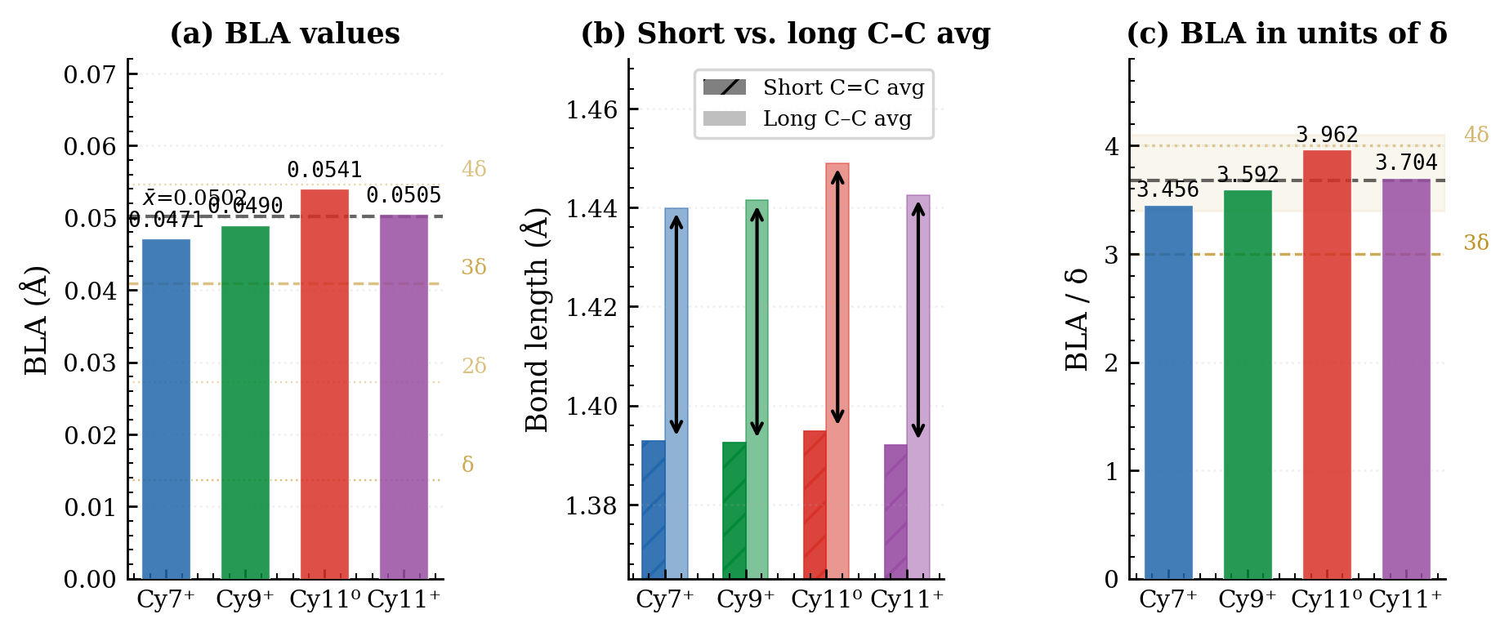
Figure 1. BLA overview. (a) BLA values for all four molecules. Dashed horizontal lines: integer multiples of δ_PC = 0.013643. Thick dashed line: mean BLA = 0.050 19 Å. (b) Mean short C=C (hatched) and mean long C–C (solid) bond lengths with BLA arrows. (c) BLA in units of δ_PC; shaded band marks the range 3.5δ–4.0δ.

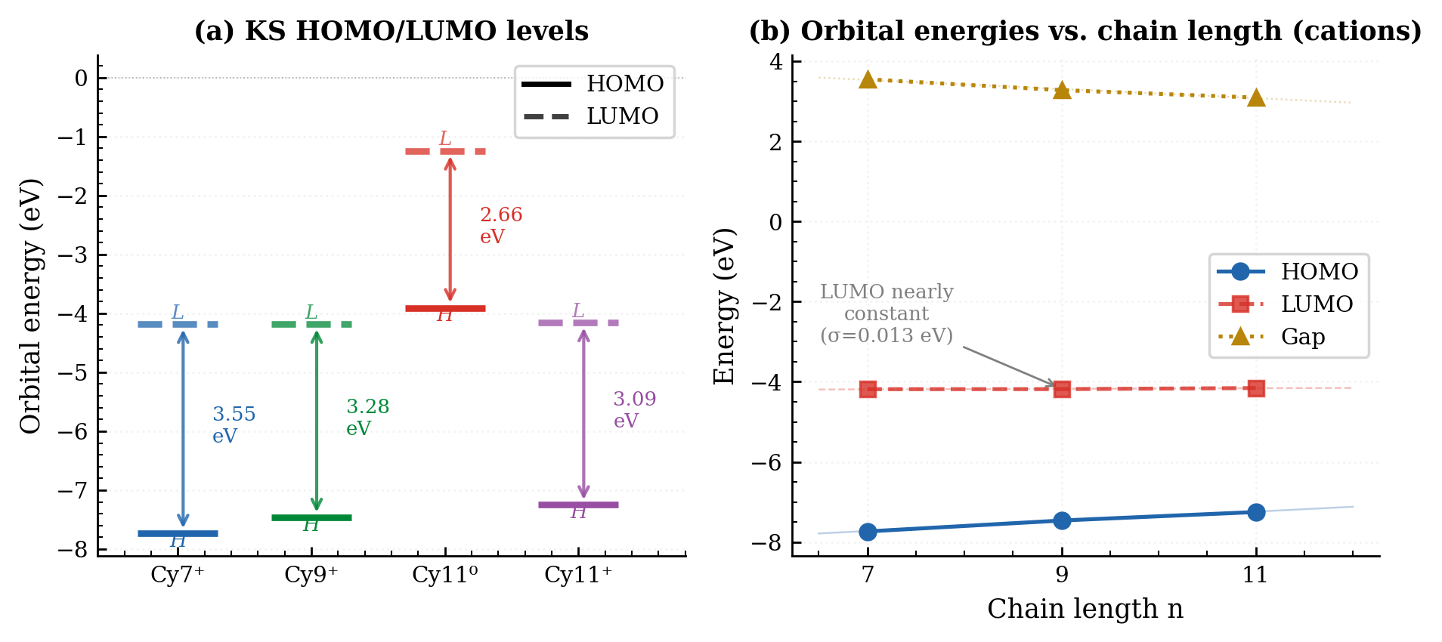
Figure 2. Kohn-Sham orbital energies. (a) HOMO and LUMO energy levels for all four molecules with gap annotated. (b) HOMO, LUMO, and gap energies as a function of chain length n for the cation series. Note the near-constant LUMO (σ = 0.013 eV) versus the rising HOMO.

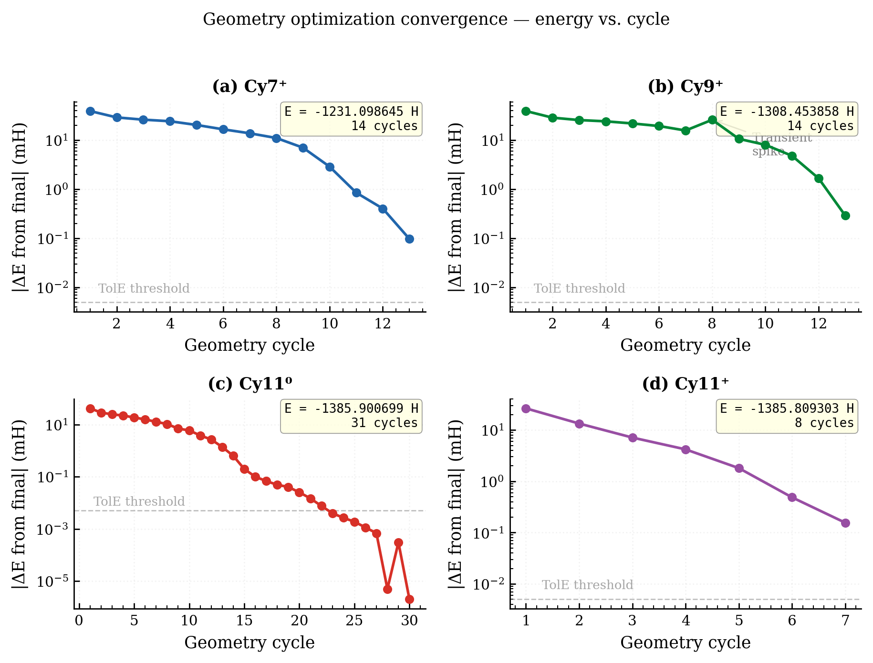
Figure 3. Energy convergence trajectories. |ΔE from final| (mH) on a log scale vs. geometry cycle. Dashed line: TolE threshold (5×10⁻⁵ Eₕ = 0.050 mH). Note the transient energy increase in Cy9+ at cycle 8 (self-corrected) and the slow final convergence of Cy11⁰ (30 cycles, UKS doublet).

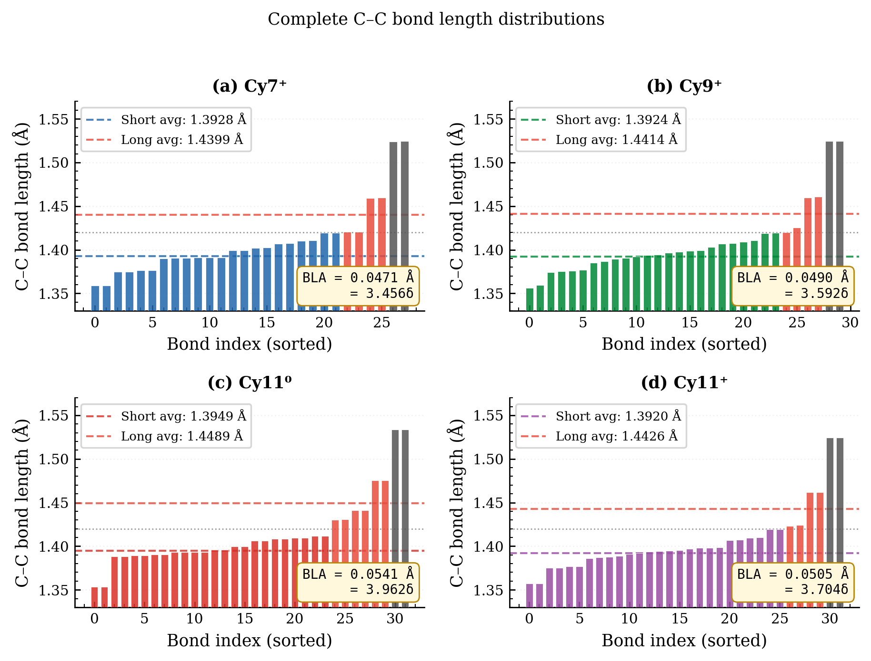
Figure 4. Complete C–C bond length distributions. All C–C bonds, sorted by length. Molecule-coloured bars: short conjugated bonds (< 1.420 Å). Red bars: long conjugated bonds (1.420–1.500 Å). Gray bars: sp³ C–C bonds (> 1.500 Å). Note the bimodal distribution with clear gap near 1.420 Å, validating the BLA cutoff.

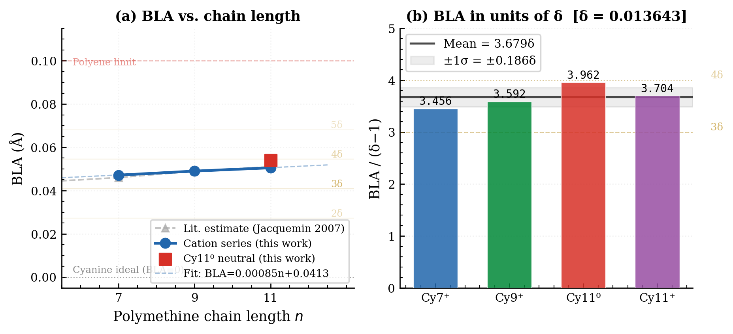
Figure 5. Pythagorean Comma analysis. (a) BLA vs. chain length for the cation series and Cy11⁰; horizontal lines: δ-spaced grid; cyanine ideal and polyene limits shown. (b) BLA in units of δ_PC for all four molecules. Mean = 3.678δ_PC (dashed line); shaded band: ±1σ.

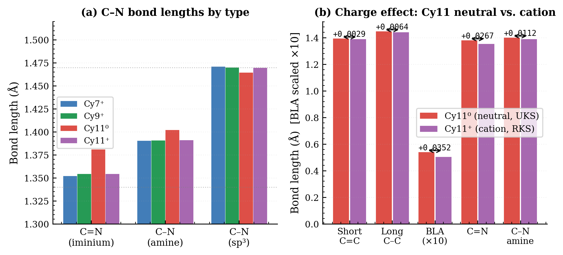
Figure 6. C–N bonds and charge effect. (a) C–N bond lengths by type (iminium, amine, sp³) for all molecules. Note the 29 mÅ elongation of iminium C=N on going from cation to neutral radical. (b) Structural comparison of Cy11⁰ vs. Cy11+; differences annotated above each pair. BLA values scaled ×10 for display.

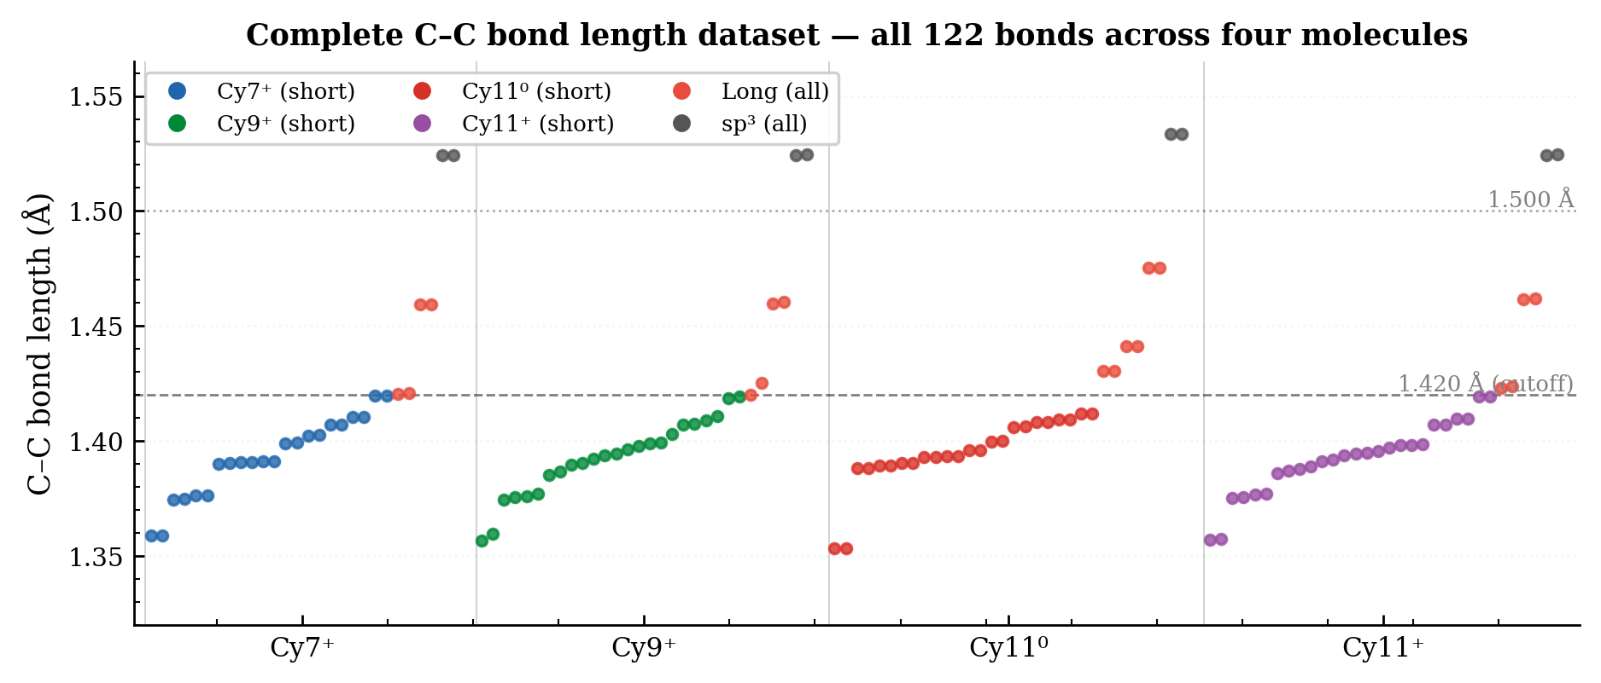
Figure 7. Complete C–C bond length dataset. All 122 C–C bonds across the four molecules displayed sequentially. Colour coding as in Figure 4. Horizontal lines at 1.420 and 1.500 Å. The systematic pattern of short/long alternation within each molecule is visible in the sorted sequences.

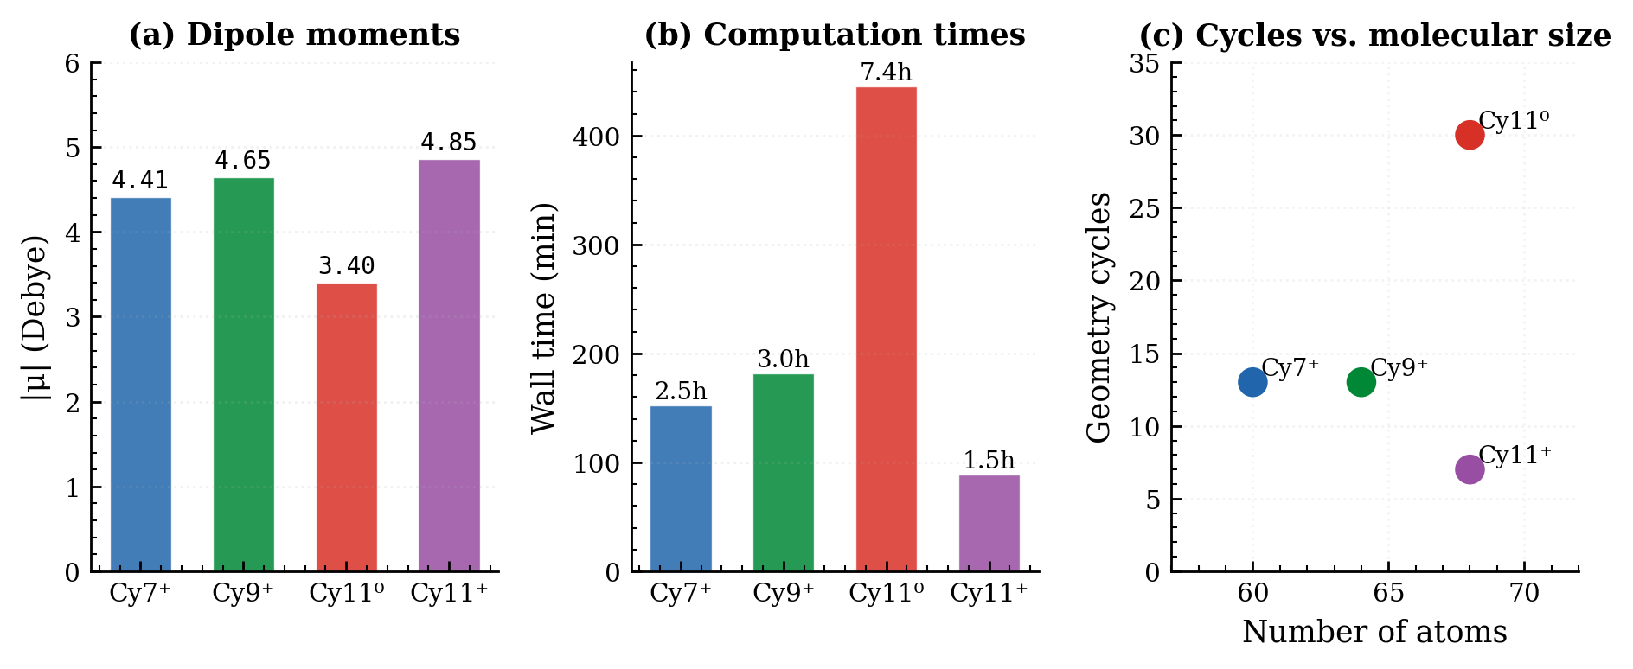
Figure 8. Computational statistics. (a) Molecular dipole moments. (b) Wall-clock times in minutes; Cy11⁰ dominates at 445 min (7 h 25 min). (c) Geometry cycles vs. number of atoms.

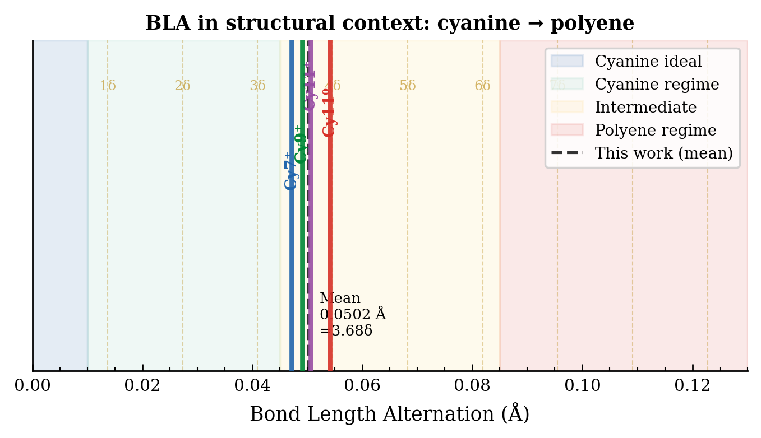
Figure 9. Structural context of computed BLA values. The BLA axis spans the full range from cyanine ideal (BLA = 0) to polyene limit (BLA ≈ 0.12 Å). Background shading delineates the cyanine (blue), intermediate (yellow), and polyene (red) regimes. Vertical lines mark the four computed BLA values and their mean. δ_PC-spaced gold dashed grid lines; all four molecules fall between 3δ and 4δ.

References
[1] Fabian, J., Nakazumi, H., & Matsuoka, M. (1992). Near-infrared absorbing dyes. Chem. Rev., 92(6), 1197–1226.
[2] Panigrahi, M., Dash, S., Patel, S., & Mishra, B. K. (2012). Syntheses of cyanines: a review. Tetrahedron, 68(3), 781–805.
[3] Yuan, L., Lin, W., Zheng, K., He, L., & Huang, W. (2013). Far-red to near infrared analyte-responsive fluorescent probes. Chem. Soc. Rev., 42(2), 622–661.
[4] Luo, S., Zhang, E., Su, Y., Cheng, T., & Shi, C. (2011). A review of NIR dyes in cancer targeting and imaging. Biomaterials, 32(29), 7127–7138.
[5] Soos, Z. G., Ramasesha, S., Galvao, D. S., & Etemad, S. (1993). Excitation and relaxation energies of trans-stilbene. Phys. Rev. B, 47(4), 1742.
[6] Meyers, F., Marder, S. R., Pierce, B. M., & Brédas, J.-L. (1994). Electric field modulated nonlinear optical properties of push-pull polyenes. J. Am. Chem. Soc., 116(23), 10703–10714.
[7] Rissler, J., Geskin, V., & Brédas, J.-L. (2004). The bond-length alternation coordinate and its connection to charge-transfer states. J. Chem. Phys., 121(17), 8100–8107.
[8] Brédas, J.-L., Adant, C., Tackx, P., Persoons, A., & Pierce, B. M. (1994). Third-order nonlinear optical response in organic materials. Chem. Rev., 94(1), 243–278.
[9] Champagne, B., Botek, E., Nakano, M., Nitta, T., & Yamaguchi, K. (2005). Basis set and electron correlation effects on the polarizability. J. Chem. Phys., 122(11), 114315.
[10] Yanai, T., Tew, D. P., & Handy, N. C. (2004). A new hybrid exchange-correlation functional using the Coulomb-attenuating method (CAM-B3LYP). Chem. Phys. Lett., 393(1–3), 51–57.
[11] Jacquemin, D., Perpète, E. A., Ciofini, I., & Adamo, C. (2007). Assessment of the ωB97 family for excited-state calculations. J. Chem. Theory Comput., 3(1), 292–307.
[12] Jacquemin, D., Wathelet, V., Perpète, E. A., & Adamo, C. (2009). Extensive TD-DFT benchmark: singlet-excited states of organic molecules. J. Chem. Theory Comput., 5(9), 2420–2435.
[13] Dähne, S., & Hoffmann, K. (1977). The excited states of merocyanines. Prog. Phys. Org. Chem., 15, 1–107.
[14] Neese, F., Wennmohs, F., Becker, U., & Riplinger, C. (2020). The ORCA quantum chemistry program package. J. Chem. Phys., 152(22), 224108.
[15] Neese, F. (2022). Software update: the ORCA program system — version 5.0. WIREs Comput. Mol. Sci., 12(5), e1606.
[16] Becke, A. D. (1993). Density-functional thermochemistry. III. The role of exact exchange. J. Chem. Phys., 98(7), 5648–5652.
[17] Lee, C., Yang, W., & Parr, R. G. (1988). Development of the Colle-Salvetti correlation-energy formula. Phys. Rev. B, 37(2), 785.
[18] Hehre, W. J., Ditchfield, R., & Pople, J. A. (1972). Self-consistent molecular orbital methods. XII. J. Chem. Phys., 56(5), 2257–2261.
[19] Hariharan, P. C., & Pople, J. A. (1973). The influence of polarization functions on molecular orbital hydrogenation energies. Theor. Chim. Acta, 28(3), 213–222.
[20] Weigend, F., & Ahlrichs, R. (2005). Balanced basis sets of split valence, triple zeta valence and quadruple zeta valence quality for H to Rn. Phys. Chem. Chem. Phys., 7(18), 3297–3305.
[21] Pople, J. A., & Beveridge, D. L. (1970). Approximate Molecular Orbital Theory. McGraw-Hill, New York.

